Site Visit Checklist
Accreditation Commission
Revised 1.6.2023

Table of Contents
From Katy Wilcox, Chair of the Accreditation Commission 3
Commissioner Responsibilities 4
Pre-Site Visit 4
Site Visit 4
Post Site Visit 4
National Site Team Chair (NSTC) Responsibilities 5
Pre-Site Visit 5
Site Visit 5
Post Site Visit 5
Site Team Member Responsibilities 6
Pre-Site Visit 6
Post Site Visit 6
Program Responsibilities 7
Pre-Site Visit 7
Site Visit 7
Post Site Visit 7
Accreditation Portfolio Part I Review 8
Part II In-Depth Review of Materials 11
SITE VISIT REPORT—PART I: INITIAL REPORT OF THE SITE TEAM 19
SITE VISIT REPORT—PART II: FINAL REPORT OF THE SITE TEAM 21
Standard Authorized Expenses 23
Expense Submission Via Certify 24
Access Certify 25

From Katy Wilcox, Chair of the Accreditation Commission

Welcome, and thank you for volunteering to serve within the ACPE Accreditation Commission!
ACPE could not accomplish its strategic initiatives or mission without ACPE members and practitioner colleagues assisting in the important work of accreditation.
We hope that you will find serving as a Site Visit Member, Practitioner Reviewer, or National Site Team Chair informative, educational, collegial, and meaningful.
This document is designed to be used as a guide for the site visit process and will provide step-by-step instructions of what needs to be done and when as well as links to the appropriate documents. This should be considered a working document for the site visit and can be used/viewed by the commissioner, the site team members, and the local ACPE Certified Educators.
Please let us know if you have any questions about your role, and how we can assist you in the ministry of accreditation review. Again, thank you for your generosity of time and expertise.

SITE TEAM MEMBERS

National Site Team Chair: _________________________________________________________________
Name, Email and Phone
ACPE Certified Educator: _________________________________________________________________
Name, Email and Phone
Practitioner Member: _________________________________________________________________
Name, Email and Phone

Program Contact: _________________________________________________________________
Name, Email and Phone

Commissioner: _________________________________________________________________
Name, Email and Phone

Commissioner Responsibilities

Pre-Site Visit

_____ Communication with the NSTC
_____ Coordinate dates
_____ Communication with the local ACPE Certified Educator
_____ Set dates of site visit
_____ Check in with the local ACPE Certified Educator that the Center’s Portfolio has been updated and is ready for review 60 days prior to the scheduled dates of the site visit
_____ Building the site team
_____ ACPE Certified Educator (Must complete the Verification of Qualifications Form)
_____ Practitioner Member (Must complete the Practitioner Member Qualifications Form)
_____ Ensure that each Site Team Member completes the Conflict of Interest Declaration
_____ Ensure that each Site Team Member completes the online Non-Disclosure Form

_____ After verification from the NSTC, review the site team’s findings related to the portfolio and the portfolio materials.

Site Visit

_____ Stay in touch with the NSTC should any issues arise

Post Site Visit

_____ Provide survey link to the Center for feedback

National Site Team Chair (NSTC) Responsibilities

Pre-Site Visit
_____ Review the NSTC Manual
_____ Communicate the site team members to Kimberly Palmer so that access to the portfolio is granted.
_____ Complete Accreditation Portfolio Review Part I Checklist (60 days prior to the Site Visit Date)
_____ Communicate directly with the ACPE Certified Educator on site
_____ Missing/Inadequate materials
_____ Local Transportation/Hotel Accommodations for the Site Team
_____ Develop site visit schedule in collaboration with the local ACPE Certified Educator
_____ Ensure that each site team member has completed the appropriate forms:
_____ For ACPE Certified Educators: Verification of Qualifications Form
_____ For Practitioner Members: Practitioner Member Qualifications Form
_____ Ensure that each site team member has completed the Conflict of Interest Declaration
_____ Ensure that each site team member has completed the online Non-Disclosure Form
_____ Ensure that each site team member has requested a Certify account from Marc Medwed for expense reimbursement
Site Team Formation
_____ Meet, establish rapport, review our overall roles/responsibilities, assign specific portfolio sections for members.
_____ Review portfolio findings w/ team members
_____ Review visit schedule.
_____ Develop strategy for visit based upon portfolio findings.

Site Visit
_____ Communicate regularly with the site team.
_____ Communicate regularly with the local ACPE Certified Educator(s).
_____ Communicate with the assigned Commissioner or Chair if any issues arise.
_____ Prepare the onsite summary of findings.
_____ Review with team the steps to follow site visit.
_____ Express thanks to team and establish ongoing contact expectations through period of team Part I/II reports.

Post Site Visit
_____ Prepare/Complete Team visit Report Parts I/II, contacting team members and site CE as needed.
_____ Complete expense reimbursement submission in Certify. Be sure to include the $500 honorarium as an expense without a receipt.
If desired, the National Site Team Chair can arrange for the ACPE Office to pay the hotel directly for all site team members. To do this, the National Site Team Chair must send the reservation information for all site team members to Terry Izaguirre at terry.izaguirre@acpe.edu a minimum of 14 days prior to the check-in date. Additionally, the final hotel bill for each room must be sent to Terry at the conclusion of the visit. All site team members are still responsible to provide a personal credit card for incidentals per hotel policies.
_____ Complete online survey for each member of the site team.
_____ Provide the online survey links for site team members
_____ Evaluation of Site Team Members
_____ Evaluation of the National Site Team Chair

Site Team Member Responsibilities

Pre-Site Visit

_____ Review Accreditation Manual and NSTC manual as basis for the “training” conversation that we have in our initial zoom meetings (Can be shared with site team by the NSTC)

_____ Arrange transportation to and from the site visit (in accordance with ACPE Policy). Questions about which airport to fly into should be directed to the center.

_____ Each site team member is responsible for their own expenses related to the site visit. Each expense must have a receipt attached to it. See Standard Authorized Expenses for more information.

_____ Coordinate transportation from airport to site/hotel with National Site Team Chair. See Standard Authorized Expenses for more information.

_____ Complete the following online forms: Non-Disclosure Form; Conflict of Interest Declaration; and as appropriate, Practitioner Member Qualifications Form or Verification of Qualifications Form for ACPE Certified Educators

_____ Ensure that you have access to review the program’s materials SharePoint. If you do not have access, please be in touch with the National Site Team Chair and Kimberly Palmer in the ACPE office.

_____ Ensure that you have an account in Certify so that you can submit for reimbursement. If you do not have an account, please send an email to Marc Medwed with your full name, phone number, and the name of the program you are visiting. You will also need to request a blank W-9 form to complete in order to be reimbursed.

Post Site Visit

_____ Expense reports and receipts must be submitted via Certify within 15 days after the completion of the Part II Report
_____ Complete the online survey links for site team members:

_____ Evaluation of Site Team Members

_____ Evaluation of the National Site Team Chair

Program Responsibilities

Pre-Site Visit

_____ Ensure portfolio is complete and ready for review a minimum of 60 days before site visit

_____ Respond to the NSTC’s requests for additional/missing materials in a timely fashion

_____ Collaborate with the NSTC to set the schedule for the visit and book interview time with the relevant persons and groups

_____ The accredited program shall assist the site team as needed to:

_____ Secure hotel reservations for the members of the site team. ACPE policy provides for a single room for each site team member if desired.
_____ Assist with arranging transportation to and from the airport.
_____ Arrange for transportation between the hotel and the program.

Site Visit

_____ Provide the site team with a private space to meet/work.

_____ Ensure that the site and people are ready to welcome the site team.

Post Site Visit

_____ Provide the NSTC with any requested items still outstanding from the portfolio.

_____ Address any issues that arose as a result of the site visit.

_____ Complete Accreditation Process Evaluation Form (Online)

Accreditation Portfolio Part I Review

The Part I Review is an initial check to ensure that all the items that are required to be in the Accreditation Portfolio have been uploaded. This part of the review process is not a full assessment of a program’s materials, but rather a check to ensure that materials are sufficient to proceed with the review.
Once the NSTC has determined that the materials are complete and sufficient to proceed with the review, transportation and lodging may be reserved.
The Accreditation Portfolio Checklist is a comprehensive list of the items that are identified as required to be in the portfolio for each standard in the manual see ACPE Standards and Portfolio Expectations for more information.
The checklist requires the reviewer to check either YES if the item is included in the portfolio and sufficient for the site visit, or NO if the submission is not sufficient for the site visit. The checklist also provides a space for notes, should the NSTC wish to document anything for the program.
If any items are missing or insufficient, the NSTC will contact the center to inquire about the missing items and provide a timeline for uploading revised materials in accordance with the Accreditation Manual.
All materials, including the comprehensive self-study, must be uploaded and sufficient for review in order for the site visit to take place.

Part I Review: Accreditation Portfolio Review Checklist

Program Name: _____________________________________Date(s) of Initial Review: ___________________

National Site Team Chair Name:_________________________________________________________________

Dashboard and Self-Study

Is the Dashboard complete and up to date: ☐ Yes ☐ No
Is the Self-Study uploaded and does it include the required elements: ☐ Yes ☐ No

Standard 1: Educational Environment
Item | Ready for Review | Notes
1. Individualized Learning Plans | ☐ Yes ☐ No
2. Clinical Site Descriptions and Agreements | ☐ Yes ☐ No
3. Evidence of Student Engagement | ☐ Yes ☐ No
4. Measuring Student Achievement | ☐ Yes ☐ No
5. Biographical Information | ☐ Yes ☐ No
6. Video Conferencing (if applicable) | ☐ Yes ☐ No

Standard 2: Curriculum
Item | Ready for Review | Notes
1. Written Curriculum | ☐ Yes ☐ No
2. Presentation of Curricular Features | ☐ Yes ☐ No
3. Curriculum Crosswalk | ☐ Yes ☐ No
4. Written Plan for Curricular Review | ☐ Yes ☐ No
5. Presentation of the Impact of Revisions | ☐ Yes ☐ No

Standard 3: Educational Resources
Item | Ready for Review | Notes
1. Student Support Services/Academic Resources Description and Impact | ☐ Yes ☐ No
2. Unique Components of the Center as a Learning Environment | ☐ Yes ☐ No
3. Educator Workload and Peer Group Size Analysis | ☐ Yes ☐ No
4. Faculty Engagement in Professional Development: Presentation and documentation of CEU completion | ☐ Yes ☐ No

Part I Review: Accreditation Portfolio Review Checklist
Standard 4 – Management of CPE Programs
Item | Ready for Review | Notes
1. Student Handbook | ☐ Yes ☐ No
2. Listing of Locally Filed Complaints and Resolution | ☐ Yes ☐ No
3. Publications, Provision of Information | ☐ Yes ☐ No
4. Policy Review Process and Analysis of Changes | ☐ Yes ☐ No

Standard 5 – Infrastructure and Financial Resources
Item | Ready for Review | Notes
1. Financial Plan/Budget | ☐ Yes ☐ No
2. Stakeholder Engagement in Program Assessment | ☐ Yes ☐ No
3. Alignment with Sponsoring Institution/Agency | ☐ Yes ☐ No
4. Organizational Chart | ☐ Yes ☐ No
5. Student Enrollment/Achievement | ☐ Yes ☐ No
Standard 6 – Continuous Improvement
Item | Ready for Review | Notes
1. Plan and Procedure for Program and Operations Assessment with Analysis | ☐ Yes ☐ No
2. Summary of Changes | ☐ Yes ☐ No
3. Educator/Faculty Hiring and Evaluation Processes | ☐ Yes ☐ No
Standard 7 – Ethical Integrity and Cultural Responsiveness
Item | Ready for Review | Notes
1. Professional Development opportunities for staff | ☐ Yes ☐ No
2. Development Initiatives for Students | ☐ Yes ☐ No
3. Feedback from PAG and other Stakeholders | ☐ Yes ☐ No
4. Non-Discrimination Polices | ☐ Yes ☐ No
5. Demonstration of the Development and Integration of Inter-Cultural Competence | ☐ Yes ☐ No
6. Examples of Culturally Responsive Student Support Services | ☐ Yes ☐ No
7. Presentation on How Center Ensures Awareness of Complaint Procedures and Code of Ethics | ☐ Yes ☐ No
8. Presentation on How Center Creates a Relational Learning Environment | ☐ Yes ☐ No

Part II In-Depth Review of Materials

In preparation for a site visit, the site team will do an in-depth review of the program’s accreditation portfolio.

The Part II Review will utilize the Accreditation Portfolio Summary Sheets, which are organized by standard. For each standard, the required items are listed, along with three check boxes for the reviewer:

- Needs Additional Information: When this box is checked, it indicates that the center has submitted materials for this item, but it is unclear to the reviewers if/how the program is meeting the standard. The site team will provide written comments for all items in this category to give the program guidance as to what is needed. If an item is checked as ‘Needs Additional Information,’ the program will have 14 days to provide the requested revision/additional information for review.

- Accomplished: When this box is checked, it indicates that the program’s materials demonstrate compliance for this item and the standard based on the program’s story and data. The site team will comment on each item, articulating, with evidence, how the program is demonstrating compliance. PLEASE NOTE: This is the minimum level of achievement that a center must reach to remain in good standing with their accreditation.

- Exemplary: When this box is checked, it indicates that the center’s materials not only meet compliance for this item and the standard, but that the materials/presentation demonstrate what the site team considers to be a best practice, are worthy of commendation, and may be shared (with permission) with other programs. In addition to the comment articulating, with evidence, how the program is demonstrating compliance, the site team will document the reasons for rating a particular area in this category.

The site team must provide specific comments for each indicator and if necessary, may include both evidence of accomplishment and additional information needed. If the site team is only writing comments for one area, please add N/A to the comment box not being used.
When the Part II Review is complete, the NSTC/reviewers will have developed a more comprehensive understanding of the program’s story. This knowledge will serve as the basis for additional conversation, updating/revision of materials as needed, and as preparation for the on-site review.

Part II Review: Portfolio Review Summary Sheet

Program Name: ______________________________________________ Date(s) of Review:_____________

Site Team Members: _______________________________________________________________________

Standard 1: A program has an educational plan that engages its students in a process model of education and clinical method of learning, ensuring an educational environment and clinical population that present appropriate learning opportunities, sites, and placements for student engagement and spiritual care.

Indicators: Assess each of the following items.

- Utilization of the process model of education and the clinical method of learning
☐ Needs Additional Information | ☐ Accomplished | ☐ Exemplary
Site Team Comments (Evidence of Accomplishment):
Site Team Comments (Additional Information Needed):
- Utilization of clinical placements
☐ Needs Additional Information | ☐ Accomplished | ☐ Exemplary | ☐ Not Applicable
Site Team Comments (Evidence of Accomplishment):
Site Team Comments (Additional Information Needed):
- Engagement of students in the learning process and the use of individualized learning plans
☐ Needs Additional Information | ☐ Accomplished | ☐ Exemplary
Site Team Comments (Evidence of Accomplishment):
Site Team Comments (Additional Information Needed):
- Process of evaluation for measuring student learning in relation to ACPE Objectives and Outcomes for CPE Level I/Level II or Competencies for Certified Educator CPE
☐ Needs Additional Information | ☐ Accomplished | ☐ Exemplary
Site Team Comments (Evidence of Accomplishment):
Site Team Comments (Additional Information Needed):
- Utilization of video conferencing and how it serves to fulfill educational goals (If applicable)
☐ Needs Additional Information | ☐ Accomplished | ☐ Exemplary | ☐ Not Applicable
Site Team Comments (Evidence of Accomplishment):
Site Team Comments (Additional Information Needed):

Part II Review: Portfolio Review Summary Sheet

Program Name: ______________________________________________ Date(s) of Review:___________

Site Team Members: _______________________________________________________________________

Standard 2: A program has an articulated curriculum for its educational programs and demonstrates a continuous process for improvement of its curriculum.

Indicators: Assess each of the following.

- Articulation of the knowledge, skills, attitudes, and values that it expects students to gain in their program.
☐ Needs Additional Information | ☐ Accomplished | ☐ Exemplary
Site Team Comments (Evidence of Accomplishment):
Site Team Comments (Additional Information Needed):
- Evidence of alignment with ACPE Objectives and Outcomes or Competencies (If applicable)
☐ Needs Additional Information | ☐ Accomplished | ☐ Exemplary
Site Team Comments (Evidence of Accomplishment):
Site Team Comments (Additional Information Needed):
- Defined process for continuous review, assessment, and updates (action-reflection-action)
☐ Needs Additional Information | ☐ Accomplished | ☐ Exemplary
Site Team Comments (Evidence of Accomplishment):
Site Team Comments (Additional Information Needed):
- Engagement of its stakeholders in the review process
☐ Needs Additional Information | ☐ Accomplished | ☐ Exemplary
Site Team Comments (Evidence of Accomplishment):
Site Team Comments (Additional Information Needed):
- Utilization of the hours required for units of CPE
☐ Needs Additional Information | ☐ Accomplished | ☐ Exemplary
Site Team Comments (Evidence of Accomplishment):
Site Team Comments (Additional Information Needed):

Part II Review: Portfolio Review Summary Sheet

Program Name: ______________________________________________ Date(s) of Review:___________

Site Team Members: _______________________________________________________________________

Standard 3: A program provides the framework and resources necessary to support and facilitate student learning.
Indicators: Assess each of the following.

- Student Support Services and Academic Resources and how students are made aware of them
☐ Needs Additional Information | ☐ Accomplished | ☐ Exemplary
Site Team Comments (Evidence of Accomplishment):
Site Team Comments (Additional Information Needed):
- Utilization of its physical setting as a learning environment, including private office space for certified educators, use of private classroom space, workspace for students along with options for secure storage, and specific clinical contexts.
☐ Needs Additional Information | ☐ Accomplished | ☐ Exemplary
Site Team Comments (Evidence of Accomplishment):
Site Team Comments (Additional Information Needed):
- Determination of educator workload and peer group size
☐ Needs Additional Information | ☐ Accomplished | ☐ Exemplary
Site Team Comments (Evidence of Accomplishment):
Site Team Comments (Additional Information Needed):
- Professional development plan for its faculty
☐ Needs Additional Information | ☐ Accomplished | ☐ Exemplary
Site Team Comments (Evidence of Accomplishment):
Site Team Comments (Additional Information Needed):
- Fulfillment of the policies related to changes in centers
☐ Needs Additional Information | ☐ Accomplished | ☐ Exemplary
Site Team Comments (Evidence of Accomplishment):
Site Team Comments (Additional Information Needed):

Part II Review: Portfolio Review Summary Sheet

Program Name: ______________________________________________ Date(s) of Review:___________

Site Team Members: _______________________________________________________________________

Standard 4: A program demonstrates consistent and fair management of its programs for all students.
Indicators: Assess each of the following.

- Defined process for continuous review of policies and procedures
☐ Needs Additional Information | ☐ Accomplished | ☐ Exemplary
Site Team Comments (Evidence of Accomplishment):
Site Team Comments (Additional Information Needed):
- Alignment of the center’s policies and procedures with ACPE Policies and Procedures
☐ Needs Additional Information | ☐ Accomplished | ☐ Exemplary
Site Team Comments (Evidence of Accomplishment):
Site Team Comments (Additional Information Needed):
- Process and mechanisms for communicating policies, curriculum, and program expectations to students and to the public, including its accredited status. All statements in advertising, catalogs, publications, recruiting, and academic calendars shall be accurate at the time of publication. Publications that advertise a center’s programs shall include the type(s) and level(s) of education offered and the ACPE telephone number and website address.
☐ Needs Additional Information | ☐ Accomplished | ☐ Exemplary
Site Team Comments (Evidence of Accomplishment):
Site Team Comments (Additional Information Needed):

Part II Review: Portfolio Review Summary Sheet

Program Name: ______________________________________________ Date(s) of Review:___________

Site Team Members: _______________________________________________________________________

Standard 5: A program demonstrates financial resources, effective leadership, collaborative relationships with stakeholders, and the structures and processes necessary to meet program goals during the period of its accreditation and employs a planning process which allows for sustainability and continuing vitality.

Indicators: Assess each of the following.

- Utilization of a financial/budget planning process.
☐ Needs Additional Information | ☐ Accomplished | ☐ Exemplary
Site Team Comments (Evidence of Accomplishment):
Site Team Comments (Additional Information Needed):
- Alignment of center goals with its sponsoring institution’s/agency’s goals
☐ Needs Additional Information | ☐ Accomplished | ☐ Exemplary
Site Team Comments (Evidence of Accomplishment):
Site Team Comments (Additional Information Needed):
- Utilization of advisers (i.e. Professional Advisory Group or other named interdisciplinary and representative members from the center’s institution/agency, community and stakeholders)
☐ Needs Additional Information | ☐ Accomplished | ☐ Exemplary
Site Team Comments (Evidence of Accomplishment):
Site Team Comments (Additional Information Needed):
- Faculty, staff, and student function/participation in light of the service needs of the institution/agency and within any department or managerial subsection thereof
☐ Needs Additional Information | ☐ Accomplished | ☐ Exemplary
Site Team Comments (Evidence of Accomplishment):
Site Team Comments (Additional Information Needed):
- Student enrollment data since the center’s previous accreditation (six years)
☐ Needs Additional Information | ☐ Accomplished | ☐ Exemplary
Site Team Comments (Evidence of Accomplishment):
Site Team Comments (Additional Information Needed):

Part II Review: Portfolio Review Summary Sheet

Program Name: ______________________________________________ Date(s) of Review:___________

Site Team Members: _______________________________________________________________________

Standard 6: A program demonstrates how it addresses continuous improvement of its operations and program management.

Indicators: Asses each of the following.

- Plan for assessment of its operations and overall program that includes accountability for compliance with all ACPE Standards, Policies, and Procedures.
☐ Needs Additional Information | ☐ Accomplished | ☐ Exemplary
Site Team Comments (Evidence of Accomplishment):
Site Team Comments (Additional Information Needed):
- Utilization of a systematic and evidence-based plan/process at regular intervals to assess students’ experience of the learning environment from application to completion
☐ Needs Additional Information | ☐ Accomplished | ☐ Exemplary
Site Team Comments (Evidence of Accomplishment):
Site Team Comments (Additional Information Needed):
- Process for implementing improvements based upon assessment results
☐ Needs Additional Information | ☐ Accomplished | ☐ Exemplary
Site Team Comments (Evidence of Accomplishment):
Site Team Comments (Additional Information Needed):
- How the center chooses and assesses Certified Educators, faculty and candidates
☐ Needs Additional Information | ☐ Accomplished | ☐ Exemplary
Site Team Comments (Evidence of Accomplishment):
Site Team Comments (Additional Information Needed):
- Maintenance of their accreditation portfolio
☐ Needs Additional Information | ☐ Accomplished | ☐ Exemplary
Site Team Comments (Evidence of Accomplishment):
Site Team Comments (Additional Information Needed):
- Attention to accreditation requirements and the timely submission of all required forms
☐ Needs Additional Information | ☐ Accomplished | ☐ Exemplary
Site Team Comments (Evidence of Accomplishment):
Site Team Comments (Additional Information Needed):

Part II Review: Portfolio Review Summary Sheet

Program Name: ______________________________________________ Date(s) of Review:___________

Site Team Members: _______________________________________________________________________

Standard 7: A program upholds ACPE Values and evidences ethical conduct and responsibility.

Indicators: Assess each of the following.

- Embodiment of ACPE values in the management of its educational program and conduct of its business.
☐ Needs Additional Information | ☐ Accomplished | ☐ Exemplary
Site Team Comments (Evidence of Accomplishment):
Site Team Comments (Additional Information Needed):
- Policies and practices designed to promote both awareness and understanding of the diversity of race, ethnicity, religious/spiritual tradition, sexual orientation, gender identity, gender expression, age, disability, and culture that are part of the fabric of ACPE
☐ Needs Additional Information | ☐ Accomplished | ☐ Exemplary
Site Team Comments (Evidence of Accomplishment):
Site Team Comments (Additional Information Needed):
- Alignment and consistency with ACPE values and center policies and practices
☐ Needs Additional Information | ☐ Accomplished | ☐ Exemplary
Site Team Comments (Evidence of Accomplishment):
Site Team Comments (Additional Information Needed):
- Ensuring adherence to the ACPE Code of Professional Ethics for its educators and for its students where appropriate
☐ Needs Additional Information | ☐ Accomplished | ☐ Exemplary
Site Team Comments (Evidence of Accomplishment):
Site Team Comments (Additional Information Needed):
- Learning environment
☐ Needs Additional Information | ☐ Accomplished | ☐ Exemplary
Site Team Comments (Evidence of Accomplishment):
Site Team Comments (Additional Information Needed):

ACPE ACCREDITATION COMMISSION

SITE VISIT REPORT—PART I: INITIAL REPORT OF THE SITE TEAM
PROGRAM: ____________________________________________ DATES OF VISIT: _________________
PROGRAM ADDRESS: _________________________________________________________________________
PROGRAM EDUCATOR(S):___________________________________
NATIONAL SITE TEAM CHAIR: ____________________________
TEAM MEMBERS: _________________________________________________________________________

1. | Describe the site team’s pre-visit orientation to its role and responsibilities and actions taken to familiarize the team with ACPE standards and accreditation procedures.
 | Site Team Comments:
2. | Briefly summarize the history and current description of the program, including the pastoral care program/department.
 | Site Team Comments:
3. | Briefly summarize the program’s prior accreditation history. What deficiencies and/or areas of non-compliance were identified since the last site visit? How were concerns, deficiencies, and areas of non-compliance addressed?
 | Site Team Comments:
4. | Assess the center’s self-study/feasibility study process and the resulting document. Your comments should address the following:  - Reflect on the program’s expressed mission, rationale, and objectives for CPE and their successes  - Review the program’s expressed challenges/limitations and whether they were successful in addressing them or how they plan to address them  - Reflect on the program’s expressed strengths.  - Reflect on the data trends the program identified: comment on their plans to address them.  - Acknowledge the content of Part Two of the self-study by summarizing the key elements.
 | Site Team Comments:
5. | Reflect on the Part I Checklist and the Part II In-Depth Review of Materials Document:  - Comment here on any deficient areas that were updated to demonstrate compliance after the forms were given to the program  - Document any outstanding issues of compliance in the program’s materials with specific reference to what the program needs to do to demonstrate compliance in their response to this report.
 | Site Team Comments:
6. | Describe each aspect of the site visit.
 | Site Team Comments:
7. | Provide an assessment of the following items:  - The program’s financial viability to offer programs of CPE  - The program’s measurement of student achievement for Level I/Level II CPE and if the program is meeting the minimum requirements
 | Site Team Comments:

Indicate the timeline for the program response and Part II Report,
including the specific dates by which each is due.
Part I Report due to Program: _______________________
The Part I Report is due to the program no later than 30 days after the conclusion of the site visit. Be sure to identify any outstanding portfolio items that must be addressed.
Program response to the Part I Report (if required) due to the National Site Team Chair: ___________________
The program’s response is due no later than 60 days after the conclusion of the site visit (30 days after the 30-day period for receipt of the Part I Report ends).
The Part II Report is due to the Program: __________________________
The Part II Report is due no later than 14 days after the 30-day period for the Center's Response ends.

Please note that if the program is in full compliance, the Part I and Part II reports may be combined. If this is the case, be sure to include the site team’s vote and recommendations to the Accreditation Commission.
_____ Check here if this is a combined Part I/Part II Site Visit Report as the program is in full compliance
For provisionally accredited programs seeking initial accreditation the site team recommends:
_____ Grant accreditation to offer CPE Level I/Level II CPE
_____ Grant Accreditation to offer CPE Level I/Level II CPE and Certified Educator CPE
For currently accredited programs seeking renewal of Accreditation the site team recommends:
_____ Grant continued accreditation to offer Level I/Level II CPE
_____ Grant continued accreditation to offer Level I/Level II CPE and Certified Educator CPE

Record the site team’s vote on its recommendation:

Upload all Site Visit documents to program’s portfolio in SharePoint and inform the ACPE Certified Educator, the assigned Accreditation Commissioner, and Accreditation Commission Chair that all materials have been uploaded.

ACPE ACCREDITATION COMMISSION

SITE VISIT REPORT—PART II: FINAL REPORT OF THE SITE TEAM
This report is due to the center 14 days after the 30-day period for the Center's Response ends.
PROGRAM: ____________________________________________ DATES OF VISIT: _________________
PROGRAM ADDRESS: _________________________________________________________________________
PROGRAM EDUCATOR(S): ___________________________________
NATIONAL SITE TEAM CHAIR: ____________________________
TEAM MEMBERS: _________________________________________________________________________

1. | Comment on the program’s written response to the Part I Report. Assess the program’s demonstration of compliance with the areas that were identified in the Part I Report. Provide distinct evidence that the information provided by the center is correct, and make additional comments, if necessary, to document points of continued non-compliance.
 | Site Team Response:
2. | If appropriate, identify any areas of non-compliance that remain, citing the specific standard(s) involved. If none, indicate that the center is in full compliance.
 | Site Team Response:
3. | Identify any areas of concern for review or discussion by the Accreditation Commission.
 | Site Team Response:

SITE TEAM RECOMMENDATIONS
For provisionally accredited programs seeking initial accreditation the site team recommends:
_____ Grant accreditation to offer CPE Level I/Level II CPE
_____ Grant accreditation to offer CPE Level I/Level II CPE and Certified Educator CPE
_____ There are identified areas of non-compliance that need to be addressed by the program

For currently accredited programs seeking renewal of Accreditation the site team recommends:
_____ Grant continued accreditation to offer Level I/Level II CPE
_____ Grant continued accreditation to offer Level I/Level II CPE and Certified Educator CPE
_____ There are identified areas of non-compliance that need to be addressed by the program

Record the site team’s vote on its recommendation:

Upload all Site Visit documents to program’s portfolio in SharePoint and inform the ACPE Certified Educator, the assigned Accreditation Commissioner, and Accreditation Commission Chair that all materials have been uploaded.

Standard Authorized Expenses

Common travel expenses considered acceptable for ACPE business travel are below. Please refer to the current ACPE Accounting and Financial Procedures Manual for full details. All expenses will be submitted in Certify. All receipts must be the itemized receipts; the summary/total with the signature is not sufficient for reimbursement.

Lodging at host hotel is reimbursed at the contracted rate for nights necessary. *Site visit team members will be reimbursed for a single room. | receipt required
Standard travel fare purchased at least 30 days in advance and under stated maximum (2023 maximum is $650.00 per fare, exceptions only with advance consultation and approval from the Associate Executive Director) | receipt required
One checked bag at standard rate and weight for respective airline, the costs of travel insurance, upgraded seating, early boarding, or bonus mileage purchases up to a maximum of $60 per event | receipt required
Mileage in lieu of travel fare is reimbursed at IRS rate up to the cost of appropriate airfare purchased at least 30 days in advance (2023 IRS mileage rate = 65.5 cents per mile) | quote for probable  airfare required
Local mileage is reimbursed at IRS rate as necessary to perform ACPE business. Must include origin and destination addresses. (2023 IRS mileage rate = 65.5 cents per mile) | no receipt required
Parking costs as necessary | receipt required
Ground transportation between airport and destination  ACPE reimburses for the lowest cost option  - public transit  most commonly preferred means of ground transportation  - shuttle, taxi, or other  - Tips may be no more than 20% of the fare. Tip amounts over 20% will not be reimbursed.  - Car rental (MUST BE PRE-APPROVED by the Associate Executive Director) | no receipt required  receipt required
Business services required to complete ACPE business such as scanning/printing/shipping | receipt required
Meals during ACPE Meetings that are not provided by ACPE  - Maximum of $20 for breakfast; $25 for lunch; and $40 for dinner  - Tips may be no more than 20% of the sub total. Tip amounts over 20% will not be reimbursed.  - ACPE does not reimburse for alcohol.  Funds may not be carried over from one meal to another. | receipt required

Expense Submission Via Certify

Thank you for your service to ACPE! To provide better service to our member volunteers, we are processing reimbursements via Certify, which is accessible at www.certify.com. To file an expense report, you must be an established user in Certify. If you do not already have an account, please send the following in an email to marc.medwed@acpe.edu: Your full name, email address, phone number, and site visit in which you are participating. We will then set up your account, after which you will receive a set-up email directly from Certify. You will also receive a blank W-9 form to complete in order to be reimbursed. This form must be completed yearly.
Reimbursement Process
- Please refer to the Standard Authorized Expenses document and the Accounting and Financial Procedures Manual for information on allowable expenses and required documentation.

- Upload your receipts to Certify. You may use your phone if you have downloaded the Certify App or you may scan and upload from your computer.

- When you open a new expense report in Certify, you will need to add each expense individually. Please note that you should ensure that the department is correct for the expense that you are submitting. If necessary, you may change the department. This helps us to properly attribute all expenditures to the right accounting line.

- When you have completed all your entries with the appropriate receipts, you will click Submit for Approval. Please select Marc Medwed as your approver.

- Expense reports are generally processed within 14 business days. Please be sure that you have entered your ACH/Bank Account information for direct deposit of your reimbursement, as ACPE only issues paper checks in very rare instances and requires prior communication with Jennifer or Brandy at accounting@acpe.edu.

Access Certify

WE HAVE CHANGED ACCESS TO CERTIFY FROM A SINGLE SIGN ON TO A DIRECT LOG IN USING YOUR EMAIL.

GO TO WWW.CERTIFY.COM. ENTER YOUR EMAIL ADDRESS THAT YOU USED TO LOG INTO THE WEBSITE (NOT SHAREPOINT, SO IT IS PROBABLY NOT YOUR ACPE.EDU EMAIL ADDRESS). IF YOU FORGET YOUR PASSWORD, YOU MAY REQUEST IT TO BE RESET BY CLICKING FORGOT PASSWORD TO RESET YOUR PASSWORD. FOR ADDITIONAL GUIDANCE, CLICK HERE.

ONCE YOU HAVE SUCCESSFULLY LOGGED IN, START A NEW REPORT HERE

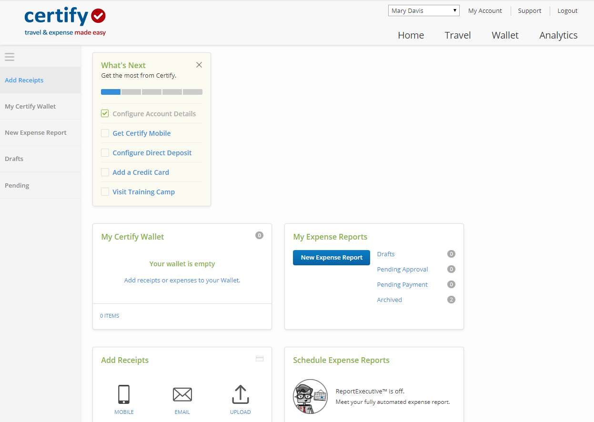

EXAMPLE
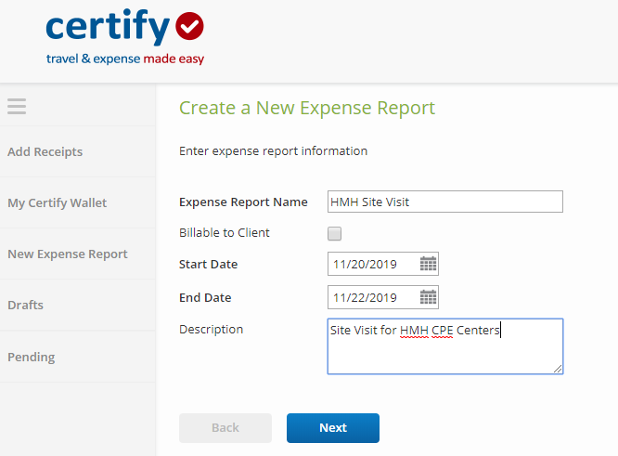

TYPE IN MORE DETAIL ON THE ‘ADD EXPENSE’ SECTION, UPLOAD RECEIPTS TO YOUR WALLET AND LINK THE APPROPRIATE RECEIPT TO EACH EXPENSE, AND SAVE.

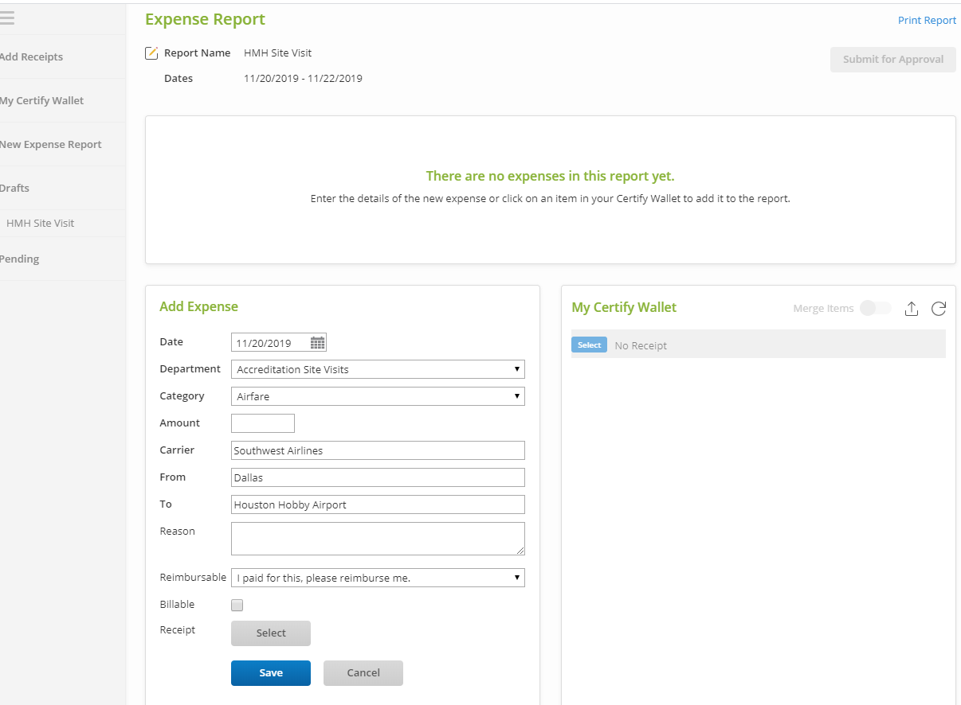

WHEN ALL HAVE BEEN UPLOADED AND SAVED, CLICK ON “SUBMIT FOR APPROVAL IN TOP RIGHT CORNER. CHOOSE MARC MEDWED AS YOUR APPROVER.

YOU CAN ALSO SAVE OR PRINT A COPY OF THE REPORT FOR YOUR RECORDS.

If you have questions about using Certify, please contact Marc Medwed, Associate Executive Director.

