Type of heat-related illness and description | Signs and Symptoms | First-Aid Measures
Heat Stroke  - Most serious heat-related disorder.  - Occurs when the body becomes unable to control its temperature  - Body temperature rises rapidly, the sweating mechanism fails, and the body is unable to cool down.  - Heat stroke can cause death or permanent disability if emergency treatment is not given. | - Hot, dry skin  - Hallucinations  - Chills  - Throbbing headache  - High body temperature  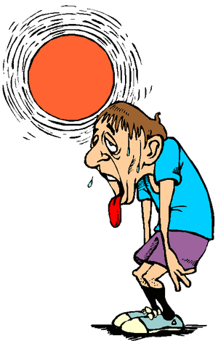  - Confusion/dizziness  - Slurred speech | - Call 911 and notify his/her supervisor.  - Move the sick worker to a cool shaded area.  - Cool the worker using methods such as:  - Soaking their clothes with water.  - Spraying, sponging, or showering them with water.  - Fanning their body.
Heat Exhaustion  - Body's response to an excessive loss of the water and salt, usually through excessive sweating.  - Workers most prone to heat exhaustion are those that are elderly, have high blood pressure, and those working in a hot environment. | - Heavy sweating  - Extreme weakness or fatigue  - Dizziness, confusion  - Nausea  - Clammy, moist skin  - Pale or flushed complexion  - Muscle cramps  - Slightly elevated body temperature  - Fast and shallow breathing | - Have them rest in a cool, shaded or air-conditioned area.  - Have them drink plenty of water or other cool, nonalcoholic beverages.  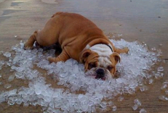  - Have them take a cool shower, bath, or sponge bath.
Heat Cramps  - Usually affect workers who sweat a lot during strenuous activity.  - Sweating depletes the body's salt and moisture levels.  - Low salt levels in muscles cause painful cramps.  - Heat cramps may also be a symptom of heat exhaustion. | - Muscle pain or spasms usually in the abdomen, arms, or legs.   | - Stop all activity, and sit in a cool place.  - Drink clear juice or a sports beverage.  - Do not return to strenuous work for a few hours after the cramps subside because further exertion may lead to heat exhaustion or heat stroke.  - Seek medical attention if any of the following apply:  - The worker has heart problems.  - The worker is on a low-sodium diet.  - The cramps do not subside within one hour
Heat Rash  - A skin irritation caused by excessive sweating during hot, humid weather. | - Looks like a red cluster of pimples or small blisters.  - Is more likely to occur on the neck and upper chest, in the groin, under the breasts, and in elbow creases. | - Try to work in a cooler, less humid environment when possible.  - Keep the affected area dry.  - Talcum powder may be used to increase comfort.

HEAT STRESS: Types, Signs and Symptoms, and First-Aid Measures

Summer is finally upon us, and as the bright sun warms things up so that we can enjoy our summertime activities, it also creates an additional hazard that we all need to be aware of. Both at work and home, the high temperatures during the summer can make us all vulnerable to a variety of different heat-related illnesses. Please take a few minutes to review the descriptions of the different heat-related illnesses, the signs and symptoms for each, and the first-aid measures for each illness.

