



Getting Started using P6 Auto Archive

Confidentiality Statement: The information contained in this document, including all forms and types of financial, business, marketing, operations, scientific, technical, economic, trade secrets and engineering information, unless otherwise noted as public information, is confidential to LoadSpring Solutions and disclosure of such information to non-authorized parties could be harmful and is therefore not permitted unless express written consent is provided by an officer of LoadSpring Solutions, Inc. Furthermore, the information contained in this document is for the sole use of LoadSpring Solutions employees.
All information provided in this document is AS IS. Although we have taken great care to represent all information in a clear and accurate manner, some information is based upon market trends, forward thinking and assumptions for which we make no warranty (express or implied) as to the accuracy or completeness disclosed herein. We expect that any parties reading this document will perform their own due diligence to verify its accuracy before making any decisions based upon information provided in this document.

Contents
Contents 2
Solution Introduction 2
Typical Use Cases 3
Using Automated Auto Archive 3
Step 1: Establish Enterprise Project Code for Archive or Consolidation. 3
Step 2: Identify Projects targeted for Archive or Consolidation. 4
Step 3: Configure P6 Archive in LoadSpring 5
Step 4: Select and Schedule Projects from the Queue 8
Batch Scheduling 9
Reset An Archived Project Back to ‘Ready For Archive’ Status 10

Solution Introduction
As a global leader, LoadSpring strives to provide custom solutions for our customers to ensure high performance, user adoption, and adherence to best practices. One of the unique challenges in the project world is the archiving of closed projects.
Most people would be shocked to know that 70% of all enterprise data in the cloud is comprised of old, inactive projects, just taking up space and slowing system performance. LoadSpring’s custom automated archiving service takes these unneeded projects/data and stores them separately from your active projects, it’s designed to automate the archiving or project migration processes. Baselines are stored within a full project record that ensures complete time-based information and record keeping. It utilizes supported Oracle provided Web Services via xml technology to move this data between databases at the project level. This solution is currently available for Oracle | Primavera P6.

Business Problems Addressed
- Application performance for Primavera P6 degrades over time. | - As new projects are added over time the data in the P6 database continues to grow. More data and constantly evolving data profiles with varied project management use cases negatively impact application performance.  - The P6 Auto Archive solution facilitates good project data quality processes by helping institute the following processes:  - Archive Process  - Scheduled Deletions Process  - Tests, copies, what-ifs required regular Cleanup Process  - Database Reorganization Process  - Knowledge Retention Process
- Manually archiving P6 projects is time consuming. | - Automating the archive process takes 4 times less effort/time per project saving countless hours over manually archiving old project data.
- Migrating/combining multiple P6 databases into a smaller number of databases. | - For organizations that have either merged divisions or companies safely migrating active projects into a new “Gold Standard” database, this is common enterprise practice. Automated Auto Archive is also known as Automated Auto Consolidation.
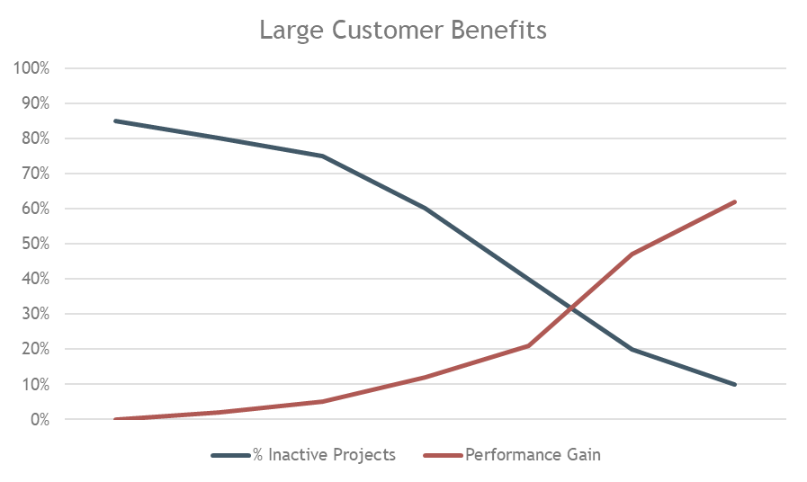

Typical Use Cases
P6 Auto Archive addresses two primary use cases.
- Archive old project data for immediate retrieval.
- Consolidate projects from multiple databases into a single centralized project database.
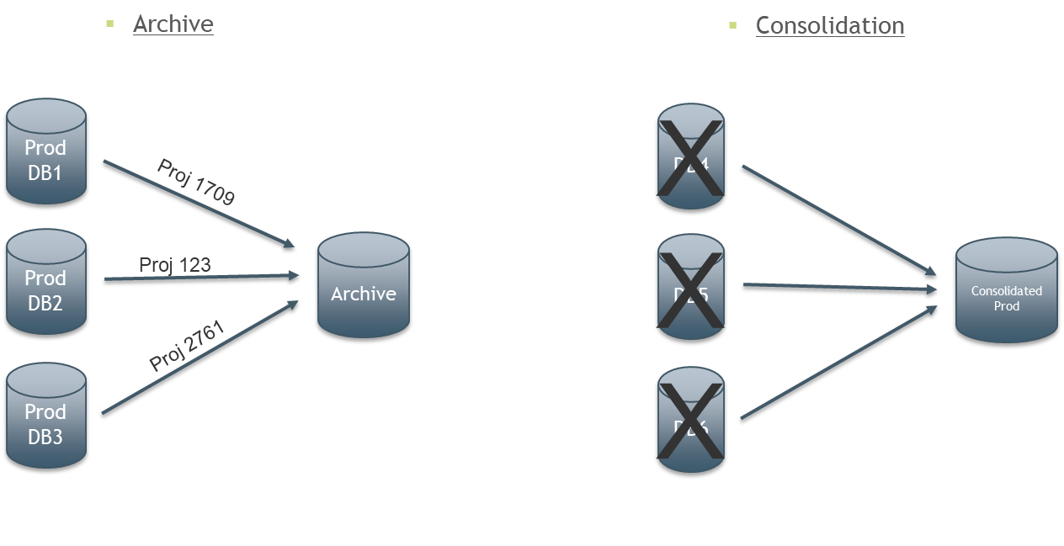

Using Automated Auto Archive

Step 1: Establish Enterprise Project Code for Archive or Consolidation.
Create or select an existing Project Code to be used to flag projects for archiving or consolidating in the P6 Environment that projects will be moved from. This Project Code must be flagged as a “Secure” Project Code in the Enterprise Data settings. The following image shows an example of this from Primavera P6. You may define your own code name and values. LoadSpring can provide process guidance separately to assist you with establishing improved project data management practices.

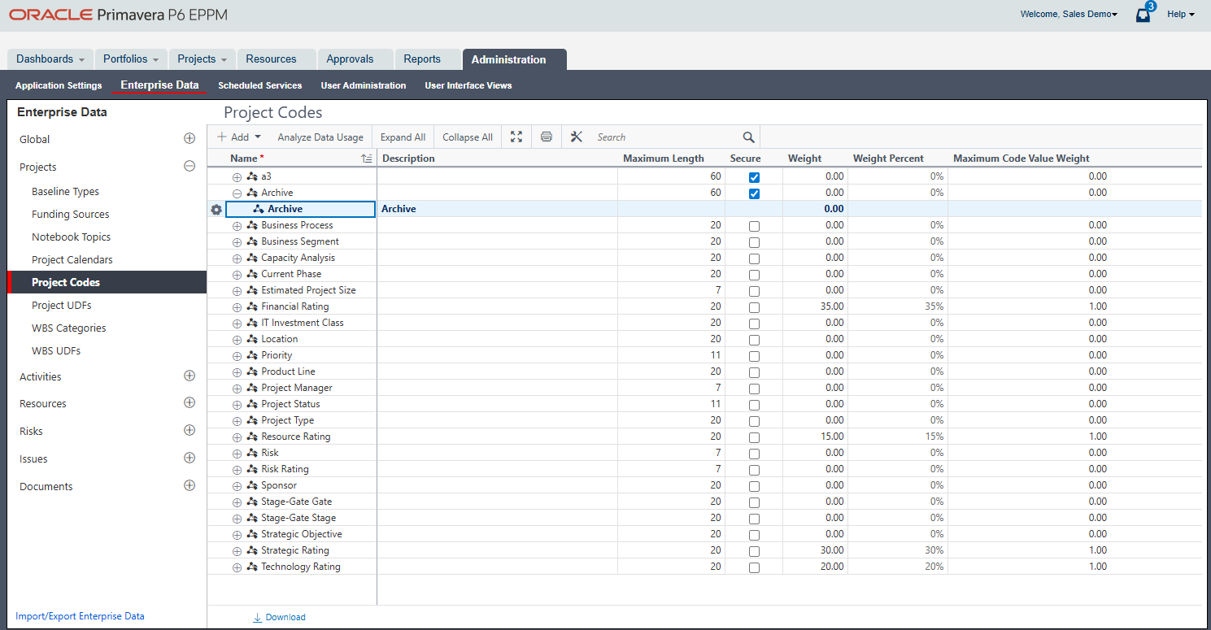
Code must be Secure
Code Name and Description as per your process
Setup a Project Code for Archive

Step 2: Identify Projects targeted for Archive or Consolidation.
Populate the Secure Project Code for projects ready to be archived.

Note: Projects will be placed into the target database under the EPS structure it had from the source. If the EPS structure above the project does not match entirely to the source, the missing EPS elements in the hierarchy will be created in the target database.

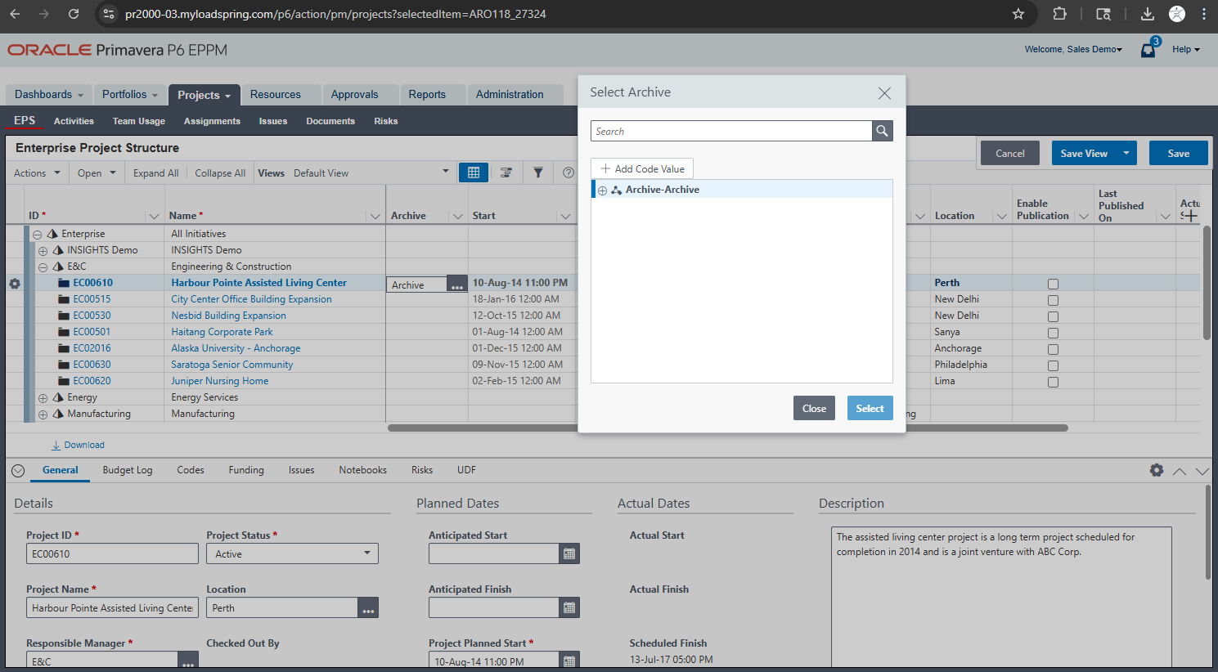
Code projects that are ready to be Archived

Step 3: Configure P6 Archive in LoadSpring
LoadSpring Company Admins have rights to the Auto Archive menu option. From the Admin Menu select the “Auto Archive for Projects” link from the 3-bar menu.
Select Auto Archive for Projects
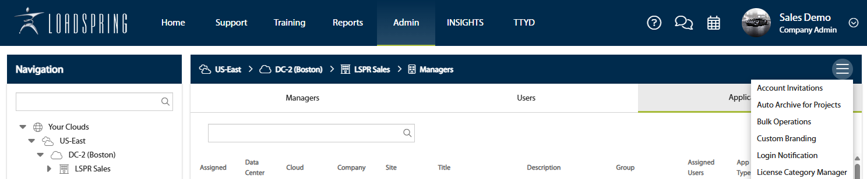

Before you can start archiving, you need to configure your source and target databases.
- Click the gear icon in the top right corner of the main dialog. This will take you to the Configuration screen.
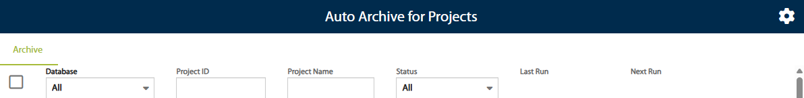
Click to Configure

- On the Configuration screen, you can set up your source and target databases, along with the project codes and values that you want to target.
- Databases are defined by adding Web API Integration records. The P6 Archive Type determines the purpose of each database:
  - Archive: The database will be used as a target for archived projects.
  - Production: The database will be used as a source for projects to be archived.
- Once you have finished setting up your databases, click the arrow icon in the top right corner to return to the main view.

The P6 Auto Archive for Projects dialogue contains a list of projects ready to archive.
This can be done individually or there is an icon at the bottom to run as a batch group.
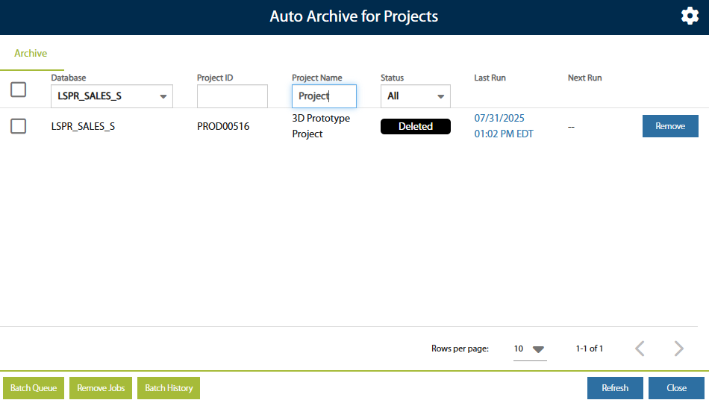

The Archive tab is where you manage your projects. It displays projects from the source databases you defined in the Configuration screen.

The Project Grid

The grid shows detailed information for each project.
- Database: The source database containing the project.
- Project ID: The ID of the project.
- Project Name: The name of the project.
- Status: The current archiving status of the project.
- Last Run: The date and time of the last archiving attempt.
  - For successful archives, you can click this field to view a log of the run.
  - For unsuccessful archives, you can click this field to see any errors that occurred.
- Next Run: The date and time of the next scheduled job (either archive or delete).

The far-right column of the grid contains a button you can use to schedule or cancel archiving or deletion jobs for a specific project.

Project Statuses

Each project can have one of the following statuses:
- Ready for Archive: The project exists in the source database but not in the target database and has not been scheduled for archiving.
- Queued for Archiving: The project has been scheduled to be archived.
- Archived: The project has been successfully archived.
- Archive Unsuccessful: The project encountered an error during archiving.
- Queued for Delete: The project has been scheduled for deletion from the source database.
- Deleted: The project has been successfully deleted from the source database.

Managing Deleted Projects

Once a project has been deleted from the source database, you can remove the record of that deletion from the grid.

- Check the box in the far left column for the project you want to remove.
- Click the Remove Jobs button at the bottom of the dialog.

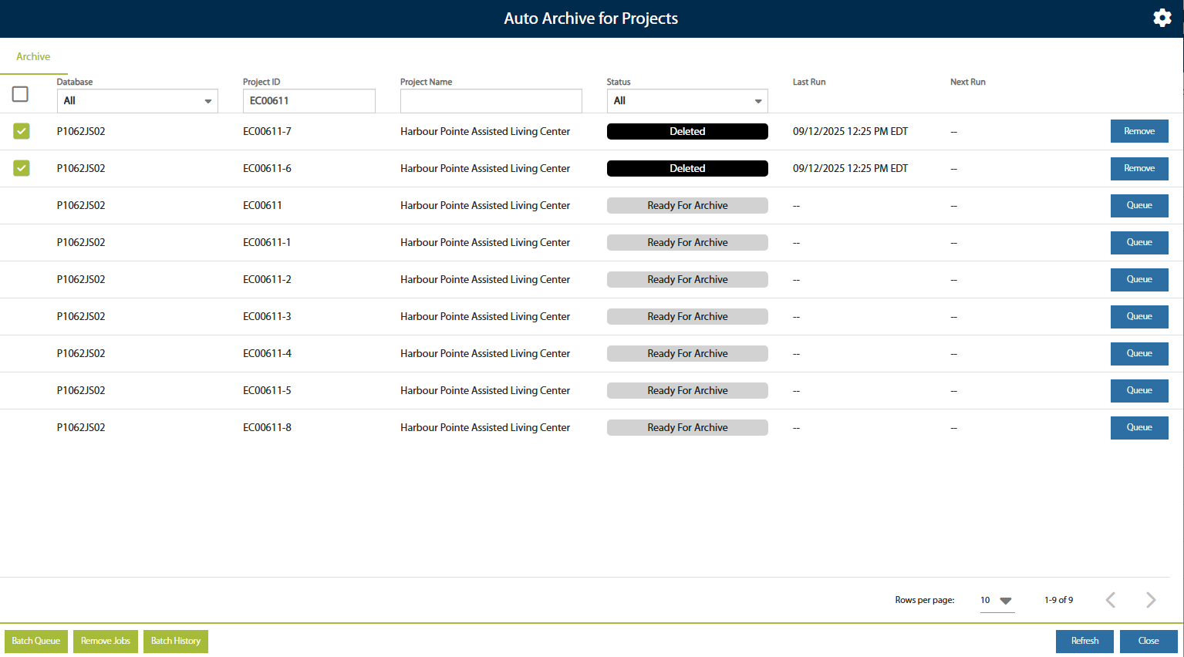

Batch History

The Batch History button, located at the bottom of the dialog, allows you to view a log of all past jobs. When you open the dialog, a notification at the top will tell you how many jobs have completed since your last visit and will direct you to the Batch History dialog for more details.

The Batch History dialog includes the following columns:

- Created Date: When the batch was created and scheduled.
- Completed Date: When the batch finished processing all its jobs.
- Total Projects: The total number of projects in the batch.
- Completed Projects: The number of projects that have completed archiving or deleting.
- In Progress Projects: The number of projects currently being processed.
- Succeeded: The number of projects that were successfully archived or deleted.
- Failed: The number of projects that failed to archive or delete.

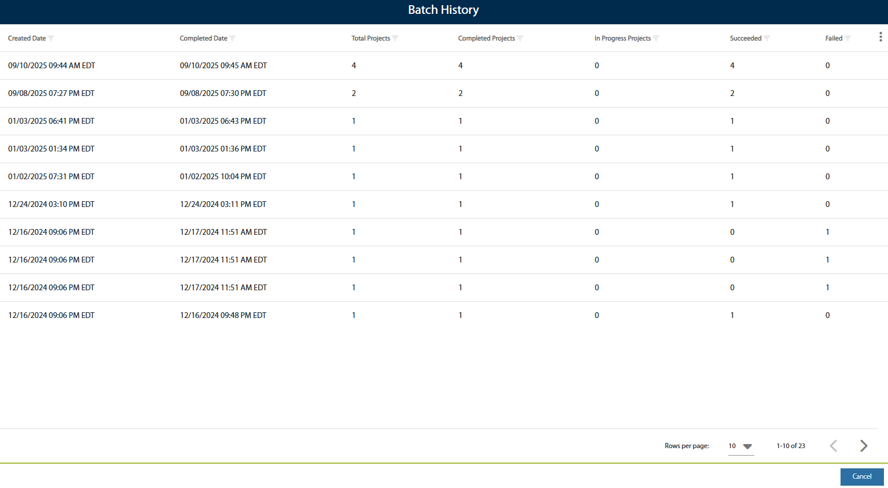

Step 4: Select and Schedule Projects from the Queue
Action Buttons to trigger scheduled events
Filter for Archive status
Queue Batches of Projects

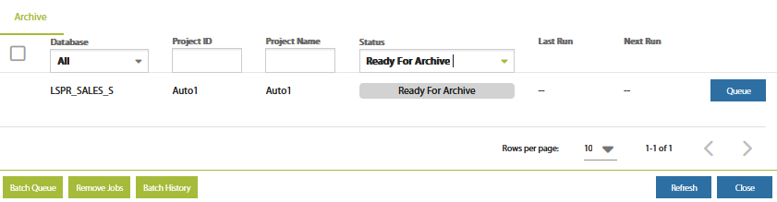

Projects that meet the configured criteria from the Admin sub-menu appear in the Queue sub-menu. This queue is where projects will be selected and scheduled for archive or consolidation. You may also queue batches of projects.
Using the filter row is the fastest way to find specific projects or status settings. Enter any criteria in any column on the filter row and select the refresh icon to execute the filter. Select the Remove Filter link to clear all filters.
Scheduling the Archive process may be selected for a single project one at a time or a batch of projects. Selecting the Queue Archive button for a single project will open the following schedule dialogue:

Baseline option

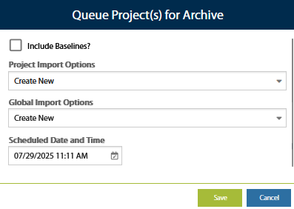
Select Off-Hour Day/Time for Deletion

Select P6 import options for project and global data

The system fully logs all activity and allows you to view the date/time stamp in the Last Run column.
NOTE: It is recommended to always schedule the archive process during low-use periods as it places a load on the Application Job Services which may impact end user performance.

Batch Scheduling
To schedule multiple projects in a batch, select the “Batch Queue” button then select Archive or Clean Up or Retry Failed Jobs. Enter the Source Database then select the projects to include in the batch process.

Select Projects for Batch run
Select Source

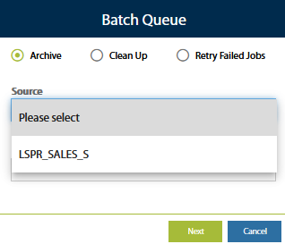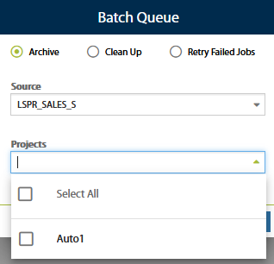

The system fully logs all activity and allows you to view the date/time stamp in the Last Run column.
Quickly view the status
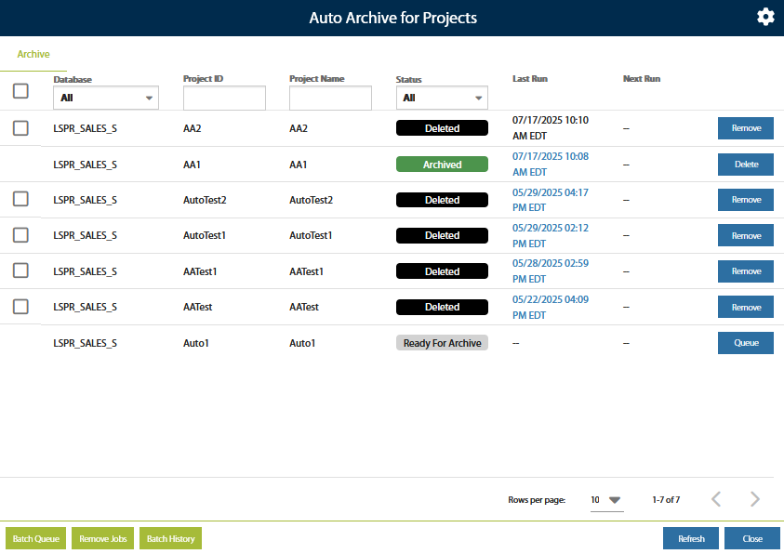

Reset An Archived Project Back to ‘Ready For Archive’ Status
Sign in to the source P6 database to remove the project code assignment and save the changes.
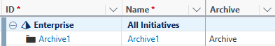
Remove the Project Code assignment

In the LoadSpring Platform, navigate into the ‘Auto Archive for Projects’ menu to remove the previously successful job.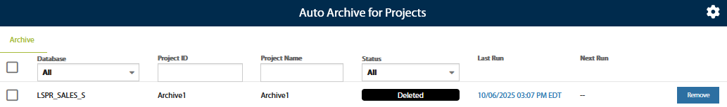
Remove the job from Auto Archive
In the source P6 database, re-assign the project code to the project and save the changes.
Re-assign the Project Code
In the ‘Auto Archive for Projects’ menu, refresh the list to see the job back in 'Ready For Archive' status.
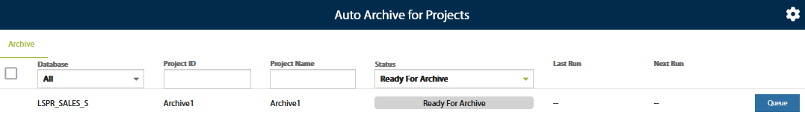

For additional questions please contact LoadSpring Support (877-LOADSPR or support@loadspring.com).

