|  |  |  |
| --- | --- | --- |
|  | Question | Answer |
|  | Which sport takes place in a velodrome? | Cycling |
|  | Which country is Roger Federer from? | Switzerland |
|  | What are the indentations on a golf ball known as? On average how many are there? | Dimples  336 |
|  | Which country won the first FIFA World cup in 1930? | 1. Uruguay |
|  | Who ended the Lionesses unbeaten run of matches in April 2023? | Australia |
|  | Who was the first Olympic gymnast to score a perfect 10? | Nadia Comaneci |
|  | The Boat Race is an annual event between which 2 universities? | Oxford and Cambridge |
|  | Where do Lancashire County Cricket Club play their home games? | Old Trafford Cricket ground |
|  | What is the nickname for Arsenal F.C.? | The Gunners |
|  | Which sport did Rob Burrow play and which team did he spend his entire career with? | Rugby League  Leeds Rhinos |
|  | Where is the next Summer Olympic Games set to take place? | Paris 2024 |
|  | What sport has been played by Eve Muirhead and David Murdoch? | Curling |
|  | Modern pentathlon involves running, shooting and horse riding. Which other two sports are featured? | Fencing and swimming |
|  | In rugby union, who is England Men’s all-time top try scorer? | Rory Underwood |
|  | Where is the FIFA women’s world cup taking place in July 2023 | Australia & New Zealand |
|  | Which sport uses a racket, a net, and a shuttlecock? | Badminton |
|  | How many players are on court in a netball match? | 2 x 7 =14 |
|  | Which footballer has scored the most goals in World Cup history? | 1. Miroslav Klose - 16 |
|  | How long is a marathon? | 26.2 miles |
|  | Which country has the most Olympic gold medals in swimming? | USA |
|  | What does NBA stand for? | National Basketball Association. |
|  | How many coloured balls are there in Snooker? | 6 |
|  | In sports, what does the term ‘GOAT’ generally refer to? | Greatest of All Time |
|  | Where was England footballer Georgia Stanway born? | Barrow-in-Furness |
|  | What is the name of the prestigious tournament held annually in Augusta, Georgia? | The Masters |
|  | In what year were women allowed to compete in the modern Olympic games and in what sport? | 1900 tennis |
|  | In which winter sport are the terms “stale fish” and “mule kick” used? | Snowboarding |
|  | What is the nickname of Morecambe Football club? | The Shrimps |
|  | What is the very centre of a target called in archery or darts? | Bullseye |
|  | Where were the Commonwealth Games held in 2022? | Birmingham |
|  | How many rings are on the Olympic flag and what do they represent? | 5 to represent the inhabited continents of the world. |
|  | What weight category does Tyson Fury box in? | Heavyweight |
|  | Who is top of the world rugby women’s rankings? | England |
|  | Who was the first Brit to win the Tour de France? | Bradley Wiggins |
|  | Who are the currently the reigning champions of Rugby League in England? | St Helen’s |
|  | Who is Sky Brown? | an Olympic skateboarder |
|  | Murderball is the original name for which sport? | Wheelchair rugby |
|  | Siblings Alice & Liam Kinsella are successful in which sports? | Alice -gymnastics  Liam - football |
|  | Which swimmer won two gold medals at the 2008 Summer Paralympics in Beijing, aged just 13? | Ellie Symonds |
|  | Who is the youth development manager for British Dodgeball? | Alice Bowler |

Return quizzes to if you want to be in with a chance of winning a prize!

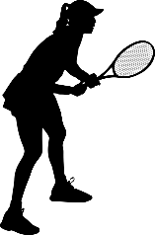

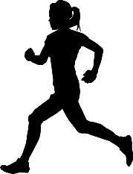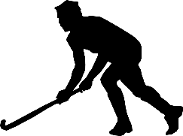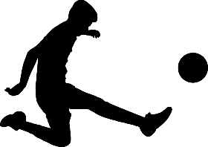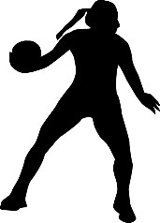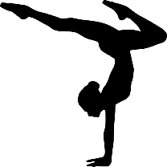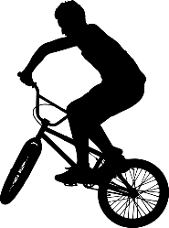

School Sports Activity Week

May 2023

Sports Quiz

£1

How good is your sports knowledge?

Give our quiz a go!

Prizes to be won!