ELECTRIC BIKES

Standard Operating Procedures

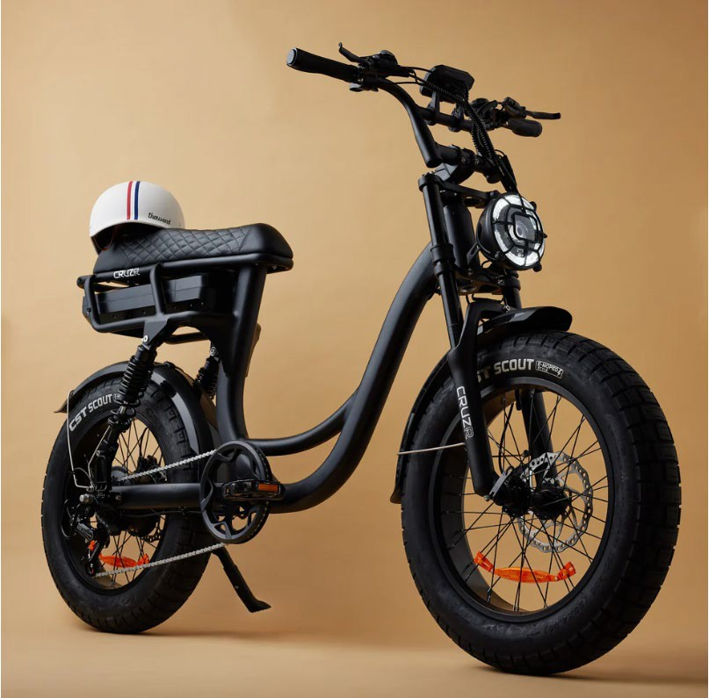

Content Page
- Terminology
- Contact Details
- Applicability
- Responsibilities of an EBO
- Responsibilities of an EBA
- EBO Qualifications
- Electric Bike Specifications
- Radio Call Signs
- Operational Checklists
  - Pre-Use
  - Post-Use
  - Cleaning
- Maintenance
  - Charging the Battery
  - Battery Safety
  - Charging Process
  - Battery Replacement
  - Maximize e-Bike Battery
  - Tyres
  - Brakes
  - Equipment
  - Error Codes
- Safety Measures
  - Riding a e-Bike
  - Carrying People on a e-Bike
  - Speed & Lights
  - Roadway & Beach Usage
  - PPE
  - Accident Reporting
  - Route Planning
  - Mounted Equipment
  - Riding on a Footpath or Shared Path
  - Pedal Assistance

Terminology

e-Bike | Electric Bike
SOP’s | Standard Operating Procedures
EBO | Electric Bike Operator
EBA | Electric Bike Advisor (assigned within club)
PC | Patrol Captain
MOP | Members of Public
SLSQ | Surf Life Saving Queensland
SLSC | Surf Life Saving Club
SOCC | State Operations Communications Centre
POM | Patrol Operations Manual

Applicability
This document provides instructions for the operation, management and safety of electric bikes (e-Bikes) and all personnel involved, that are operating under SLSQ as a volunteer member signed onto patrol. These SOPs are subject to change at any time and should be considered non-current once printed.

Responsibilities of an Electric Bike Operator (EBO)
For the purpose of this SOP, an EBO is a current & financial member of a SLSC. The EBO is responsible for:
- Conduct and complete a pre & post use checklist
- Conducting roving patrols in line with the POM
- Safe operations of the e-Bike & avoid unsafe moves that could put you or MOP at risk.
- Ensuring the e-Bike is more than 70% charged before conducting operational use
- Acting in accordance with SLSQ policies, procedures & guidelines
- Acting in accordance with Qld Government Bicycle Road rules & safety.
- Ensuring all faults are notified to the PC & EBA
- Ensure the e-Bike is safely put on charge after use

Responsibilities of an Electric Bike Advisor (EBA)
For the purpose of this SOP, an EBA is a current & financial member of a SLSC and has been inducted as the club’s advisor. The EBA is responsible for:
- Ensuring all members that use the e-Bike do so safely

- Ensuring all charging of e-Bikes is in accordance with Qld Government regulations

EBO Qualifications
An EBO must be the following:
- Financial members of an affiliated SLSC
- Be a proficient SLSA award holder
- Must be at least 16 years old
- Must have at least a QLD Leaner’s permit
It is desirable that an EBO hold the following:
- First Aid Certificate
- Advanced Resuscitation Certificate

Operational Checklists
Pre-Use

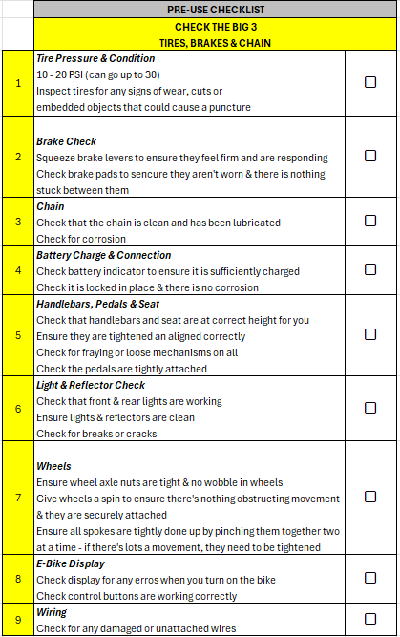
Post-Use

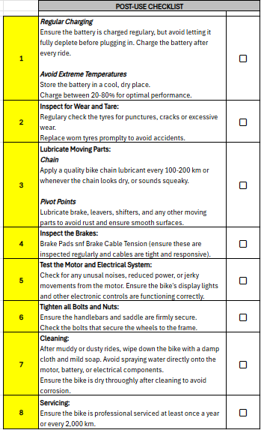
Cleaning
To ensure the longevity of the e-Bike, regularly clean your e-bike with a soft, damp cloth to remove dirt and debris. Ensure to wash your bike after beach riding to avoid damage from salt water and help prevent rust and corrosion. Avoid using high-pressure water or abrasive cleaners that could damage the electrical components. Store your bike in a cool dry place when not in use and avoid leaving it outside in direct sunlight or heavy rain for an extended period of time.
- After each shift the bike will be required to be cleaned with fresh water. Ensure that all salt and sand is removed.
- Use silicon spray to lubricate the chain, cog, crank and suspension components weekly to ensure components are protected from corrosion.

Maintenance
Maintenance shall be carried out in accordance with manufacturer’s instructions, although, more regular maintenance will be needed to combat the harsh conditions of operating in a beach environment. Avoid tampering with your bike, especially the motor and brakes - this will void the warranty and cause serious safety issues. An e-Bike is a machine with many moving parts, and it needs to be maintained.

Charging the Battery
Before your first ride, charge the battery fully. Connect the charger to a power outlet and the charging port on the e-bike battery. The battery can be charged while on the e-bike or once removed from the bike. The red light on the charger will turn RED on connection, then GREEN when complete. Once completely charged, remove the battery from the charger.
Only use the charger provided with the e-bike to charge the battery.

Charging Process

Before charging, let the battery cool to room temperature before plugging it in. Plug in the charger first. Connect the charger into the wall outlet before plugging it into the bike’s battery to prevent sparks. Do not leave the charger connected after the battery is fully charged. If you must use an extension cord, ensure it is a heavy duty one.

Battery Safety
The following tips are recommended to ensure the e-Bikes battery is maximized and less prone to battery failure:
- Charge your battery when it is low (e.g., 20%) and never run it to empty.
- Charge in a well-ventilated, open space.
- To avoid overheating batteries, never overcharge your device - unplug the device asap once it is fully charged (when light turns GREEN on charger).
- Never store you bikes battery or charge in direct sunlight or hot places - keep in cool dry place.
- If you plan to not ride for extended periods of time, place your battery on charge once per month even if not used, this will keep your cells active.
- Avoid charging your device on flammable materials, such as the bed, couch or on paper. Always place charger on hard dry surfaces.
- Never allow your battery to get wet or be exposed to water/moisture.
- Always use a genuine charger approved by the manufacturer
- If your battery or charger has been exposed to damage of any kind - discontinue use immediately and have inspected by a professional or dispose of safely.
- Store your battery in a cool, dry place away from flammable materials. If you notice signs that the battery has a problem, such as overheating, odors, leaks, or change in

colour/shape, shut off the device and move it away from things that can catch fire. Dispose of immediately at a certified disposal site
- Avoid extreme temperatures (hot or cold) when charging or storing it.
- Make sure there is a working smoke or heat alarm in the area where you charge or store the bike. Have a fire blanket in the vicinity.

Battery Replacement
All batteries supplied by Cruzr bikes are covered under warranty for 12 months. If a replacement battery is needed, outside of the 12 months of ownership, the Club EBA is to contact their relevant Regional Coordinator and discuss purchasing options.

Maximise e-Bike Battery
According to many manufactures, there are three tips to prolonging the life of an e-Bikes battery.
- Charge the battery whenever possible, ensuring the club is following SLSQ’s Electric Safety Awareness recommendations.
- Use ‘Eco’ mode where possible, as wind resistance increases with speed, so if the battery is dropping it is best to slow down and go further with less power/speed.
- If you’re going to store the e-bike for a long time, avoid keeping it fully charged or fully uncharged. Anything between 30% to 60% is ideal for long-term storage. Storage Mode can be activated on the charger before storing the battery away and make sure to check back and charge it once every 3 months to maintain battery health at its peak!

Tyres
Check the tyre pressure regularly and maintain it within the recommended range. Inspect the tires for any signs of wear or damage and replace them if necessary. If you get a flat tire, do not keep riding, it needs to be to be patched or fixed immediately. Let your PC know, who will inform the club EBA & the bike will be tagged with a yellow ‘Do Not Use’ tag.

Brakes
Ensure that the brakes are working correctly before each ride. If you notice any issues with the brakes, such as reduced stopping power or squealing, have them inspected and serviced by a qualified bicycle repairer.

Equipment

Ensure all equipment, strapped to the e-Bike, is secured tightly & will not cause any harm to a member of public while in use.
Error Codes
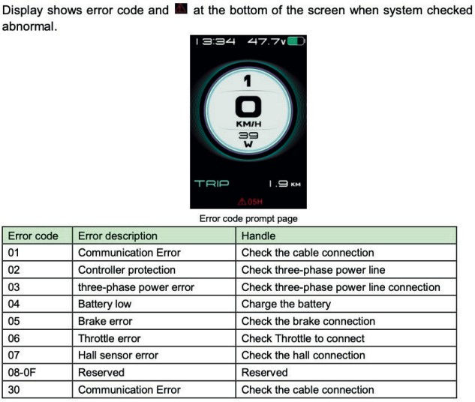

Safety Measures

Riding an e-Bike
When an EBO rides a e-Bike, they must:
- Have 1 leg on each side of the seat
- Face forward
- Keep at least 1 hand on the handlebars at all time.
- Never operate your e-bike when you are under the influence of alcohol or drugs.
- Keep hands, feet, and loose clothing away from moving parts while riding.
- Always ride at a speed appropriate for the conditions.
- Always wear a properly fitted helmet when riding your e-bike.

Carrying People on a e-Bike
- SLSQ does not allow anyone other than the operator to be on the EBO.

Riding with Vehicles Around
An EBO must always keep at least 2m between themselves and the back of a vehicle when following said vehicle for over 200m. They must also ride with due care and attention, to all members of the public around, being considerate of people on foot or other electric beach equipment. This can be achieved by not doing the following:
- Dangerously swerving in and out of pedestrians.
- Riding at unsafe speeds around corners where members of the public may be present.

Speed & Lights
The speed limit in heavily populated areas and between the red & yellow flags is 5km/hr & 18km/hr in less populated areas and outside the red & yellow flags.
When operating the e-Bike, the light on the front should always be on. To turn on your headlight; hold down the [+] button on the display. Brake lights at the rear of the bike are fitted into the battery and these will automatically turn on when applying brake pressure.

Roadway & Beach Usage
Legislative requirements and road rules must be complied with at all times when the e- Bike is driven on a roadway and/or beach.
Bicycle road rules and safety | Transport and motoring | Queensland Government

PPE
Operators shall always wear the following PPE whilst operating an e-Bike:
- Patrol Shirt
- Patrol Shorts
- Protective eyewear (100% UV recommended)
- Approved Helmet(s)
- Booties (recommended)

Accident Reporting
All accidents must be reported to the SOCC immediately and the report must be completed. All information must be obtained at the scene of the accident, if possible, including but not limited to:
- Names
- Addresses
- Photographs/diagrams of incident.
If an accident occurs between an EBO on a footpath, bicycle path, shared path, car park, beach or other public areas where e-Bikes can be ridden, they must stop, remain on scene and give assistance to anyone injured & exchange personal information with the other person(s) involved.

Route Planning
Safe and efficient driving is crucial to incident-free operations, therefore planning out your route when using an e-Bike is a practical approach to ensure member welfare. The following aren’t requirements but are strongly suggested when planning out a route:
- Walk new routes, where possible and if necessary, to check for hidden obstructions that may damage the tires.
- Familiarise yourself with the surface and allow for changes to the surface due to weather conditions.

Mounted Equipment
The e-Bike should always have the following equipment mounted to it, as per appendix X:
- First Aid Kit
- Oxygen Equipment
- Defibrillator
- Rescue Tube
The EBO must always check that all equipment required is readily available and in serviceable condition.
There are to be no club modifications to this equipment.

Riding on a Footpath or Shared Path
On footpaths and shared paths, you share the space with pedestrians. You must:
- keep left and give way to all pedestrians
- always ride to the left of bicycle riders coming toward you.

Pedal Assistance
An e-Bike is propelled forward through pedaling & the motor is used to help maintain speed while riding and may be helpful when riding uphill or against wind. At speeds up to 6km/h, the electric motor can operate without you pedalling. The motor can help you when you first take off. At speeds above 6km/h, you must pedal to keep the bicycle moving with the motor providing pedal-assist only.

