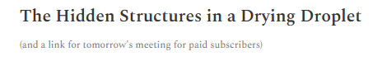
Hi everyone,

This week I have been working on my latest book:

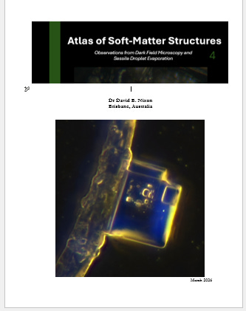

I am pleased to say that the Atlas of Soft-Matter Structures is now nearing completion, although as always that depends slightly on what additional images or sequences I decide to include.

The atlas currently contains over 80 plates, drawn from a wide range of preparations—from Articaine to Zizine, although the majority of the material comes from lignocaine and Comirnaty samples.

As throughout my work, the emphasis is on observation rather than interpretation. The purpose of the atlas is simply to document what appears under dark field microscopy and during sessile droplet evaporation.

That said, the structures that repeatedly emerge are clearly not the simple salt or cholesterol crystals often suggested. Instead they belong to a far more interesting world: soft matter physics, which continues to prove one of the most fascinating areas of modern science.
Soft matter physics describes the states that exist between a liquid and a solid. It turns out there is a remarkable variety of such states — far more than most of us ever imagined. These are the kinds of states my colleagues and I have been exploring over the past three years: microdomains of liquid, colloidal particles and microbubbles, vesicles, fibres, and crystals of various sorts. Not to mention, of course, the many interactions between them.

Special thanks to Karl C, who introduced me to the use of different dyes and encouraged experimentation.

The image below shows a range of structures: microdomains, particles, probable microbubbles, fibres, and phase separation at the edge of a drying droplet. The sample in this case is plain lignocaine with two added dyes — fluorescein and crystal violet.

Of course, it is possible that some of the visible structures arise as a consequence of the dyes themselves rather than revealing pre-existing features. Nevertheless, the result colourfully illustrates the potential complexity that may lie beneath the surface of what appears to be a simple homogeneous liquid.

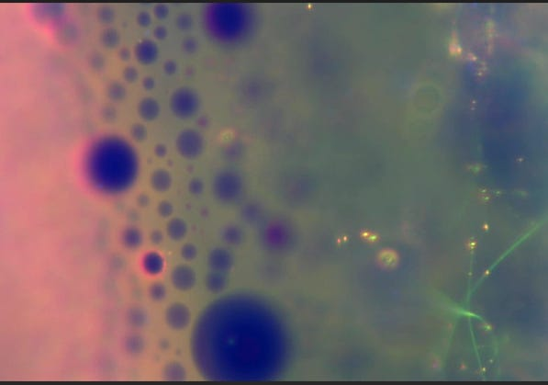

Dark-field microscopy of a drying lignocaine droplet containing fluorescein and crystal violet. Microbubbles, fibres and phase separation are visible at the edge of the evaporating droplet.

More soon.
David

PS Thank you again to my supporters without which this would not be possible.


Buy Nixonlab a Coffee

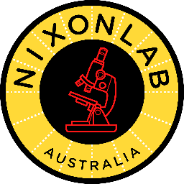

www.drdavidnixon.com
www.journalbnt.org
https://us06web.zoom.us/j/82585921575?pwd=AQJPqaglIaBOrXPVIP61xrH5RGlBZi.1

