Contents
Weekly Changes Sept 24, 2024 1
Pole Barns 1
Sketches 1
Tax roll Process. 2
Assessment 2
Edit Log 2
Property Class 2
Mortgage Company 2

Weekly Changes Sept 24, 2024

Pole Barns
- There was an issue with the cost table provided by NBC with longer length pole barns. There was a drastic drop in cost where there should not have been. This has been the case since the 2019 manual. This has been corrected in the 2024 manual. The list of these miscellaneous codes is listed below.
- There were issues with pole barn costs where at times the base floor was coded as concrete where it should have been dirt. The pole barn miscellaneous codes have been updated to have dirt as the base floor.
- With these changes records in the residential and commercial appraisal records with either miscellaneous improvements or site improvements will need to be recalculated. An easier way may be to recalculate all active account and appraisal status records.

Misc Code | Description
ARNC | Arena - Covered
ARNE | Arena - Enclosed
HAYS | Hay Shed Open Sides
HRSA | Horse Arena Covered
POLE | Pole Building - Enclosed
POLO | Pole Building - Open Side
QUON | Quonset - Round Top

Sketches
- When using the rotate sketch to the left the sketch would rotate to the right. This has been corrected. Using the rotate section to the left menu option has always worked.
- The mobile home length and width will update based on the styles <19 where add on sections were being included in the update.

Tax roll Process.
- At the end of the file exported to the treasurer’s vendor there the indication if the name on the account is coded as being redacted.

Assessment
- When changing the account status there will be an edit created when the values are locked. Prior the value log was the only place this was tracked.
- Subdivides will not take off the building and outbuilding value. Prior to the update this was not being done.
- When printing the mapped parcel report (File-Print-OTC Audits – Mapped Parcel Report) if you are in an index, you will be asked if you want to print the report from the index. Prior the report would always print the report based on the entire file.
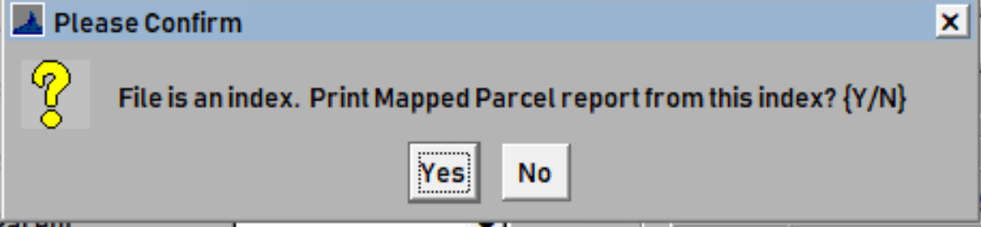

Edit Log
- When deleting table rows in the tax district, tax area, neighborhood, lot model, MRA, and GRM will be tracked in the edit log.

Property Class
- An OTC property class field has been added on the property class form. This will be editable when on a real property type record. This currently is not being used but will be in the future.
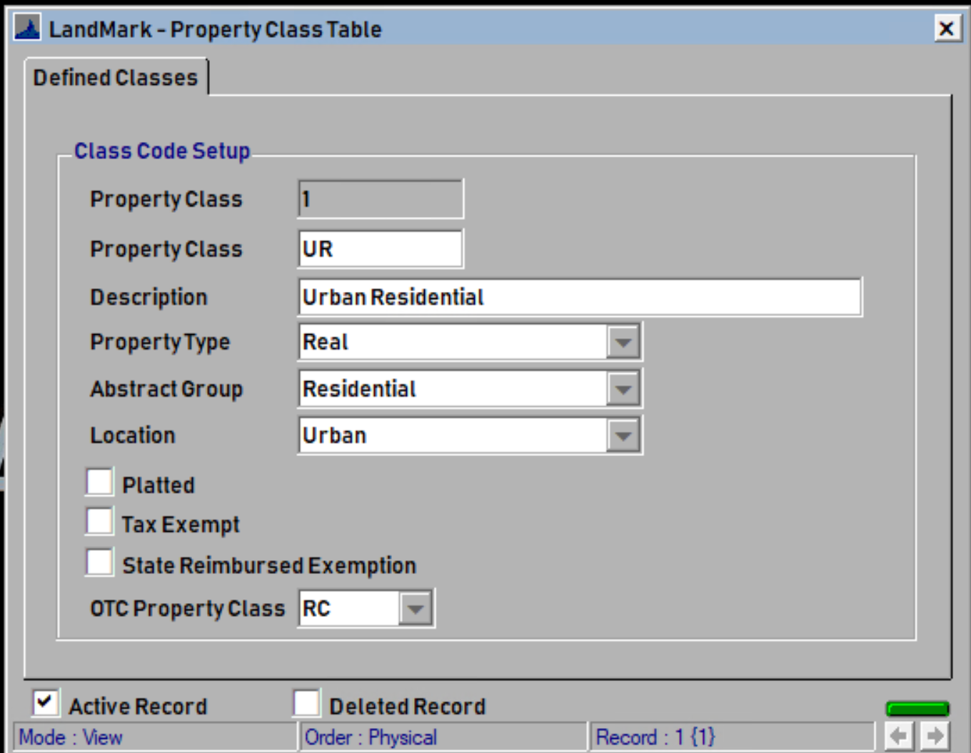

Mortgage Company
- The mortgage has been updated to allow the active and deleted record information to be visible.
