Contents

Weekly Changes November 24, 2021 1

Notes 1

Trending 1

State Reimbursement Report 1

Self-Intersecting Lines 2

Personal Property 2

Assessment File 2

Sketches 3

Reports 3

# Weekly Changes November 24, 2021

## Notes

### Trending

* Nov 24th The trending rates may be changing. We hope to know by December 1st that these are finalized. We will keep you updated.

### State Reimbursement Report

* Nov 24th The state reimbursement report will pull records that are active, have the parcel size in Acres, and has a property class that is coded as State Reimbursed.

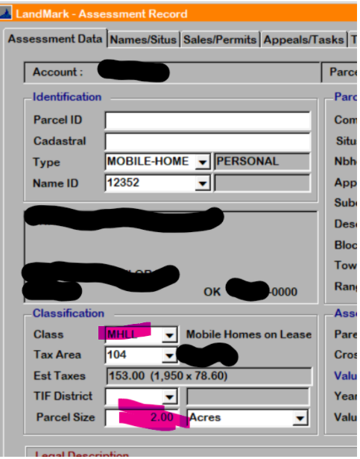

Taxing information tab in the Assessment Form

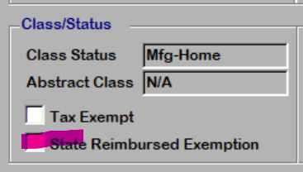

### Self-Intersecting Lines

* Nov 24th LandMark calculates polygon areas. In drawing concrete around a building or something similar the entry of the line lengths is crucial. In the sketches images below the one on the left a self-intersecting line was created with white area vs the one on the right is a polygon with the area. Both sketches start with the same line (highlighted pink), the difference starts at the blue dot. In the case of the self-intersecting lines this will be treated as two polygons in the calculation.
  + Vectors for sketch on left: Left 20, Up 40, Right 20, Down 50, Left 30, Up 60, Right 40, Down 60, Left 10, Up 10
  + Vectors for sketch on right: Left 20, Up 40, Right 20, Down 50, Right 10, Up 60, Left 40, Down 60, Right 30, Up 10

## Personal Property

* Nov 15th The new trending rates are available. These are updated in the process pending accounts process. After the pending process is done the personal property file should be recalculated. The reasons: This will update the items with the additional year of depreciation and new trending rates will apply to the applicable accounts. If you have already processed pending accounts, please let us know.

## Assessment File

* Nov 8th When modifying the filing date, the filing date on the appraisal file will be updated.
* Nov 15th When doing a combine the option of combining images will be checked by default.

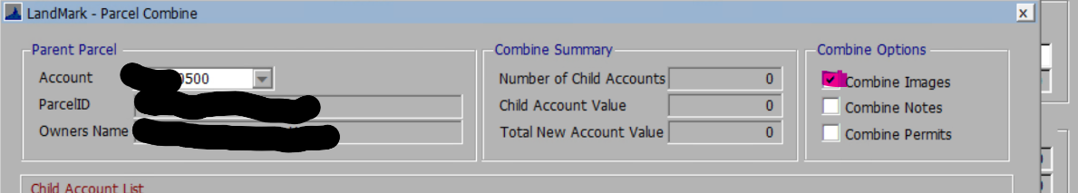

* Nov 15th When updating the filing date on the appraisal file the filing date on the assessment form will update.

## Sketches

* In the update on the 15th on the residential file there will be an option to select outbuilding on the site plan that are currently on the sketch. After selecting this you will go to the sketch and remove the outbuildings that were just placed on the site plan. This will be a good option to use if creating site plans from converted records.
* Nov 15th When creating outbuildings and commercial buildings from the sketch/site plan the calculated effective age, physical depreciation, and functional depreciation will automatically be checked by default. In the case of editing the residential properties in the residential sketch if there is not a type of these fields will automatically be checked.
* Nov 24th When modifying a residential sketch if the miscellaneous code is changed to an existing area the description will be updated for that record. In addition, if a flat rate was in the system when the sketch was modified the description for the line would change. The flat rate would be codes such as @S2.

## Reports

* Nov 8th The File - Print Forms have been updated and will go out with the weekly update on Sunday. Please note your tax year will not change until you process pending accounts.
* Nov 8th Sales Verification Letters are also complete. To change the report you want to use, go to System - Report Manger. Browse to find the Sale_VerificationLetter. By default, everyone is using the Sale_VerificationLetterNew report (the first Ref 961). To change this report, edit the report options and drop down the File Name. In the browse box, you can either select OTC_Form961 or Sale_Verification3 (the new Ref 961 which prints based on Property Class). You may need to edit your parameters to only show InstrumentID and CountyNumber. Your CLGT person can also do this for you if you want.

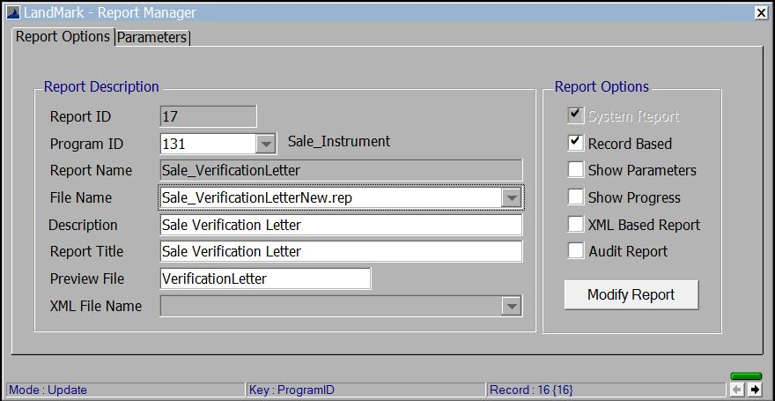

* + Nov 24th The sales verification reports will be updated with the release. Agricultural property types will now print.
* Nov 8th The OTC Editable forms have been updated. To update these, go to System - System Updates - Update OTC Forms. Gerald sent these to me yesterday afternoon so I will work on having the other forms ready to go out in the weekly update.