Contents
Weekly Changes May 3, 2023 1
Name 1
Appraisal Zone Table 1
BOE 2
Personal Property 2
Reports 3
General 3
Revaluation Edit 3
Linked Owners Report 3
Residential and Commercial Report and Cards 4
926P – Personal Property COV 5
901 and 924 5
Schedule Listing 5
OTC Item Audit 6
PDF Viewer 6
User Defined Imports 6

Weekly Changes May 3, 2023

Name
- Apr 24th – There is an indication if the accounts are active in the name form. This will allow to determine which account are active for a given name.
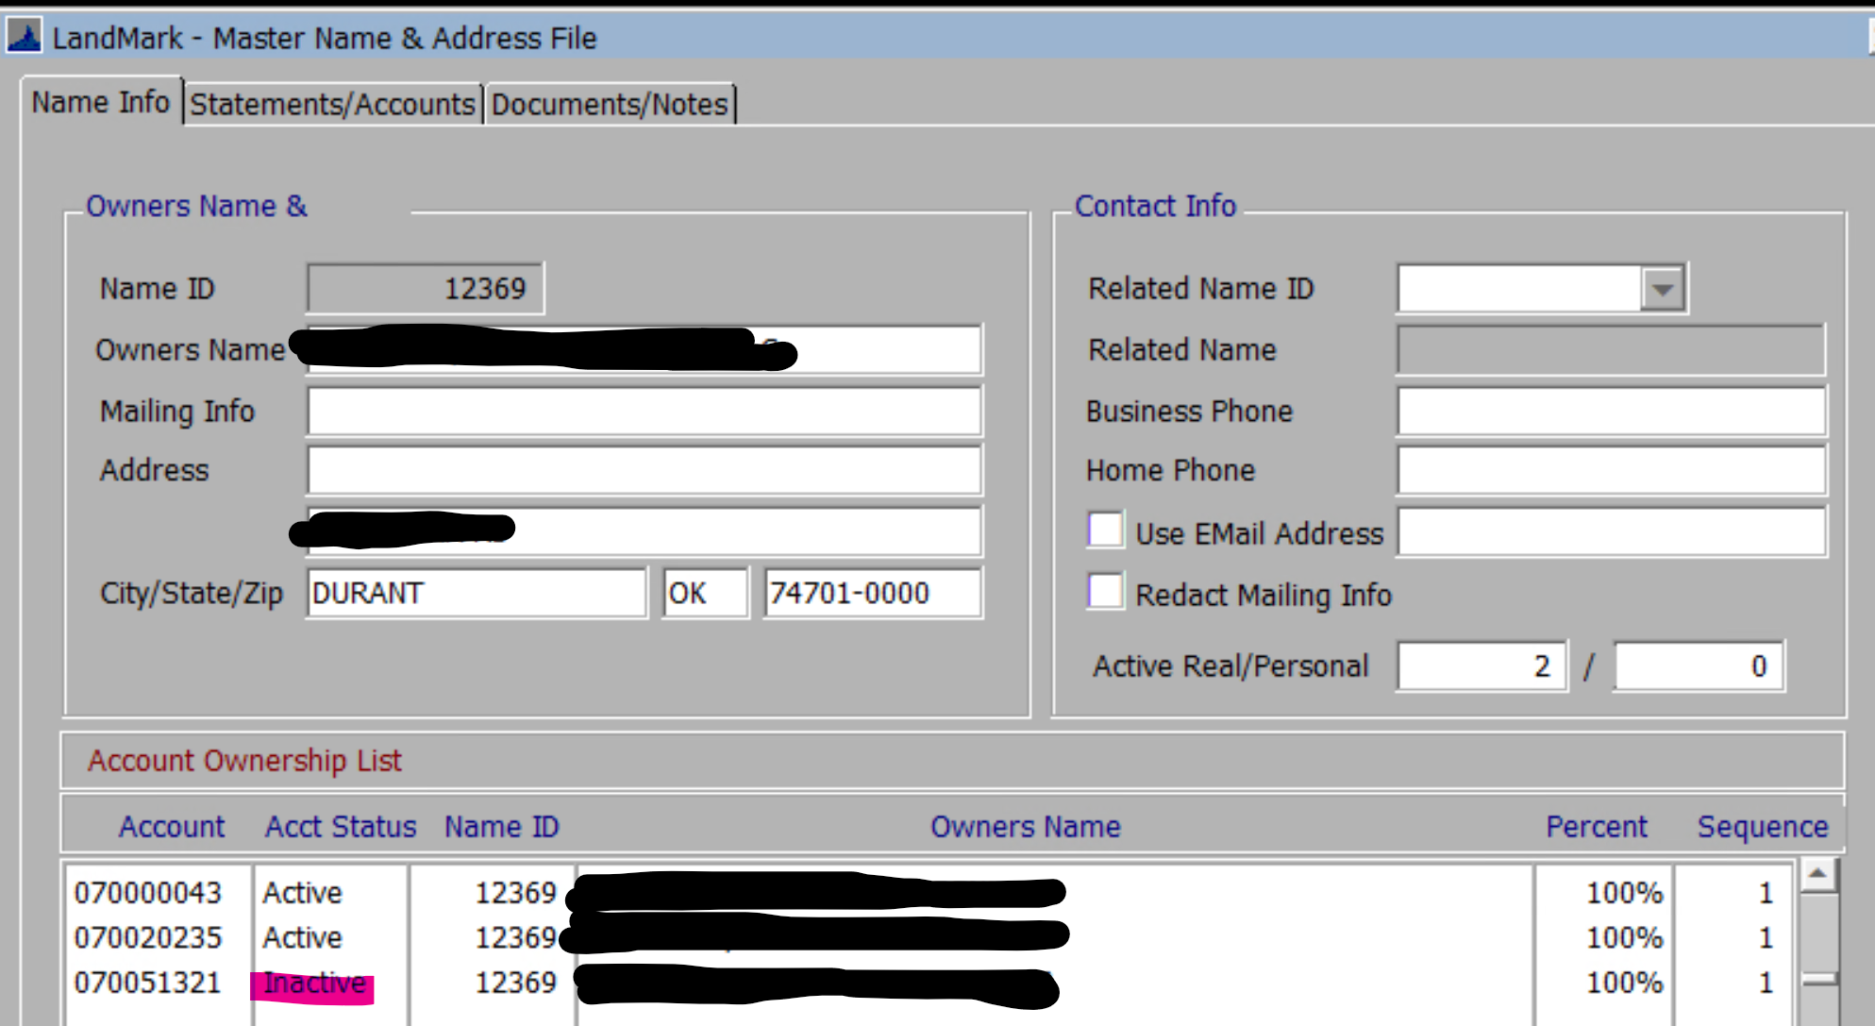

Appraisal Zone Table
- May 1st – The base year in the appraisal zone table will be read only. This is changed in the county information table.
Working Year Update - Annual Procedures - 1 (manula.com)
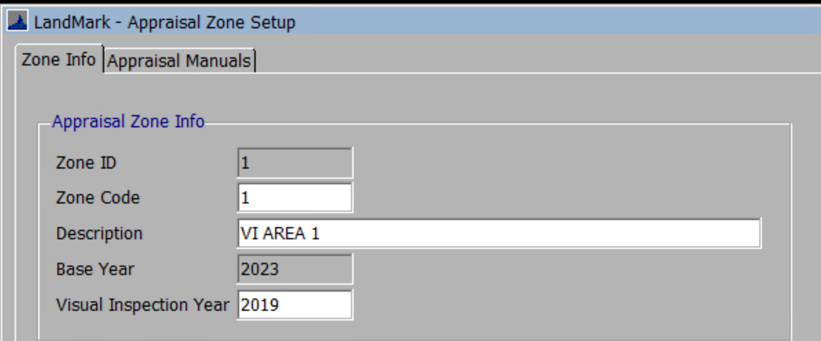
- Apr 17th – The manual information is read only. This is changed when changing the manuals in the county information form and descriptions in the appraisal manual form.
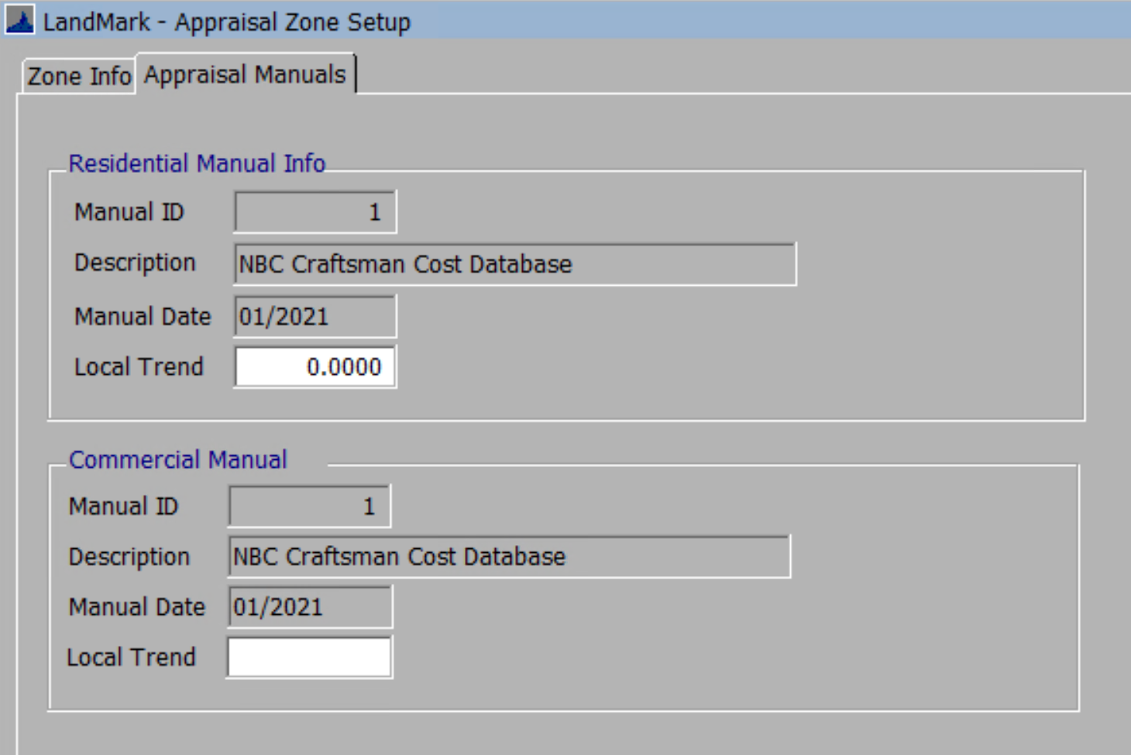

BOE
- May 1st – The label Appraised has been changed to Current Market. When created this is the Fair Cash Value from the assessment form.
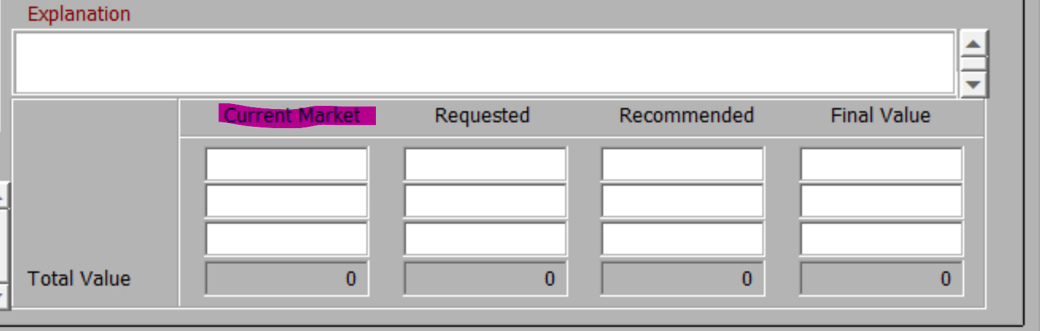
- May 1st – When attaching a document/note to an appeal record the default will be a private note. Images will continue to default as publc.
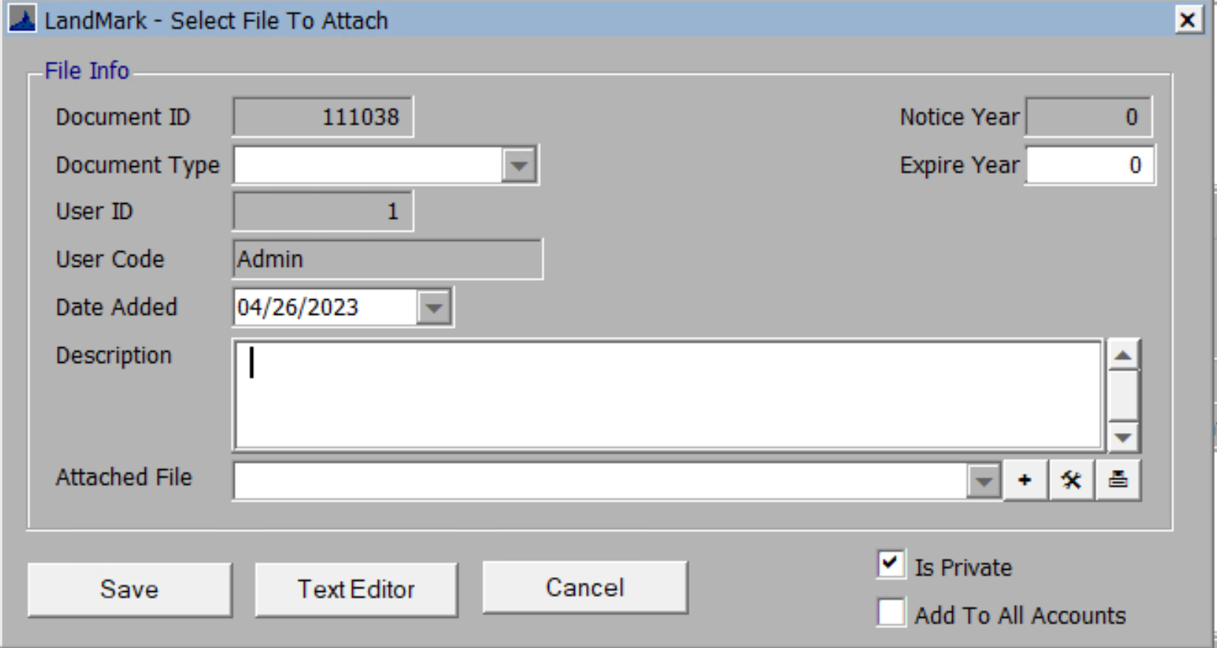

Personal Property
- Apr 24th – On the TASC import there was a difference where rounding occurred and decimal places on calculating the value. We now match the value column to the calculated FMV that TASC provides. TASC has two columns that could adjust the value. We adjust the cost column to account for this in order to get a cost new value.

Reports

General
- May 1st – When printing report the report id will be in the print options. This will allow you to find the report easier in the report manager. The start and end page will work as well.
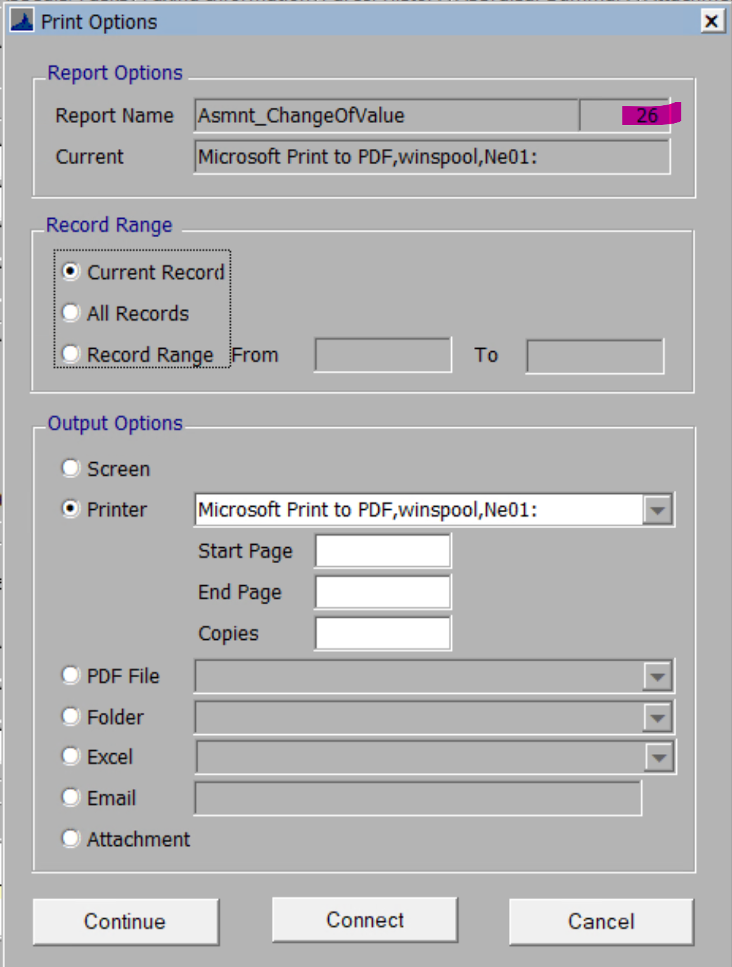

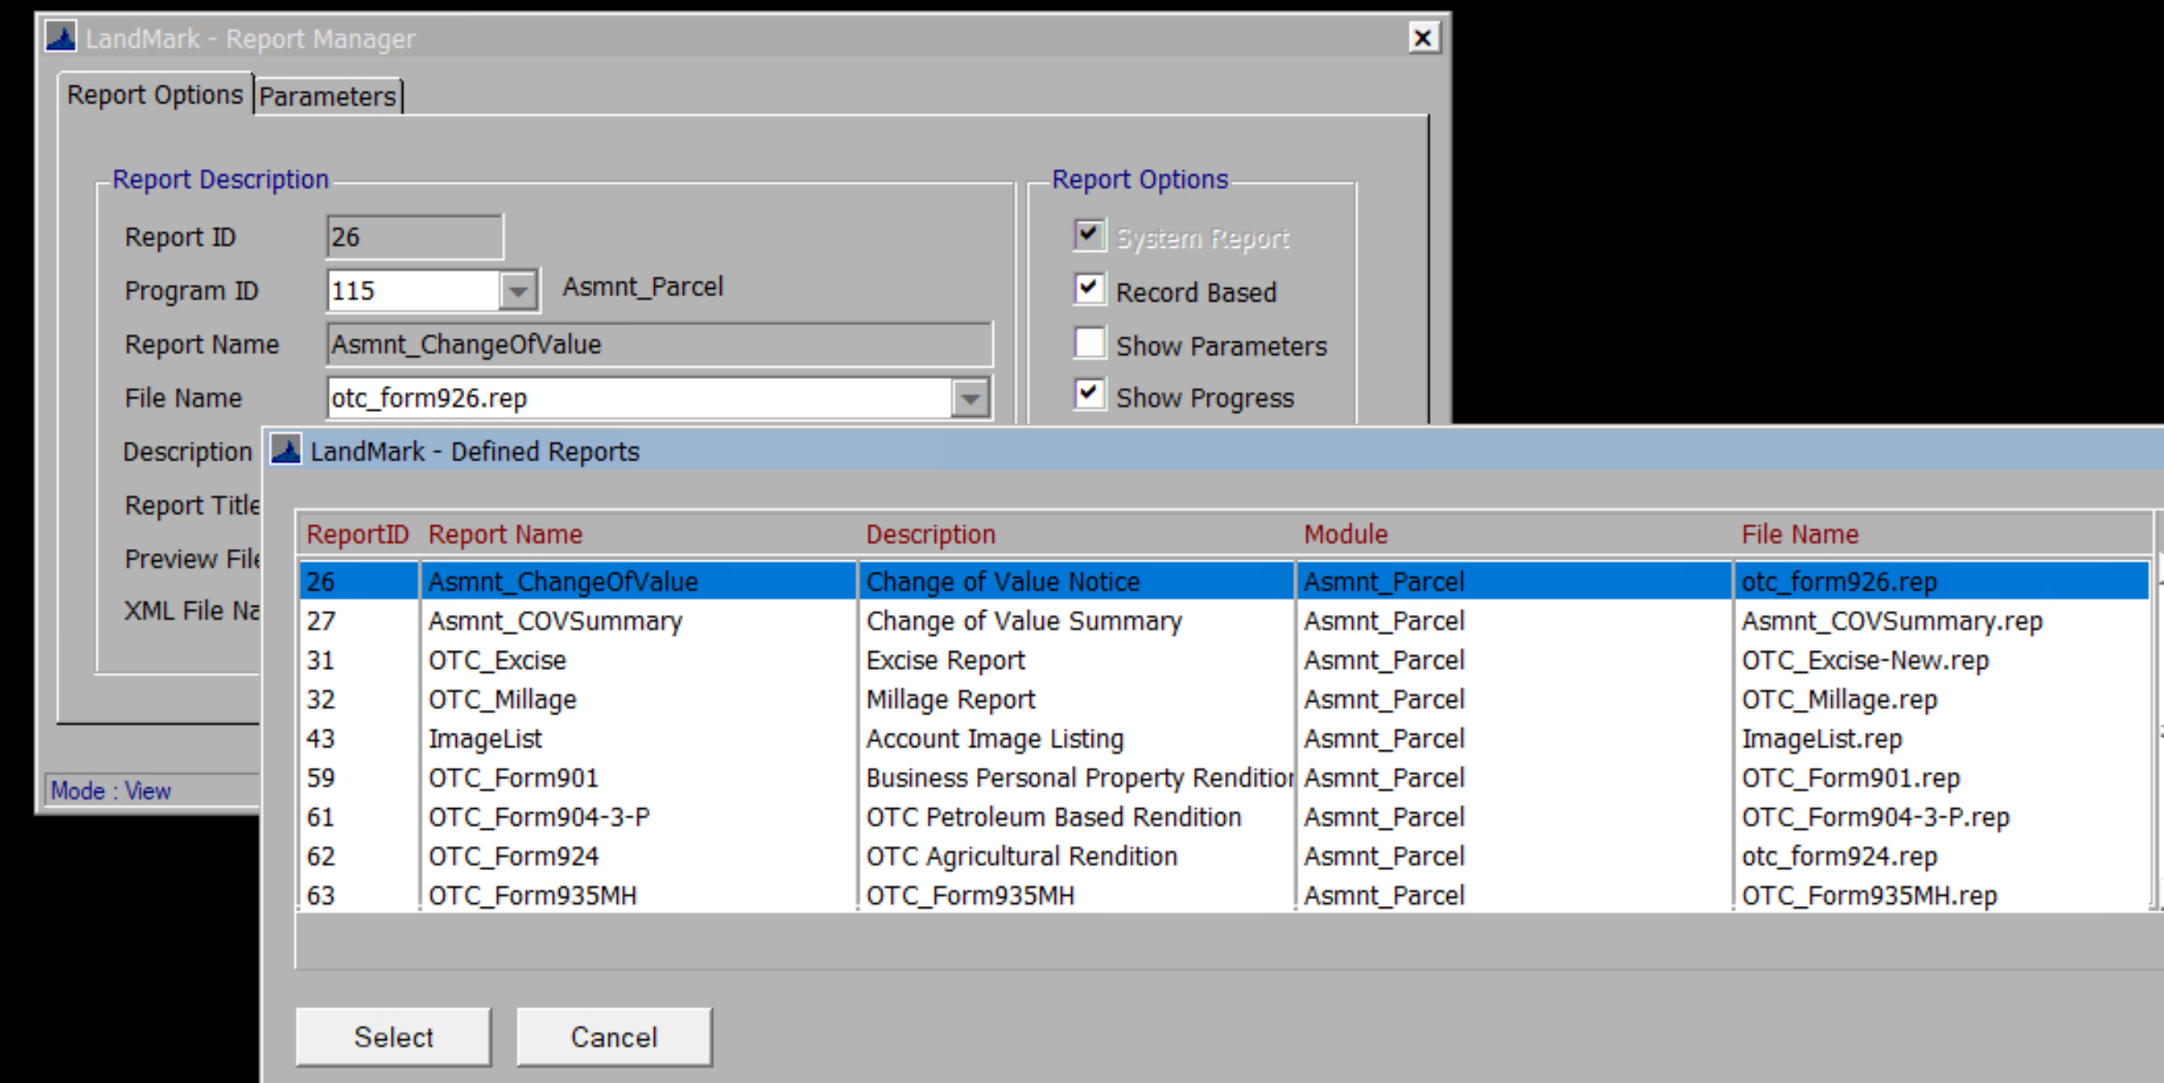

Revaluation Edit
- May 1st – The heading of the Revaluation Edit report has changed. Personal property accounts will have the first 14 characters of the name followed by the last notice date. The last inspection date will be the filing date. This is complicated in that the report can contain a combination of real and personal accounts.
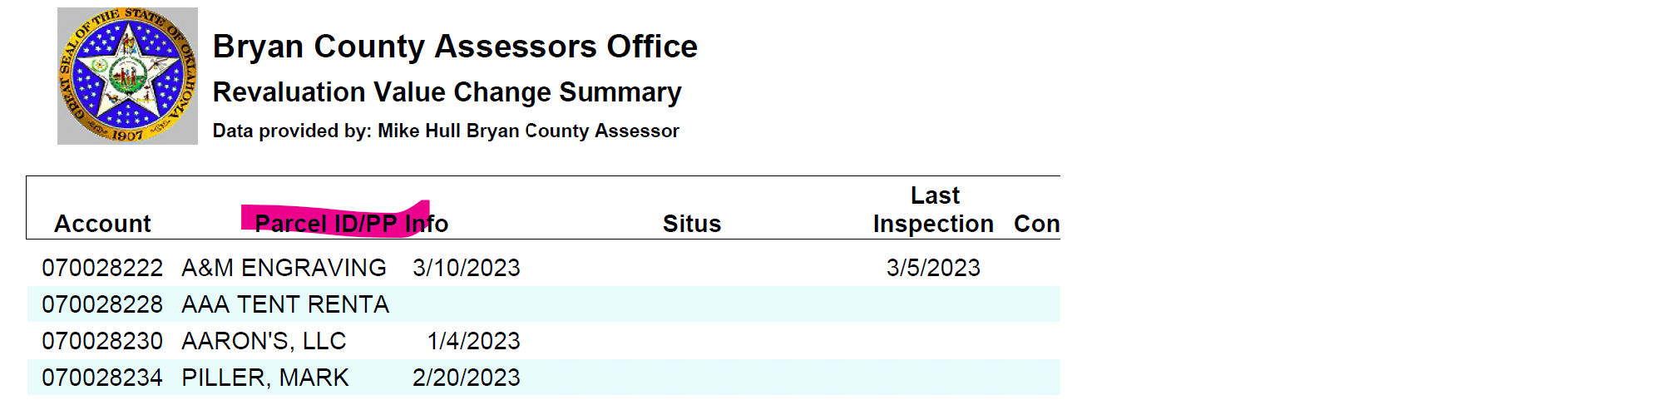

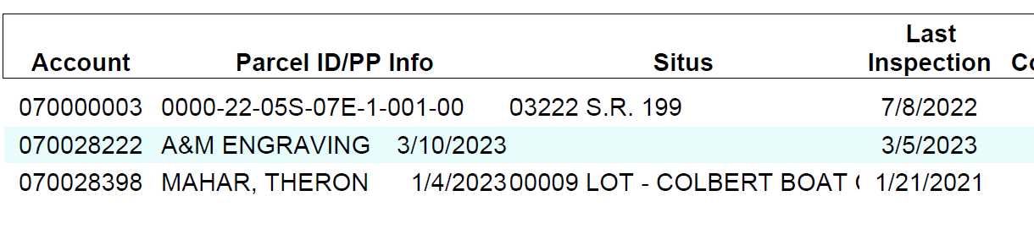

Linked Owners Report
- May 1st – The Linked Owners Report can now be printed for an individual record. The report works a bit different than other reports. If you are on a record that has a fractional or linked ownership you will be asked to print the report for the current record. If you select yes the report will print for the record you are on.
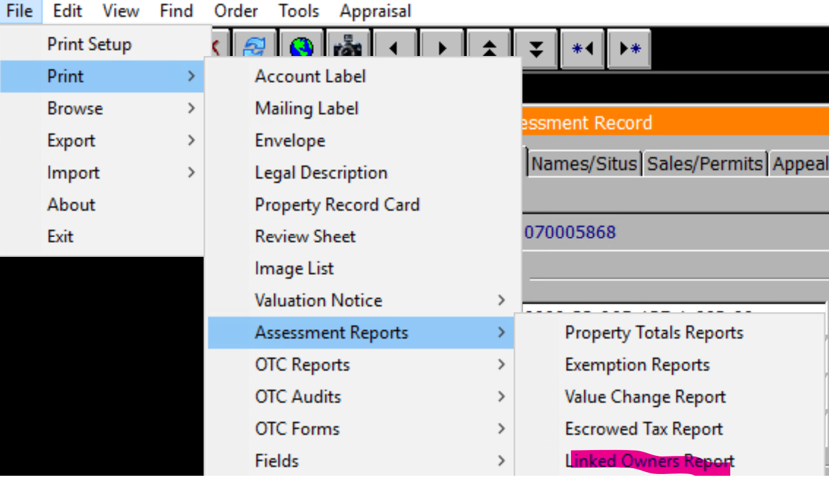


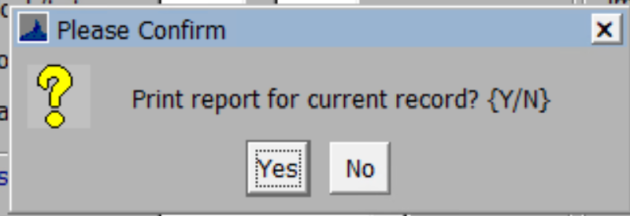

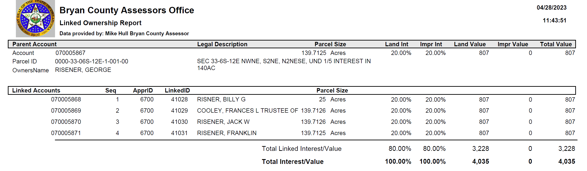

Residential and Commercial Report and Cards
- Apr 17th – There is a parameter that will print the linked assessments on the residential and commercial reports and cards. This will also right click and Print Appraisal Report in the assessment form.
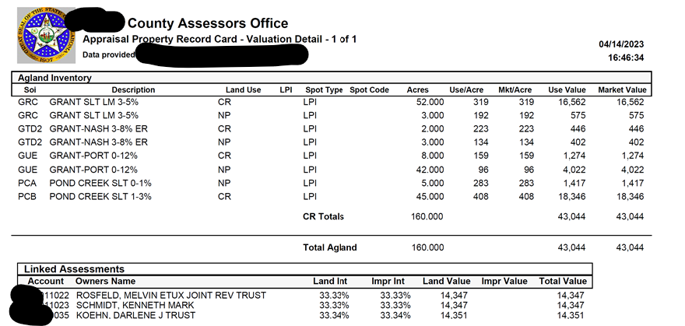

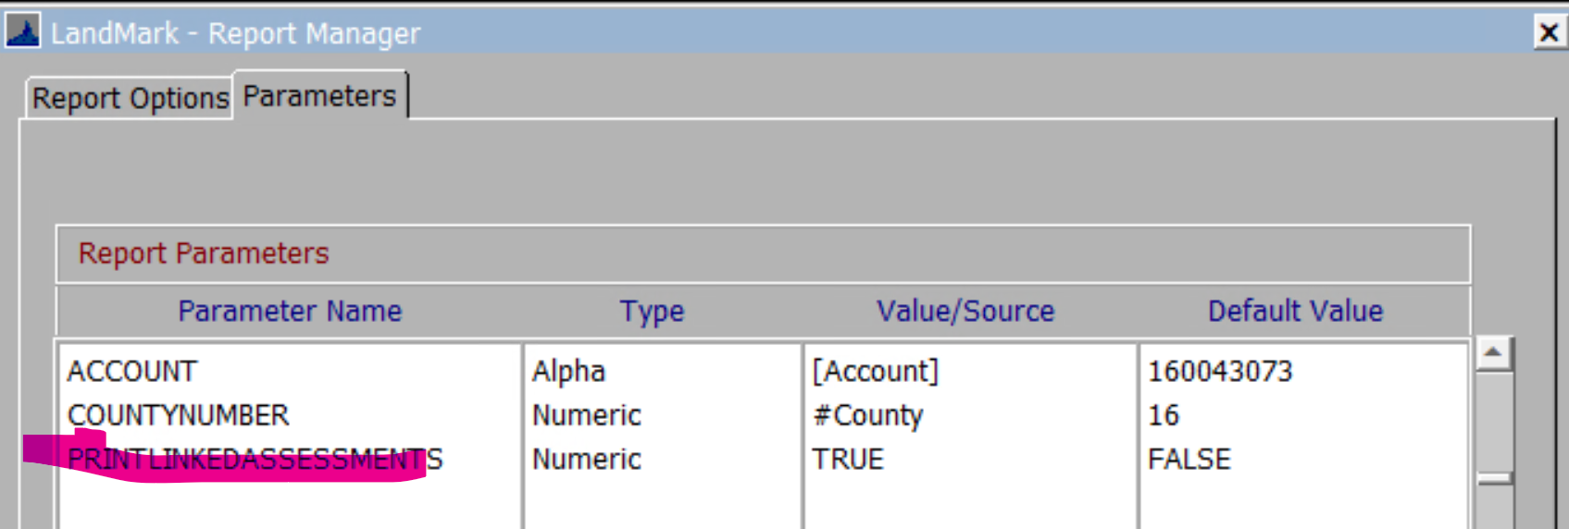

File – Print – Appraisal Report from residential appraisal
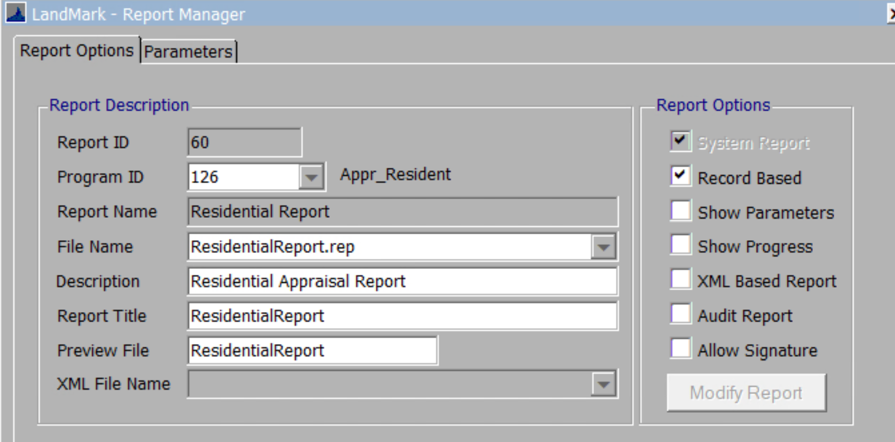
File – Print – Residential Report from residential appraisal
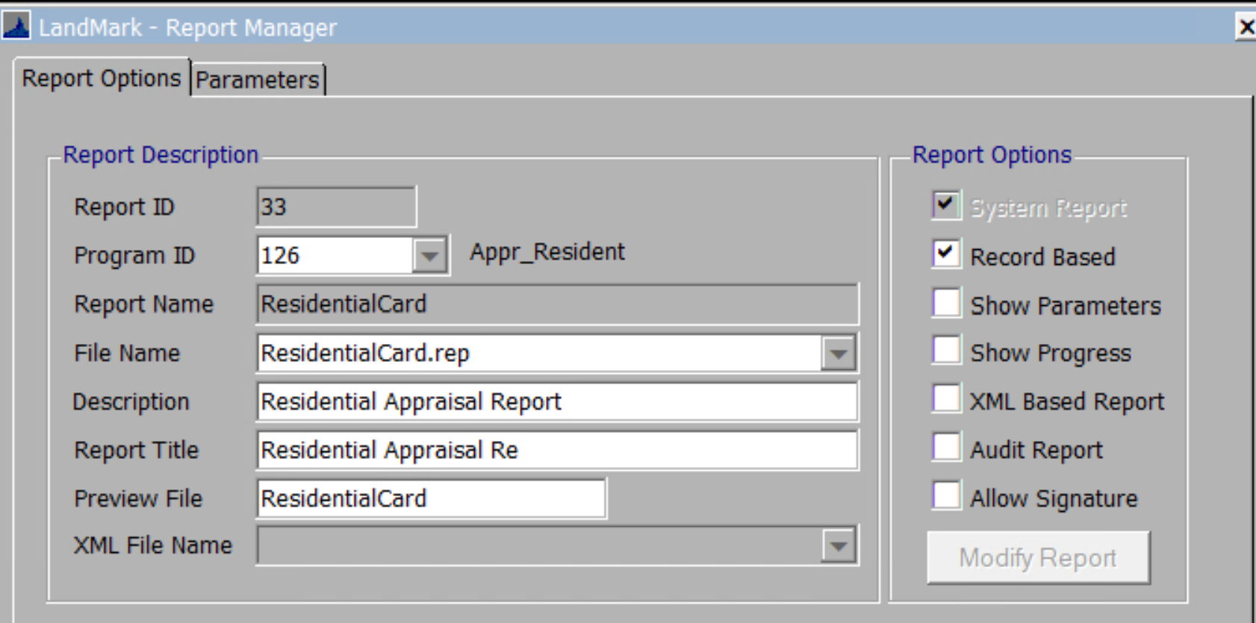
File – Print – Appraisal Report from commercial appraisal
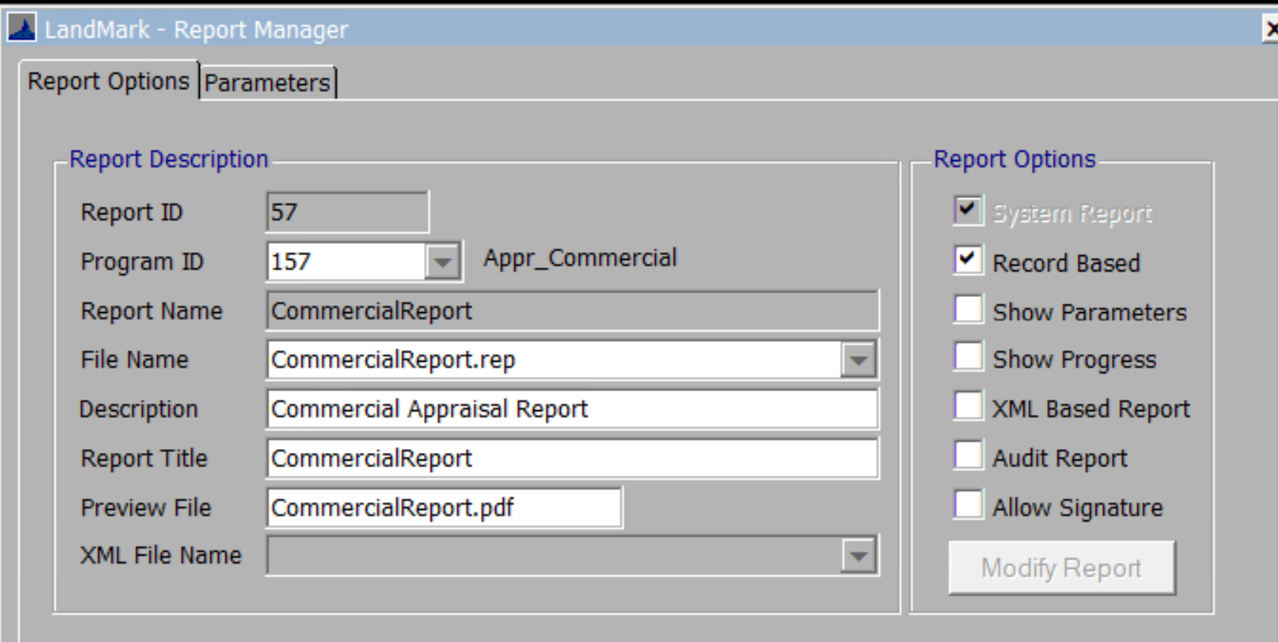
File – Print – Commercial Card from commercial appraisal
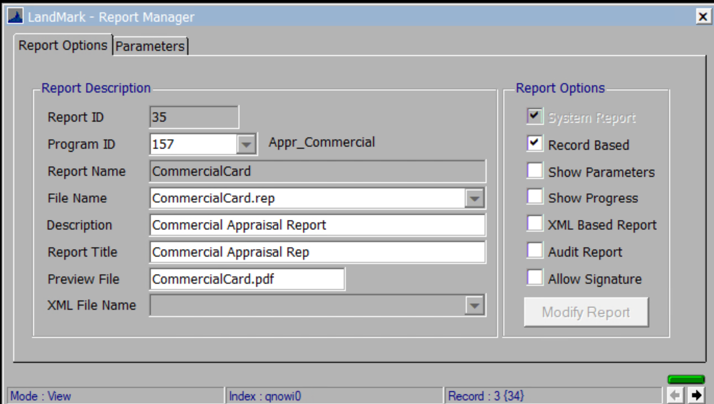

926P – Personal Property COV
- Apr 24th – If there are multiple appraisal records items will print on the report and will be in appraisal id order

901 and 924
- Apr 24th – If there are multiple appraisal records items will print on the report and will be in appraisal id order

Schedule Listing
- Apr 24th – If there are multiple appraisal records items will print on the report and will be in appraisal id order
- May 1st – There is an option to print the outbuildings on the schedule listing. The parameter PRINTOUTBUILDINGS must be added to the report and set to true. If the parameter is not added there will no change to the report. Prior the residential improvements would not print on the schedule listing.
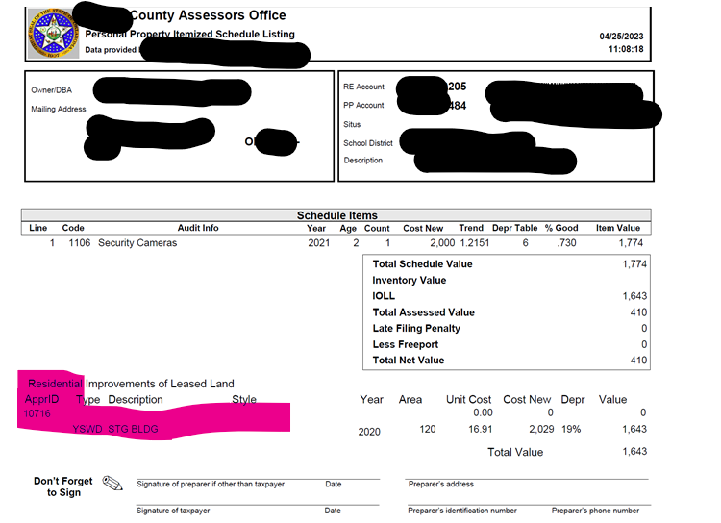
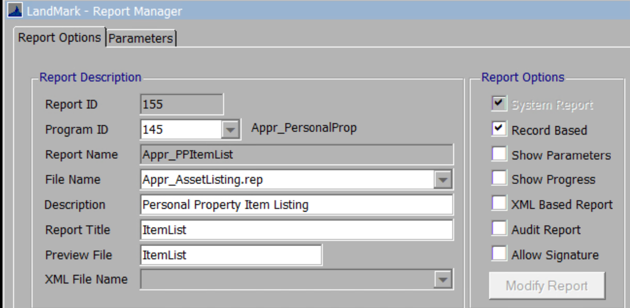
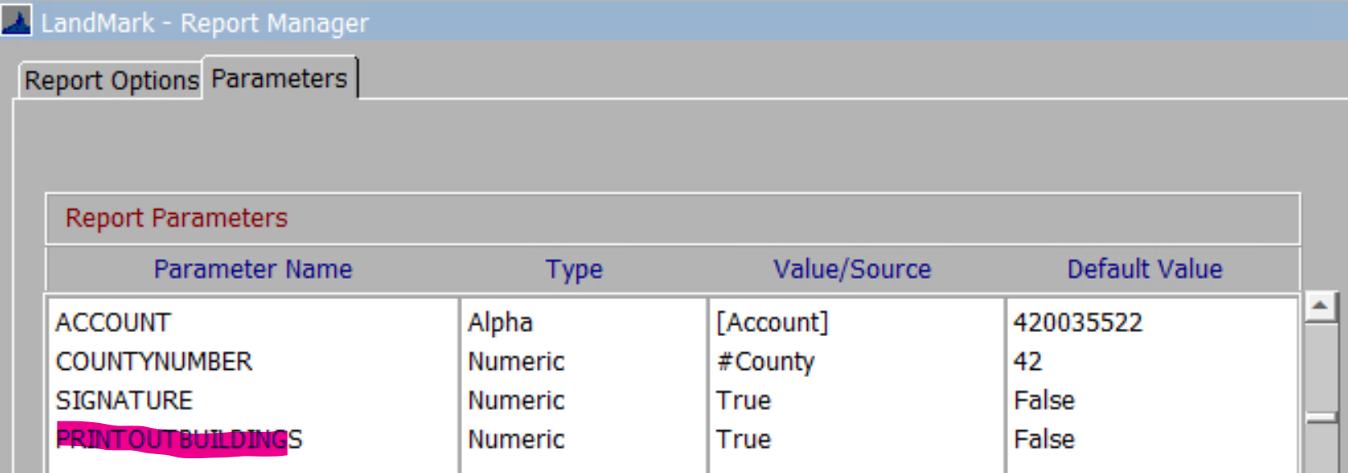

OTC Item Audit
- Apr 24th – If there are multiple appraisal records items will print on the report and will be in appraisal id order

PDF Viewer
- Apr 17th – When attaching the form the date added in the attached documents section was a day prior to the actual date. This has been corrected.

User Defined Imports
- May 1 – The user defined imports for Excel documents will now import.

