Contents
Weekly Changes May 22, 2023 1
General 1
Parcel 1
BOE 1
Residential File 3
Commercial File 3
Outbuildings 4
Reports 4
Correction Form 4
Abstract 4

Weekly Changes May 22, 2023

General
- May 15th – When doing an index and then editing the field that was just indexed the information would not be saved. This has been corrected.

Parcel
- May 8th – If doing a split and then cancel the account number that was going to be used will be reset if no other accounts were created by others in the time the split process was open.

BOE
- May 8th – The order menu in the BOE file has been changed.
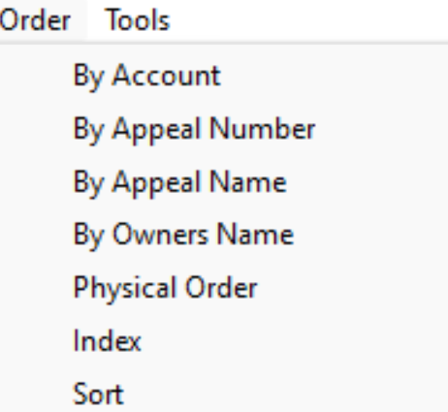
- May 15th – The account status and source information has been added to the BOE form.
- May 22nd – There is the ability to copy appeal information onto another account. This is available under the Tools-Copy Appeal. This can be used if the same company is protesting multiple accounts with the same information. If an informal protest changes to a formal protest this could be used keeping in mind to complete the informal protest.
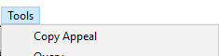
The highlighted fields will be copied to the exiting record.
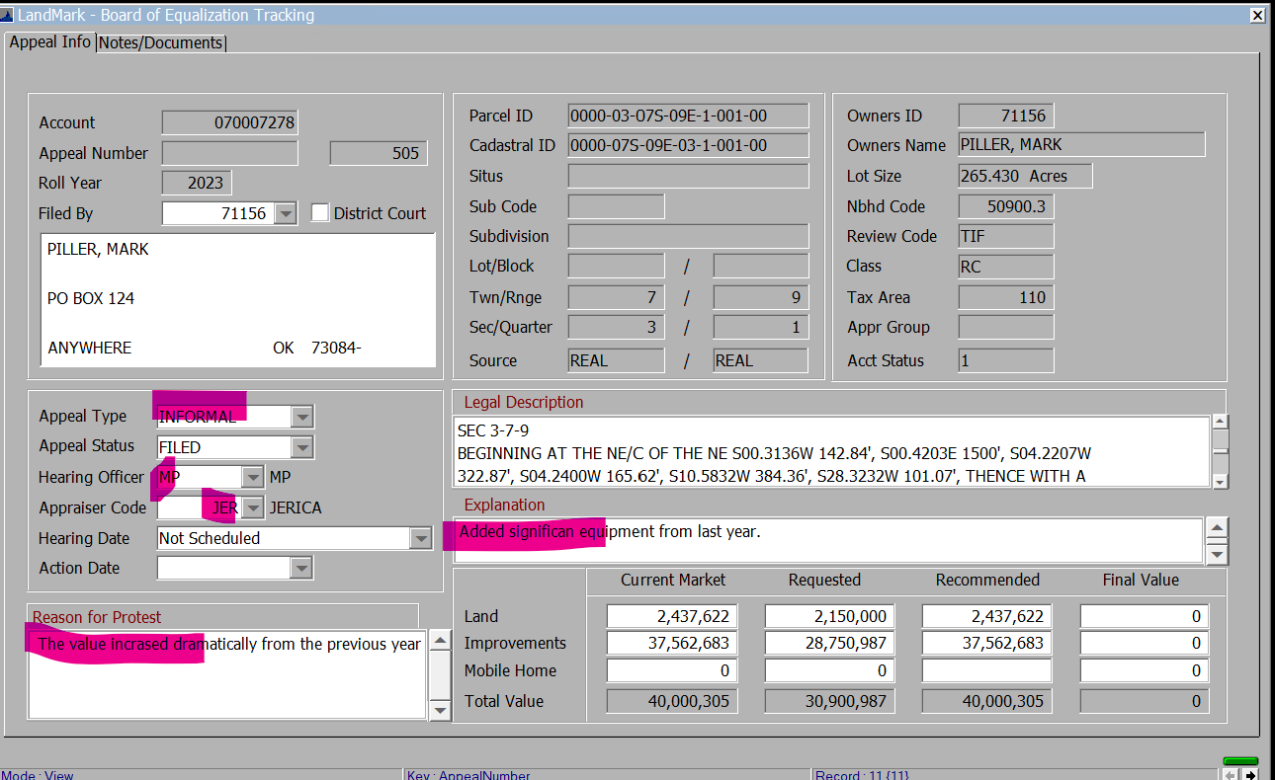
Once the menu option is selected the user can enter the parcel and requested amounts can be entered.
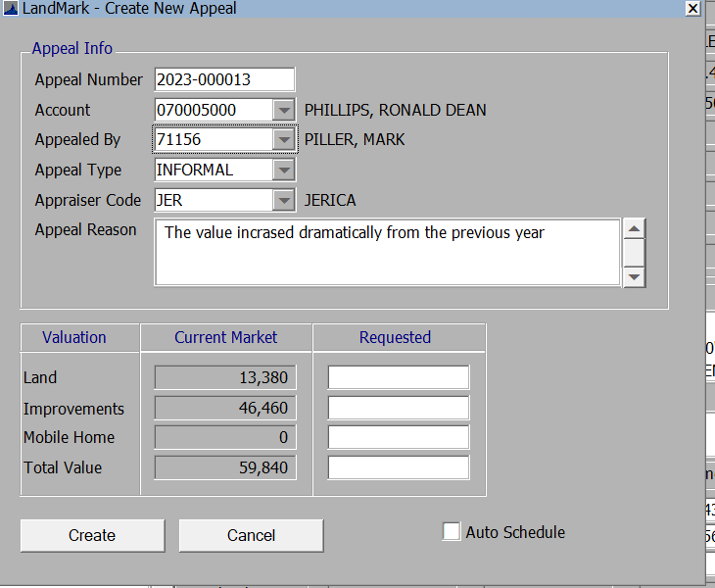
Information will be copied and then the recommended amounts can be entered.
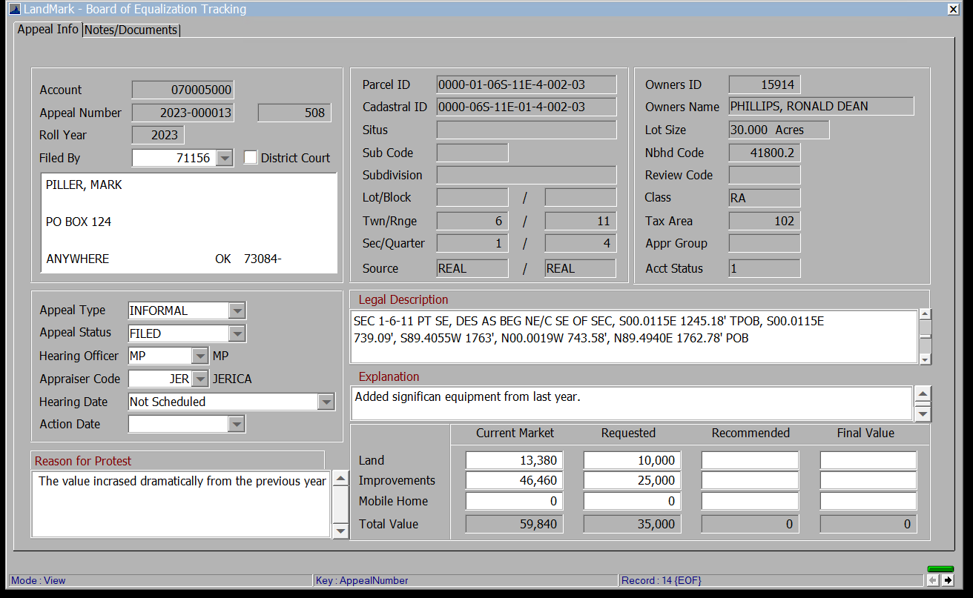

If the account has an active appeal for the current year, you will be asked to create the appeals.
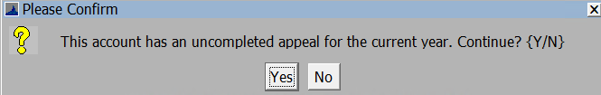

- May 22nd – The menu option for the District Loss Listing is available.
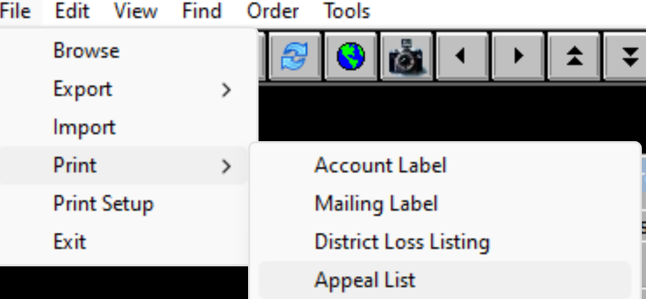

This will find personal property accounts that have fair cash value >=3M and have open appeals for the current year.

If no records are found, you will receive this message.

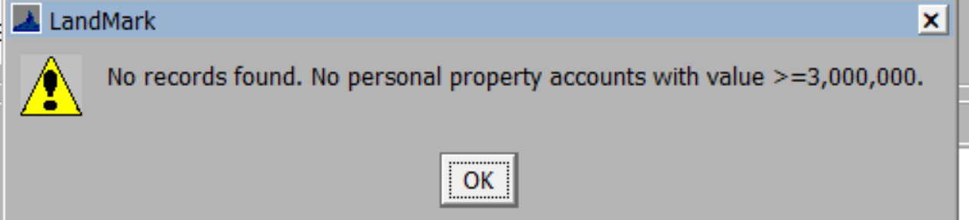

The report will contain each district and then have totals. For the taxable value change and estimated tax change the recommended values will be used. If there is no recommended value, then the current fair cash will be used. You can create an index of records and then the report will include those records. When creating an index be sure to include records only for the current appeal year, records where the account status is >0, and not include completed appeals.

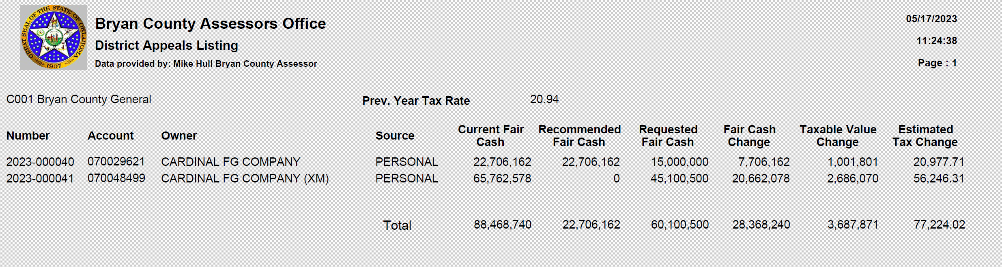
- May 15th – Appeal Listing The report for the appeal listing has been updated. This will print all appeals for the current year. You can index the file and then these records will be included in the report.
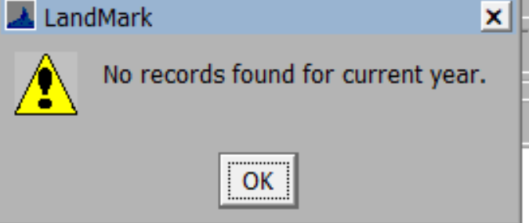
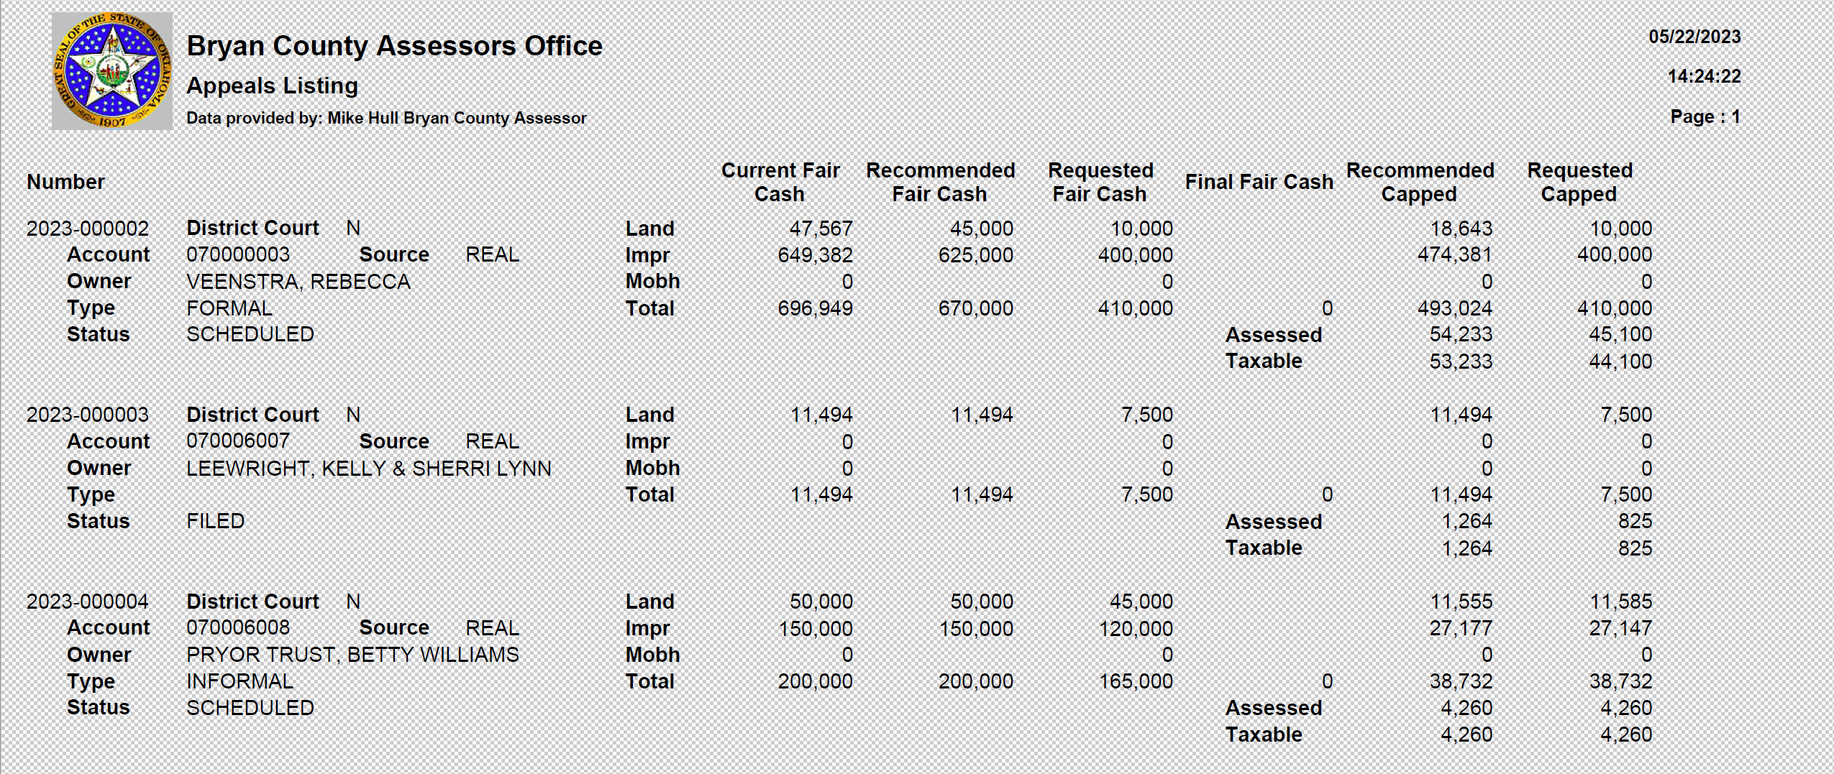

Residential File
- May 15th – The individual heat pump code now has a lower cost associated with it.

Commercial File
- May 15th – The controlled atmosphere heating code has been adjusted to cost at a lower rate than what it has been.
- May 22nd – There is a menu option to apply penalties in the commercial file. This will apply and clear penalties similar to the personal property and residential files. The source on the account will need to allow penalties and then based on the filing date penalties will be calculated and included in the appraisal file. These will then need to be brought into the assessment file.
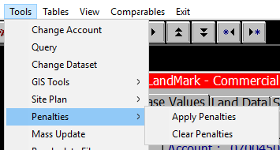

Outbuildings
- May 15th – Codes SSAG and SSIG are now available on the outbuilding drop down.
- May 22nd – Code SOLP is now available on the outbuilding drop down.

Reports

Correction Form
- May 22nd – A few changes to the correction report to match OTC report.

Abstract
- May 15th – The numbering of the rows has been adjusted.
- May 15th – Abstract line 8 items will be accounted for in the other personal property row.

