Contents
Weekly Changes May 14, 2022 1
Assessment 1
Fractional Interest 2
Appeals 2
Tax roll Correction 3
Personal Property 3
TIF District 3
Reports 3
Top Taxpayer 3
924 3
Datasets 3

Weekly Changes May 14, 2022

Assessment
- May 16th The TIF district is read only in the assessment file.
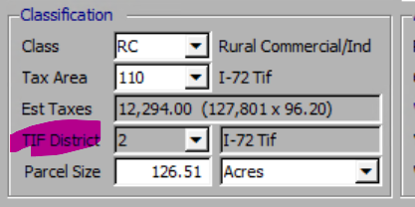
- May 16th The TIF district is a calculated field which will always be based on the tax area. If the tax area is the base tax area of a TIF this will be what the TIF district will be.
- May 9th When using the attach document option if the file is >16MB there will be an attempt to compress the file so it can be attached. If still over 16MB you will receive the following message. In this case the attach document record will be created however nothing will be attached to this as the maximum file size is 16MB.

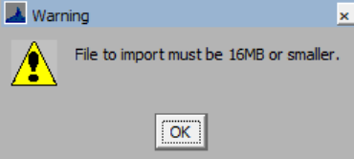
- May 2nd When importing pictures through the Import Images .pdf documents would import in and be part of the images. This will not occur and will be in the error listing.
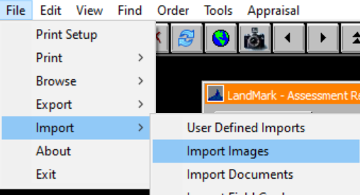f
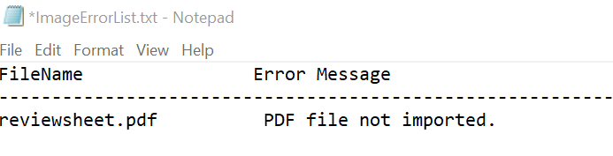

Fractional Interest
- May 16th When combining fractional interest accounts there were times where the account would have a fractional interest that was not linked and then would go to the first account. This process has been adjusted where the fractional interest will be removed appropriately when combining the accounts.
- May 16th When trying to delete a residential or commercial record that has a linked assessment you will receive a message where the linked assessment needs to be reviewed/deleted prior to deleting the record.
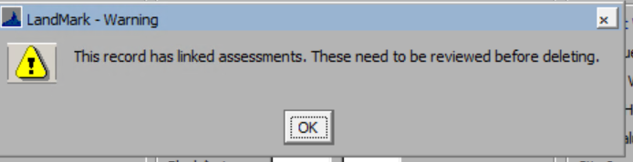

Appeals
- May 2nd When appealing a persona property, the working of the value lines would not update. These now match the wording on the assessment screen.
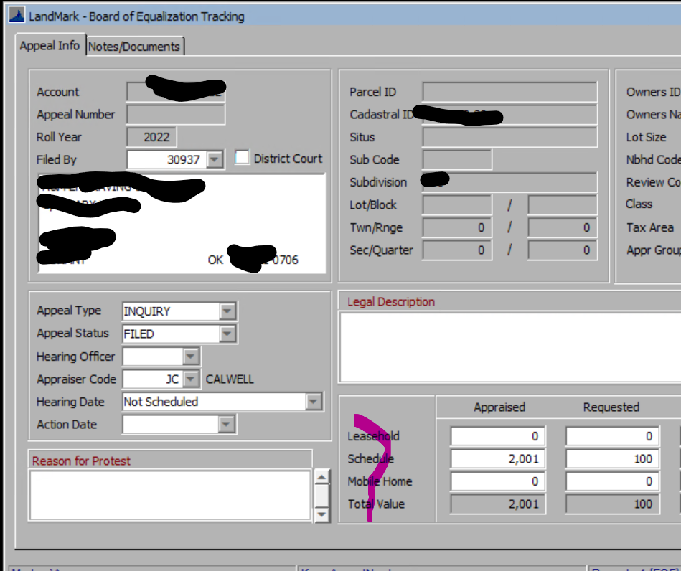
- May 9th There is a new checkbox on whether the appeal is in district court.
- Note: Appeal number can be auto generated by checking the option in the county information table. By default, this is not checked.
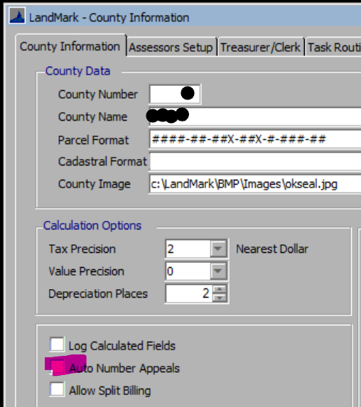

Tax roll Correction
- May 9th There is not the ability to check the applied box on correction. The applying of the correction needs to be done on the toolbar.

Personal Property
- May 9th There was an issue with multiple accounts with the same school district in the TASC import.
- May 16th When importing in the TASC schedule the spelling of TASC has been corrected.

TIF District
- May 16th If you try to delete a TIF district that has accounts associated with it you will not be able to delete the record.
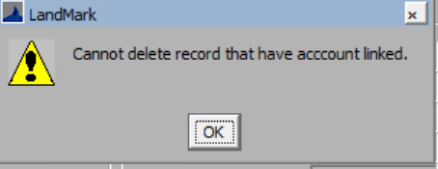

Reports

Top Taxpayer
- May 2nd The report was including inactive public service accounts prior to the release date.

924
- May 2nd The word acquired was misspelled on the form.

Datasets
- May 9th When using a dataset with a different cost table

