Contents
Weekly Changes March 15, 2022 1
Assessment 1
Residential Appraisal 2
Commercial Appraisal 3
Query 3
Reports 4
Schedule Listing 4
936 4
Review Sheet 4
Property Record Card 4
Residential Report 4

Weekly Changes March 15, 2022

Assessment
- Mar 7th When doing a split, the site plan would not be removed if an account had all items moved to the child parcel. This has been addressed. There will be additional split changes in next week’s release.
- Mar 15th The Annual Inspection Count report has changed. The user will be asked for a VI code. You can enter 2..3 if you want VI areas 2 and 3 on the report.
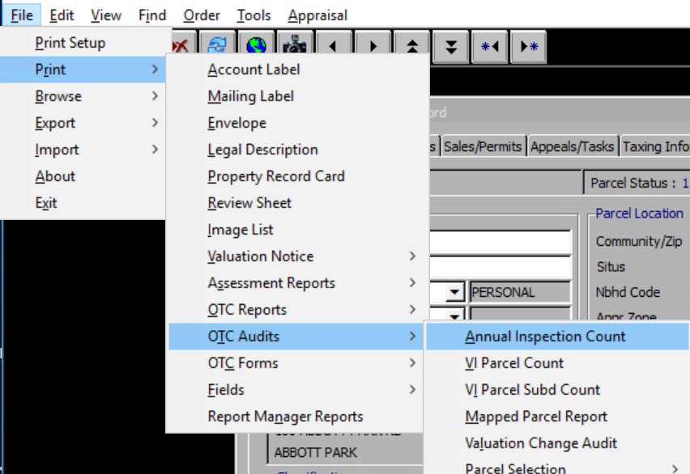

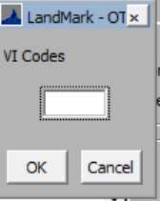

The inspection count will be from January 1st of the appr year to Feb 1 of the next year. The entrance county will be January 1st of the appr year to March 1 of the next year.
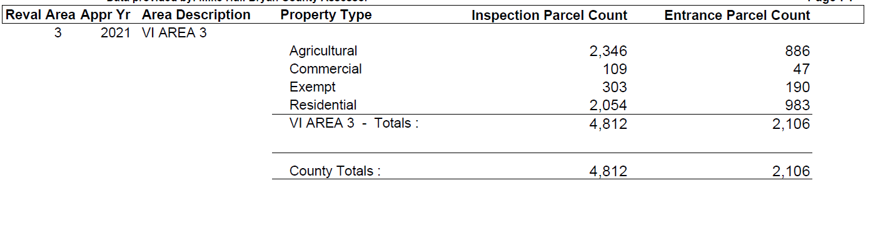
The appr year is the inspection year set in the appraisal zone table.
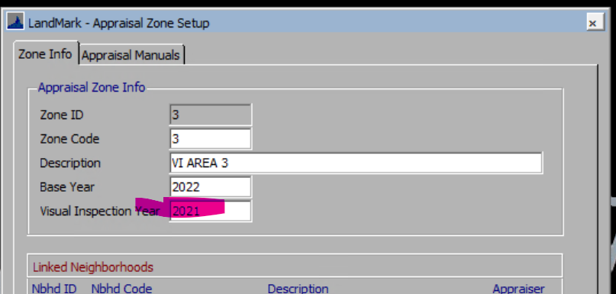
- Mar 15thCommercial split that had buildings on multiple cards were having issues where the buildings were not getting to the new parcel. In addition all site improvements would go to one account. These has been addressed.

Residential Appraisal
- Mar 7th When moving a site improvement from residential to commercial the sketch would not move the sketch. This has been addressed.
- Mar 7th Cannot move a misc. improvement from a residential card to commercial card. This is because the miscellaneous improvements in commercial are tied to the buildings.
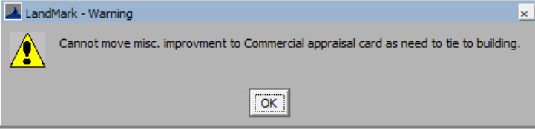
- Mar 7th When adding a residential building and there is already a site plan there is a need to display the site plan and the place the homesite in the site plan. If this is not done the homesite will not be on the site plan. There is a report to find these. In the residential file select Tools – Listings-Sketch Not On Site Plan.
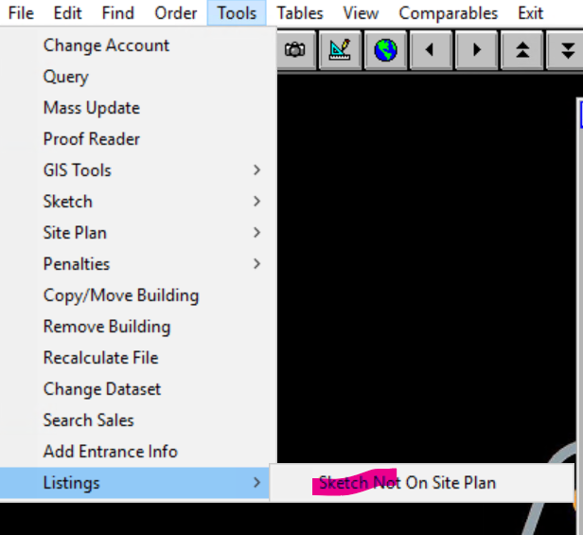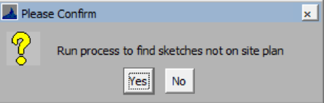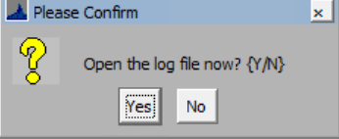

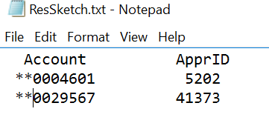
- Mar 7th If a value >1 is entered in the percent of style the user will be informed of this and the percent will change to 100%. If multiple styles are in place the second style will be removed. If the percentage of the style is changed the second style percent will automatically change instead of having to tab through the second style.
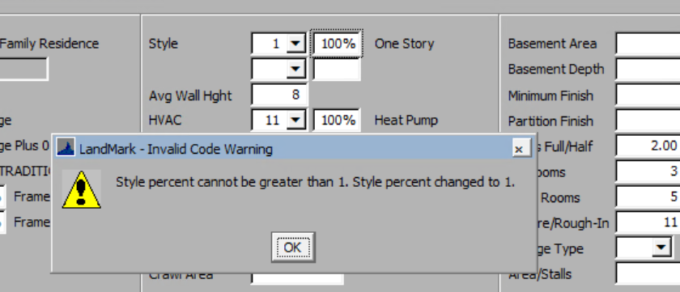
- Mar 7th If a value >1 is entered in the percent of the hvac the user will be informed of this, and the percent will change to 100%. If multiple styles are in place the second style will be removed. If the percentage of the hvac is changed the second hvac percent will automatically change instead of having to tab through the second hvac. This also occurs when editing the residential properties on the sketch.
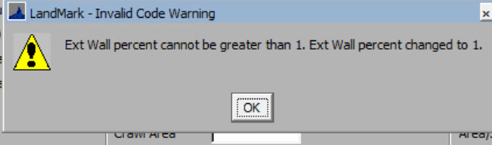

Commercial Appraisal
- Mar 7th On the right click options on the miscellaneous improvements took the option of Move Misc. Improvement off list. This was not doing anything.

Query
- Mar 15th When importing in a query from the packages the quotes (“) would be removed. This would cause the query not to function at times. This has been corrected.

Reports

Schedule Listing
- Mar 15th On the schedule listing (File- Print – Schedule Info) from the personal property file. If the parameter is set to print the signature line the information on where to send the form back will be included.
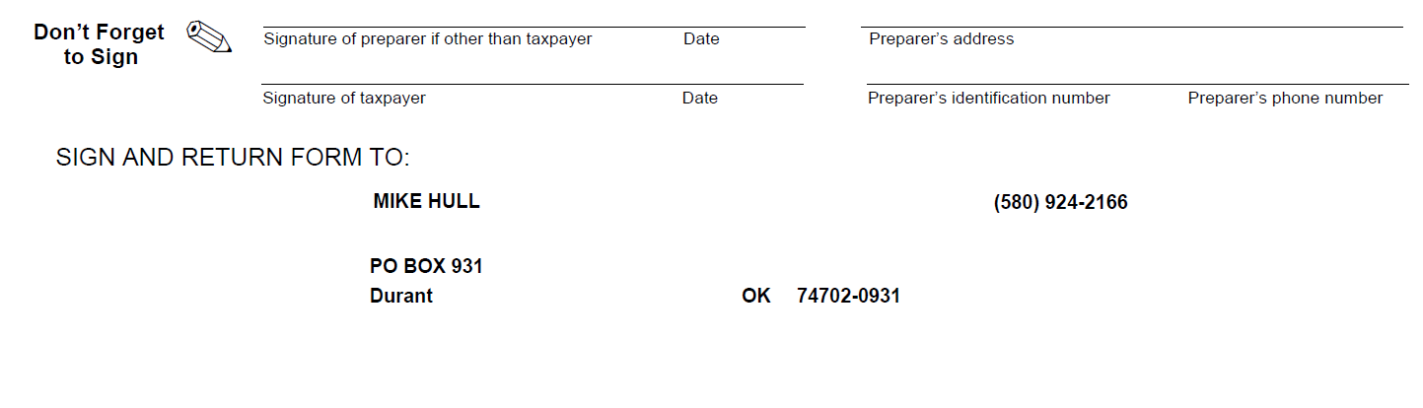

936
- Mar 15th If transferring from real to mobile home the account number would not print on the form.

Review Sheet
- Mar 7th On residential accounts the lot model description at times would not reflect what was on the account.

Property Record Card
- Mar 7th On residential accounts the lot model description at times would not reflect what was on the account.

Residential Report
- Mar 7th On residential accounts the lot model description at times would not reflect what was on the account.

