Contents
Weekly Changes June 4, 2024 1
District and Tax Area 1
Residential File 1
Residential and Commercial File 2
Documents 3
Export OTC and Annual Homestead Report 3

Weekly Changes June 4, 2024

District and Tax Area
- The description fields have been changed to allow 50 characters.

Residential File
- When the structure type is changed the label for the section will update. Previously the description would not update.
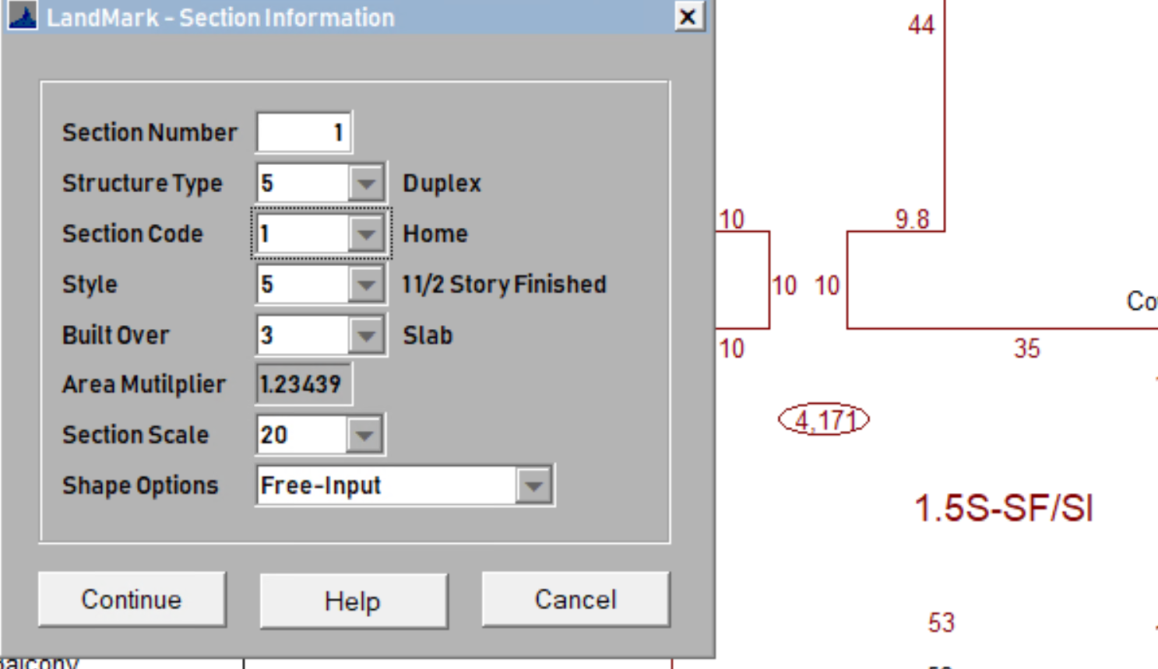

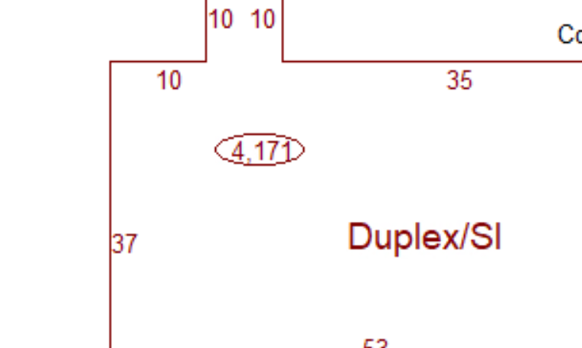
- When there is a site plan on an account and then a sketch is added (new house) the homesite is not automatically added to the site plan. The reason for this is that it is not known where the homesite sits in relation to the outbuildings on the site plan. You can select Tools – Site Plan – Edit Site Plan and the homesite will be placed on the site plan and you can move in relation to the buildings. Prior to 6/3/2024 you could only do this once and then have to log out and back in to do others. This has been fixed. To find records where there is a site plan/sketch where the sketch is not on the site plan select Tools = Listings = Sketch Not on Site Plan.
  - You will be asked to run the process.
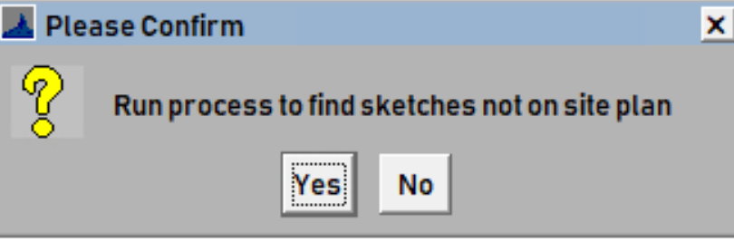
  - The process will run.
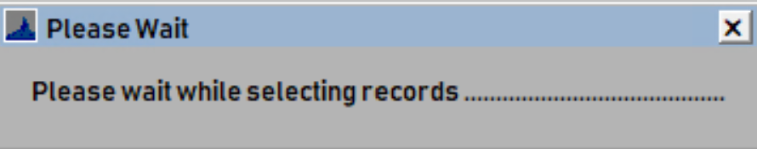
  - You will be informed if there are no records or to open the file.
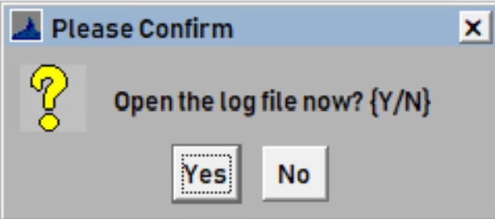
You can then add the sketch to the site plan. Not adding the sketch to a site plan doesn’t have a negative impact on the valuing of the record.

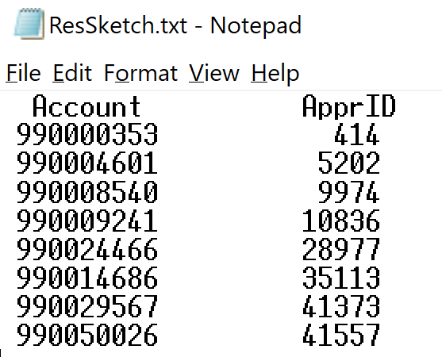

Residential and Commercial File
- When the developer deferment is selected instead of asking the user to remove the new construction you will be informed that a portion of the new construction will roll to the assessment file. In order to receive the message the new construction year will need to be the working year in the county information table. This will not roll information to the assessment side. This will be done when you read the appraisal information to the assessment file.
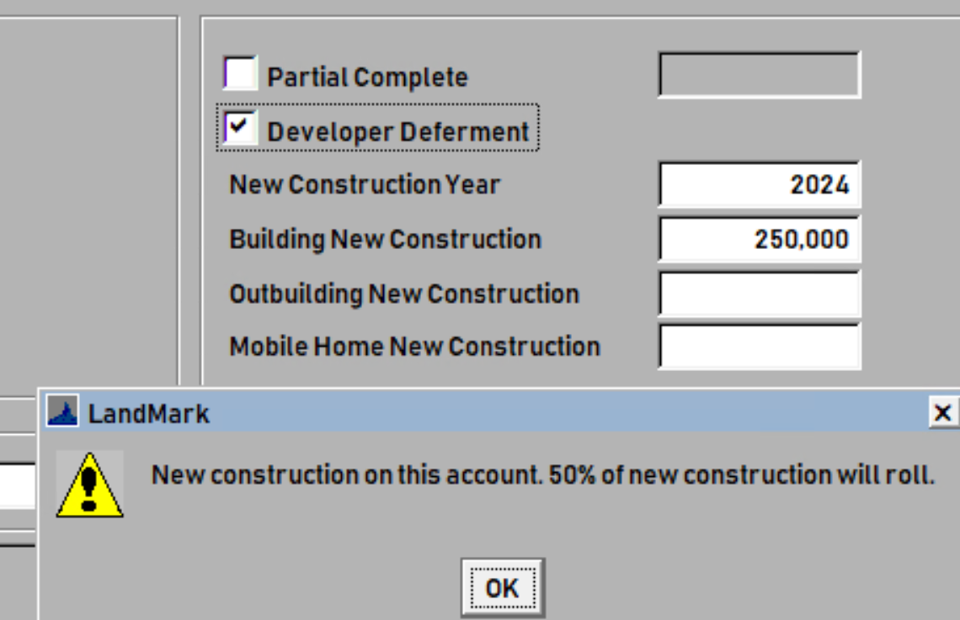

Documents
- When attaching documents if you select the Add To All Account checkbox you will be informed how many records this will be attached to.
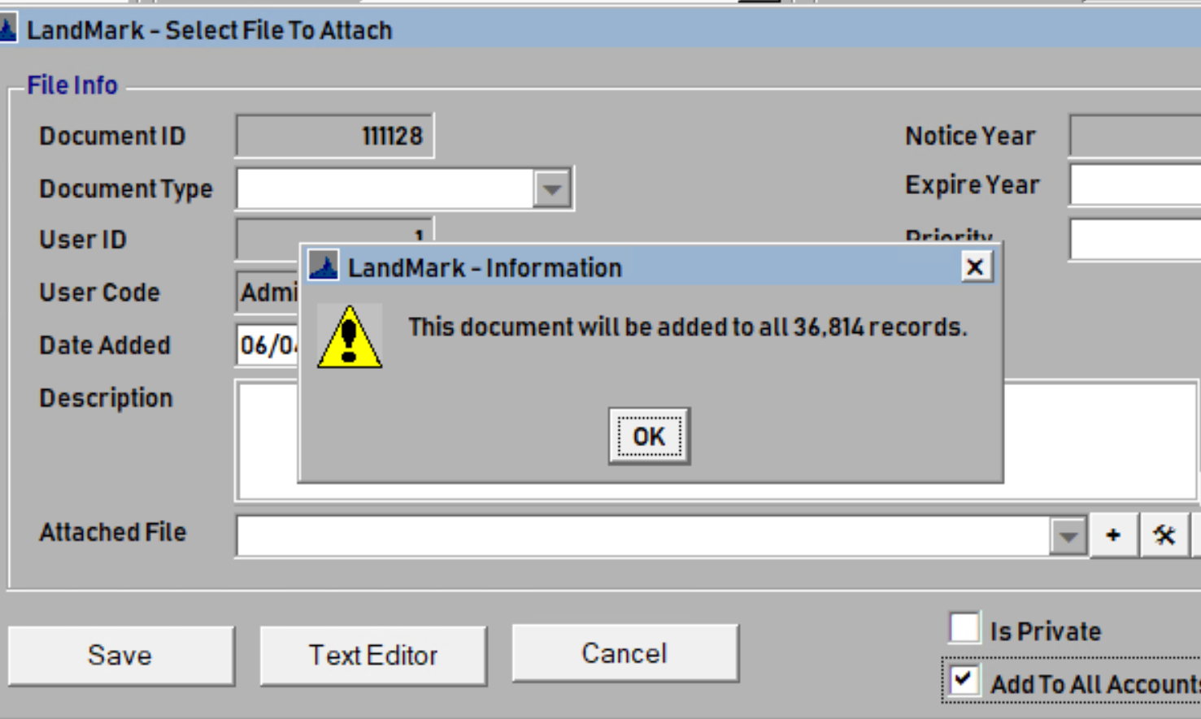

Export OTC and Annual Homestead Report
- There is a menu option to export out a spreadsheet that contains the abstract and annual exemption report information and sent to OTC. Before running the report, you will want to be sure the abstract has been recalculated and balanced and the annual exemption report run. This will be sent to Teresa Wood at OTC. The user will also receive a copy of the email as well.
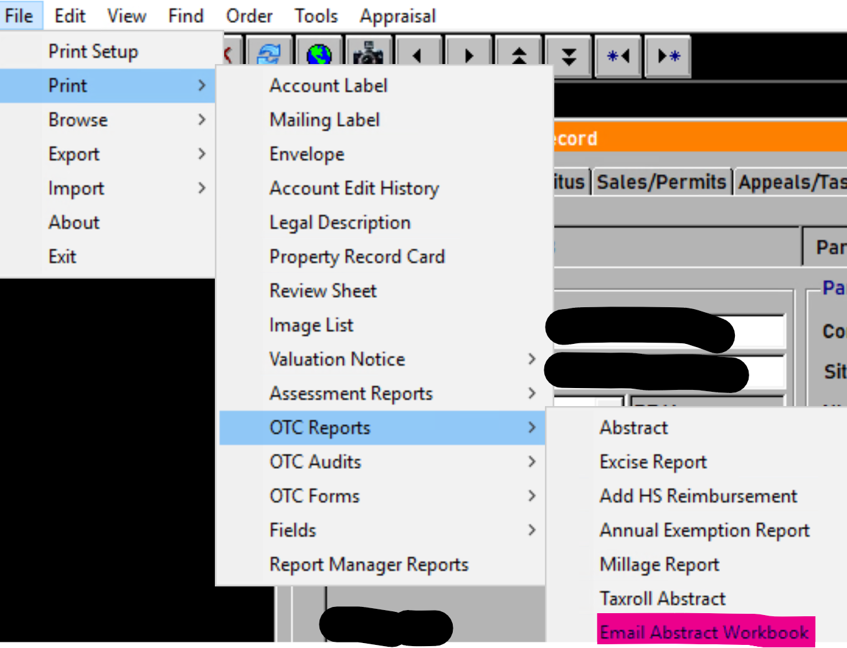
  - When selecting the option, you will be informed that the abstract should be recalculated and annual exemption report run prior to exporting out the information.
