Contents

Weekly Changes June 28, 2022 1

Reports 1

Excise Report 1

# Weekly Changes June 28, 2022

## Reports

### Excise Report

* June 28th The new excise board report format is now available.
  + There is a new report parameter on whether to print the detail pages. The default is N (don’t print) but can be changed to Y to print them.

* + The districts must be linked to the appropriate tax area. One common item is that the city/villages in some counties may not be linked to tax areas.

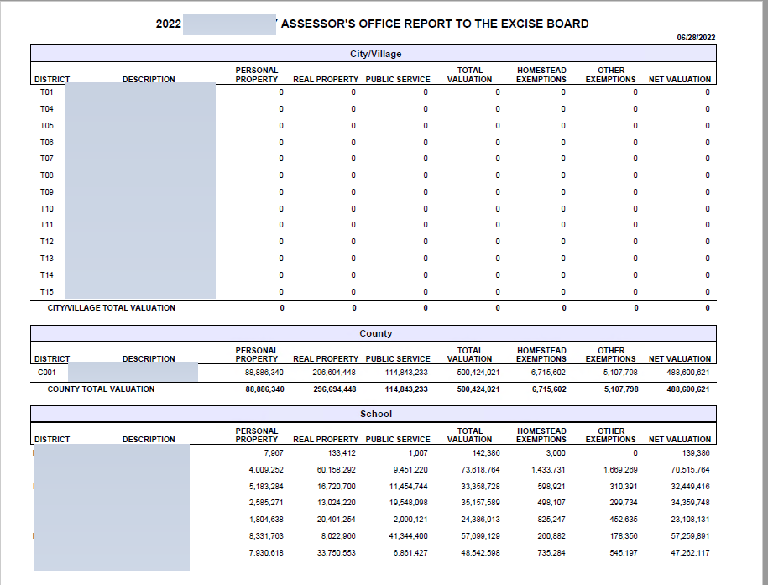

Details

