Contents

Weekly Changes June 21, 2022 1

Assessment 1

Appraisal/Edit Log 2

Appeals 2

Reports 2

Review Sheet 2

Abstract 4

998 4

Reports to Screen 4

Datasets 5

# Weekly Changes June 21, 2022

## Assessment

* June 21st There is an option to mark a photo as private. These will not export on the export image process. There will be modifications in the future where these will not display on the website. The additional column will be in the attached photos table in the parcel, residential, commercial, and personal property files.

* June 21st On the attached documents there is now an expire year. These records will be deleted during the process pending account process. This column will be in the attached documents table in the parcel, residential, commercial, and personal property files.

## Appraisal/Edit Log

* June 21st When doing a recalculation of the file the edit logs will be grouped into a run id where indexing can be done on those records.

## Appeals

* An explanation field has been added that will print on the 975 report.

## Reports

### Review Sheet

* June 21st This effects fractional owner accounts only. There is a parameter where the entire appraised value will print on the first page instead of the value still attributed to the card to the primary owner.

Appraisal

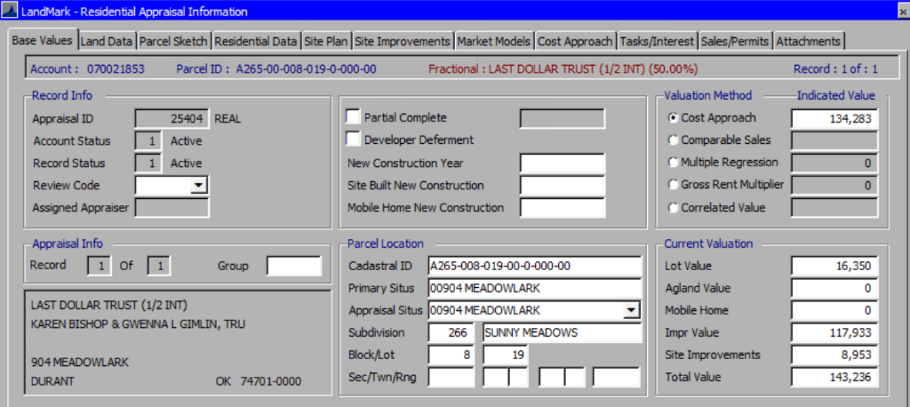

Current

New Parameter on report – Default is false if there is no parameter set up

New Report

* June 21st There is a new parameter (PRINTAPPRDATE) that will allow the appr date to not print. By default this is set to TRUE.

### Abstract

* June 21st When running the abstract if there are no errors a message box will appear where currently there is no message.

### 998

* On the 998 there is a prompt for the year to use on the report.

## Reports to Screen

* The editable forms will print to a new PDF viewer which will allow the customer to sign the form and then have it sent to the attached documents. This is currently available for renditions as well. There are devices that can be set up to take the signature of the taxpayer and place on the form prior to attaching. Please contact Aaron for additional information on implementing these.

Editable forms will be sent to the new pdf viewer.

The attach option will sent the report to the attached documents.



In the case of renditions there is the option to allow a signature on reports. If set then when printed to the screen you will get the new pdf viewer.

## Datasets

* June 21st When creating a data set there is an option to also copy the GIS data and tie to the dataset. This is available for any county that uses the database option of the GIS.

