Contents
Weekly Changes January 18, 2022 1
Reports 1
Renditions 1
MH935 Rendition 1
Clerical Error and Value-Change Correction Report 2
Assessment 2
Indexing 2
User Profile 3
Sales 3
Tractors 3

Weekly Changes January 18, 2022

Reports

Renditions
- Jan 17th All renditions being printed from the menu option will print the xml. This means you will not have to go to the Report Manager Reports to print renditions quicker. With this the report parameters will be based on those that are set up for the xml version vs the regular version. Report Manager Reports - Assessment File - 1 (manula.com)

MH935 Rendition
- Jan 17th If an account had multiple appraisal records with a mobile home on them only one 935MH form would print. With the change there will be a form for each mobile home. The report has the option of printing the assessed or appraisal value. In the case of using the assessed value each form will have the same value. This is where the parameter VALUETOUSE is set to True. (which is the default if there is nothing in the parameters)
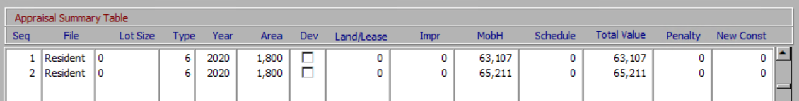
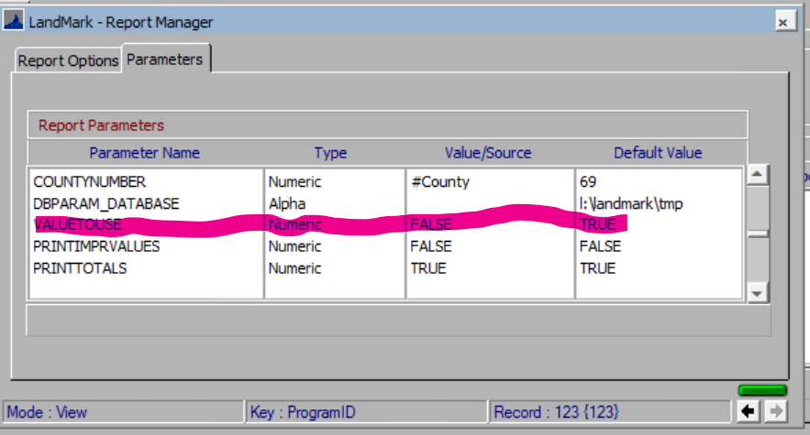

Clerical Error and Value-Change Correction Report
- Jan 17th If the status of the property changed or the tax area changed the as entered would be representing the same as the changed status vs what it was before the correction.
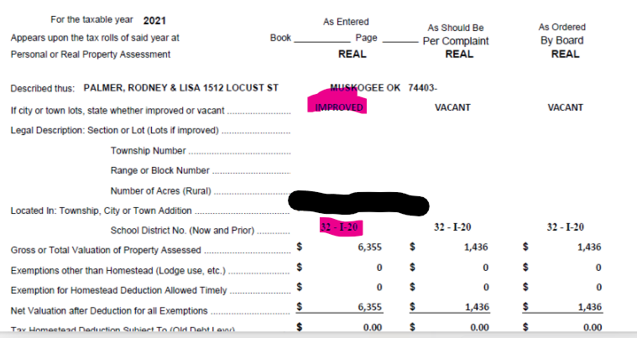

Assessment
- Jan. 12th The exemptions will be order by active exemptions followed by the exemption codes descending. Before they were in the order entered where active records may be at the end of the file.
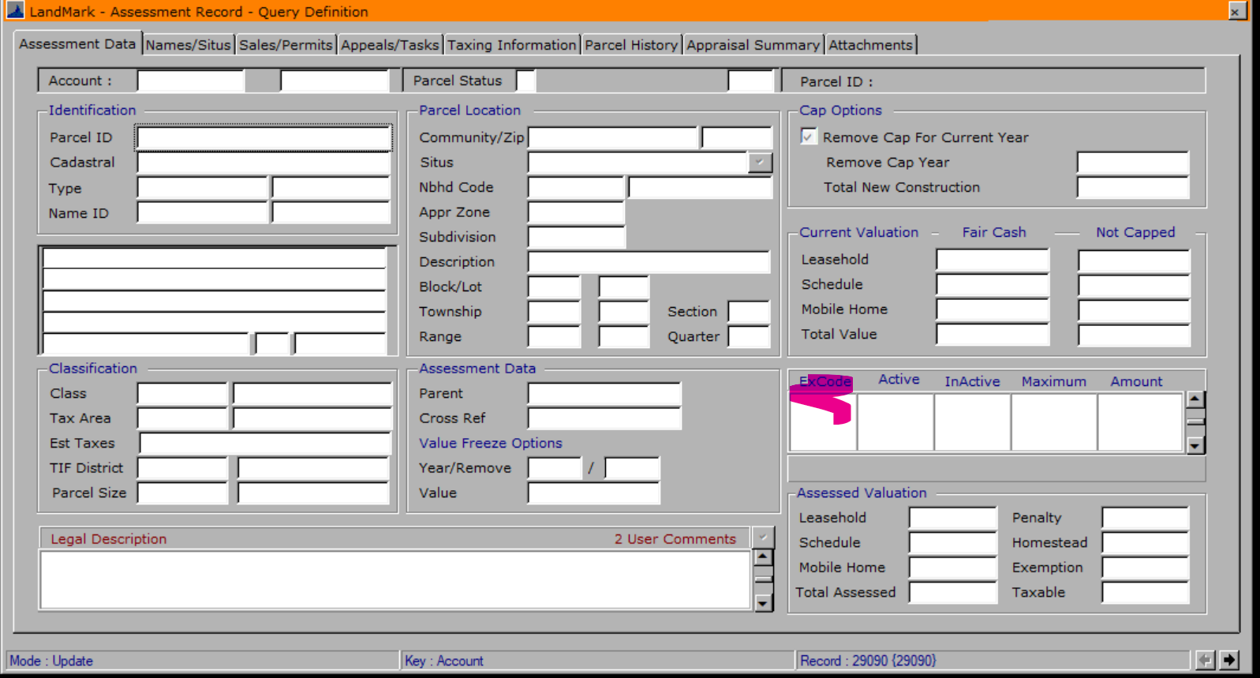
- Jan. 17th If the user is in a group that does not have edit rights to the assessment form and the name is redacted the name on the first tab will not be visible. Other tabs and forms are being worked on.

Indexing
- Jan. 12th The exemptions will be order by active exemptions followed by the exemption codes descending. Before they were in the order entered where active records may be at the end of the file.
- Jan. 12th The creating of indexes was requiring the user to create an index and then save vs creating this at the same time.
- Jan. 12th If the user would run a query and then sort the user would go to physical order.
- Jan. 12th If the user would sort the file after a temporary index an index would save, however it could not be reopened.
- Jan. 12th If the user would give a sort of file a long name an error message would appear. This has been corrected.

User Profile
- Jan. 12th The update web profiles were not working for certain users. This has been corrected.

Sales
- Jan. 12th The sales options that are selected when entering a sale will be stored in the sales files. This started being done for sale entered after January 1st.
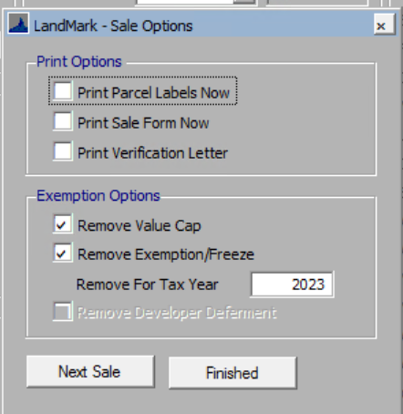
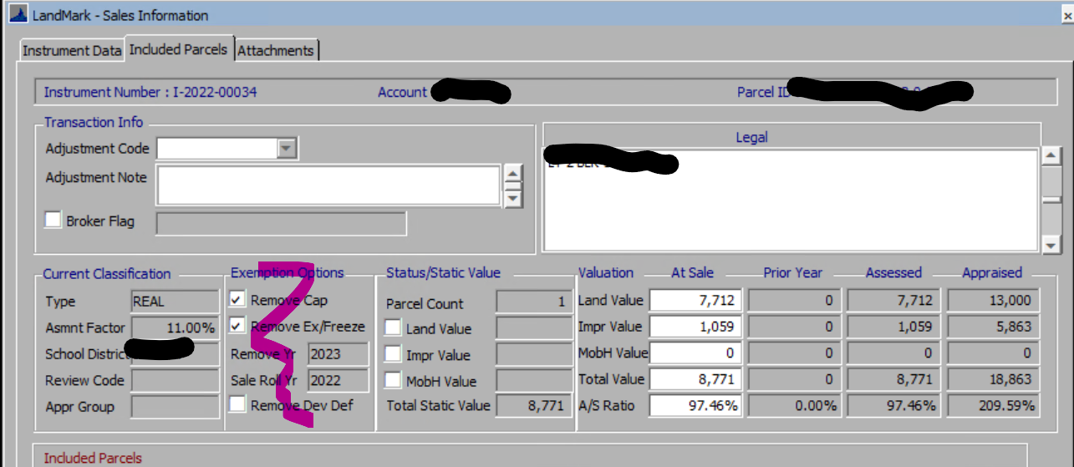

Tractors
- Jan. 12th If you are wondering whether you are trending and what depreciation table is being used for tractors you can see this in the item type table and recovery. The item type will tell you whether the item is being trended and what recovery table is being used. The recovery table gives you the details of the depreciation schedule. For tractor item codes 45 and 1525 are used. In either case there is the option of overriding the default on any given schedule item and using a specific life and to trend/not trend the item.
