Contents
Weekly Changes December 27, 2021 1
General 1
Reports 1
901P and 901PXML 1
Image Viewer 1

Weekly Changes December 27, 2021

General
- After doing a query and then sorting the file would go back to physical order. This has been corrected.

Reports

901P and 901PXML
- There is a new parameter INCSCCHEDULE. The default of this is TRUE. If set to false the schedule items won’t print.
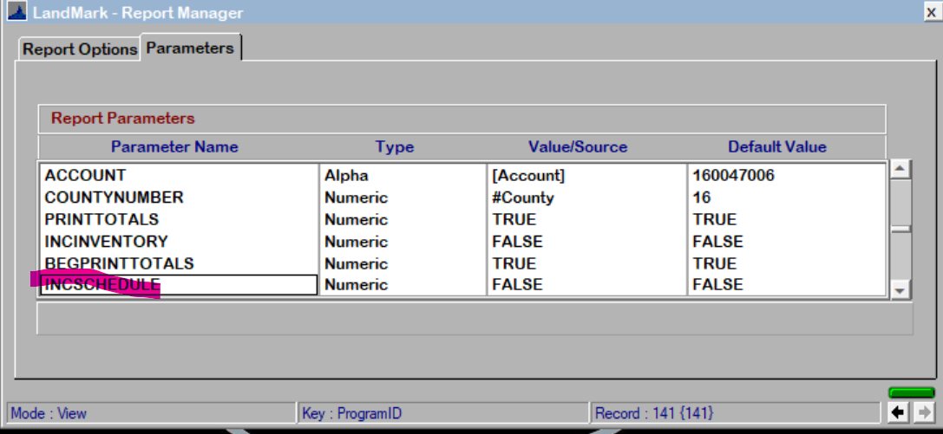
Schedule Items
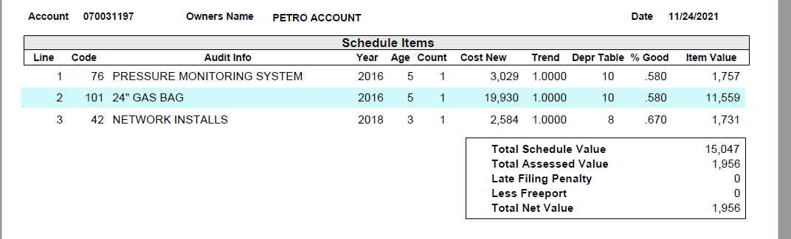

Image Viewer
- Attributes spelling has been corrected.
