Contents
Weekly Changes December 20, 2021 1
Setting Values 1
Reports 1
924B and 924B-XML 1
Review Sheets 2
Personal Property Information 2

Weekly Changes December 20, 2021

Setting Values
- The process of setting certified values has been removed from the abstract to the excise report. We recommend setting these values in August when the excise board report is run.
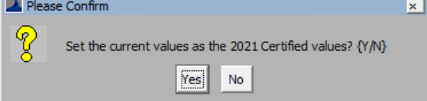

Assessment
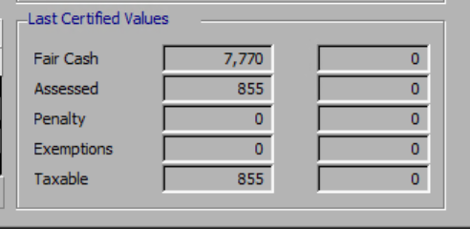
County Information Table
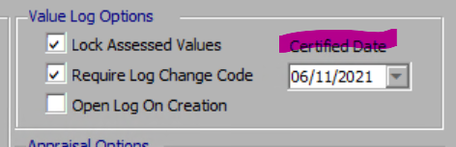

Reports

924B and 924B-XML
- Dec 20th There are two new parameters. DOCKDETAILS will determine if the dock information will print. The USEASSESSMENTVALUE determines if the assessment value (true) or appraisal value (false) is used. Making no changes to the parameters will keep the report as it is.
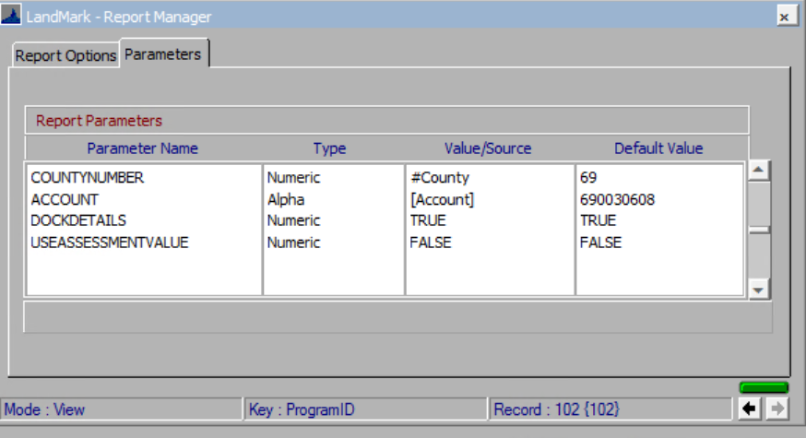

Review Sheets
- Dec 20th The OTC reference has been added at the top of the report.


Personal Property Information
- There are situations where the value of the schedule may end up more than the original cost. The example below is a 25,000 item that is six years into depreciation/trending.

Depreciation year is 2016 and year acquired

