Contents
Weekly Changes April 2, 2022 1
Assessment 1
Appraisal 3
Residential Appraisal 4
Commercial Appraisal 5
Personal Property 5
Query 5
Reports 5
935MH 5
926 (COV) 6
Commercial Report 6
Neighborhood List 6
924 7
Schedule Listing 7
936 7
Review Sheet 7
Property Record Card 7
Residential Report 8

Weekly Changes April 2, 2022

Assessment
- Apr 3rd When running the excise board report once values are set you will not be asked to set them again. This is to prevent setting them after you wanted them set.
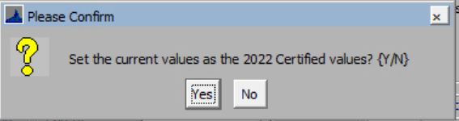
  - This is based on the “Lock Assessed Values” option in the county information table.
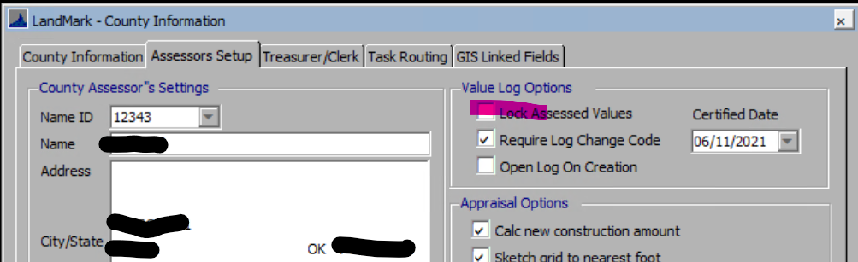
- Apr 3rd When doing a correction on a personal property if there was penalty the billed total tax did not include the penalty. This has been adjusted.
- Apr 3rd The annual inspection report title spelling of “Inspection” has been fixed.
- Apr 3rd When doing a split if there is new construction on the account and all the improvement value is moved to the child account the parent won’t have any new construction on the valuation summary tab.
- Mar 7th When doing a split, the site plan would not be removed if an account had all items moved to the child parcel. This has been addressed.
- Mar 15th The Annual Inspection Count report has changed. The user will be asked for a VI code. You can enter 2..3 if you want VI areas 2 and 3 on the report.
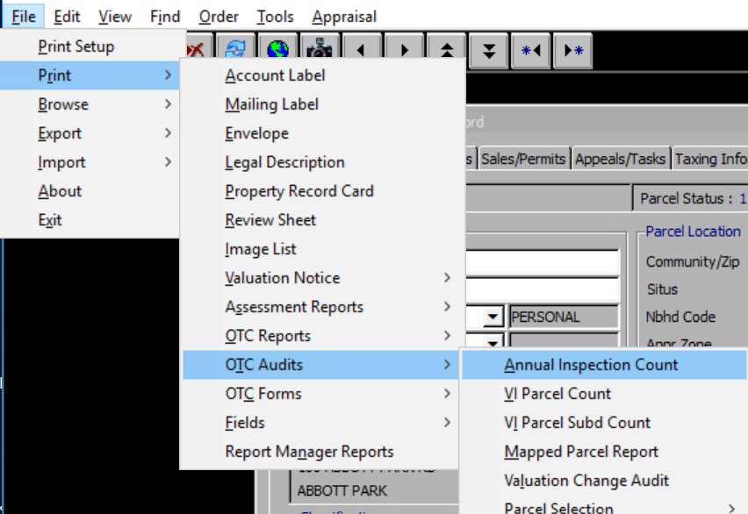

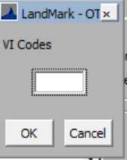

The inspection count will be from January 1st of the appr year to Feb 1 of the next year. The entrance county will be January 1st of the appr year to March 1 of the next year.
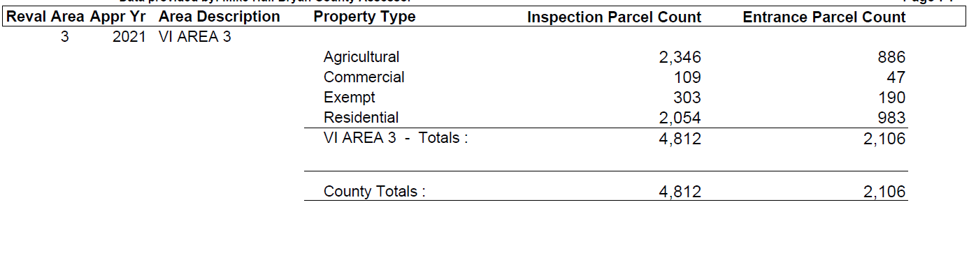
The appr year is the inspection year set in the appraisal zone table.
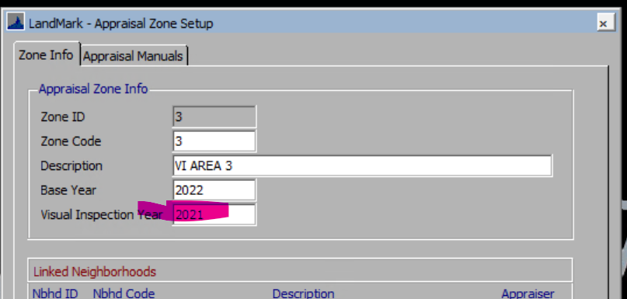
- Mar 15thCommercial split that had buildings on multiple cards were having issues where the buildings were not getting to the new parcel. In addition all site improvements would go to one account. These has been addressed.

Appraisal
- Apr 3rd In the Jan 24th release a fix to the garage cost was done (Same time the exterior wall for mobile home was done). Before the local factor was being applied twice for the garages. The first three digits of the base zip code from the county information table is used to determine the rate. In this case it is 11%. In this case an addition 11% was taken away from any garage on the account. When recalculating this will be adjusted back. In all cases except for zip codes starting with 738 this will increase costs of garages slightly. In 738 these will actually decrease the garage cost.

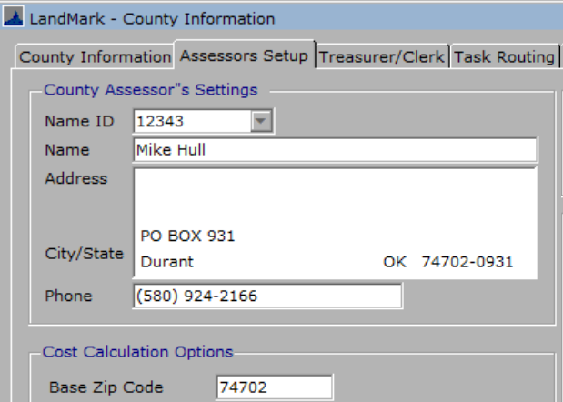
Page 8 of the 2022 NBC manual
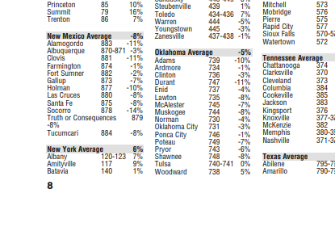
Values from database. This is what is being used.
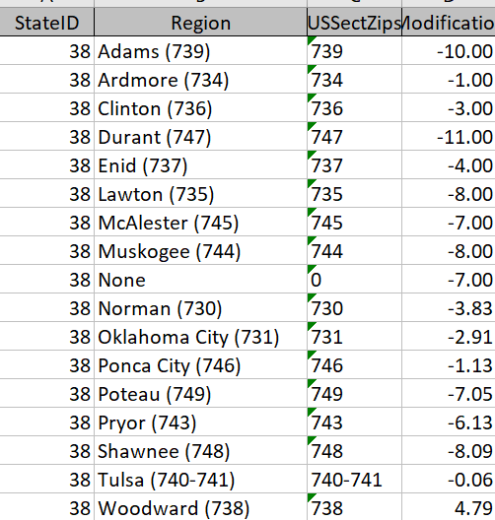

Residential Appraisal
- Mar 7th When moving a site improvement from residential to commercial the sketch would not move the sketch. This has been addressed.
- Mar 7th Cannot move a misc. improvement from a residential card to commercial card. This is because the miscellaneous improvements in commercial are tied to the buildings.
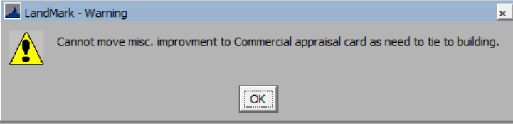
- Mar 7th When adding a residential building and there is already a site plan there is a need to display the site plan and the place the homesite in the site plan. If this is not done the homesite will not be on the site plan. There is a report to find these. In the residential file select Tools – Listings-Sketch Not On Site Plan.
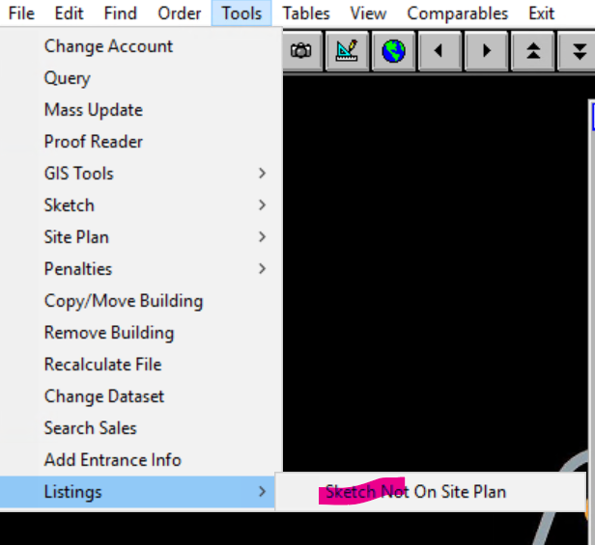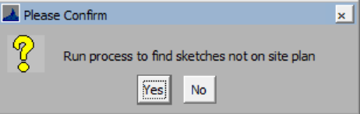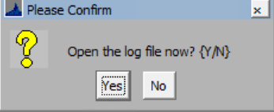

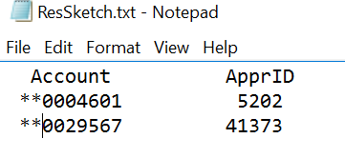
- Mar 7th If a value >1 is entered in the percent of style the user will be informed of this and the percent will change to 100%. If multiple styles are in place the second style will be removed. If the percentage of the style is changed the second style percent will automatically change instead of having to tab through the second style.
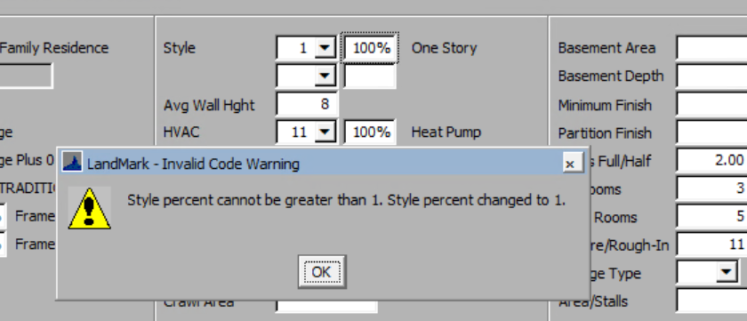
- Mar 7th If a value >1 is entered in the percent of the hvac the user will be informed of this, and the percent will change to 100%. If multiple styles are in place the second style will be removed. If the percentage of the hvac is changed the second hvac percent will automatically change instead of having to tab through the second hvac. This also occurs when editing the residential properties on the sketch.
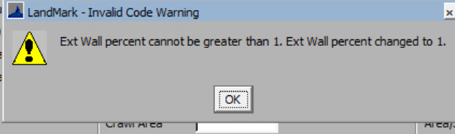

Commercial Appraisal
- Mar 7th On the right click options on the miscellaneous improvements took the option of Move Misc. Improvement off list. This was not doing anything.

Personal Property
- Apr 3rd On the TASC import and import of the rendition if there was a deleted appraisal record the import would import to the deleted record causing issues. This has been adjusted to import to the active appraisal record.
- Apr 3rd If the TASC import file had some or the incorrect account on the spreadsheet and a diferent account was selected then the row would not import or import to the incorrect account.
- Apr 3rd If the TASC import had the same school district on two different accounts there would be an issue importing the file. This has been corrected.

Query
- Apr 3rd Similar to the importing of the query the mass update with quotes would be removed. This has been corrected.
- Mar 15th When importing in a query from the packages the quotes (“) would be removed. This would cause the query not to function at times. This has been corrected.

Reports

935MH
- Apr 3rd The work exemption was misspelled on the form.

926 (COV)
- Apr 3rd There is a parameter to not include the previous year fair cash value on the change of value notice (926). By default this will print.
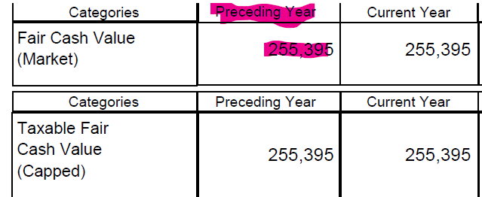
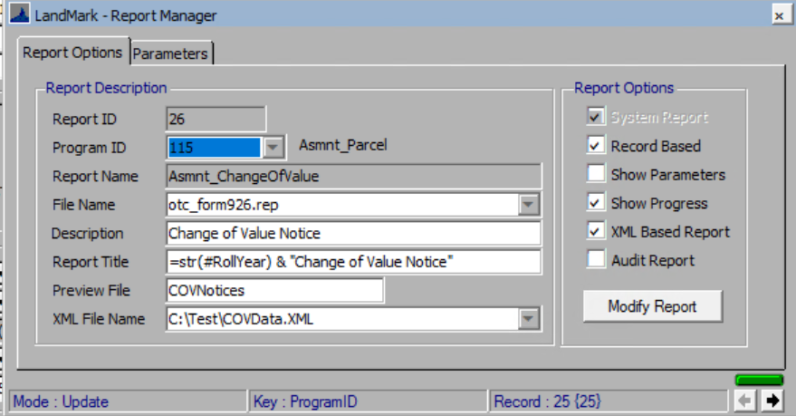
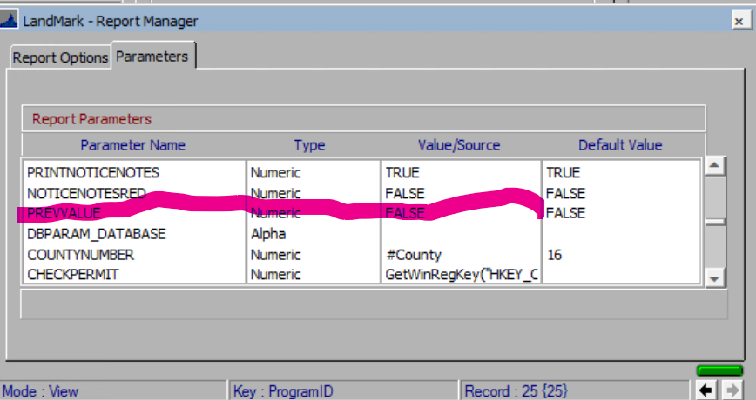

Commercial Report
- Apr 3rd The construction class would print the old property class that is deprecated. This has been adjusted to be the structure class and description.
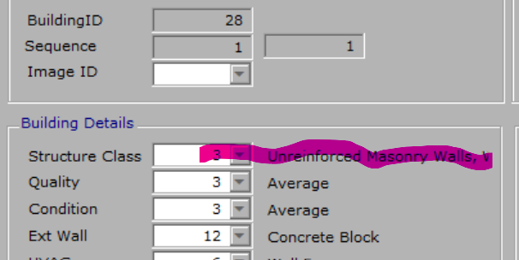
- Apr 3rd The building images will print on the report.

Neighborhood List
- Apr 3rd The parcel count will print for each neighborhood. This is the menu option File – Print – Nbhd List from the neighborhood table.
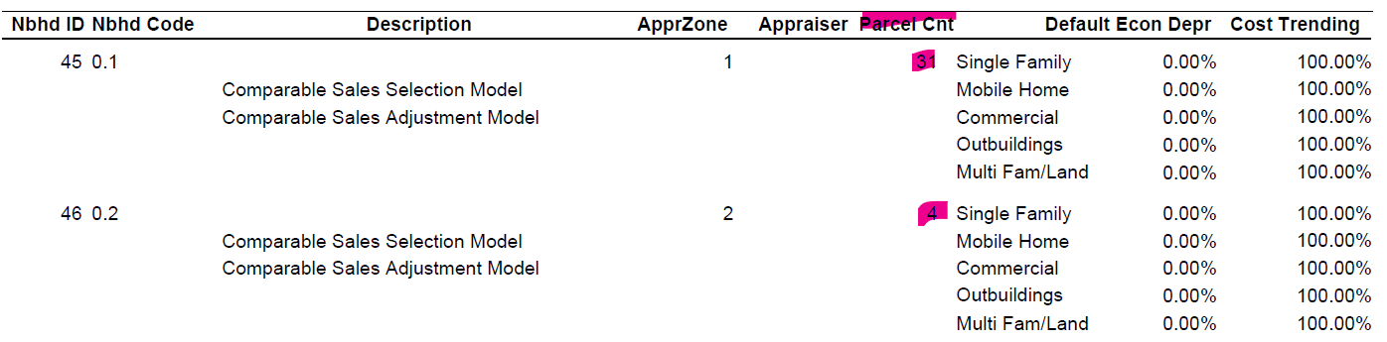

924
- Apr 3rd Only the first 12 tractors would print on the 924. This has been adjusted.

Schedule Listing
- Mar 15th On the schedule listing (File- Print – Schedule Info) from the personal property file. If the parameter is set to print the signature line the information on where to send the form back will be included.
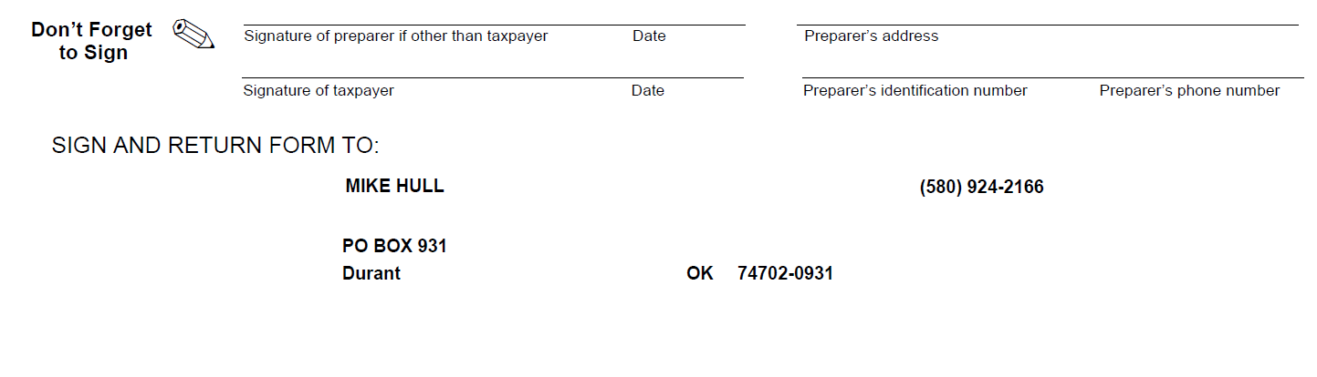

936
- Mar 15th If transferring from real to mobile home the account number would not print on the form.

Review Sheet
- Apr 3rd If there are multiple cards (appraisal records) and a log of agland records or miscellaneous improvments they may have printed over a picture. This was reviewed and corrected.
- Apr 3rd In the case of including the cross reference account it was looking for the cross reference on the account was being printed. This would not include account where the record being printed was cross reference. (i.e Land record being printed which is then cross referenced to one or more mobile home accounts) Both situations will printed if configured to print these.
  - County Information table (Assessor tab) Also must have parameter of RSFILTER in report setup.
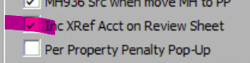
- Mar 7th On residential accounts the lot model description at times would not reflect what was on the account.

Property Record Card
- Apr 3rd The quality description for commercial properties did not include the description just the code. The construction class would print the old property class that is deprecated. This has been adjusted to be the structure class and description.
- Apr 3rd On the property record card the site plan(s) for commercial properties were not printing. This has been adjusted.
- Mar 7th On residential accounts the lot model description at times would not reflect what was on the account.

Residential Report
- Mar 7th On residential accounts the lot model description at times would not reflect what was on the account.

