Contents
Required On Sketch 1
Required on sketch 1
Miscellaneous Improvements 1
Outbuildings and Commercial Cards 2
Query package to find required miscellaneous codes and outbuilding not sketched 4
Commercial Building and Miscellaneous Improvements 4

Required On Sketch
There has been some discussion on miscellaneous improvements and outbuilding disappearing when working with the sketch and site plan.

Required on sketch
Each miscellaneous code is coded as required on sketch or not. These are the codes used in the miscellaneous improvements and outbuildings.
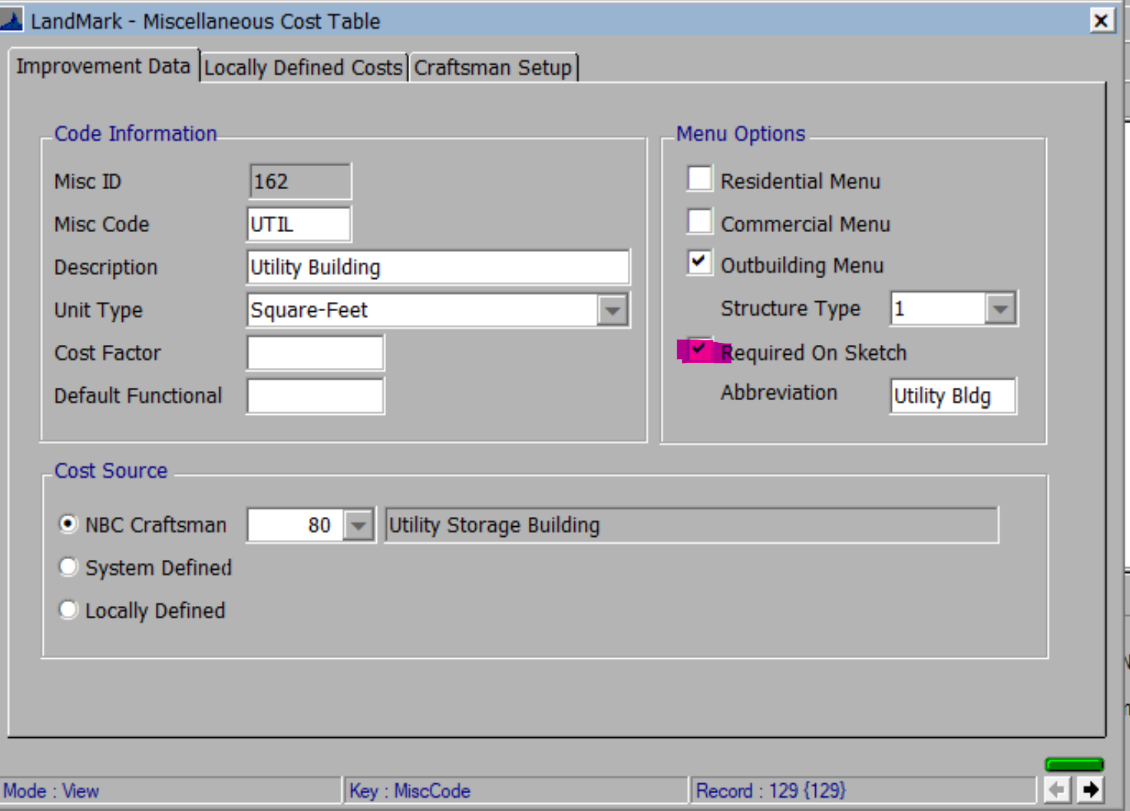

Miscellaneous Improvements
- In the case of residential cards. If the code is required on sketch then the item needs to be drawn on the sketch. In the case of commercial cards these must be drawn on the site plan.
- In the case of residential cards if entering a miscellaneous code and it is required you will be informed of this.
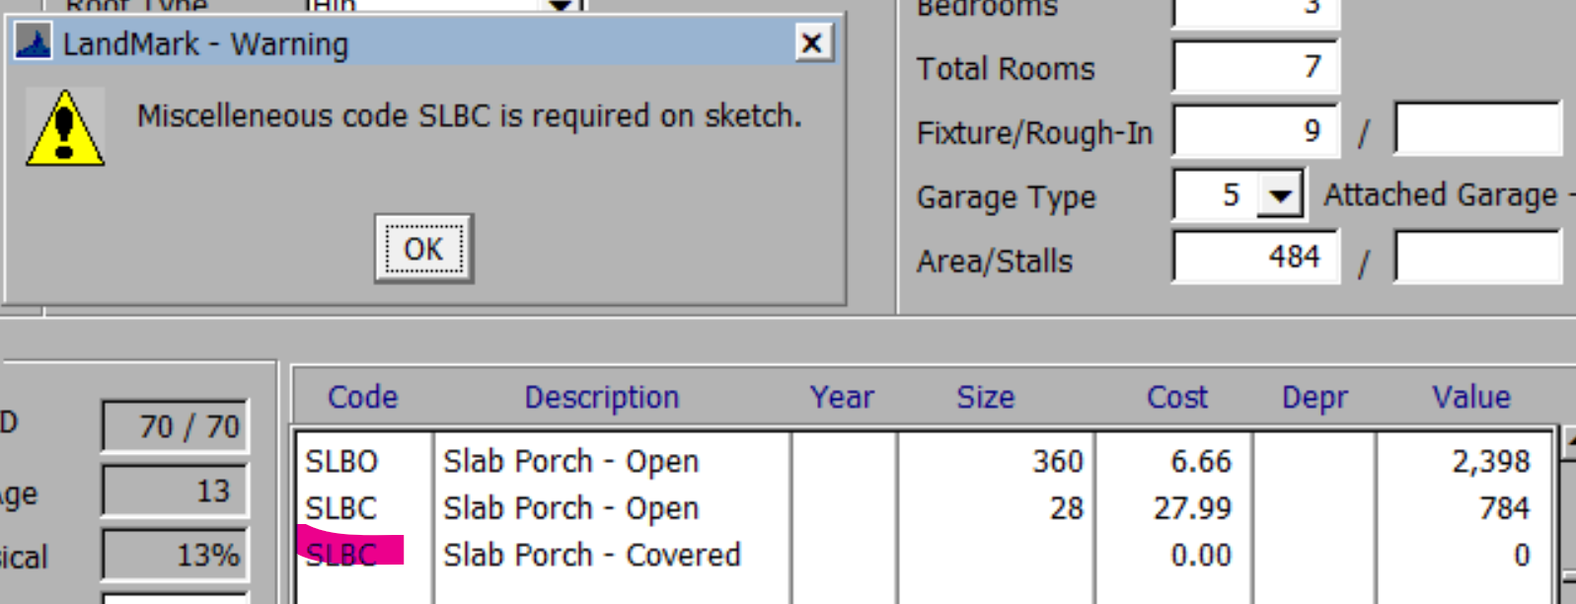
- In the case of the commercial building a similar message is presented.

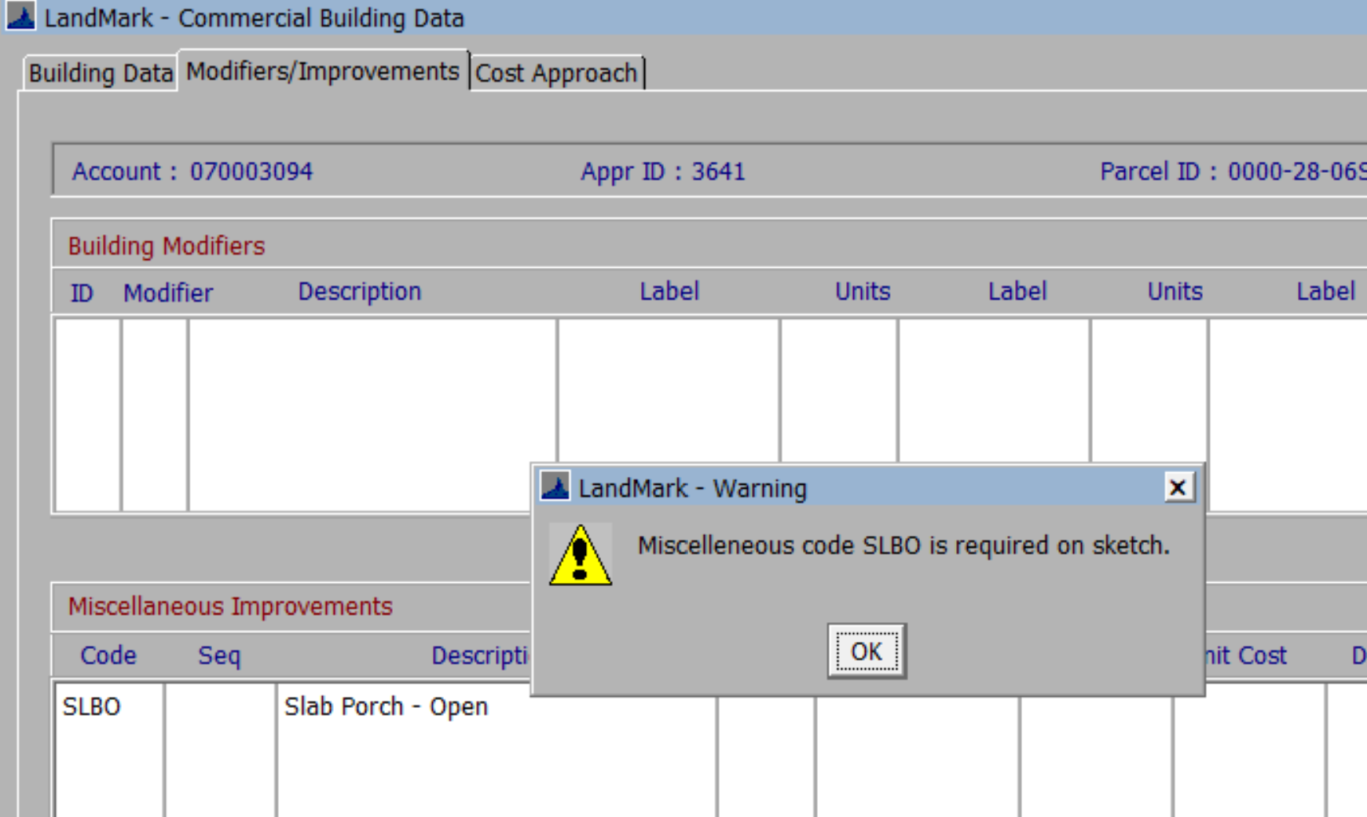
- In both cases if going to the sketch and saving in the case of residential and site plan for commercial and the miscellaneous improvement is required on sketch and not added it will be removed once saved.
- During conversion there were times where multiple porches, wood decks, etc where in two different tables or they were not drawn that may cause this issue.
- A query package is available to find these records.

Outbuildings and Commercial Cards
- If required on sketch and entered in the site improvements the item needs to be drawn if there is a site plan on the residential record and in case of commercial will always need to be drawn.
- During migration there may have been barns, utility buildings, etc that were in the legacy outbuilding table but were not drawn. There are quite a number of these.
- If editing only the residential sketch the outbuildings will not be removed if not drawn.
- If creating a site improvement, you will be informed that the item is required on the site plan.
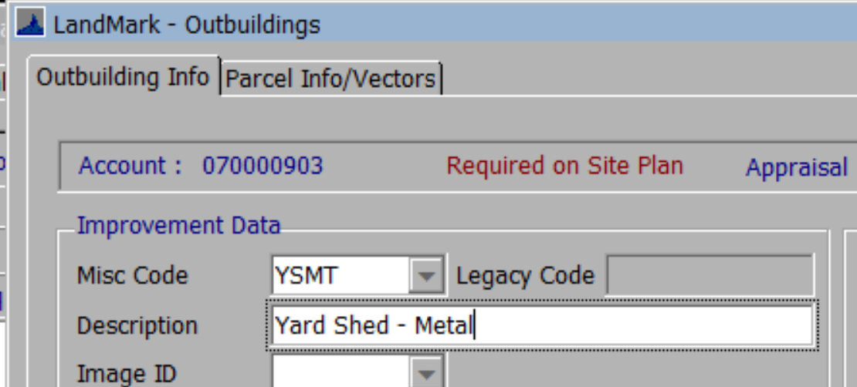
- When in the site plan and creating a new outbuilding, you can select the drop down on the sequence where you will see the outbuildings that are not on the site plan. Keep in mind some counties put some of the outbuildings on the sketch. These outbuildings would show up here. In this case, if you want them on site plan you can select the code and then after going to the sketch and remove the item from there. If you don’t remove it from the sketch the outbuilding will show up twice in the outbuilding list.
- It is recommended when creating a new site plan or working the VI for the first time to use the drop down to see what has not been sketched yet. If there is not a length and width a flat area can be used.
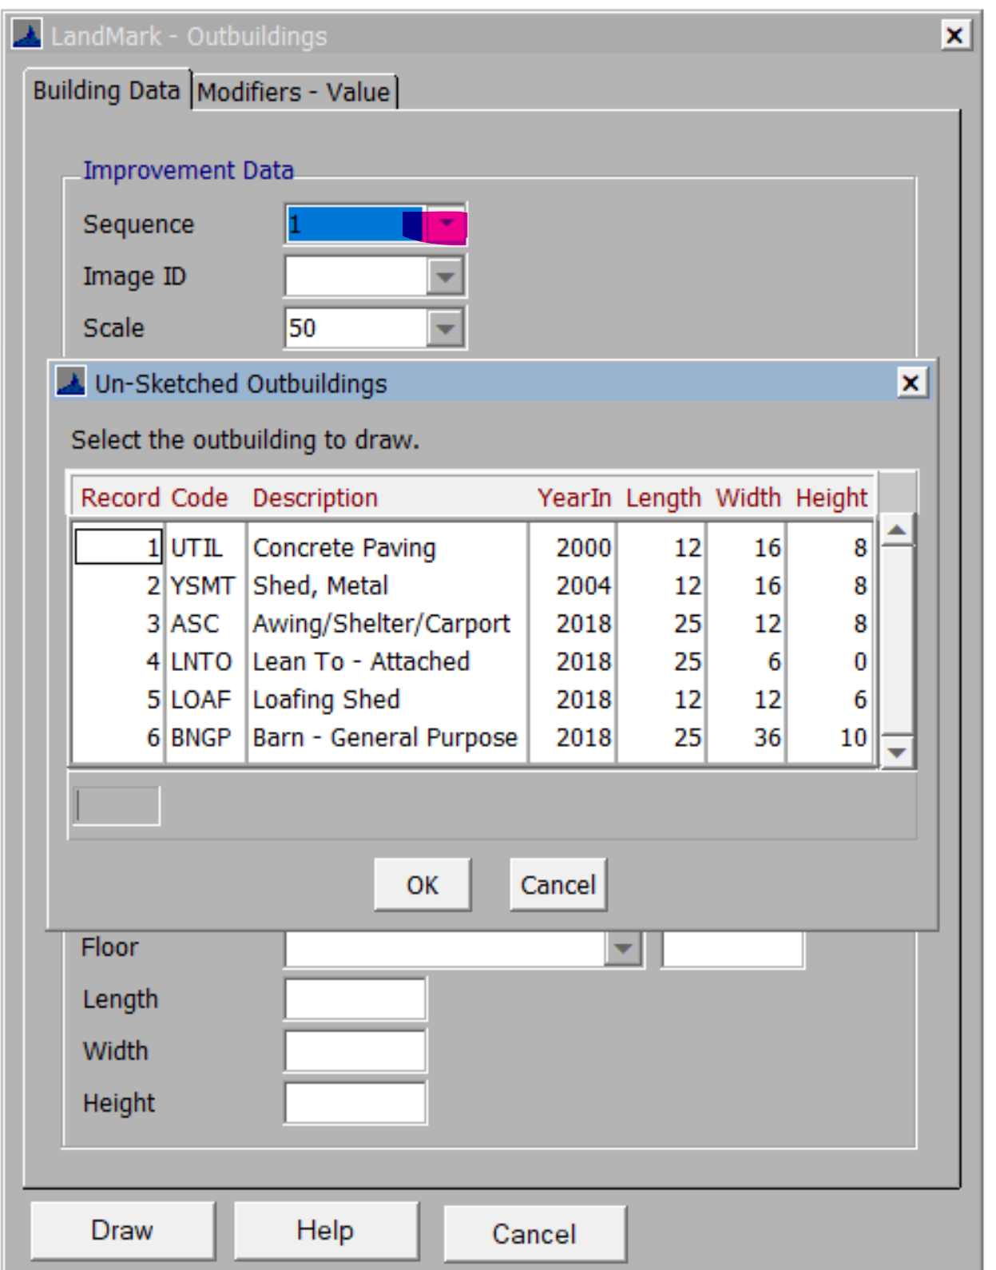
- A query package is available to find these records.

Query package to find required miscellaneous codes and outbuilding not sketched
- There is information about queries in the help file.
Query Packages - Videos, FAQs, and Software Updates - 1 (manula.com)
- These queries would be done in the miscellaneous improvement and site improvements linked tables. (Appraisal – Linked Tables – Misc Improvements and Appraisal – Linked Tables – Site Improvements)

ReqSketchMisc will need to be imported for the miscellaneous improvements and ReqSketchOut for Site Improvements.
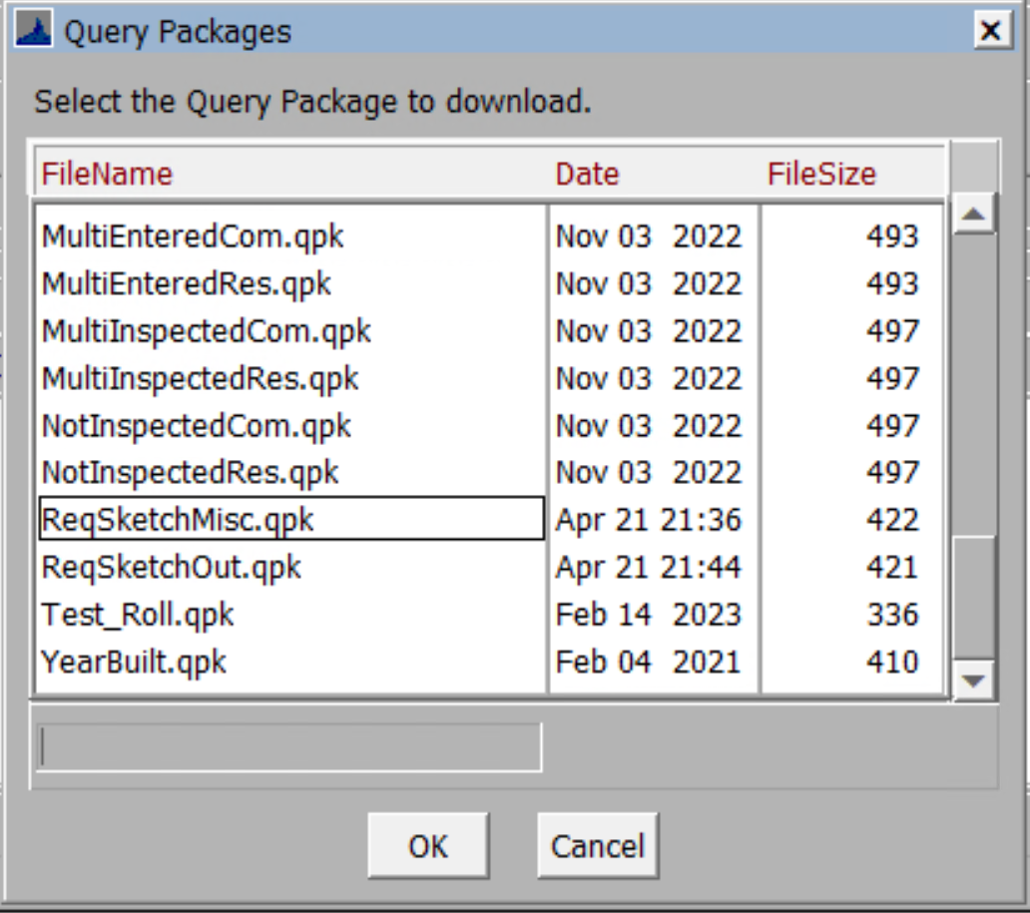

- After running these the records can be exported to Excel and then worked.

Commercial Building and Miscellaneous Improvements
- There are a couple ways to delete out buildings on commercial records. The method used will have a difference on what occurs with the miscellaneous improvements.
- If you right click and delete the building the buildings and miscellaneous improvement(s) will be deleted.
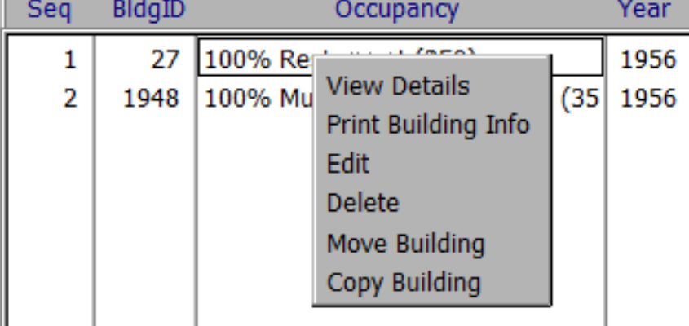
- If you delete from the site plan the miscellaneous improvements will not delete (unless they are removed from the site plan). If a new building is drawn the miscellaneous improvement can be linked to this building (or any other building on the site plan) through the site plan or right clicking on the improvement and changing the building id.

Starting record status

