
LandMark GSI
Packages
Delivered: 04/11/2022
Version History
Version # | Date | Revised By | Reason for change
1.00 | 4-11-2022 | Mark Piller | - Initial Version
1.01 | 5-18-2022 | Mark Piller | - Added Active MH query and MH Active Update
1.02 | 7-14-2022 | Mark Piller | - Added Sales Queries and Queries for multiple inspection and entered in res and com.
1.03 | 11-3-2022 | Mark Piller | - Periodic Update
1.04 | 8-31-2023 | Mark Piller | - Periodic Update

Contents
Purpose 4
General Information 5
Packages 5
Sales Adjustments 5
Remodel Codes 5
User Defined Exports 6
Assessment 7
COV Notices 7
GIS_Data 2 package 7
Mobile Home 7
Mortgage Account 8
OTC Annual Export 9
Sales 9
OSU Sales Data 9
WillSales 10
Residential Sales 10
GIS_Data package 10
MRA 10
Group Profile 11
User Defined Import 11
Assessment 12
Lot Model 12
Miscellaneous Cost 12
Proof Reader 13
Query 13
Assessment 14
50KFairCashandCapped 14
901PRendition 14
901Rendition 14
Abstract Totals 15
Active Real 15
Active Mobile Home 16
Decrease In Land Value 16
Decrease In Value 16
Error Check 16
FairCashCapChange 17
FractionalandLinkedOwnership 17
FractionalOwnership 17
HSTrusts 18
Linked Business Account 18
Linked Farm Account 18
Linked Individual Account 18
Linked Mobile Home 19
Linked Ownership 19
Linked Real 19
Low_Land_Value 19
Residential Appraisal 20
ErrorCheckAppraisalRes 20
MultiEntered 20
MultiInspected 20
NotInspectedRes 21
NotInspectedRes 21
YearBuilt 22
Commercial Appraisal 22
ErrorCheckAppraisalCom 22
MultiEntered 23
MultiInspected 23
NotInspectedCom 23
NotInspectedCom 24
Outbuilding 24
ReqSketchOut 24
Miscellaneous Improvements 25
ReqSketchMisc 25
Sale Instrument 25
AgResidual 25
User Defined Reports (Report Manager Reports) 26
Sales Selection 26
Default Selection Model 26
Mass Update 27
Assessment 27
Clear Advance Taxes 27
PPValue 28
Remove Review Code 28
Residential Appraisal 29
Cost to Correlated 29
Remove Land Adjustment 30
Update Fixture Count 30

Purpose
The purpose of this document is to explain the packages that are available. There are several modules where packages can be imported.
*.apk - Sales Adjustments Table
*.dpk – Remodel Code
*.epk – User defined exports
*.fpk – MRA
*.gpk – Group Profile
*.ipk – Imports
*.ipk – For Income Model that currently is not an option.
*.lpk – Lot model
*.mpk – Miscellaneous Cost
*.ppk – Proof Reader
*.qpk - Query
*.rpk - Reports
*.spk – Sales Selection
*.upk – Mass Update

General Information
As packages are moving targets and user can add to the packages available to keep the list of the packages available becomes a difficult proposition.
In the help file there is information on query packages.
Query Packages - Assessment File - 1 (manula.com)

Packages

Sales Adjustments
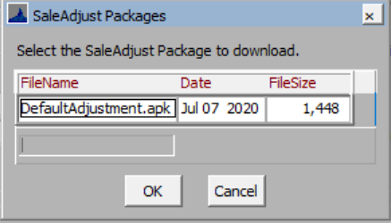
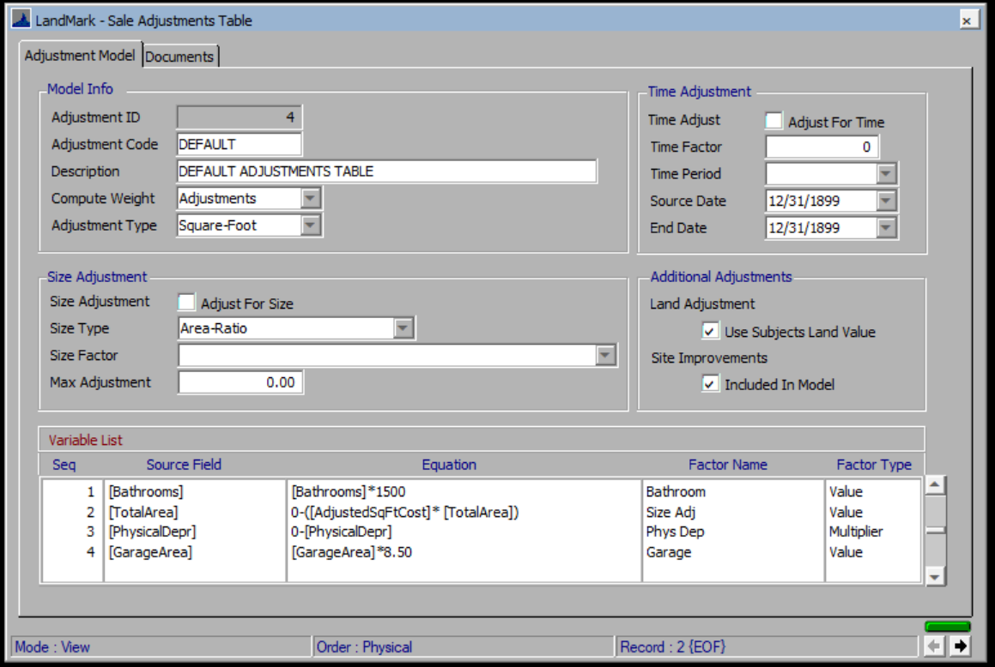

Remodel Codes
Currently there are no packages for remodel codes.
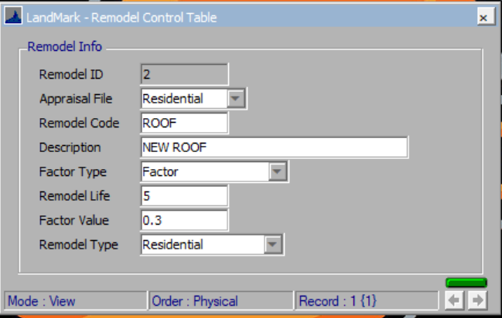

User Defined Exports
The user defined exports allow the user to export out information and then email, place on ftp site, etc. When importing a package special care should be done where the destination file would be. This is available in many of the forms. The location and query being used will come in based on the export and should be verified before using. The query that was exported may not be the one that will be used.
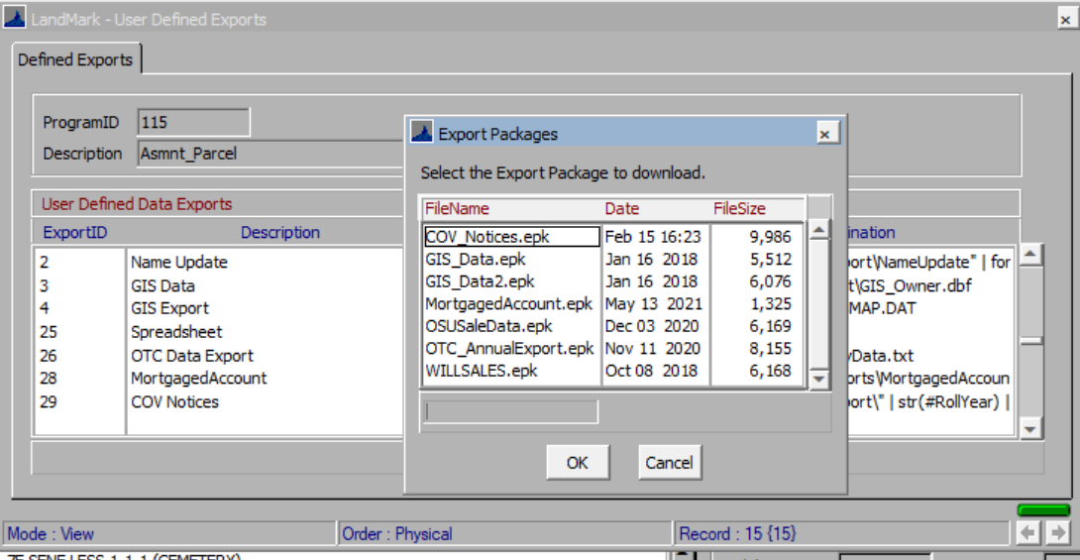

Assessment

COV Notices
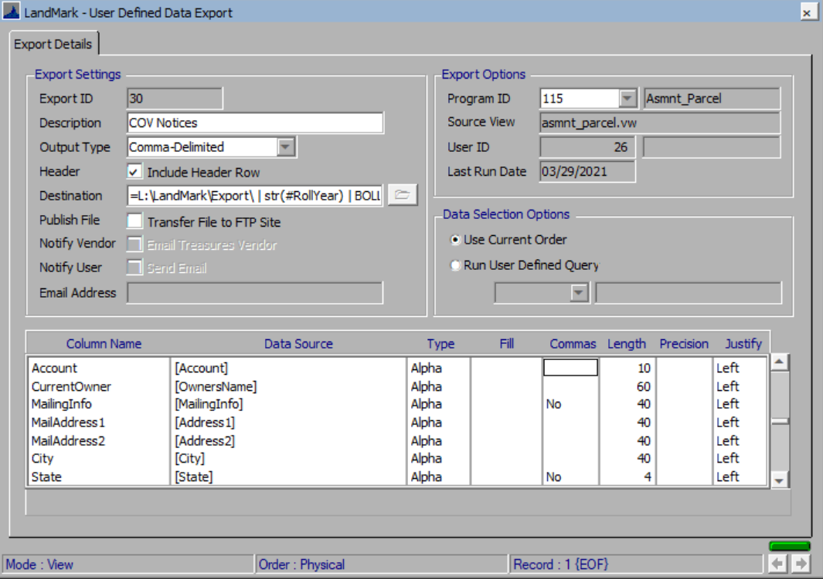

GIS_Data 2 package
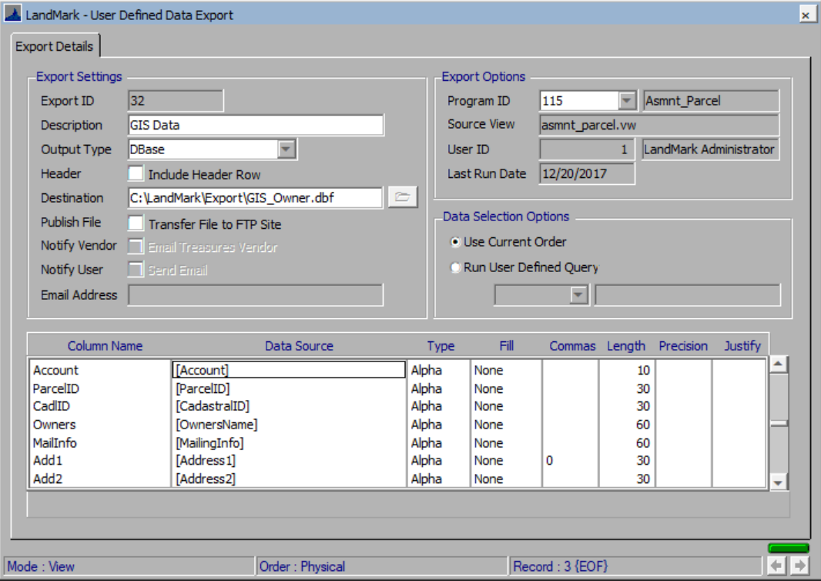

Mobile Home
This will export the active mobile homes accounts. The ActiveMobileHome query will need to be exported and then placed on this record after importing the user defined export. This will be sent to the treasurer’s vendor. This has the same layout as the name update.
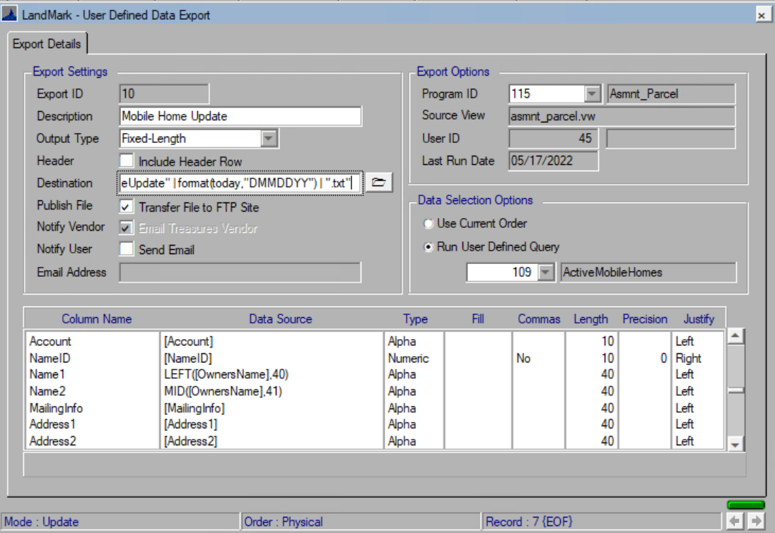
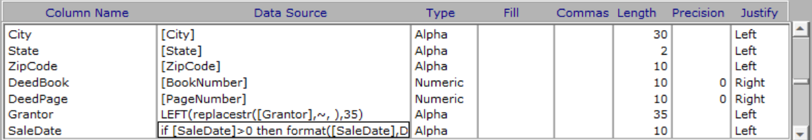

Mortgage Account
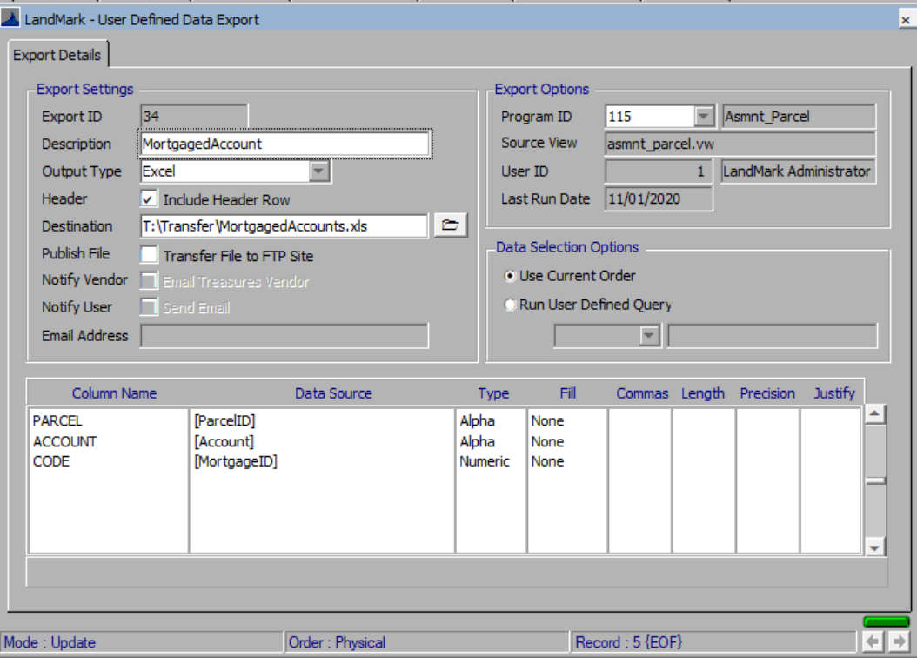

OTC Annual Export
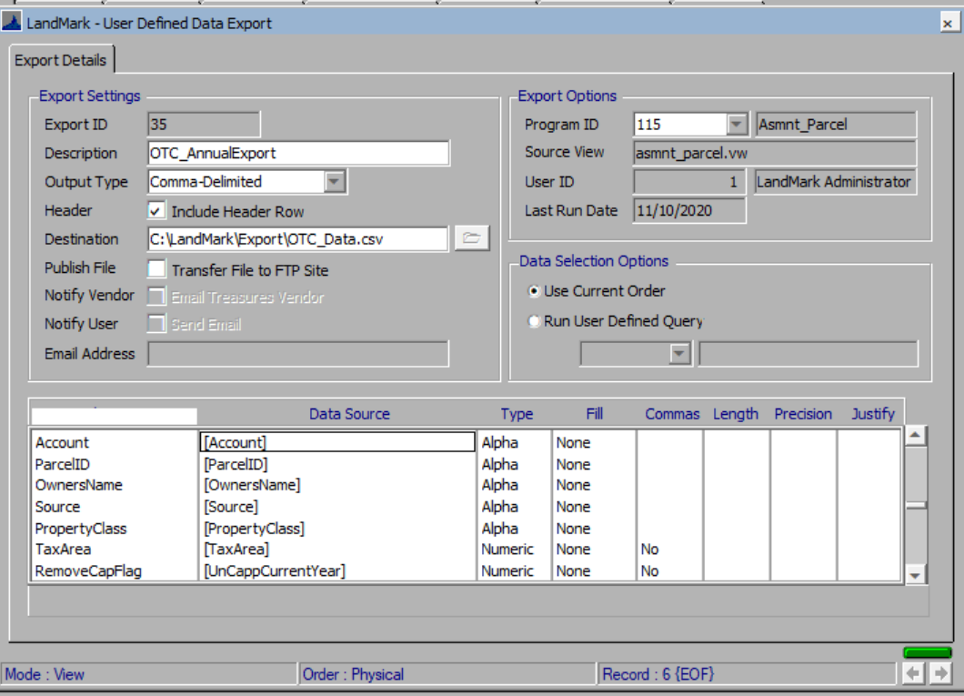

Sales

OSU Sales Data
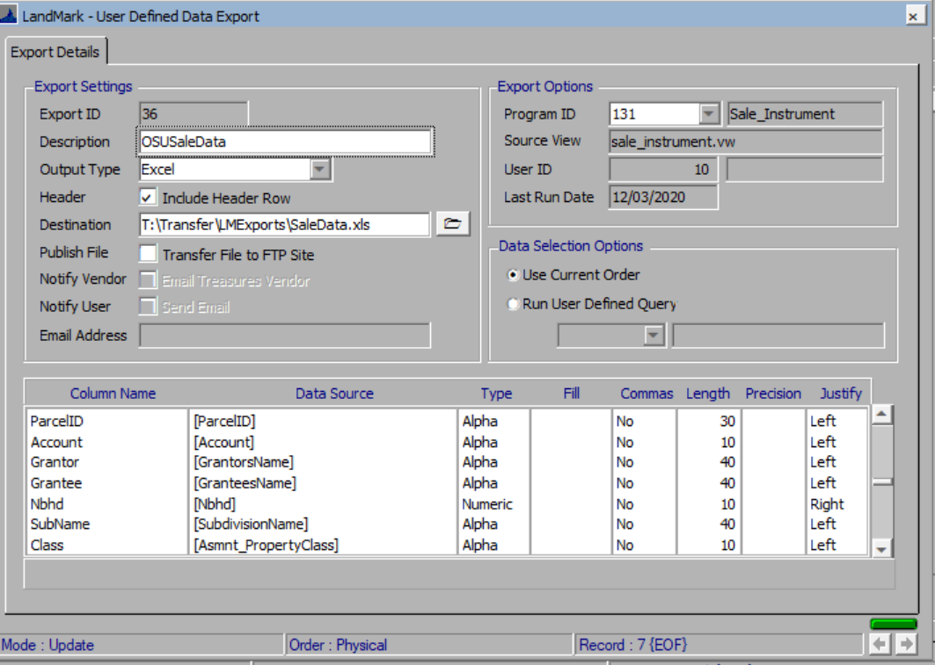

WillSales
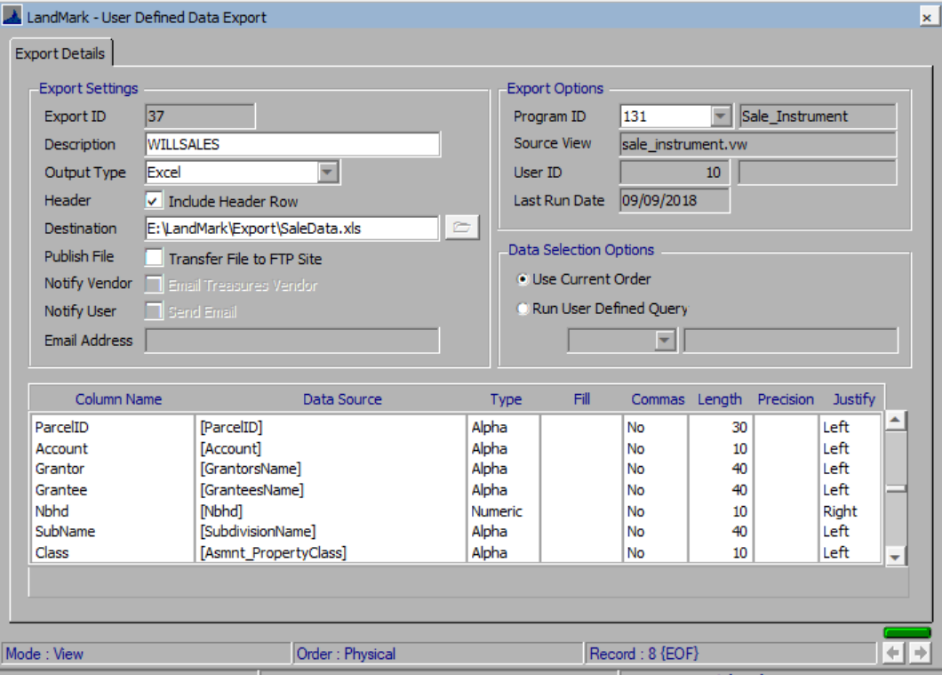

Residential Sales

GIS_Data package
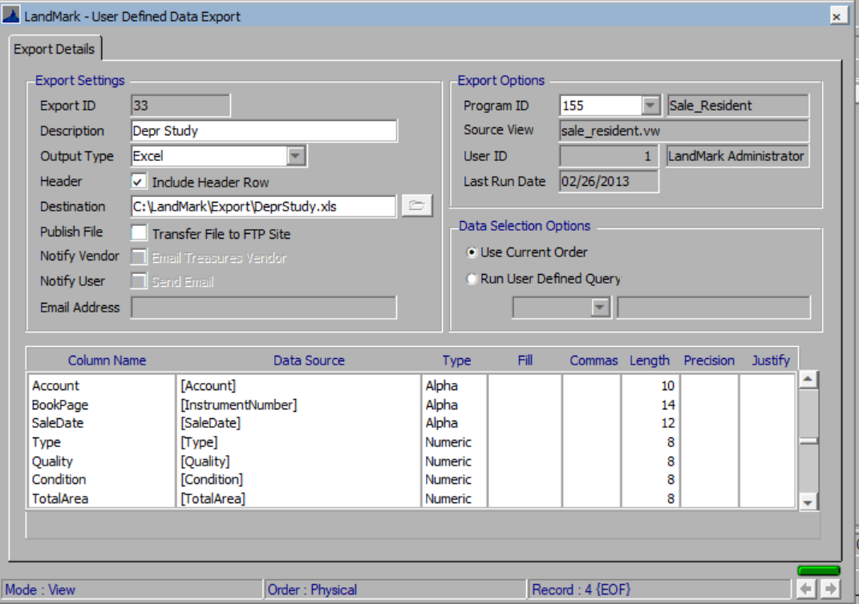

MRA
Currently there are no packages for MRA.
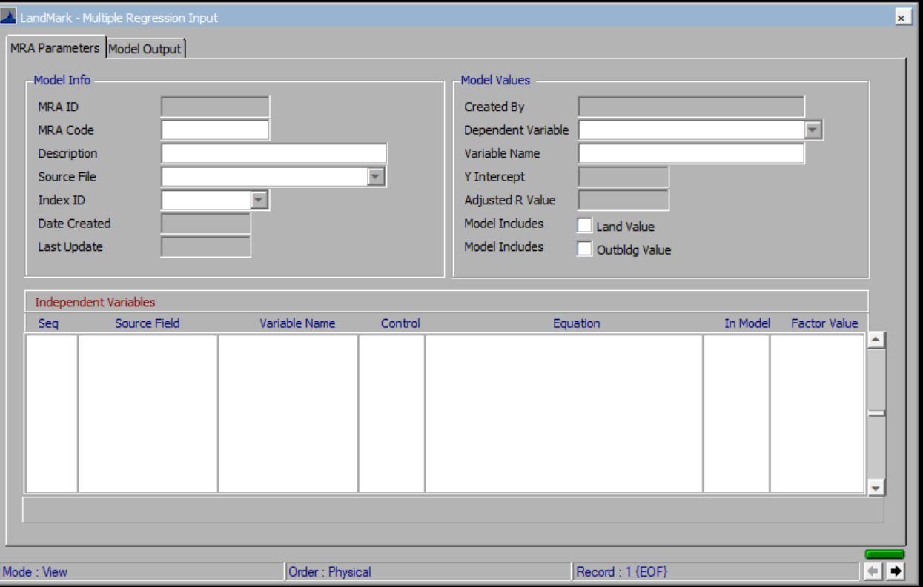

Group Profile
Currently there are no packages for group profiles.
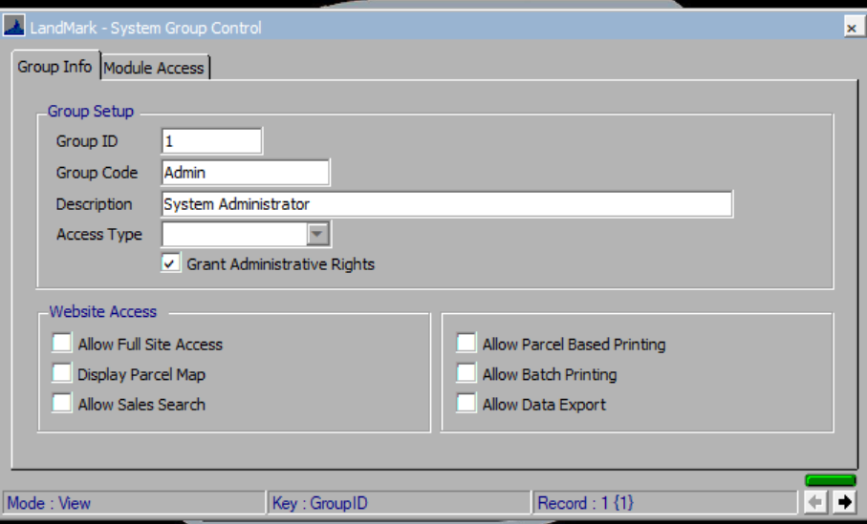

User Defined Import
The user defined imports allow for importing data. This is available in several of the forms. The location of the files and import action and links are important.
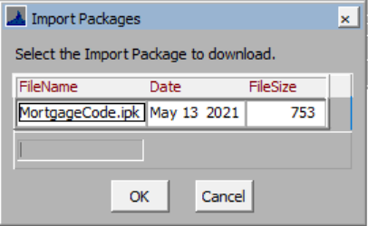

Assessment
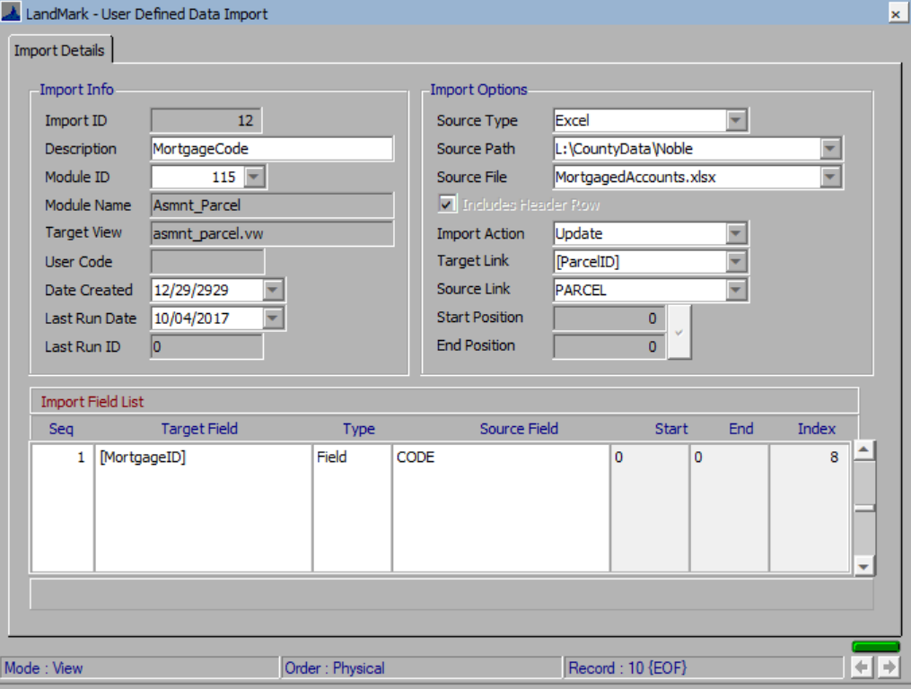

Lot Model
Currently there are no packages for lot models.
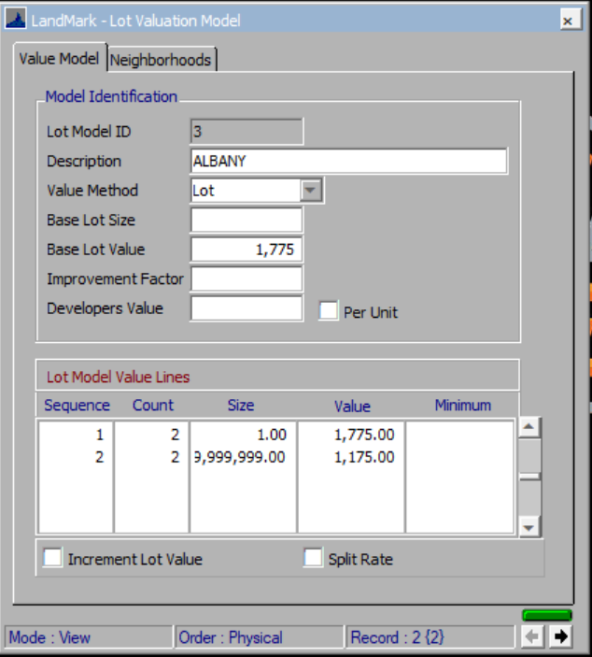

Miscellaneous Cost
Currently there are no packages for miscellaneous costs.
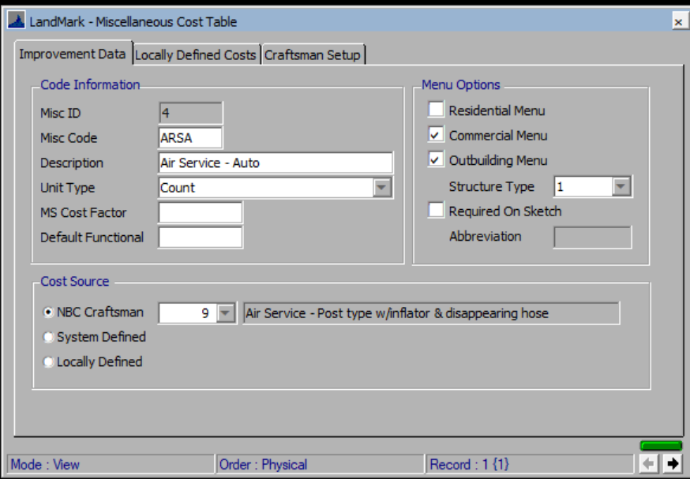

Proof Reader
Currently there are no packages for the proof reader. The proof reader option is available in many of the forms and can be turned on to read certain information on all accounts or give a verbal message based on the conditions of the record.
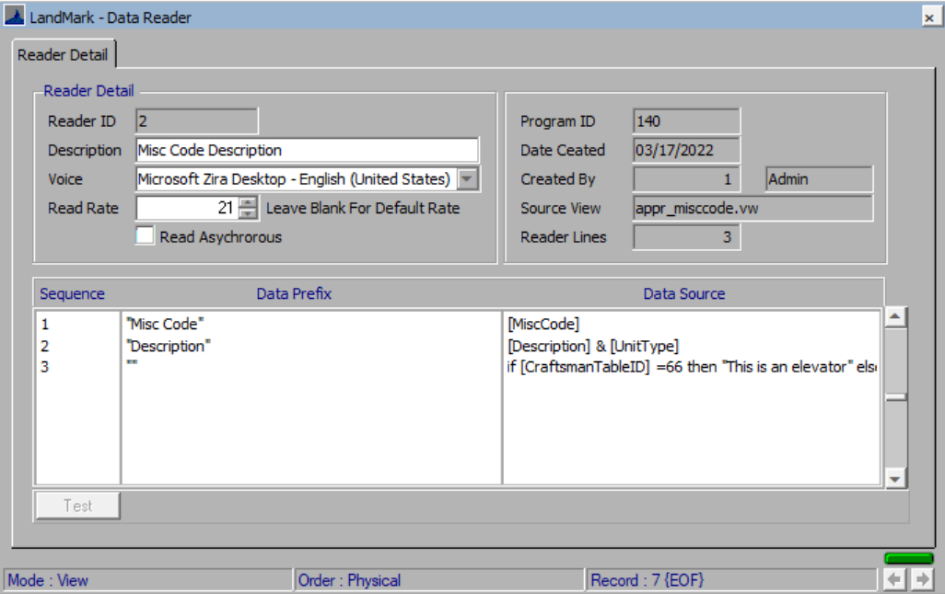

Query
These are for user defined indexes that can then be run on demand. This is available in many of the forms. The menu option is generally available at Tools – Query.
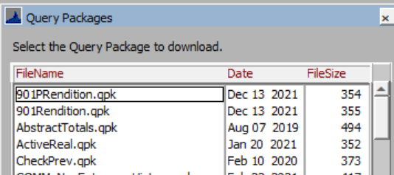

Assessment

50KFairCashandCapped
This finds any real property record where the fair cash or capped value will increase/decrease 50,000 and in VI Areas 2, 3, or 4. The FairCashCappedChange is similar except for the value change and no VI Area.
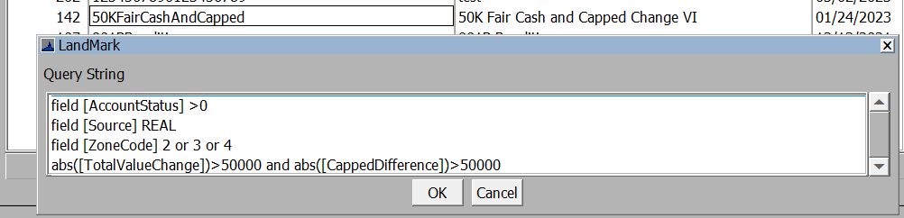

901PRendition
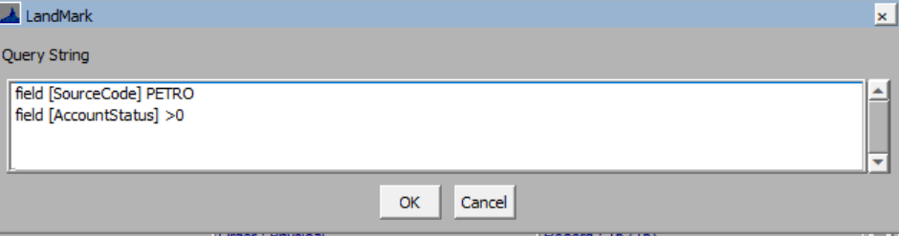

901Rendition
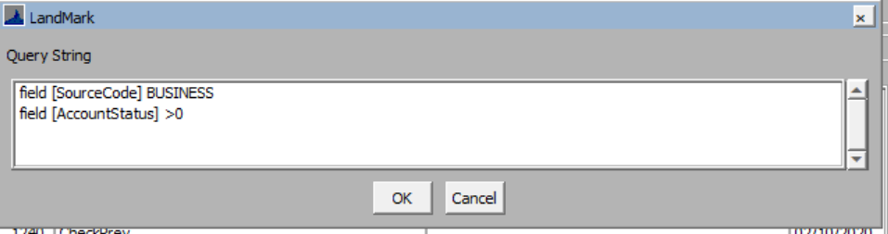

Abstract Totals
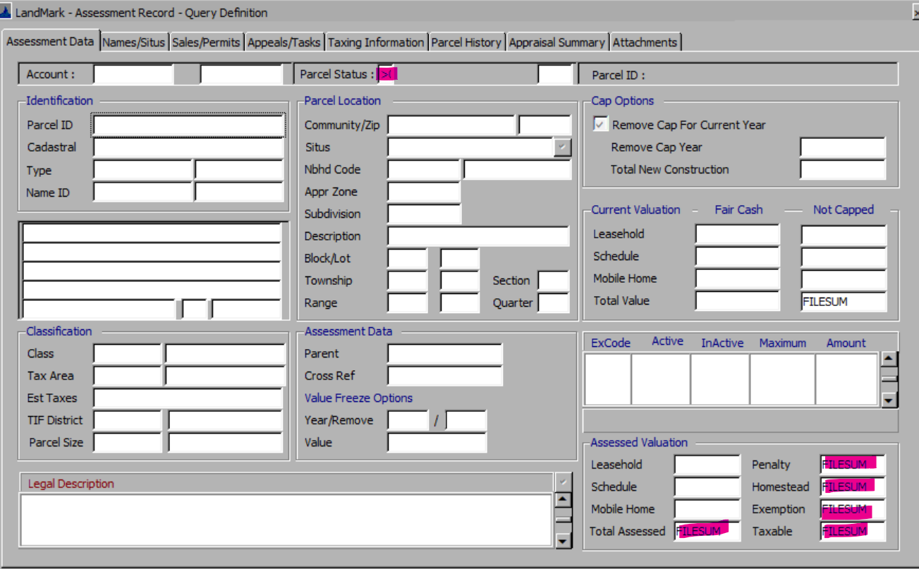
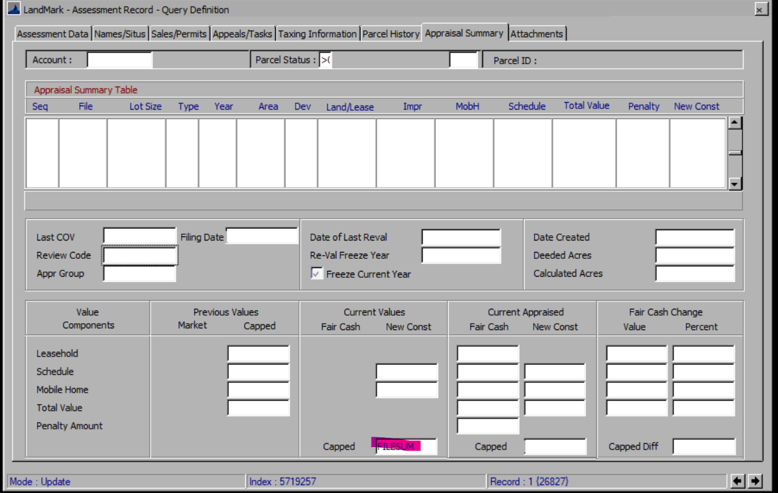

Active Real
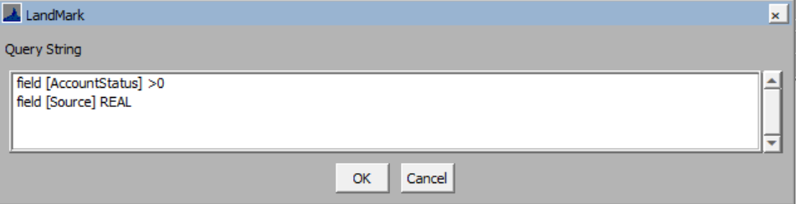

Active Mobile Home
This is to find several different sources that may be coded as mobile homes that are active, and the account status is also active.
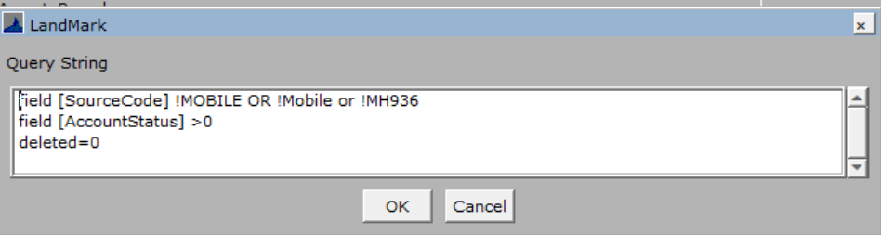

Decrease In Land Value
This could be modified to also include the appraisal zone (VI). This finds records where the land value in the appraisal record(s) is less than the current land fair cash value on the assessment file.
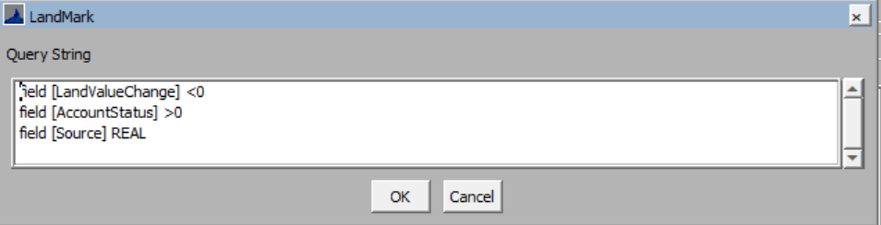

Decrease In Value
This could be modified to also include the appraisal zone (VI). This finds records where the value in the appraisal record(s) is less than the current fair cash value on the assessment file. This excludes records with the property class E.
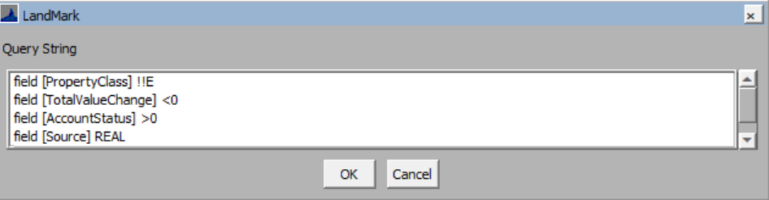

Error Check
This will find records that have a red x in the toolbar.
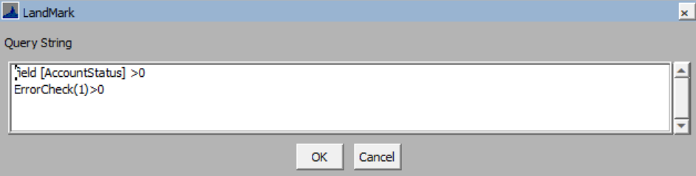

FairCashCapChange
This finds any real property record where the fair cash or capped value will increase/decrease 10,000. The 50KFairCashAndCapped is similar except for the value and VI fieldfield.
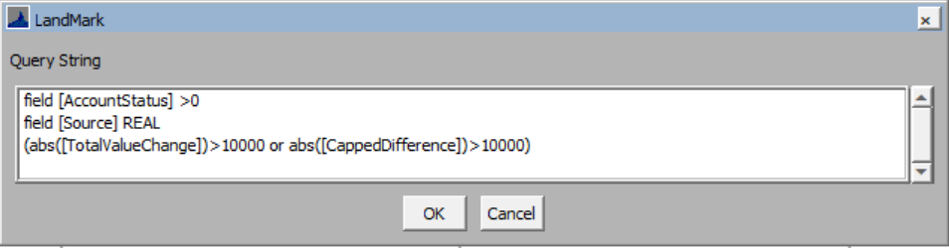

FractionalandLinkedOwnership
This will find both the records where the appraisal records are apportioned from and those accounts that are receiving that apportionment.
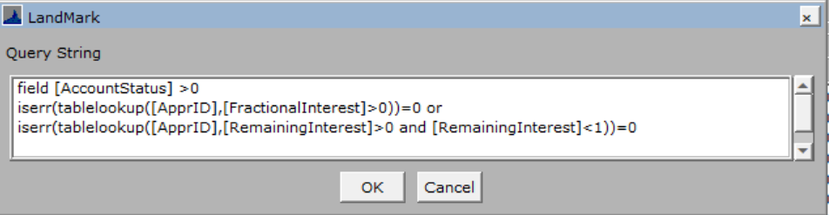

FractionalOwnership
This finds records where the account has its appraisal file linked to it.
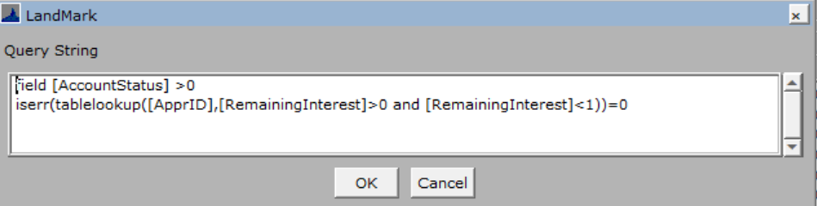

HSTrusts
This finds records that have a homestead, and the owner’s name has 4 different spellings for trust.
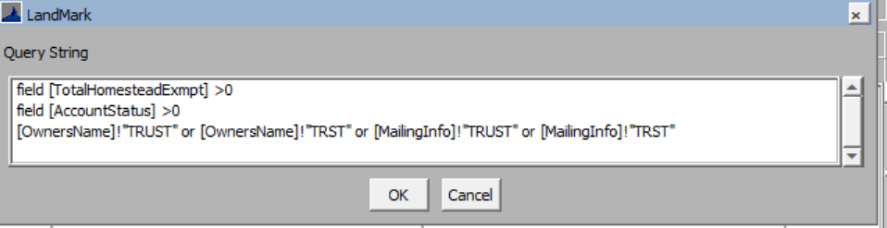

Linked Business Account
This finds records where the cross-reference account that is a business source.
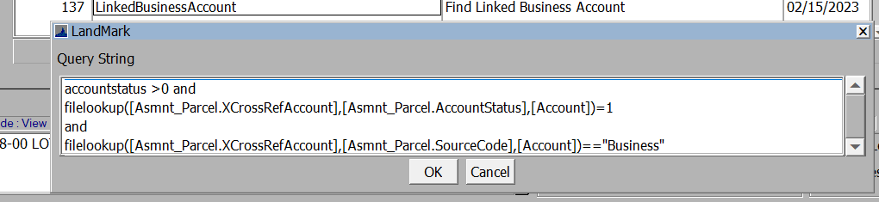

Linked Farm Account
This finds records where the cross-reference account that is a farm source.
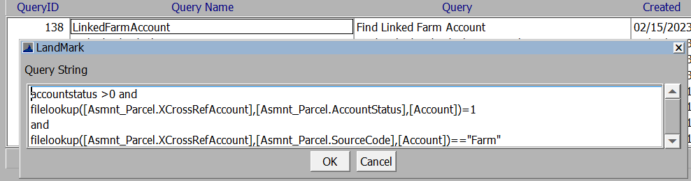

Linked Individual Account
This finds records where the cross-reference account that is an individual source.
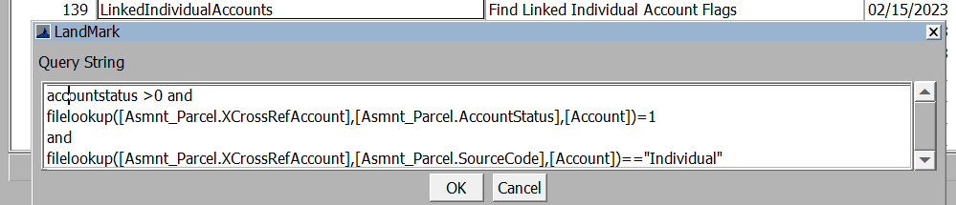

Linked Mobile Home
This finds records where the cross-reference account that is a mobile home source.
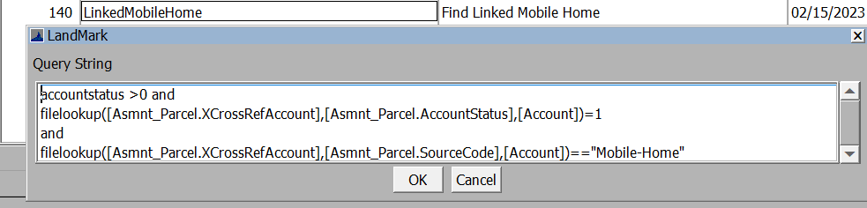

Linked Ownership
This finds records where the account is linked to another appraisal record.
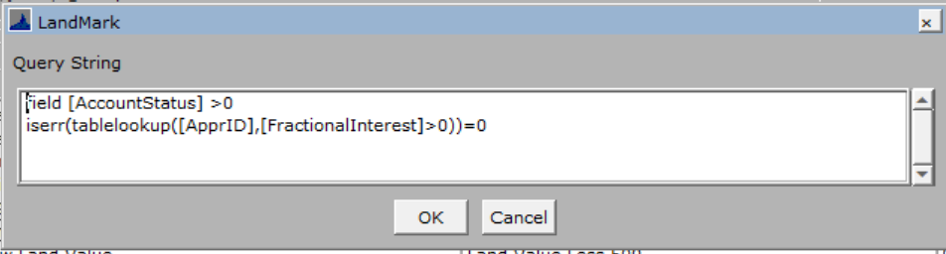

Linked Real
This finds records where the cross-reference account that is a real source.
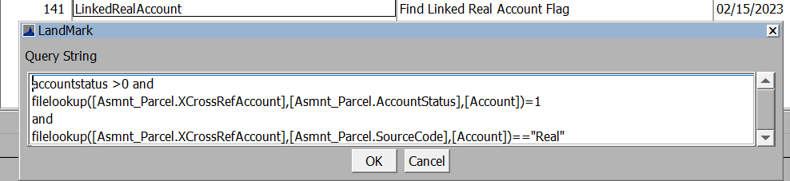

Low_Land_Value
This finds records that are active and have a land value of less than 500.
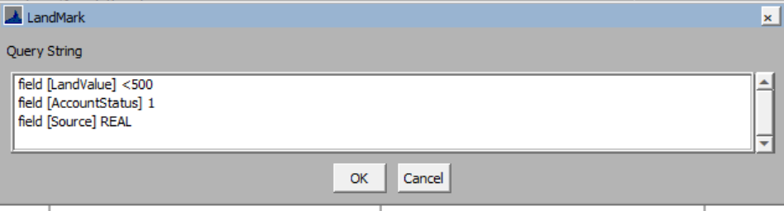

Residential Appraisal

ErrorCheckAppraisalRes
This finds active accounts/appraisal records that have a red x in the toolbar.
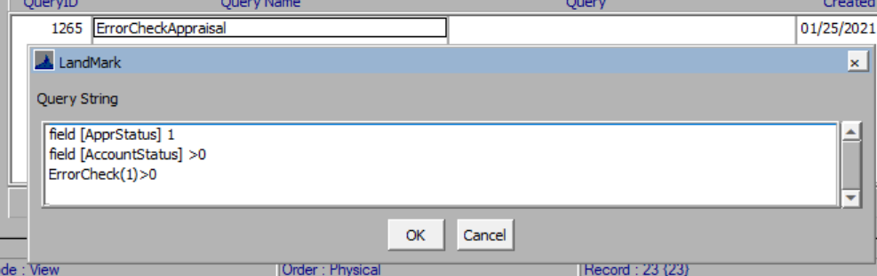

MultiEntered
This will find active accounts/appraisal records that have been entered more than once during a cycle. The base query does not have an appraisal zone, but one can be entered on the cost approach tab. The entered dates would need to be changed each year.
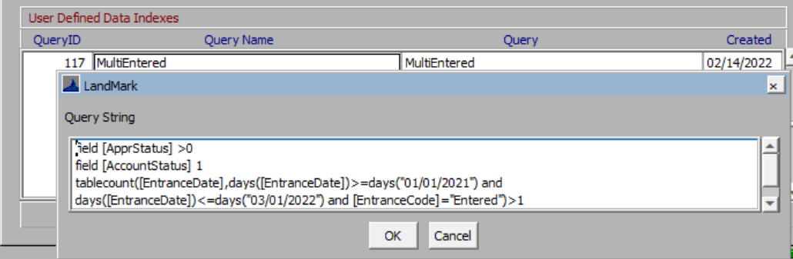

MultiInspected
This will find active accounts/appraisal records that have been entered more than once during a cycle. The base query does not have an appraisal zone, but one can be entered on the cost approach tab. The inspection dates would need to be changed each year.
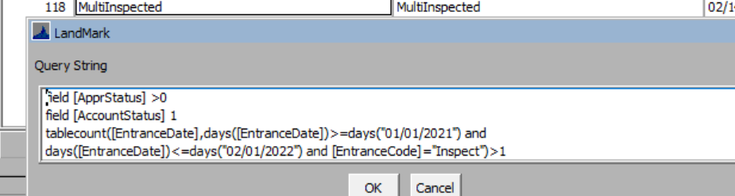

NotInspectedRes
(InpectedButNotEntereRes)
This will find active accounts/appraisal records that have been inspected and not entered. The base query does not have an appraisal zone, but one can be entered on the cost approach tab. The inspection dates would need to be changed each year. The default has inspections for 01/01/2021 and 02/01/2022 and entered between 01/01/2021 and 03/01/2022.
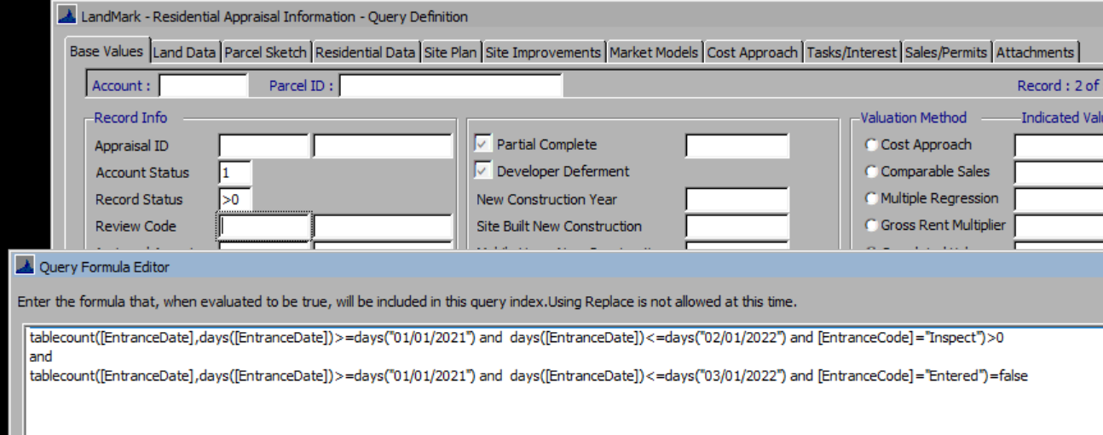
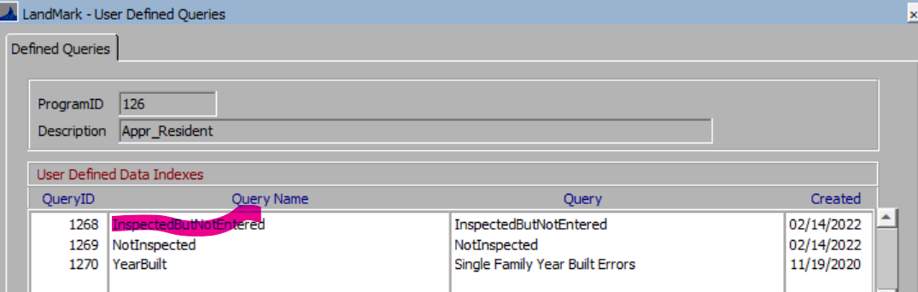

NotInspectedRes
This will find active accounts/appraisal records that have not been inspected. The base query does not have an appraisal zone, but one can be entered on the cost approach tab. The inspection dates would need to be changed each year. The default has inspections for 01/01/2021 and 02/01/2022.
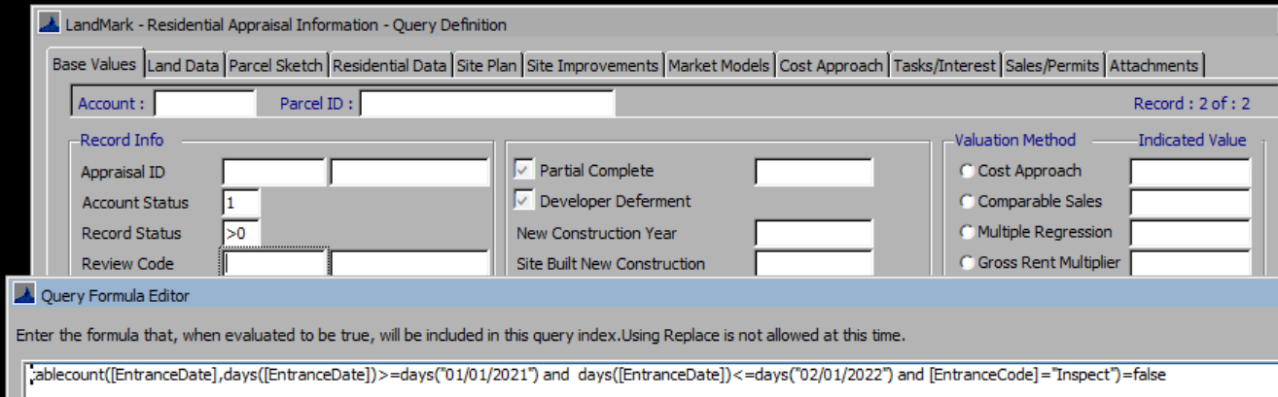
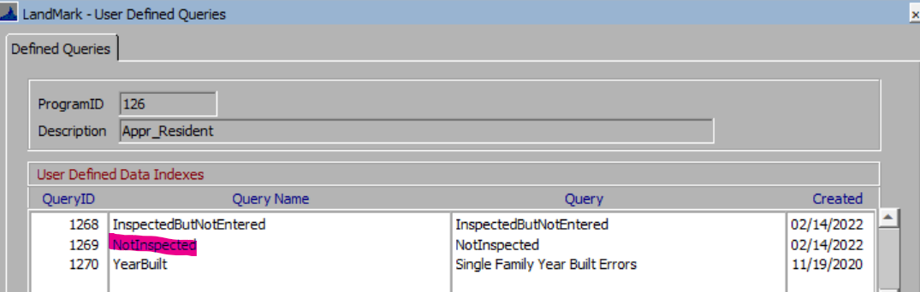

YearBuilt
This find records that are SFR where the year building >0 and either <1850 or >2021.
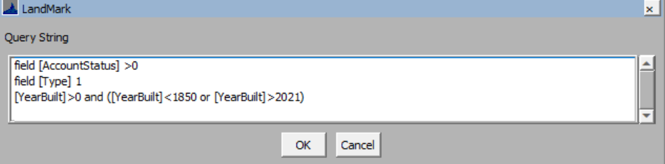

Commercial Appraisal

ErrorCheckAppraisalCom
This finds active accounts/appraisal records that have a red x in the toolbar.

MultiEntered
This will find active accounts/appraisal records that have been entered more than once during a cycle. The base query does not have an appraisal zone, but one can be entered on the cost approach tab. The entered dates would need to be changed each year.

MultiInspected
This will find active accounts/appraisal records that have been entered more than once during a cycle. The base query does not have an appraisal zone, but one can be entered on the cost approach tab. The inspection dates would need to be changed each year.

NotInspectedCom
This will find active accounts/appraisal records that have been inspected and not entered. The base query does not have an appraisal zone, but one can be entered on the cost approach tab. The inspection dates would need to be changed each year. The default has inspections for 01/01/2021 and 02/01/2022 and entered between 01/01/2021 and 03/01/2022.
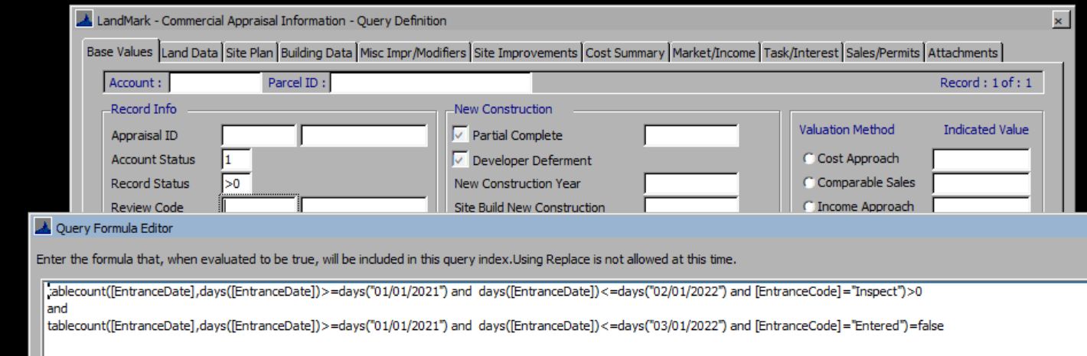
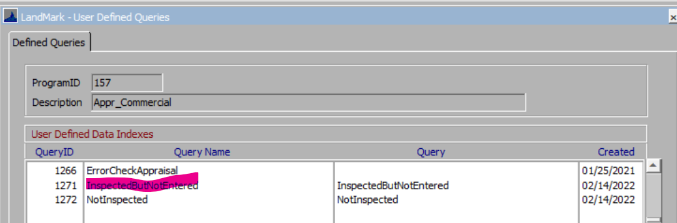

NotInspectedCom
This will find active accounts/appraisal records that have not been inspected. The base query does not have an appraisal zone, but one can be entered on the cost approach tab. The inspection dates would need to be changed each year. The default has inspections for 01/01/2021 and 02/01/2022.
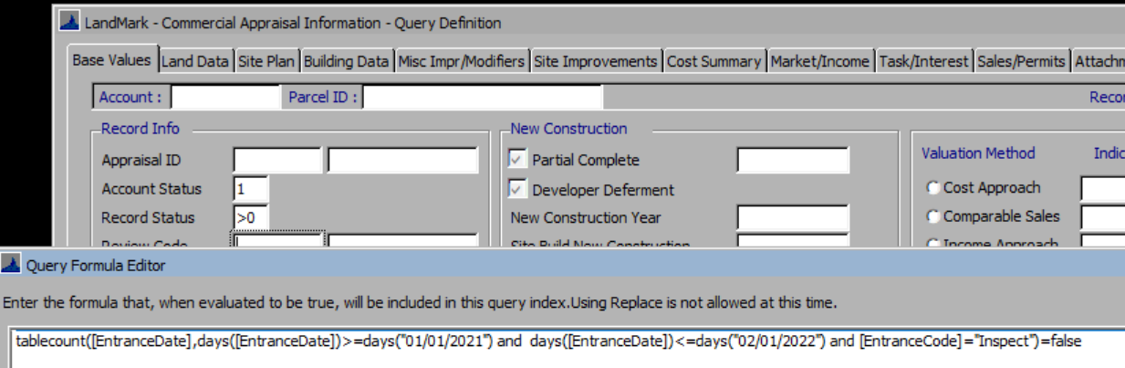
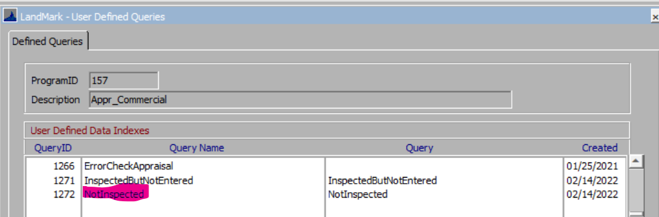

Outbuilding
These are in the Outbuilding linked table.

ReqSketchOut
This will find active outbuildings that are required on sketch that are not drawn. If the sketch/site plan is edited these records will be removed.
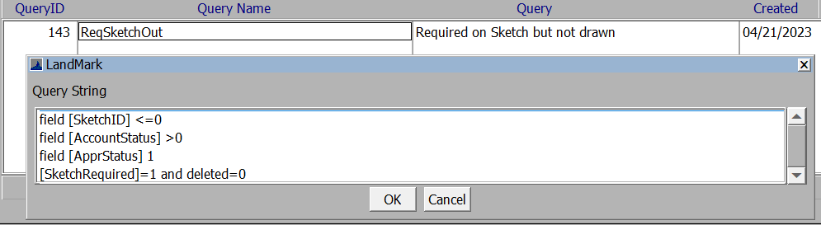

Miscellaneous Improvements
These are in the Miscellaneous linked table.

ReqSketchMisc
This will find active miscellaneous improvements that are required on sketches that are not drawn. If the sketch/site plan is edited these records will be removed.
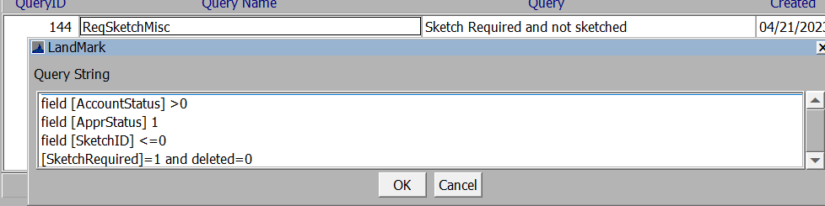

Sale Instrument

AgResidual
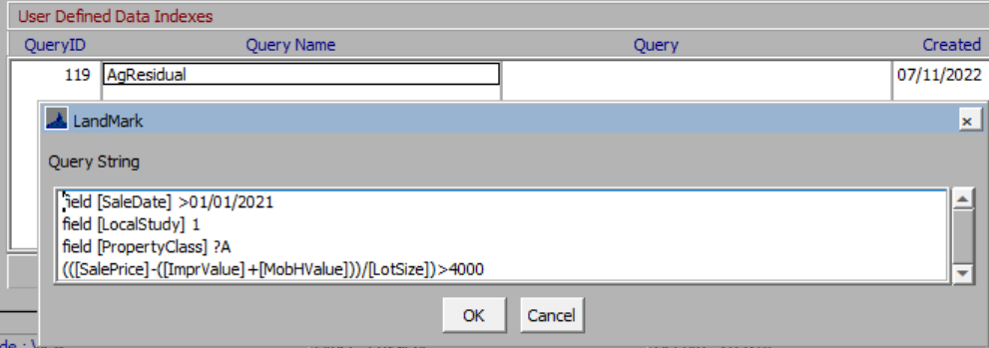
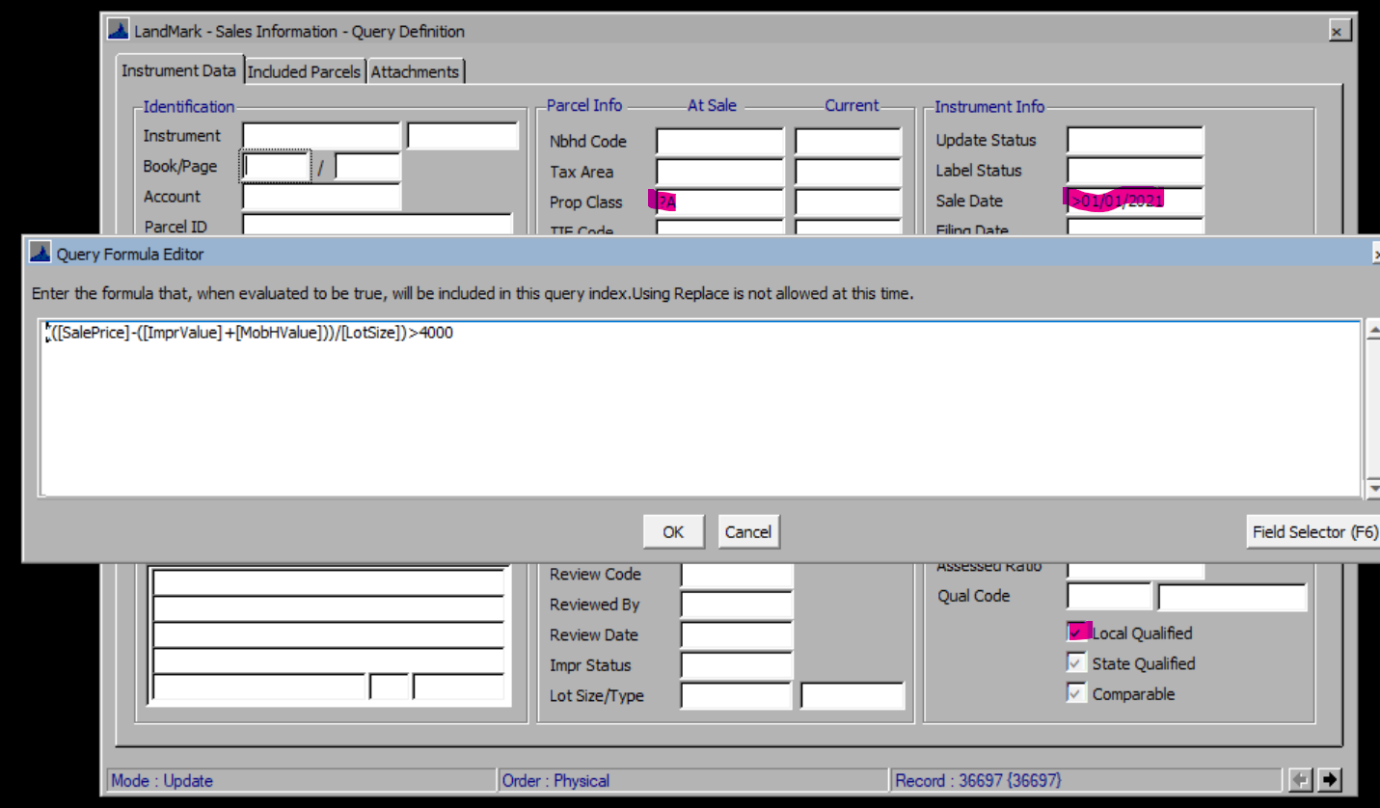

User Defined Reports (Report Manager Reports)
Currently there are no packages for reports.
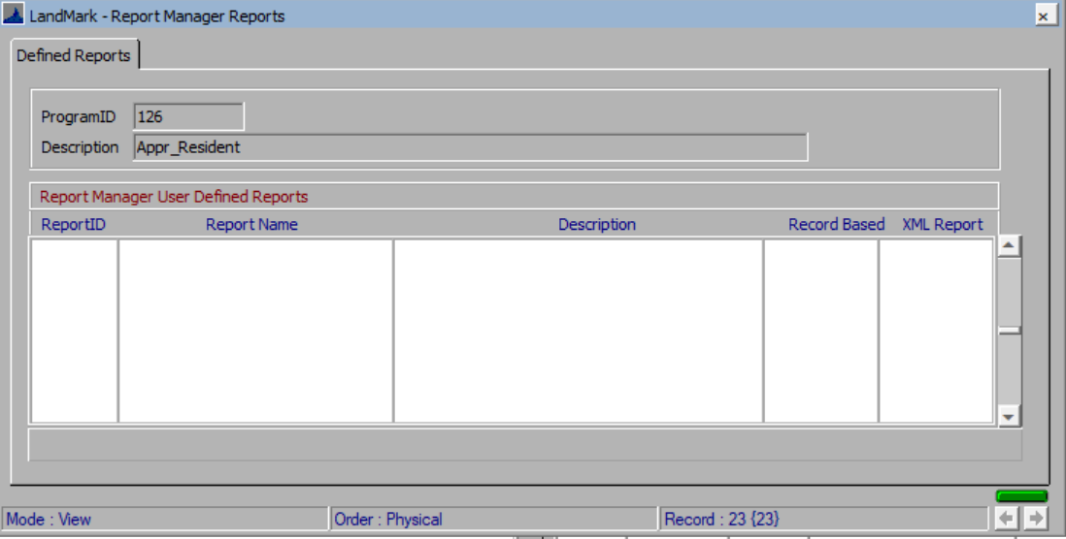

Sales Selection

Default Selection Model
This is for the comparable sales selection that can be added to neighborhoods.
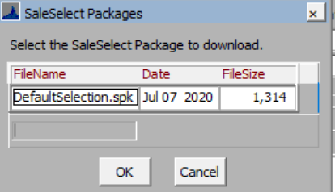
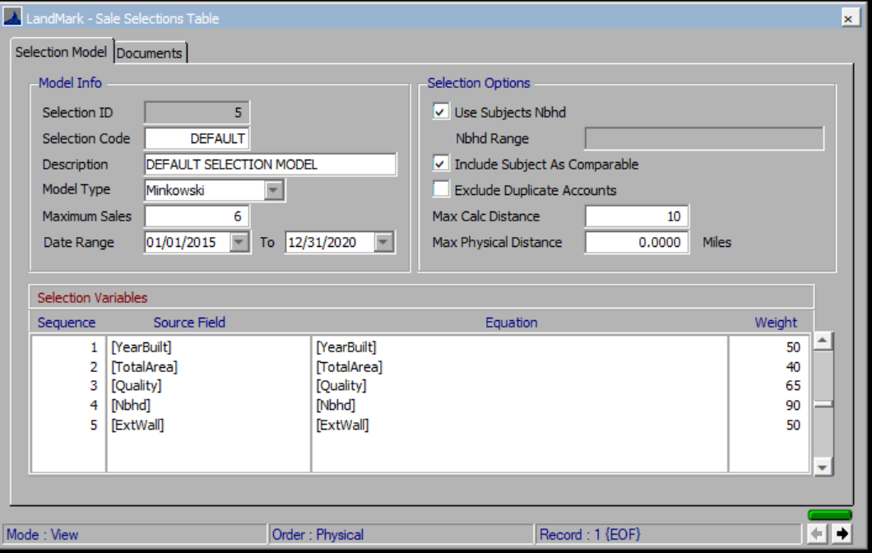

Mass Update
This is or the mass updates that are available in many forms. Generally this is located under Tools – Mass Update. After importing these packages, it is highly recommended you review the update to be sure you will be updated what you want to. When running this generally the user will be in an index and will want to ensure the correct record set is what they are wanting.
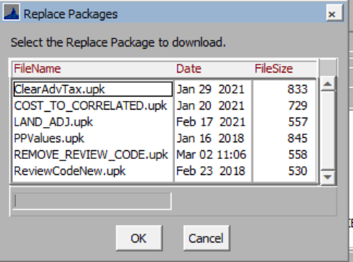

Assessment

Clear Advance Taxes
To clear advance taxes.
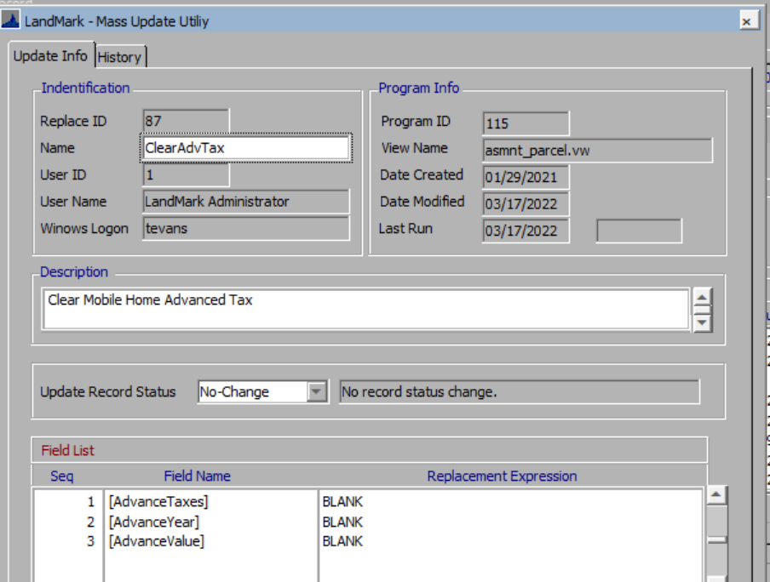

PPValue
To move appraisal vales from appraisal summary to fair cash
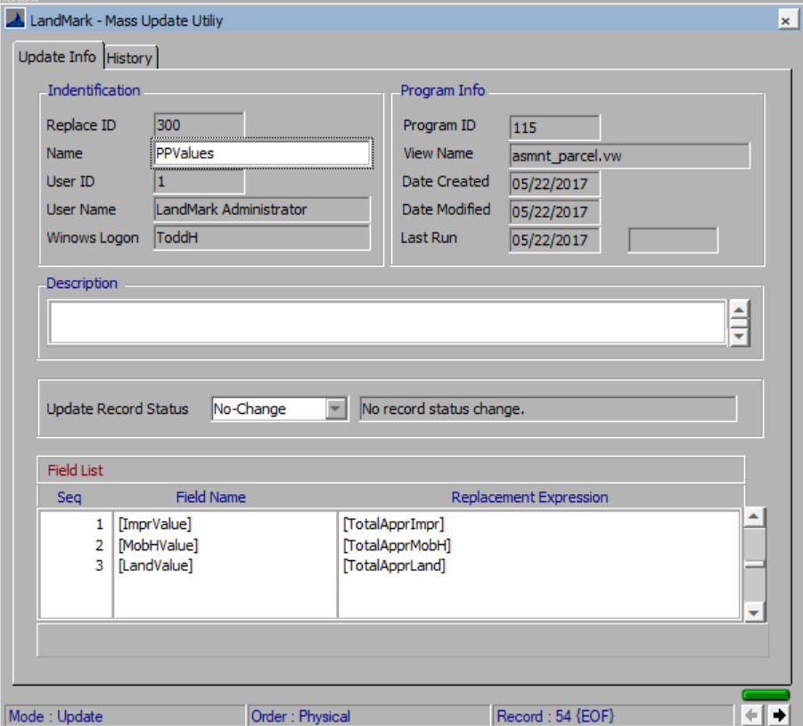

Remove Review Code
Removes review code from assessment screen.
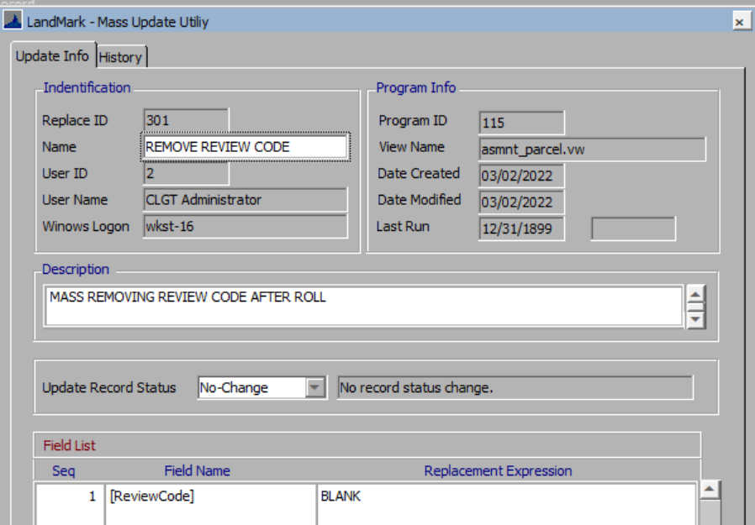
ReviewCodeNew – This changes the review code to PPVAL. You will want to change to be the review code you want the records changed to.
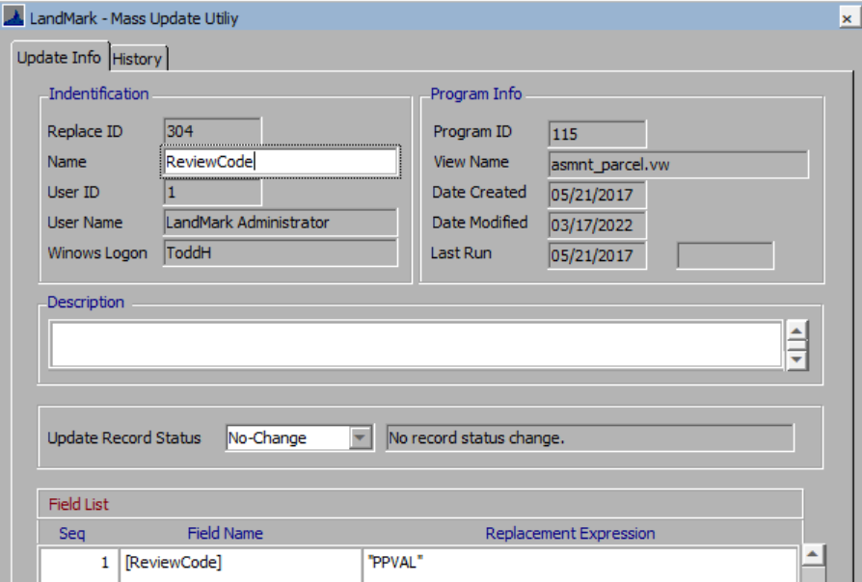

Residential Appraisal

Cost to Correlated
Changes the cost method to correlated value and sets to what the cost value is.
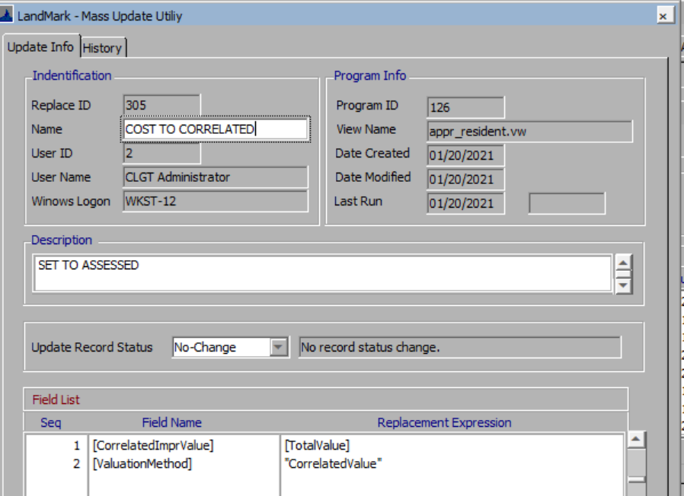

Remove Land Adjustment
To remove adjustments off of residential land records
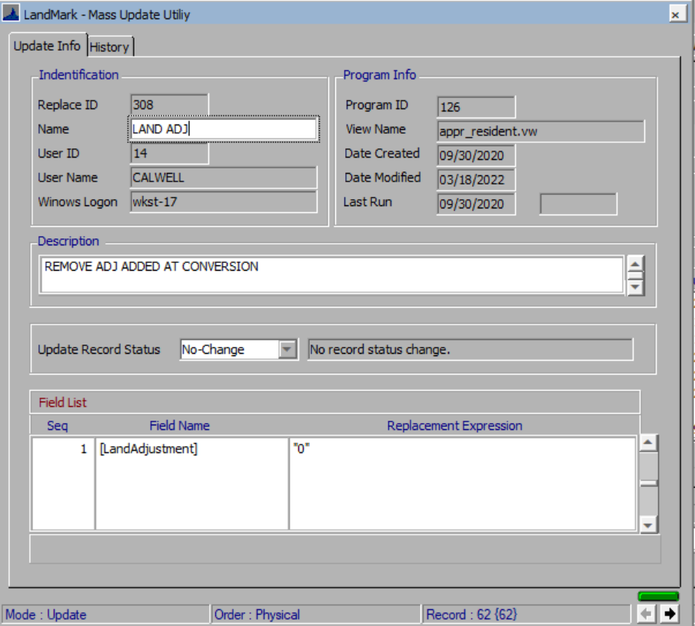

Update Fixture Count
This will update the fixture count. This should be run after finding the record to be updated.
