**LandMark GSI**

**Personal Property Abstract Numbers**

**Delivered: 06/14/2024**

**Version History**

|  |  |  |  |
| --- | --- | --- | --- |
| **Version #** | **Date** | **Revised By** | **Reason for change** |
| **1.00** | **6-14-2024** | **Mark Piller** | * **Initial Version** |
| **1.01** | **10-24-2024** | **Mark Piller** | * **Update/Review of document** |

Contents

Personal Property Abstract Numbers 1

Purpose 1

Prereqs 2

First Step 2

Non OTC SQFT method 2

Example 1 3

Example 2 4

Example 3 4

Property Class 5

Item Code Abstract Line 6

OTC SQFT method 6

# Personal Property Abstract Numbers

## Purpose

To identify where the fair cash values for lines 1 -10 on the abstract come from. The way the numbers on the abstract for personal property can be rather confusing. Ideally this will clear this up.

## Prereqs

Ensuring that that values from the personal property file have been rolled to assessment is important in this step. The reason for this is the starting point for an account is the fair cash on the assessment and then adjustments are made based on the item code and book value of the schedule items on the account. If the value on the assessment is not the same as the appraisal adjustments are made until the value is account and then no other adjustments are made.

## First Step

The first step is to determine if the appraisal record uses the OTC SQFT method for valuation. If this is the case, then one method is used to distribute the value otherwise a different method is used. The indication of the OTC SQFT method being used is on the Tasks/Assessment Data tab of the appraisal file.

## Non OTC SQFT method

In the case of an account that is valued based on reported items the entire value of the account goes on one line that is determined by the property class. See the section on property class to see how this is determined. If this is a linked 5-year exempt account then the property class of the linked account is used.

From the value then adjustments are made from the original line the value is placed to other lines based on the abstract line for each of the item codes. The inventory on the account is moved to line 5.

1. Inventory is moved to line 4.
   1. This is the inventory on the appraisal form.

1. Livestock items - These are item codes with the abstract code of 8 and are moved to line 9.

1. Tractors and Farm Equipment items - These are item codes with the abstract code of 9 and are moved to line 8.

1. Other Personal Property items - These are item codes with the abstract code of 10 and are moved to line 9.

1. The rest of the item codes remain with the abstract line they are coded with. This includes abstract lines 1 – manufacturing, 2 -refineries, 3-other oil, gas, mining, 4 – inventory, 5- business furniture/fixtures, 6 MH, and 7 - IOLL.

Appraisal

Assessment

### Example 1

Schedule Items Example 1

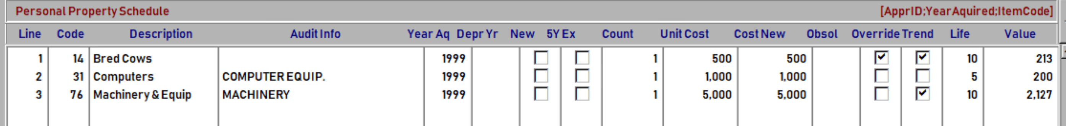

1. The value of 6,184 goes to line 1 based on PMP property class.
2. 1,000 added to line 4 and removed from line 1 based on inventory.
3. 213 added to line 9 and removed from line 1 based on code 14.
4. No adjustment for codes 31 and 76 as they are abstract line 5 with no adjustment.
5. End result is line 1 - 4,971, line 4 – 1,000, and line 9 – 213.

Abstract Example 1

### Example 2

Schedule Items Example 2 (same as example 1 except different prop class)

1. The value of 6,184 goes to line 5 based on BPP property class.
2. 1,000 added to line 4 and removed from line 5 based on inventory.
3. 213 added to line 9 and removed from line 5 based on code 14.
4. No adjustment for codes 31 and 76 as they are abstract line 5 with no adjustment.
5. End result is line 4 – 1,000, line 5 - 4,971, and line 9 – 213.

Abstract Example 2

### Example 3

Schedule Items Example 3 (same as 2 except change in one of the line items from code 76 to 70)

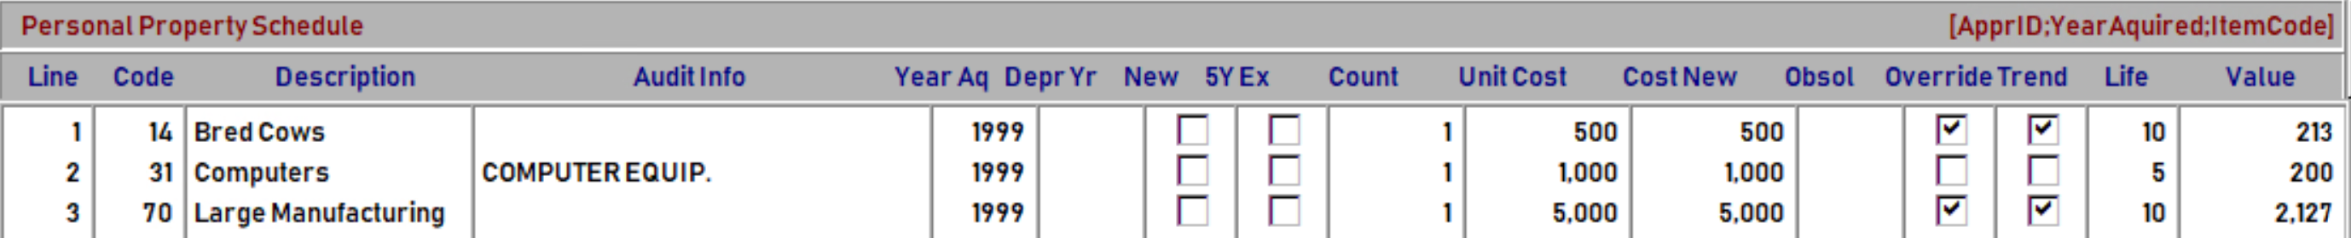

1. The value of 6,184 goes to line 5 based on BPP property class.
2. 1,000 added to line 4 and removed from line 5 based on inventory.
3. 213 added to line 9 and removed from line 5 based on code 14.
4. No adjustment for codes 31 as they are abstract line 5 with no adjustment.
5. 2,127 added to line 1 and removed from line 5 based on code 70.
6. The end result is line 1 2,127, line 4 – 1,000, line 5 – 2,844, and line 9 – 213.

Abstract Example 3

### Property Class

Assessment

The abstract group on the property class will determine where the value is classified to.

|  |  |  |  |
| --- | --- | --- | --- |
| Class | Description | Abstract Group | Abstract Line |
| AGP | Agricultural Personal Property | Agricultural | 9 |
| BPP | Business Personal Property | Business | 5 |
| IOLL | Improvements on Leased Land & Leasehold | IOLL | 7 |
| MHLL | Mobile Homes on Leased Land | Mfg-Home | 6 |
| MMD | MEDICAL MARIJUANA DISPENSARY | Business | 5 |
| MMG | MEDICAL MARIJUANA GROWER | Business | 5 |
| MMP | MEDICAL MARIJUANA PROCESSOR | Business | 5 |
| PE | Personal Exempt | Business | 5 |
| PMP | Manufacturing & Processing | Manufacturing-Processing | 1 |
| POG | Other Oil, Gas and Mining Property | Other-Petro/Mining | 3 |
| PRC | Refineries, Plants, Gathering & Comp | Refineries-Compression | 2 |
| RA | Rural Agricultural | Agricultural | 9 |
| UA | Urban Agricultural | Agricultural | 9 |

### Item Code Abstract Line

Each item code is assigned an abstract line that determines where book value is moved from the line item based on the property class to that of the item code.

## OTC SQFT method

When the square foot method is in use the schedule items on the account doesn’t make a difference in the calculations. The schedule value is posted to line 5 of the abstract and inventory is posted to line 4.

Appraisal

Assessment

Abstract

