
LandMark GSI
OTC Form 935MH
Delivered: 11/29/2021
Version History
Version # | Date | Revised By | Reason for change
1.00 | 11/29/2021 | Mark Piller | - Initial Version
1.01 | 10/12/2023 | Mark Piller | - Review

Contents
Purpose 2
Brief Report Description 2
Parameters 3
VALUETOUSE 3
True 3
False 4
Both 5
PRINTTOTALS 5
PRINTIMPRVALUE 6
Values on Improvements 6
Information 6
Manufactured Home 6
Other Improvements 7
Miscellaneous Improvements 8
Outbuildings 8
Schedule Items 8
Note 8
Examples 9

Purpose
The purpose of this document is to document what sections will print/not print based on parameters that can be set up. This will grow to include fields printing and other information on the report as versions of the document are expanded.

Brief Report Description
This report is printed for mobile home accounts..
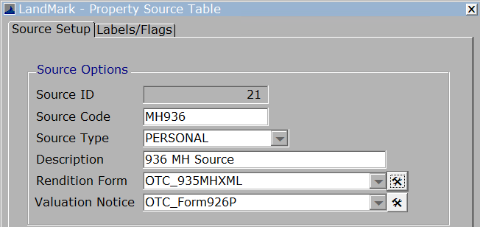

Parameters
These are the parameters that affect the printing of sections on the report. When the parameter is not in the parameters table there is a default. In the case of this report there are no parameters that cause sections to print or not.
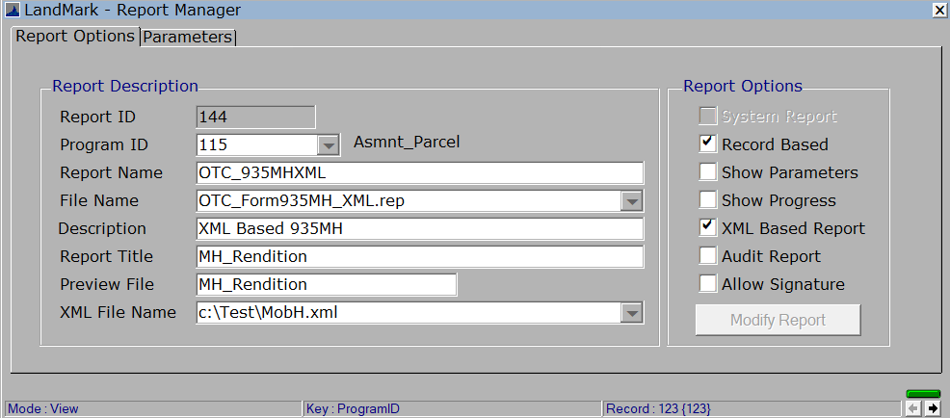
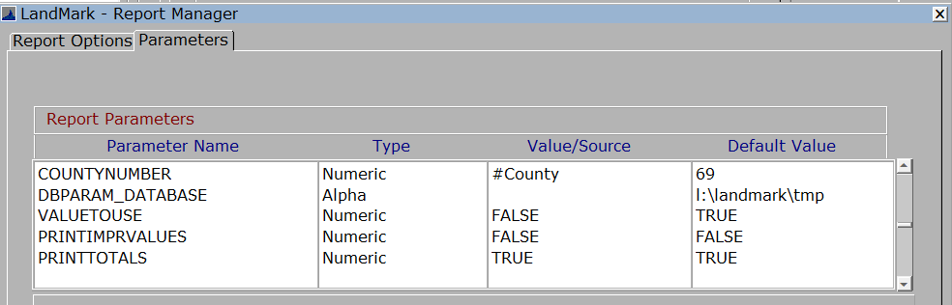

VALUETOUSE
Default – True
General meaning. True the values on the report will be from the assessment form. When false the values will be from the appraisal file.

True
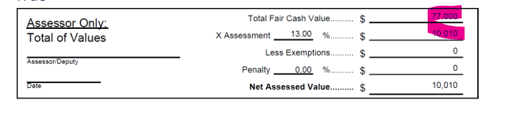
The fair cash value and assessment value will come from the assessment screen.
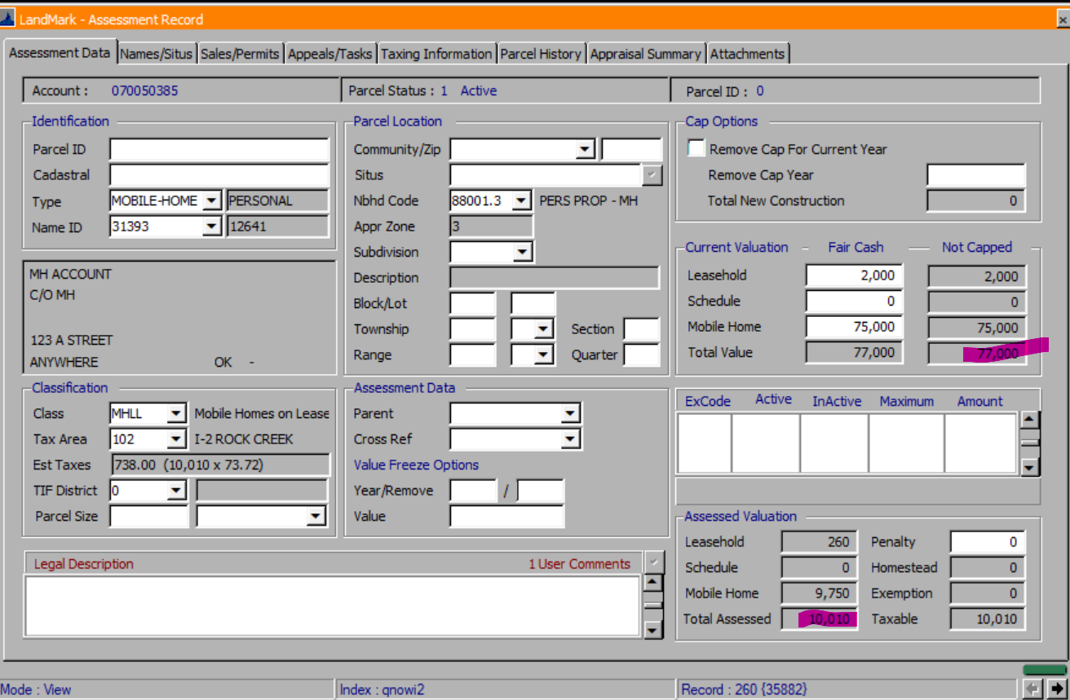

False
- Total fair cash on residential property
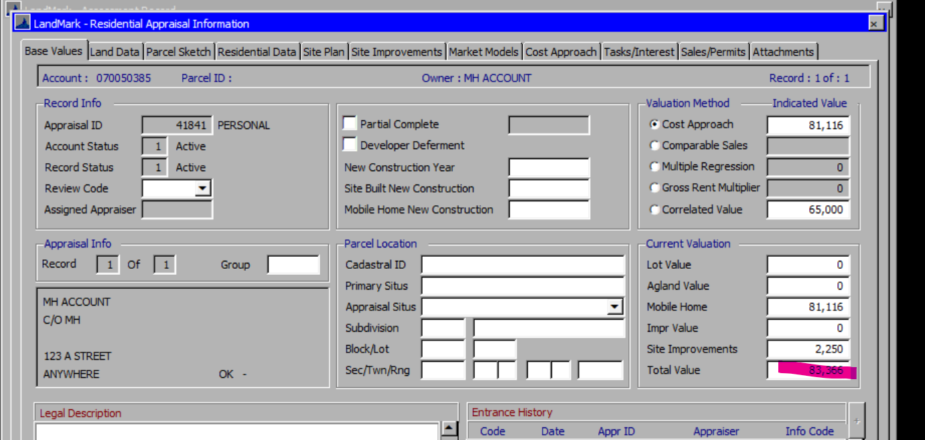

- Total fair cash on personal property will be schedule total + mobile home.
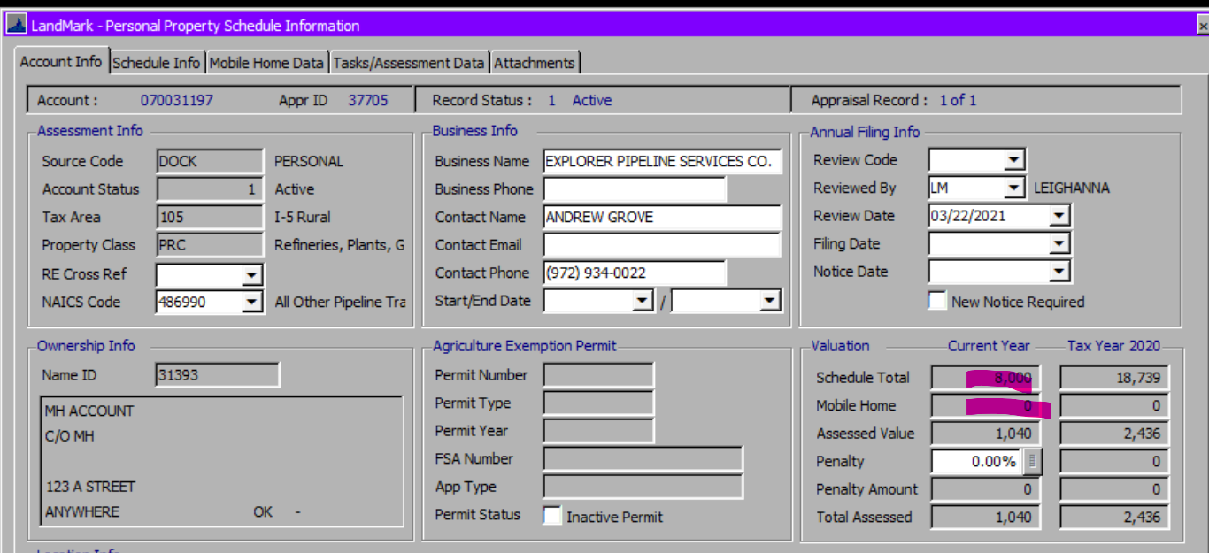
- The assessment will be the value from appraisal screen * the assessment rate

Both
- The less exemption amount will be the sum of the amount column of the exemptions – freeport exemption. The freeport exemption will be added the freeport amount * assessment level if the freeport year is the assessment level in the county information table.
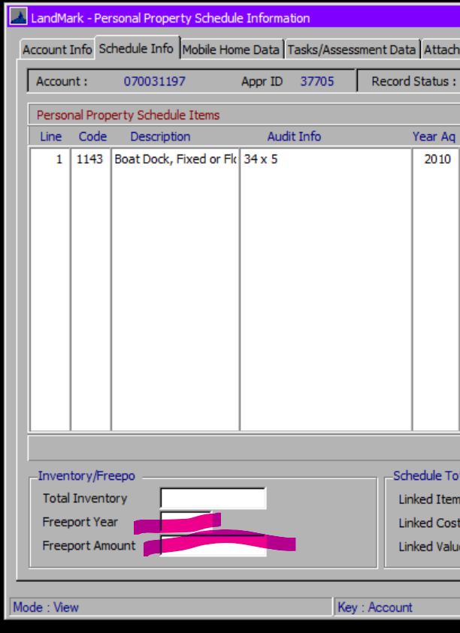
- The penalty amount will always come from the appraisal file.

PRINTTOTALS
Default - True
What won’t print if set to false
- The value fields from the assessor’s only section will not print.
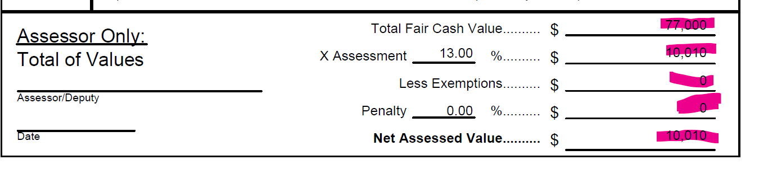

PRINTIMPRVALUE
Default – False
True – The values in the improvements will print otherwise there will only be a code and description. The VALUETOUSE parameter must be set to False as well.

Values on Improvements
In order to print the VALUETOUSE must be set to False and PRINTIMPRVALUE must be set to True
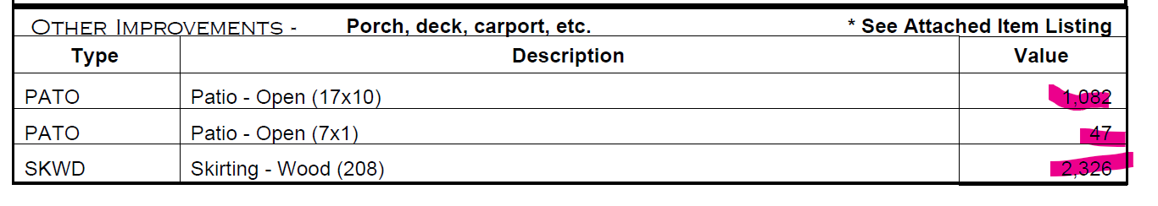
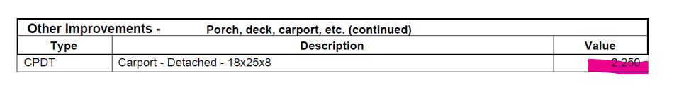

Information

Manufactured Home
- If the parameter VALUETOUSE is set to true, this will be the fair cash value on the assessment screen.
- If the parameter VALUETOUSE is set to false and PRINTIMPRVAL is false, then the value will be the same as the fair cash when VALUETOUSE is false.
- If the parameter VALUETOUSE is set to false and PRINTIMPRVAL is true, and the value method is not correlated value then the value will be mobile home value – value of the misc. improvements.
  - If correlated value, then this will be the total value – site improvements.
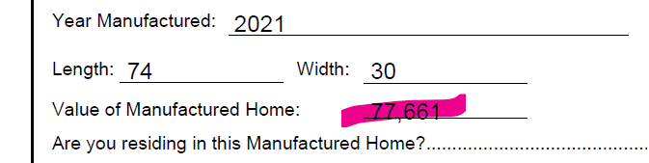

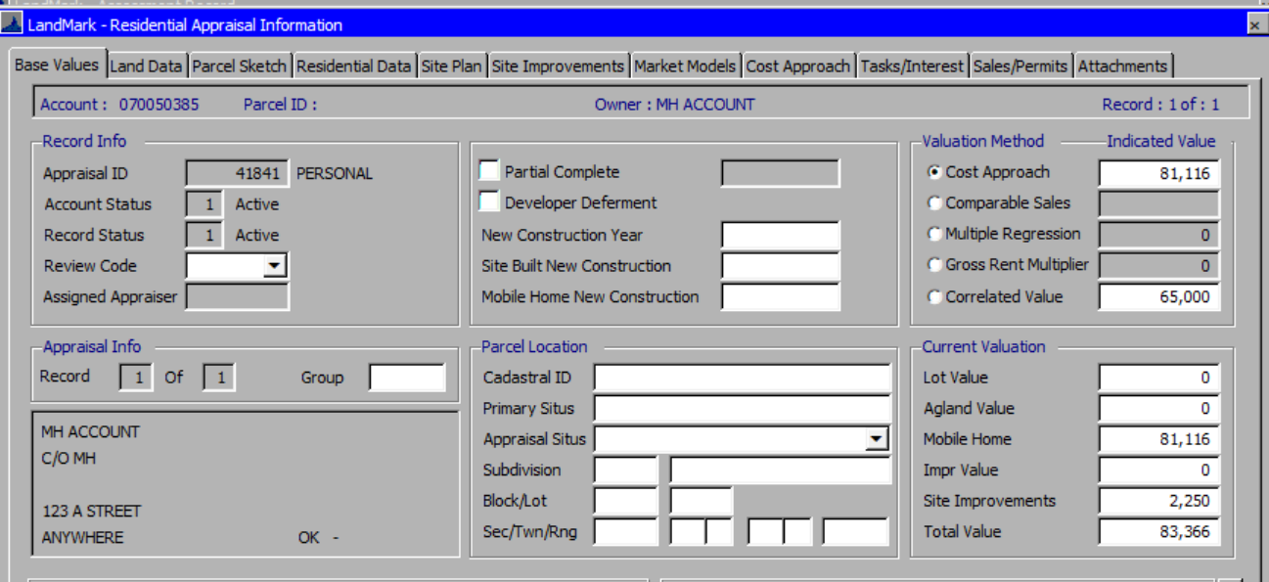

Other Improvements
In order for the label “*See Attached Item Listing” will only print if there are more than three improvements to print. This also goes for the 2nd improvements section that prints at the end of the report. These will print from the miscellaneous improvements, outbuilding, and schedule items.
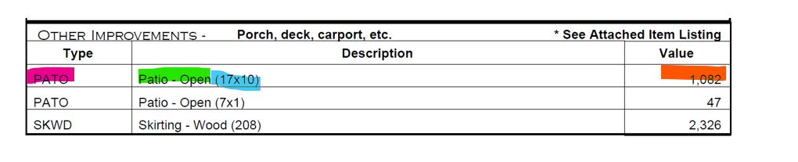
2nd section
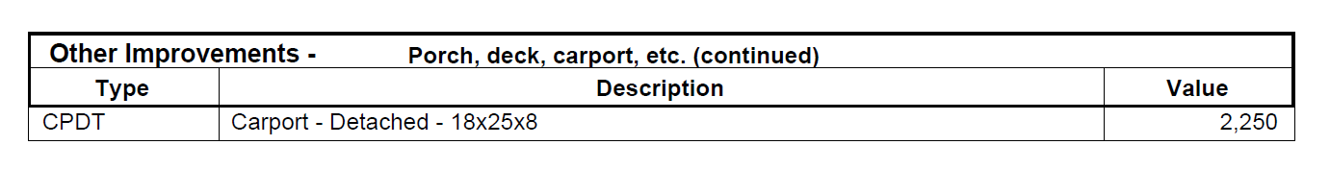

Miscellaneous Improvements
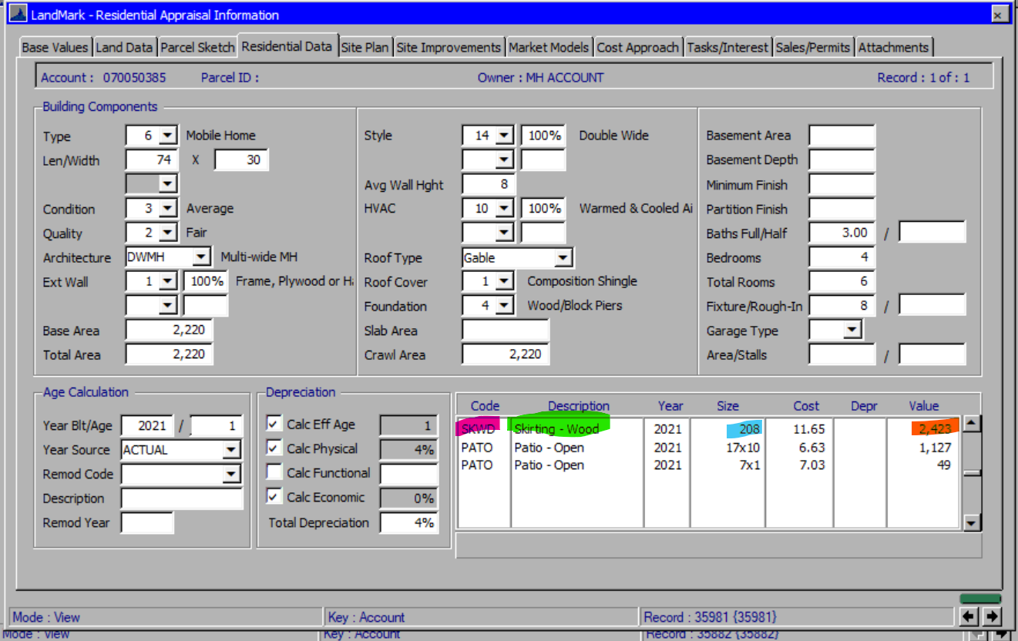

Outbuildings
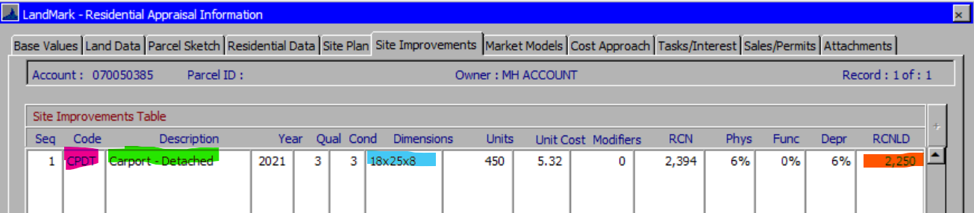

Schedule Items
(In the examples there is not a personal property appraisal record)
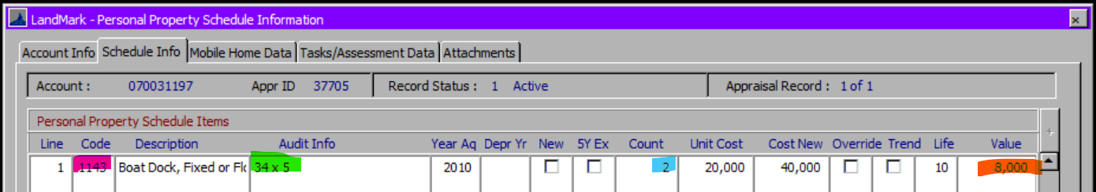

Note
The question if the appraisal information is going to be read into the assessment will need to be taken into account with how the parameters are going to be used.

Examples

