
LandMark GSI
OTC Form 926P
Delivered: 01/30/2023
Version History
Version # | Date | Revised By | Reason for change
1.00 | 01/30/2023 | Mark Piller | - Initial Version
1.01 | 03/5/2023 | Mark Piller | - ESTTAX parameter
1.02 | 3/31/2023 | Mark Piller | - PROPACCOUNTASACCOUNT parameter
1.03 | 10/12/2023 | Mark Piller | - Review and Obsolescence

Contents
Purpose 2
Brief Report Description 2
Parameters 3
CURRENTDATE 4
PRINTNOTICENOTES 4
NOTICENOTESRED 5
TASC 5
INCSCHEDULE 5
ESTTAX 6
PROPACCOUNTASACCOUNT 6
Information 7
Name 7
Account Information 8
Value Information 9
Legal 10
Notes 10
Assessor Information 11
Attached Report Description 11

Purpose
The purpose of this document is to document what sections will print/not print based on parameters that can be set up. This will grow to include fields printing and other information on the report as versions of the document are expanded. The initial version will not discuss linked values (reimbursement), and residential/commercial information (MH that will print). These section print if the parameter INCSCHEDULE is true.

Brief Report Description
This is used when printing personal property change of value notices. The help manual gives good information on what records are selected.
Change of Value Notices - Assessment File - 1 (manula.com)

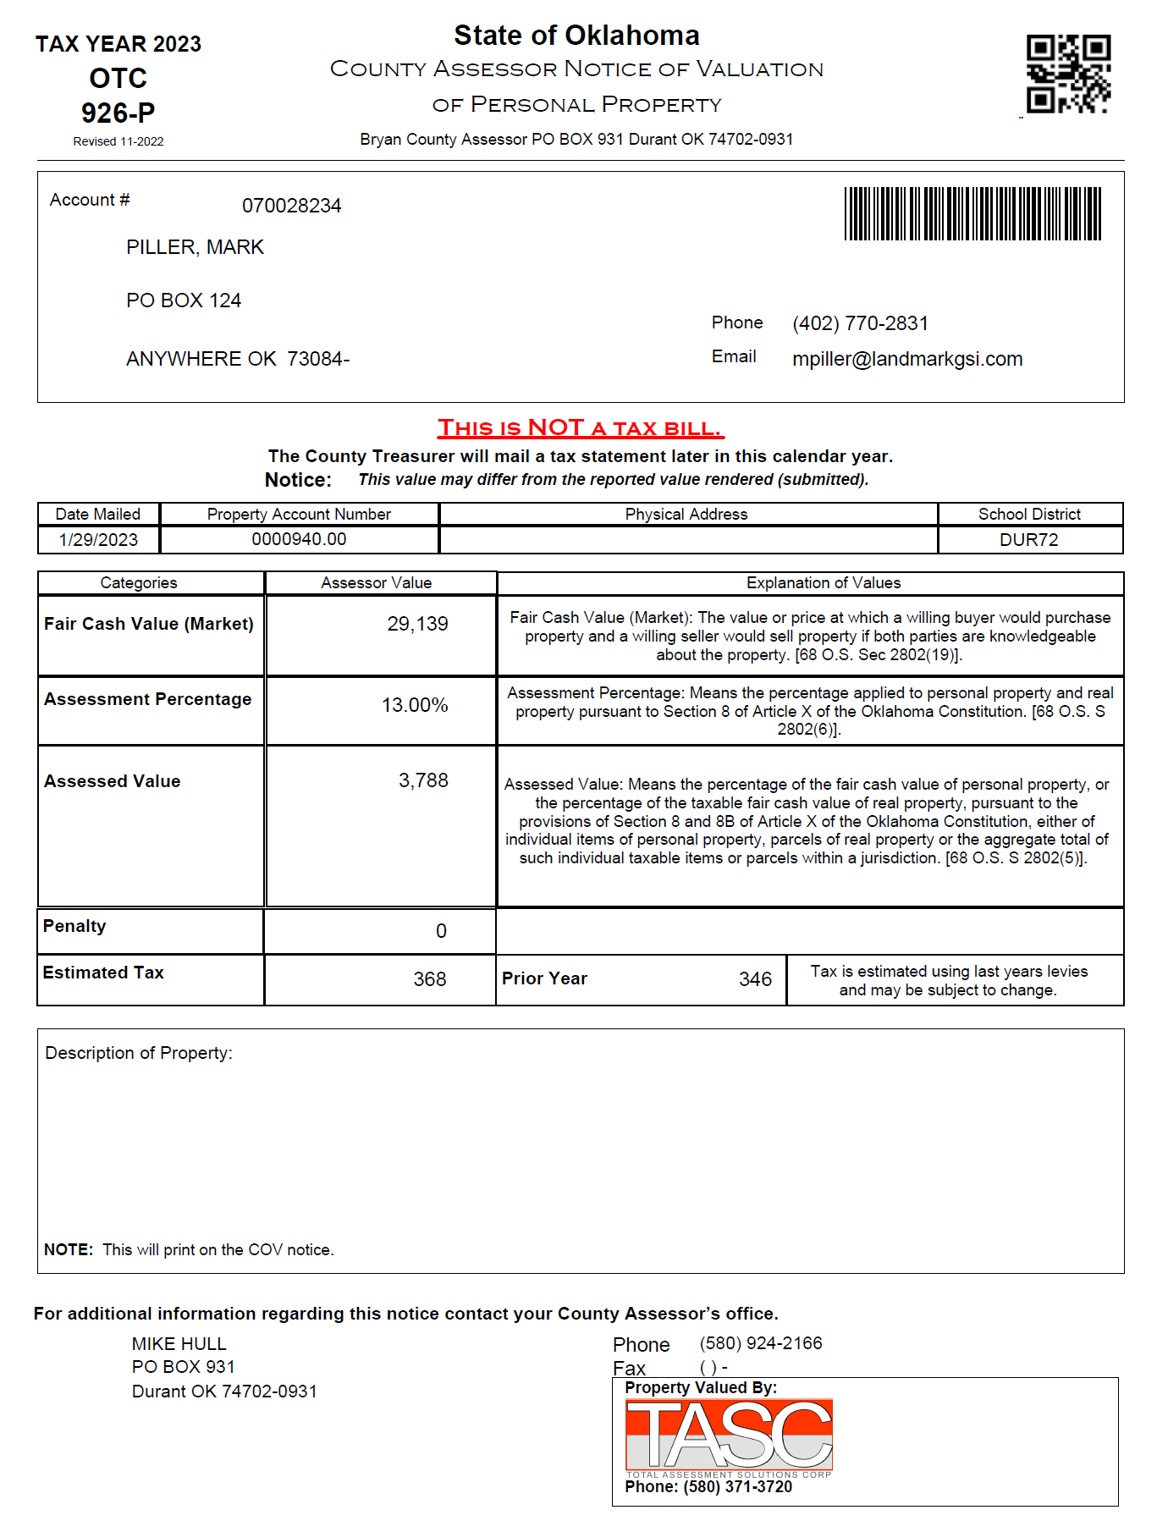

Parameters
These are the parameters that effect the printing of sections on the report. When the parameter is not in the parameters table there is a default. In the case of this report there are no parameters that cause sections to print or not.
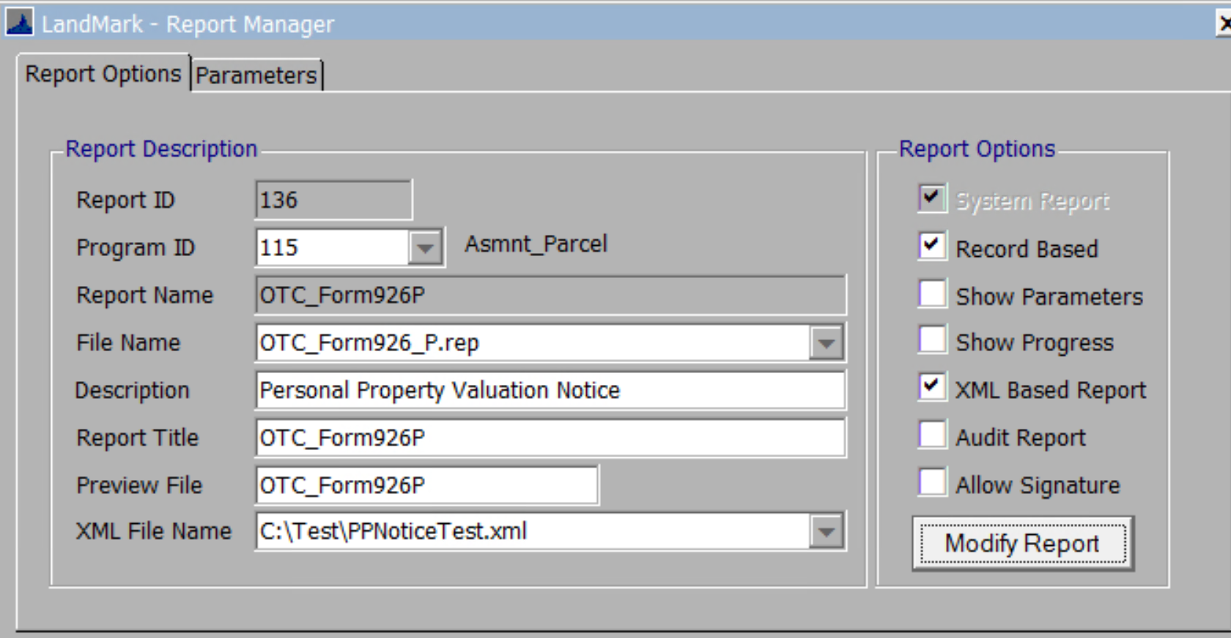
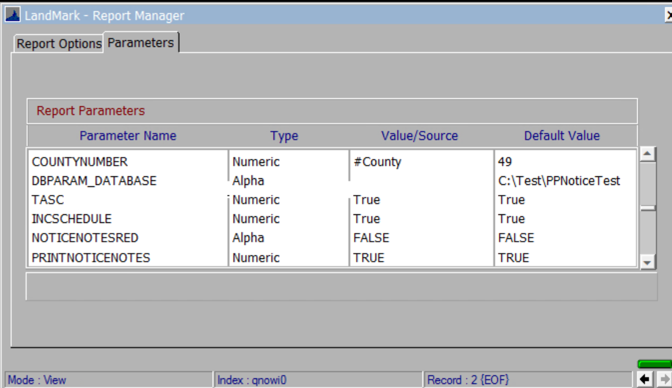

CURRENTDATE
Default - False
If set to false, this will be the date in the notice parameters. If set to true, then this will be the current date. This will also be the date on the schedule listing.
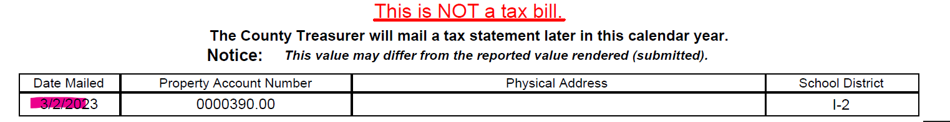

PRINTNOTICENOTES
Default - True
What will not print if set to false
- The notice notes.
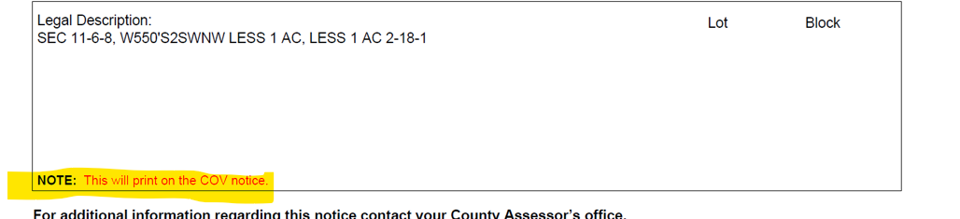

NOTICENOTESRED
Default - False
- The PRINTNOTICENOTES must be true for the notes to print. If this parameter is set to false the notes will print black. If set to True, the note will print red.

TASC
Default - False
- If set to true, this will print on petro accounts.
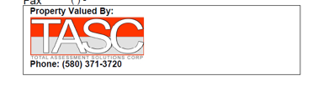

INCSCHEDULE
Default - True
What will not print if set to false
- The residential building and outbuildings. (If applicable)
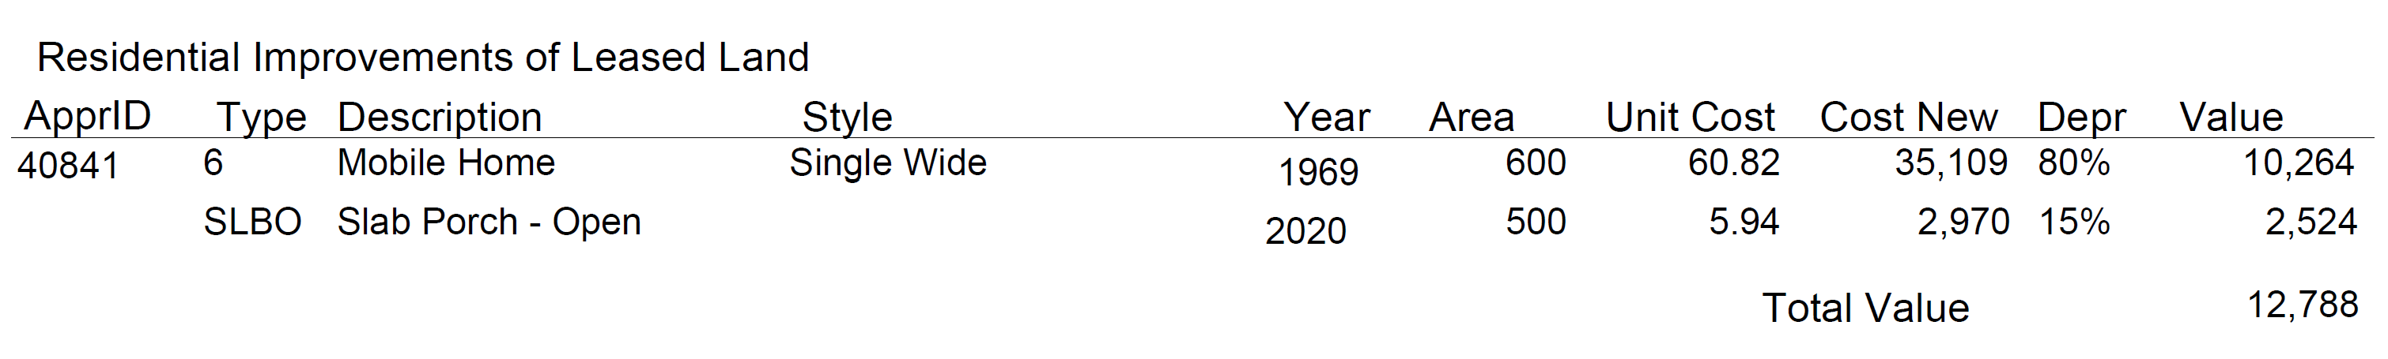
- The commercial building and outbuildings. (If applicable)
- The schedule items will have this layout.
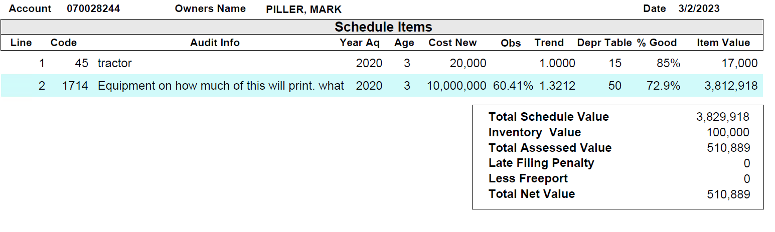
- The linked reimbursement accounts. The default will be the same as the personal property items.

ESTTAX
Default - True
What will not print if set to false
- The estimated tax section.

PROPACCOUNTASACCOUNT
If set to false this will print the cadastral id if there is one. If set to true, then this should be the account number.
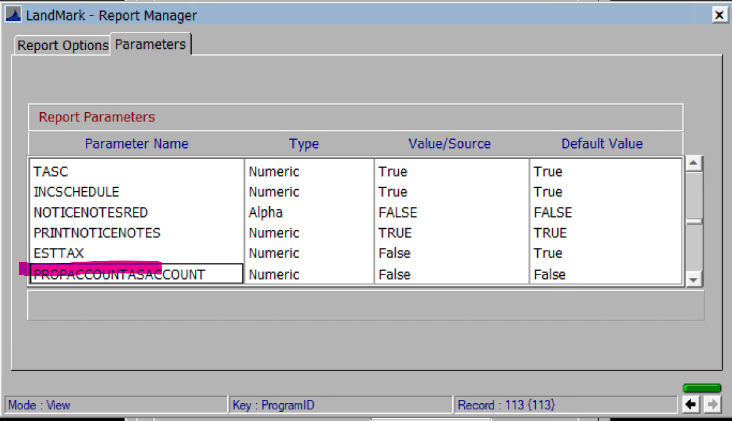
Default and set to False
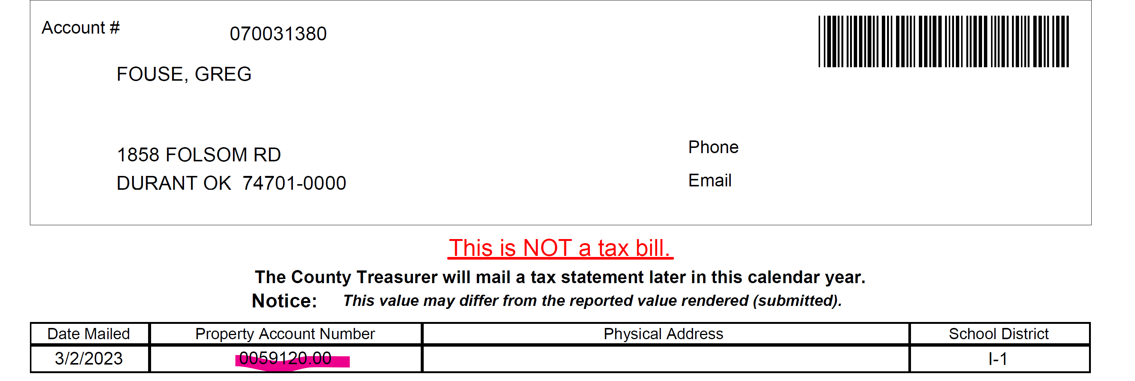

Set to True
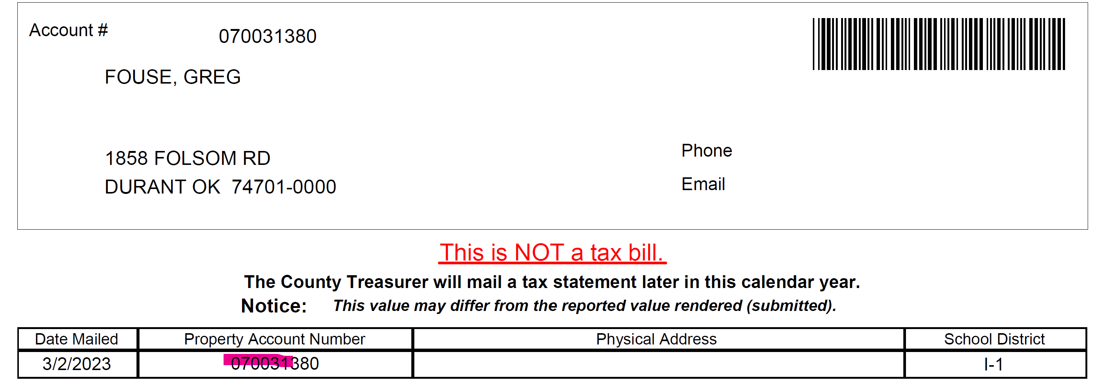

Information

Name
This is based on the name record on the assessment form. If there is not a business phone the home phone would be used.
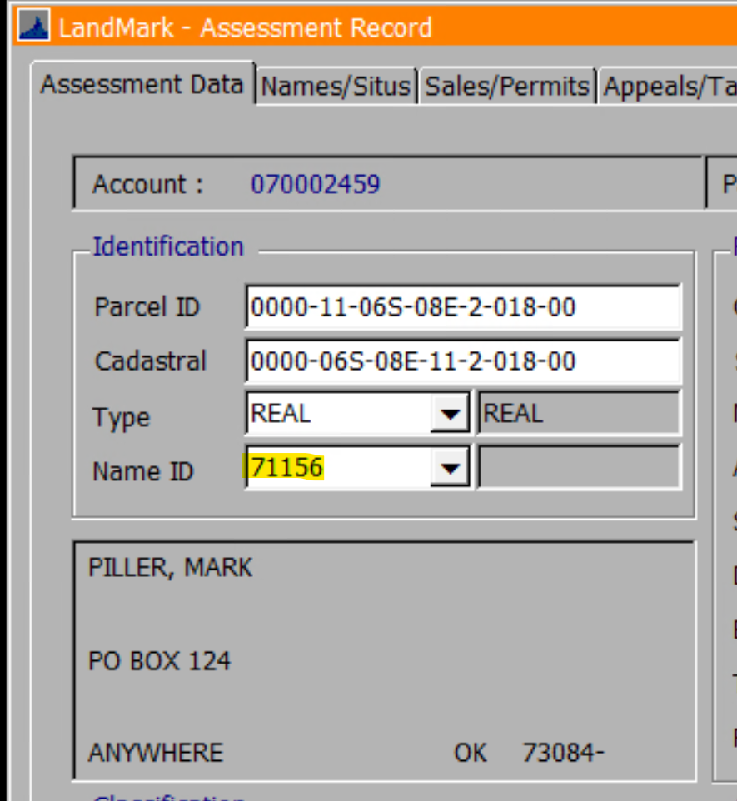
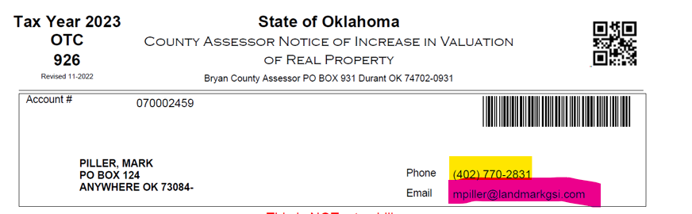

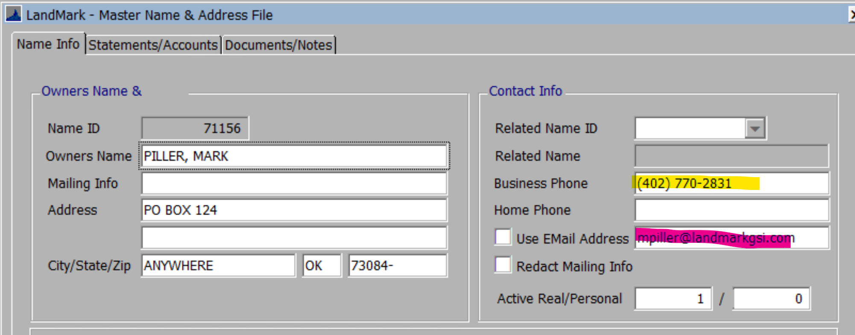

Account Information
- The date mailed will be the date in the COV parameters. If there is not a date in the parameters, then this will be the date of the printing.
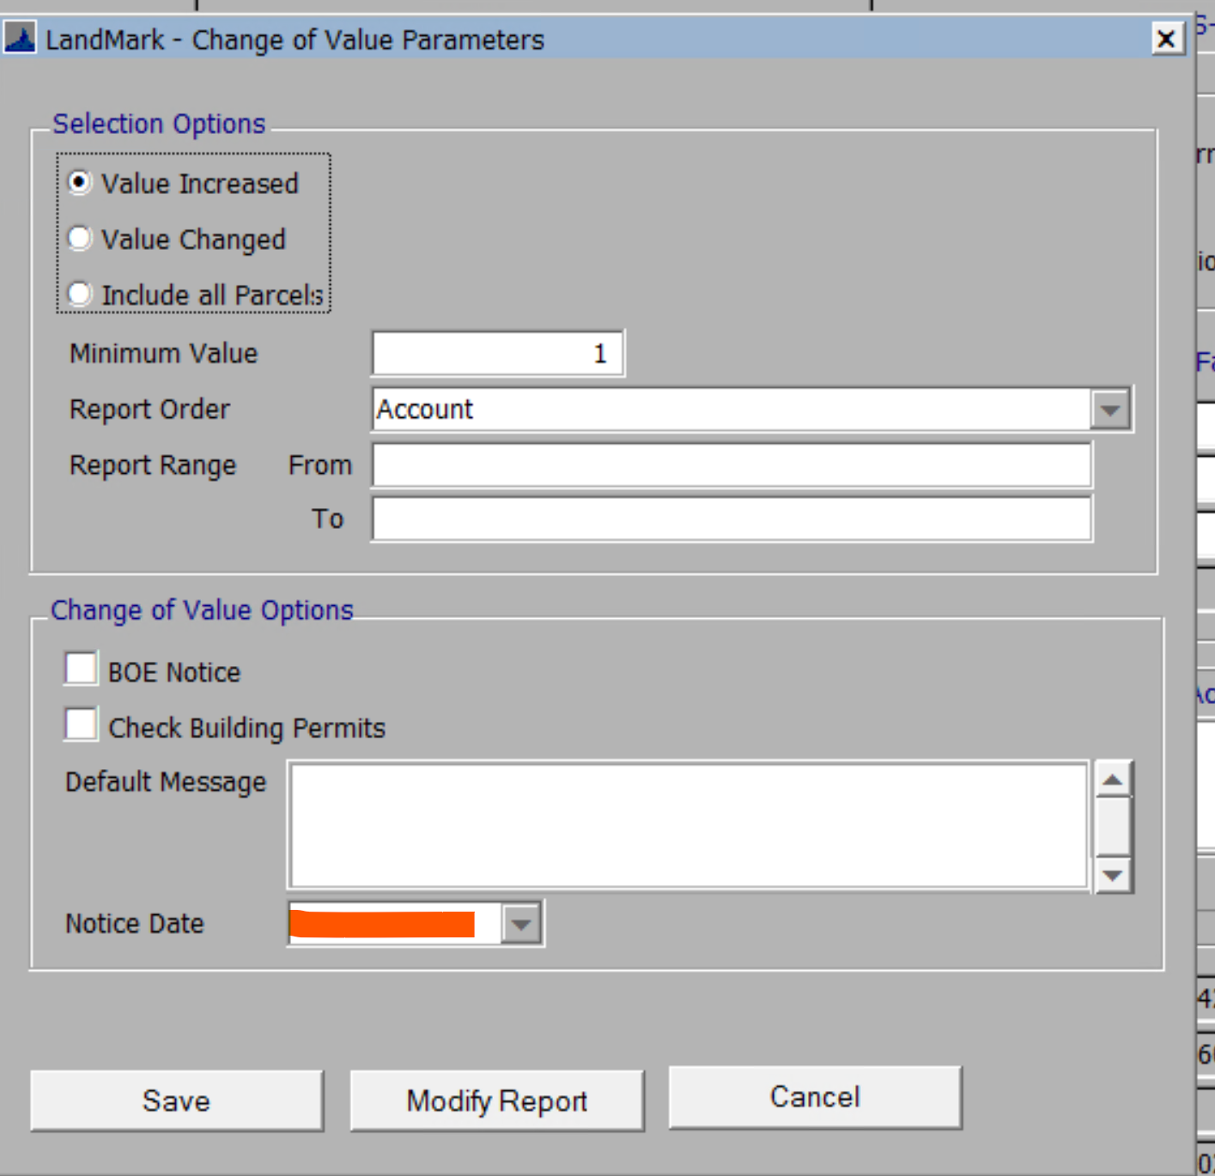
- The parcel account be the cadastral number. If there is not a cadastral number, this will be the account number. There is a parameter to change this where the account number will always print.
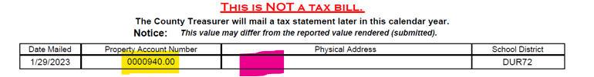
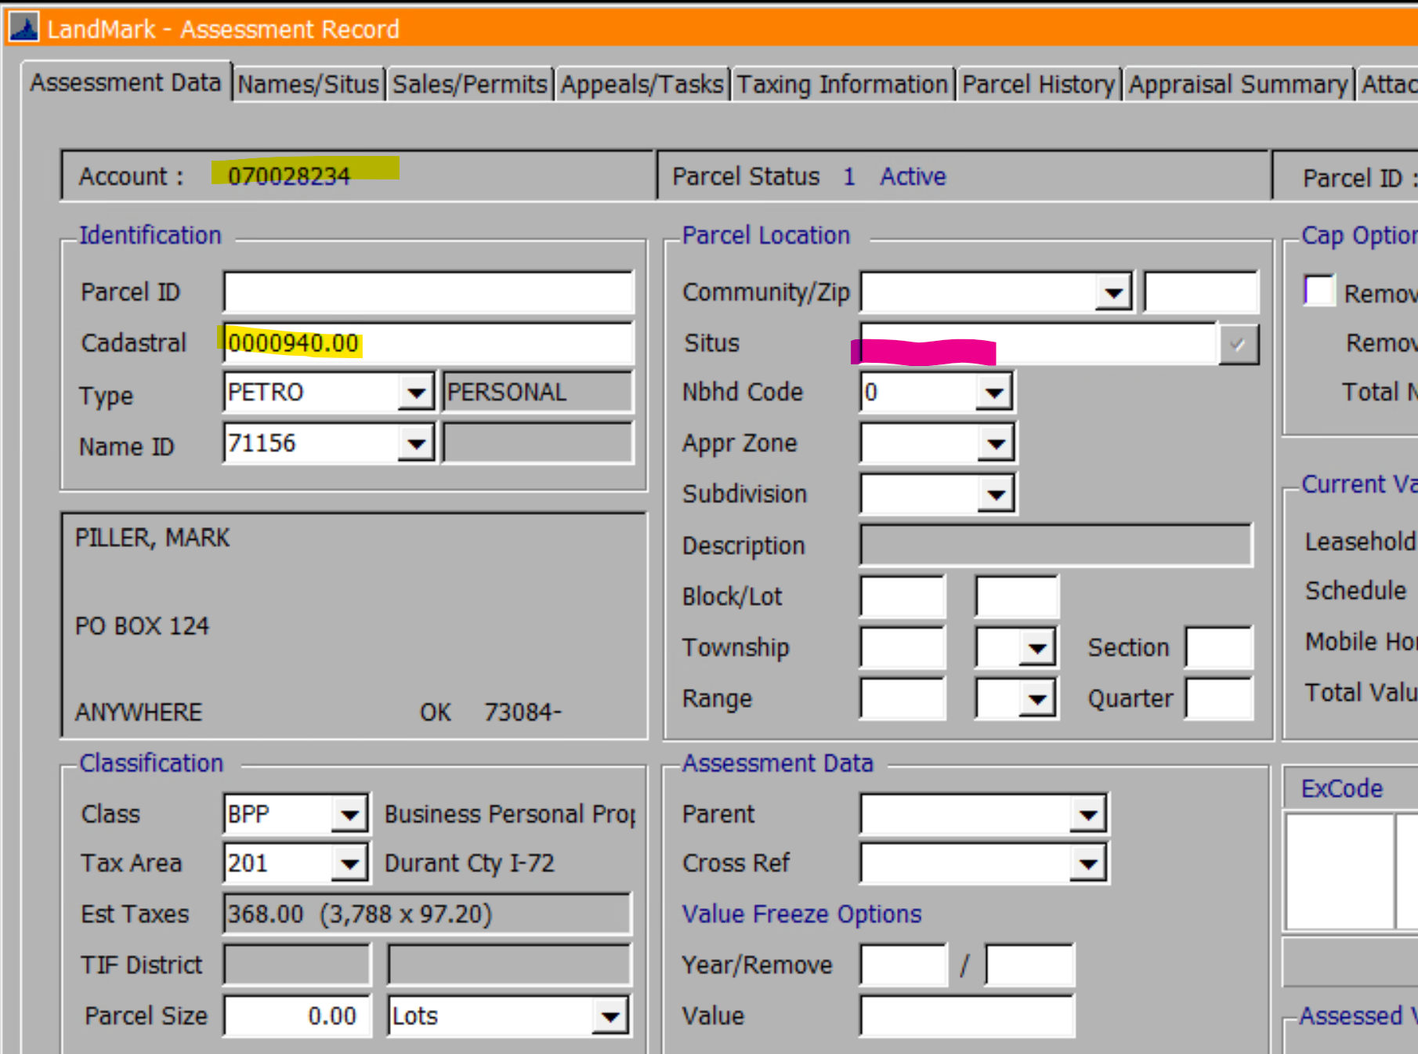
- The school district is the cross reference from the tax area table.
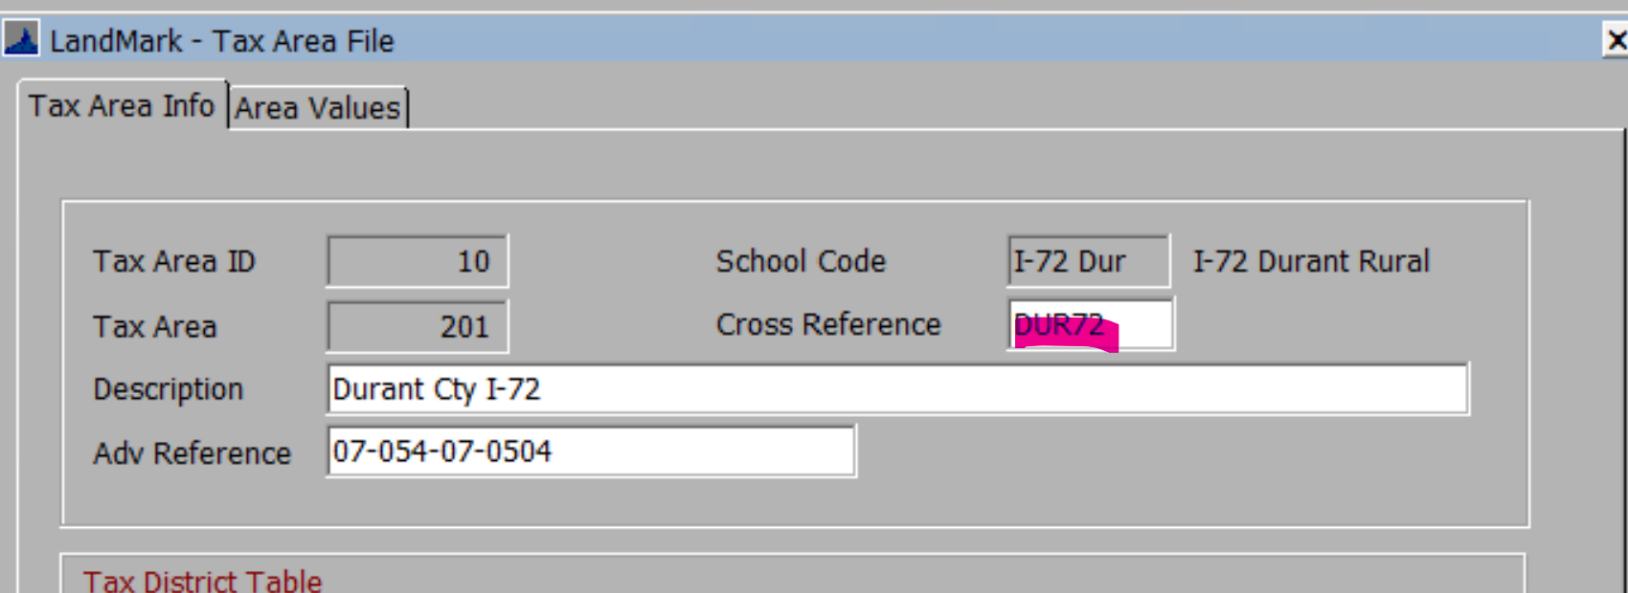

Value Information
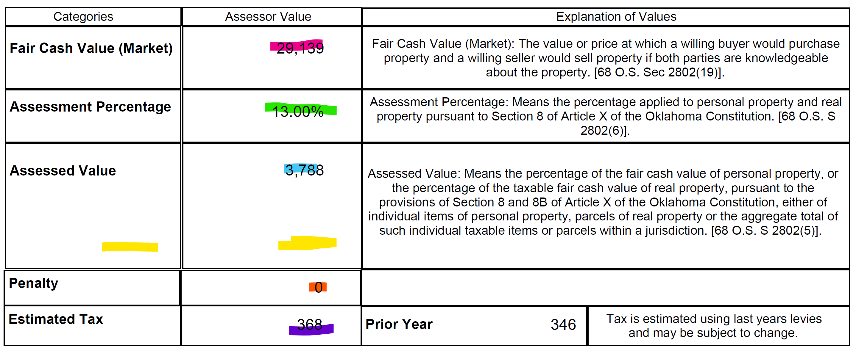
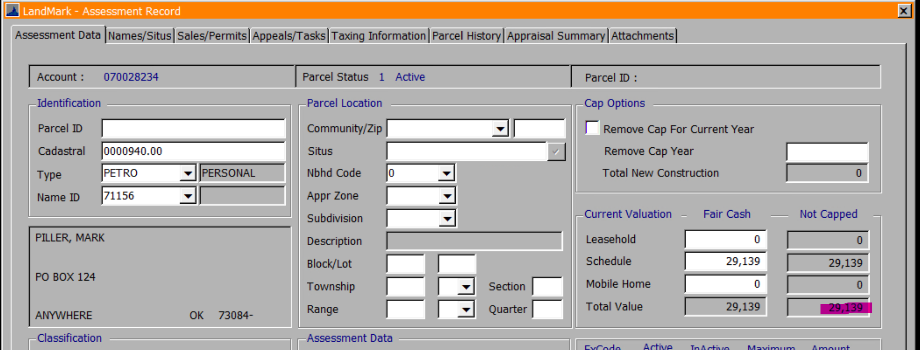
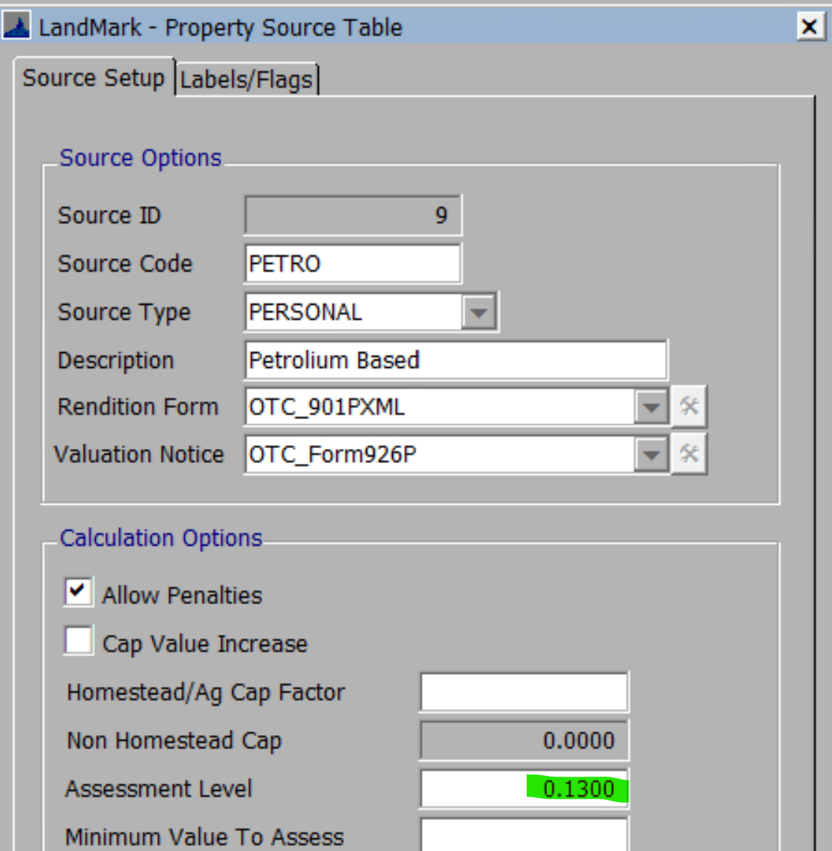
- Assessed value will be the Fair Cash Value (Market) * assessment level.
- Yellow If there is a freeport or exemptions this will have the exemption amount and the label Exemption(-) .
- Penalty will be reported as a percentage.
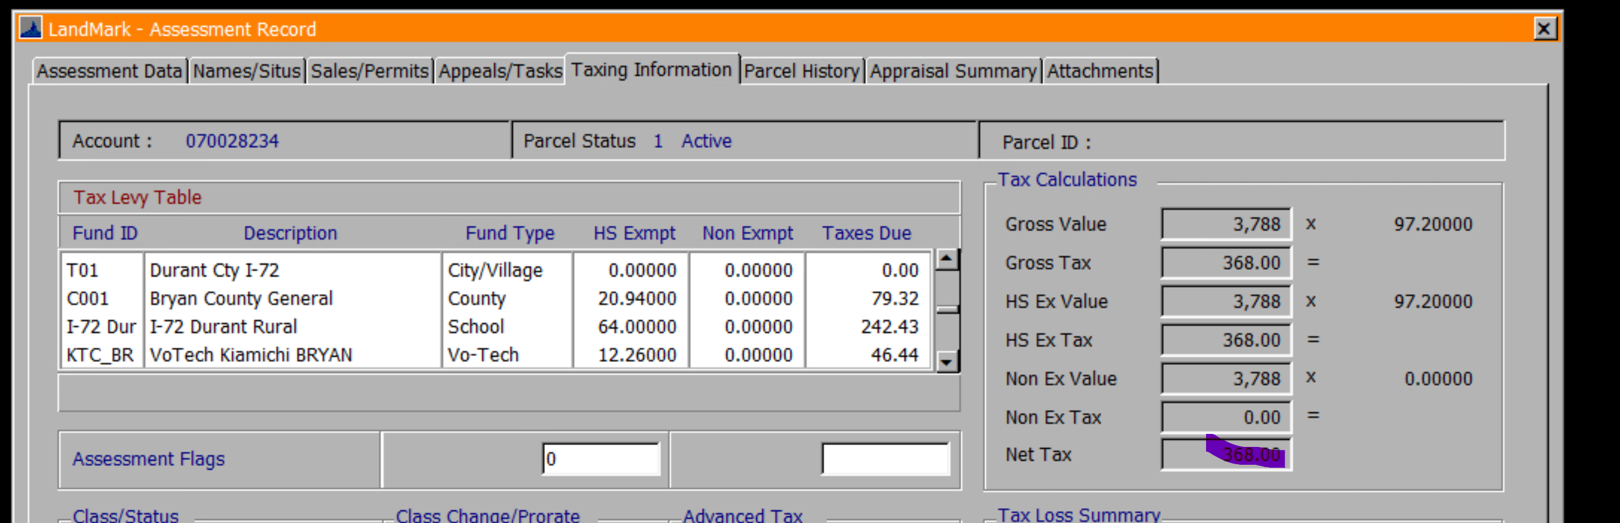
- The estimated will be the prior year that the COV is for.
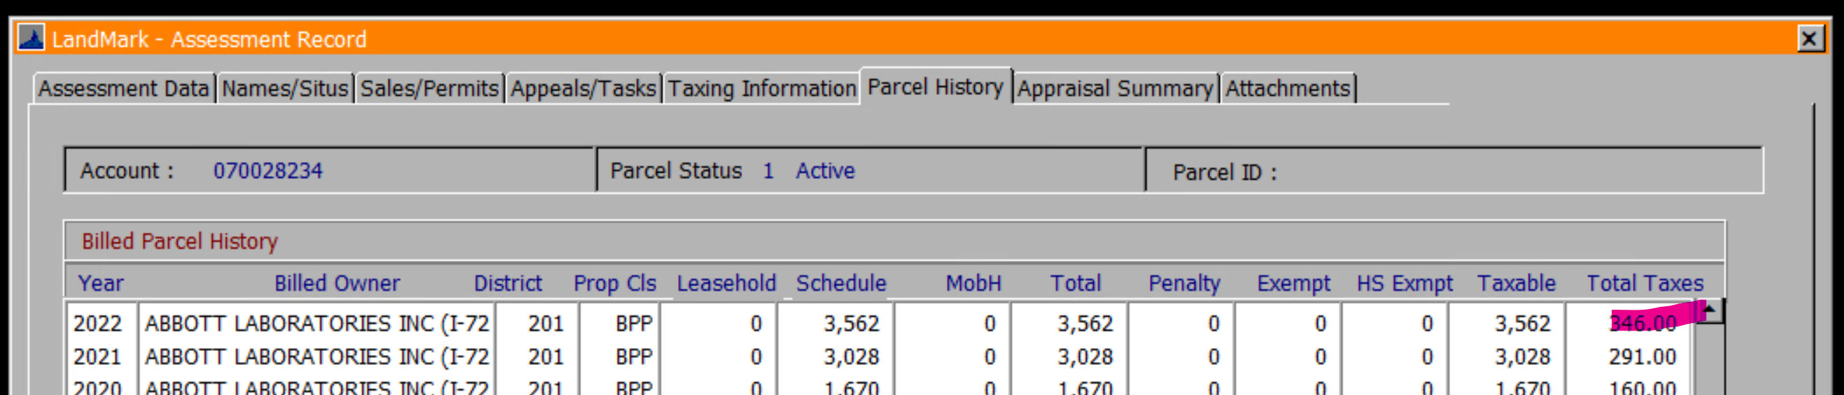

Legal
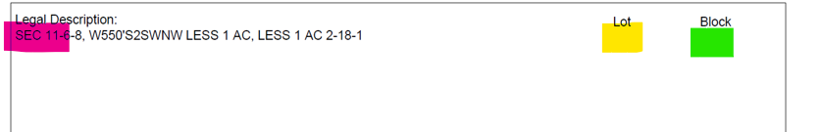
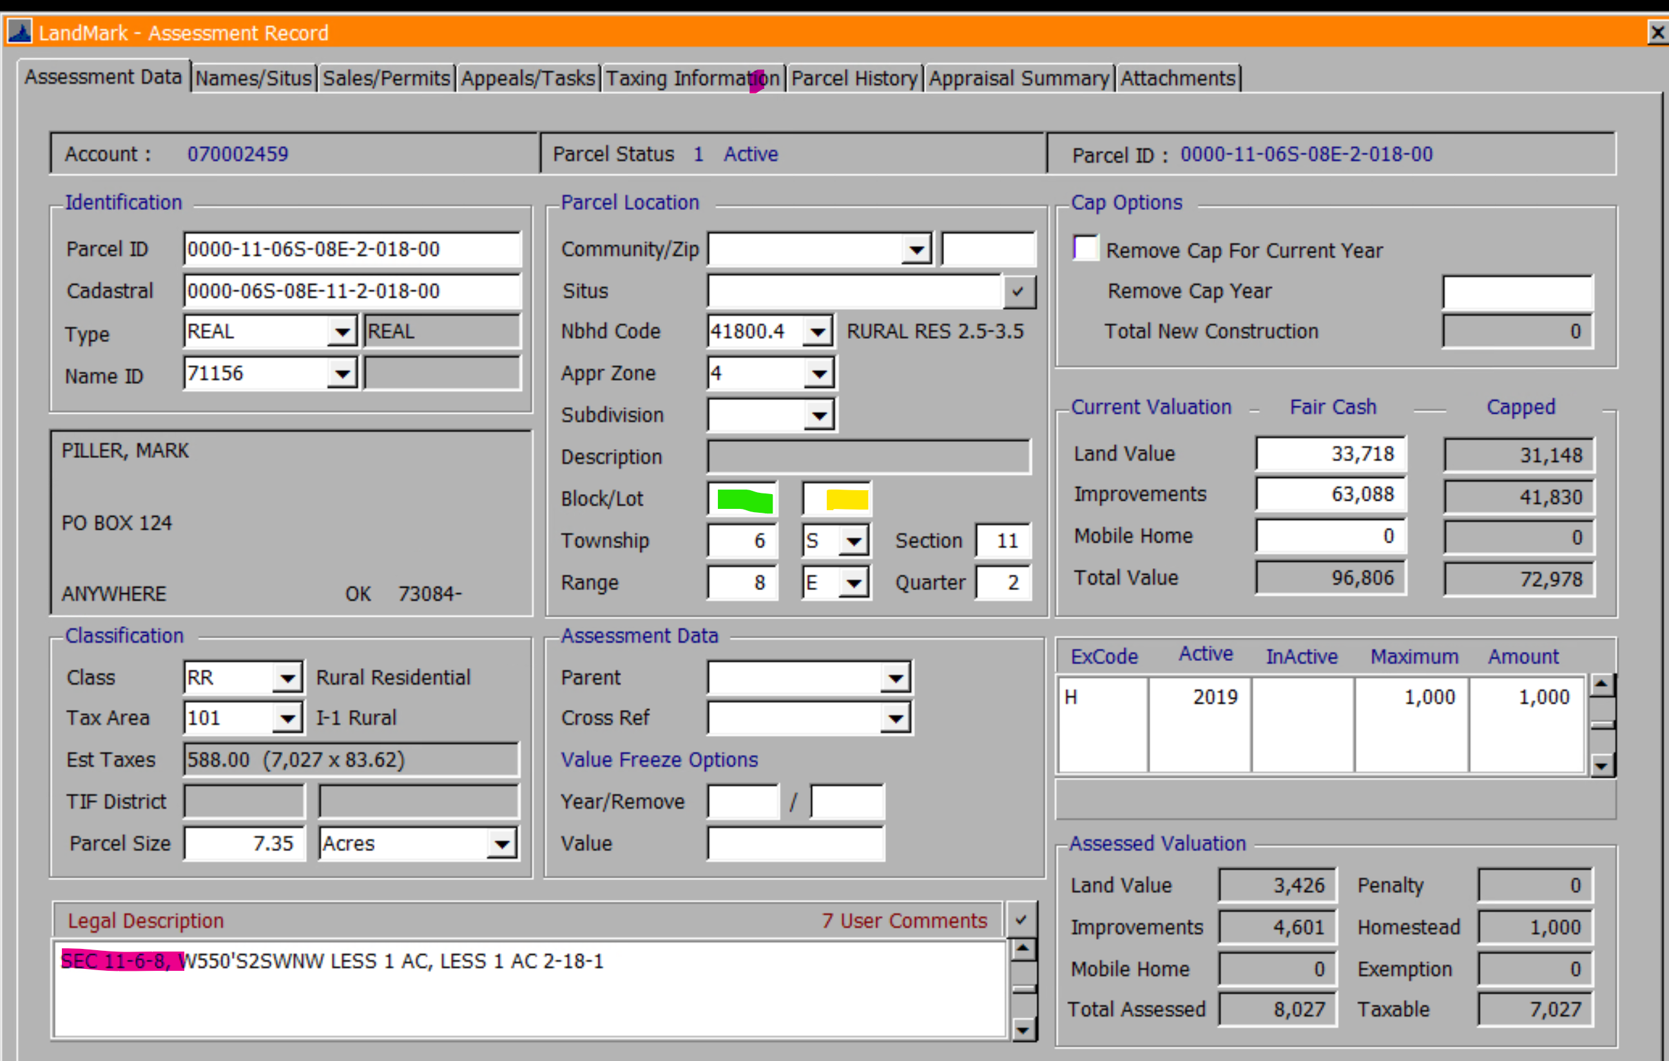

Notes
- Will be the first Notice-Text document type on the parcel with the same notice year as what is in the assessment year on the county information table.
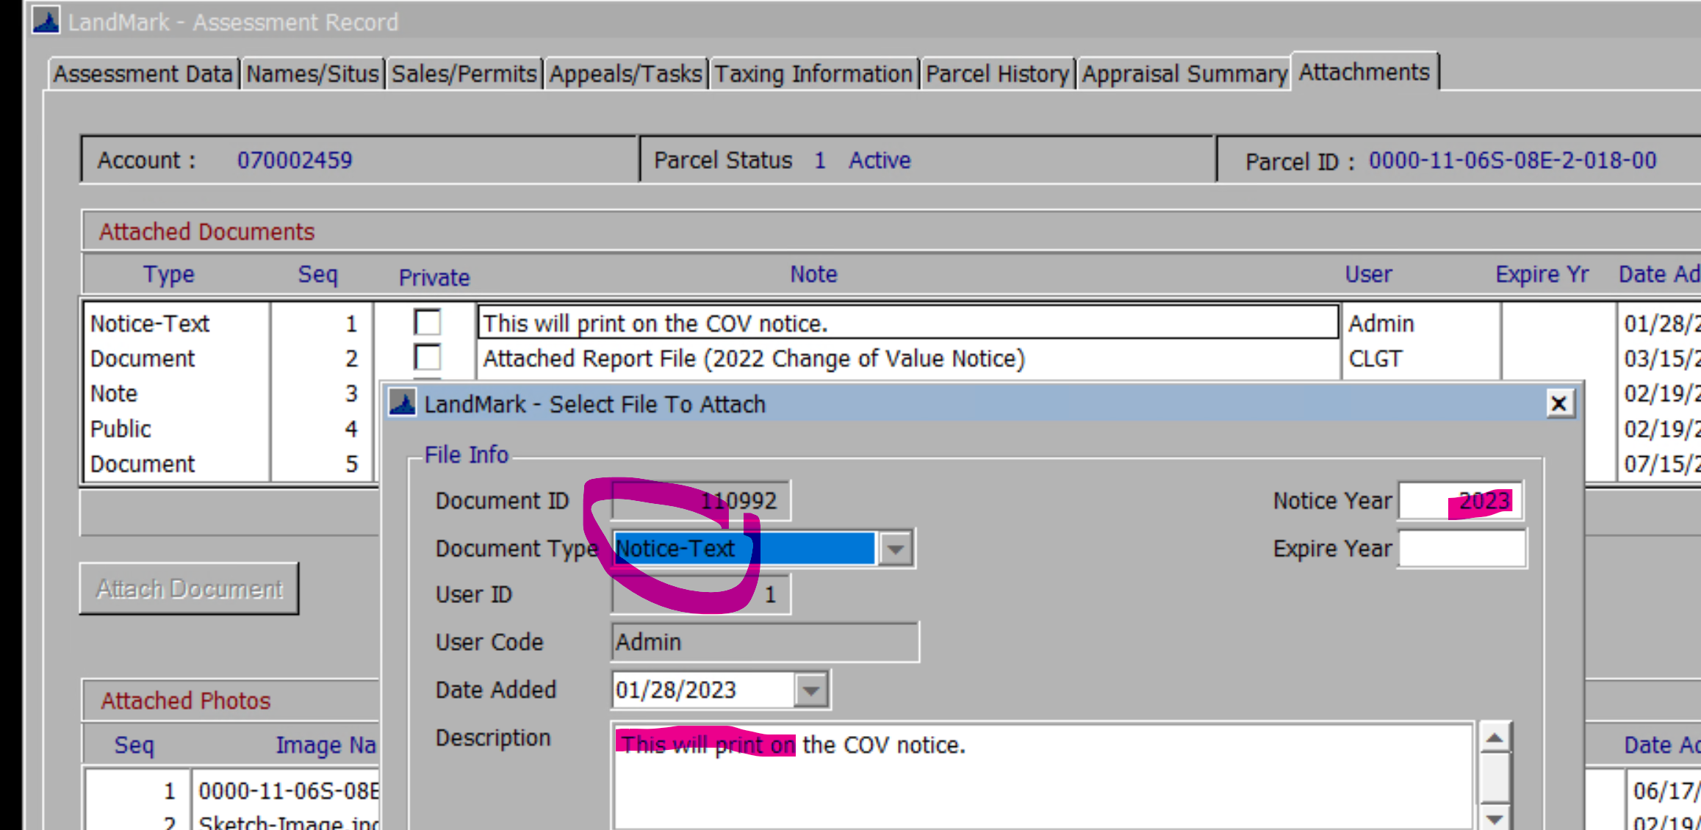

Assessor Information

- The home phone will the fax number and mailing information does not print on the form.
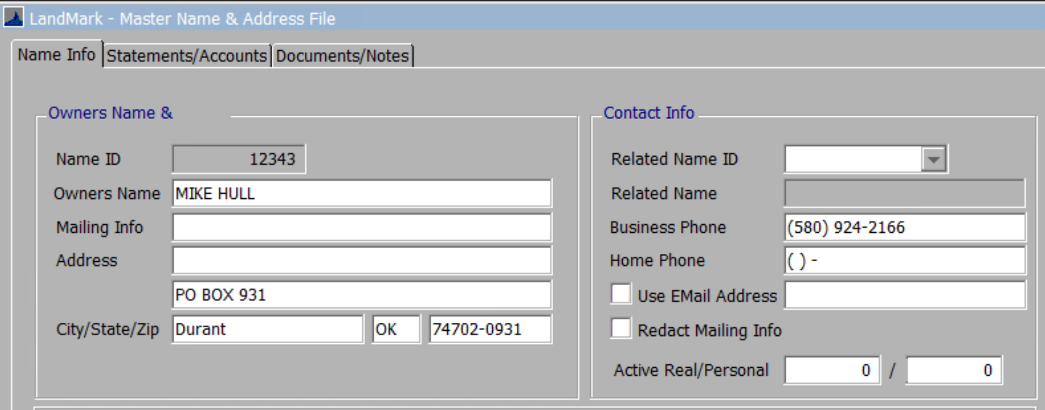

Attached Report Description
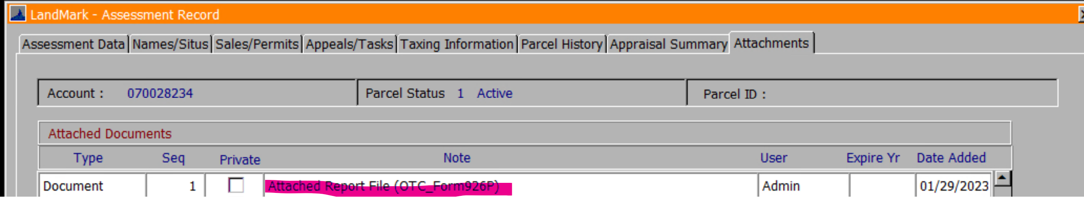
- The report title will be in parentheses.
