
LandMark GSI
OTC Form 924B
Delivered: 12/20/2021
Version History
Version # | Date | Revised By | Reason for change
1.00 | 12/20/2021 | Mark Piller | - Initial Version
1.01 | 10/12/2023 | Mark Piller | - Review

Contents
Purpose 2
Brief Report Description 2
Parameters 2
DOCKDETAILS 3
USEASSESSMENTVALUE 3
Information 3
Boat Dock Information 3
Value Information 5
Example 6

Purpose
The purpose of this document is to document what sections will print/not print based on parameters that can be set up. This will grow to include fields printing and other information on the report as versions of the document are expanded.

Brief Report Description
This report is printed for boat dock accounts.
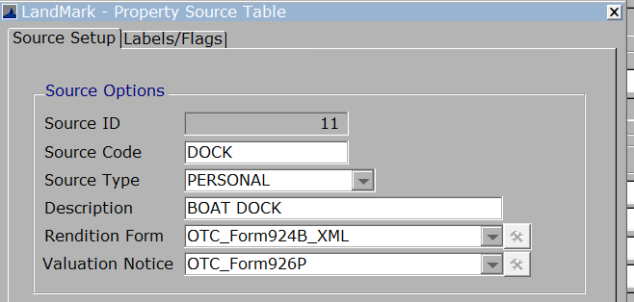

Parameters
These are the parameters that effect the printing of sections on the report. When the parameter is not in the parameters table there is a default.
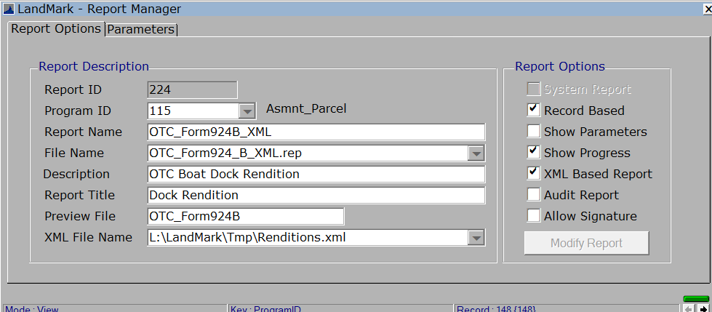
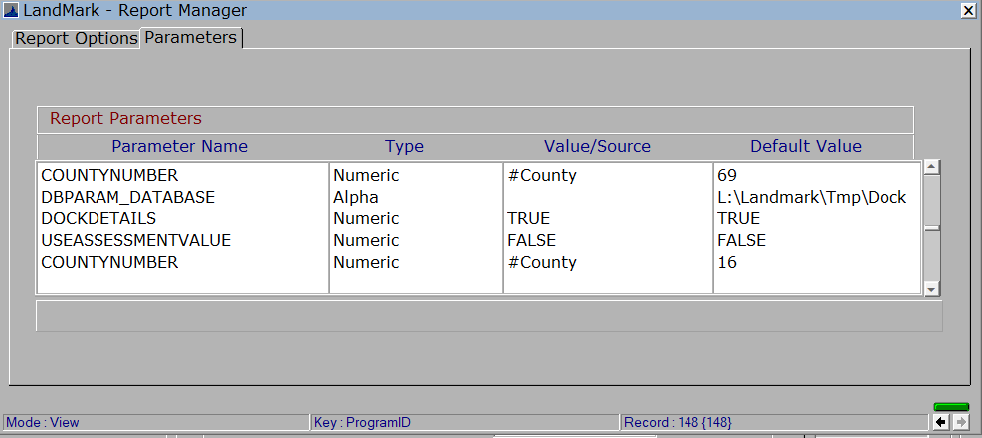

DOCKDETAILS
Default - True
What will not print if set to false
The boat information will not print.
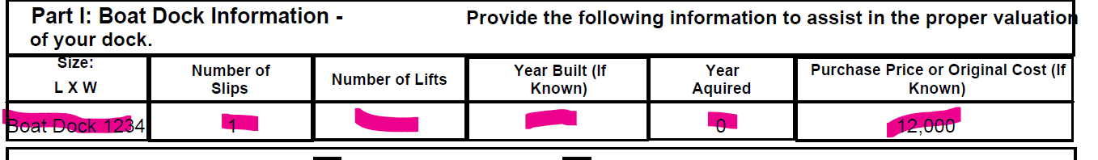

USEASSESSMENTVALUE
Default - True
This option determines the value information in the office information section of the report. If true the values will be from the assessment form otherwise information will pull from the appraisal file.If you are going to read the appraisal information into the assessment screen you may want the parameter to be set to false.

Information

Boat Dock Information
In order to print the item code must be 1143. If there are multiple 1143 items only the first record will print.
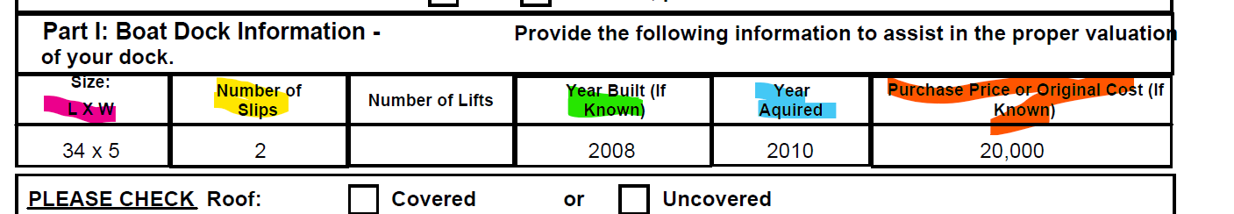
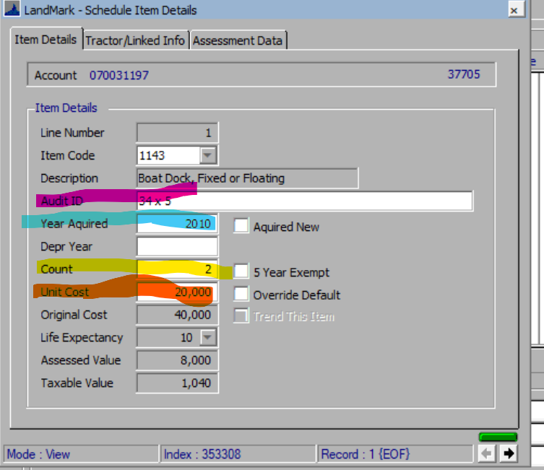
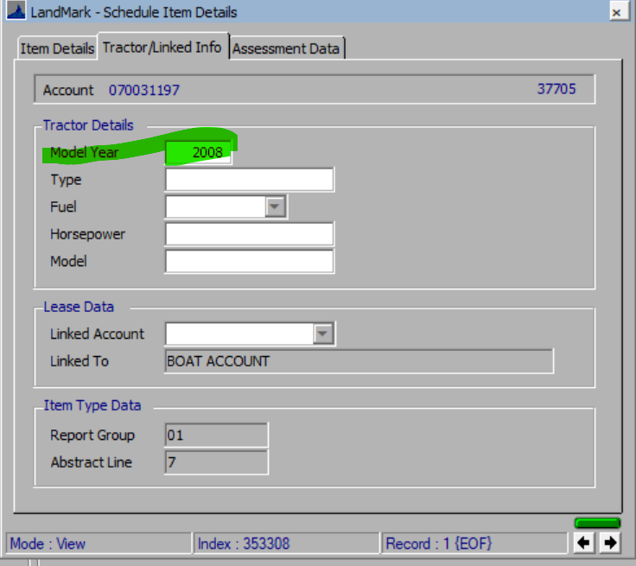
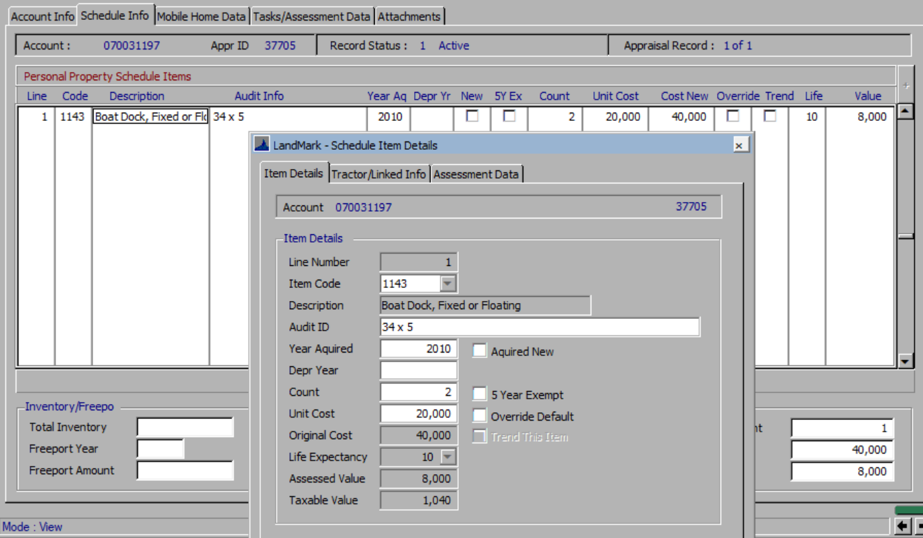

Value Information
The information for the boat dock information is coming from the appraisal record. The value information is coming from the assessment screen.

If Parameter USEASSESSMENT is true

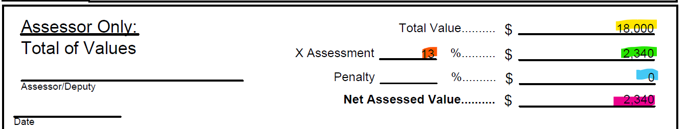
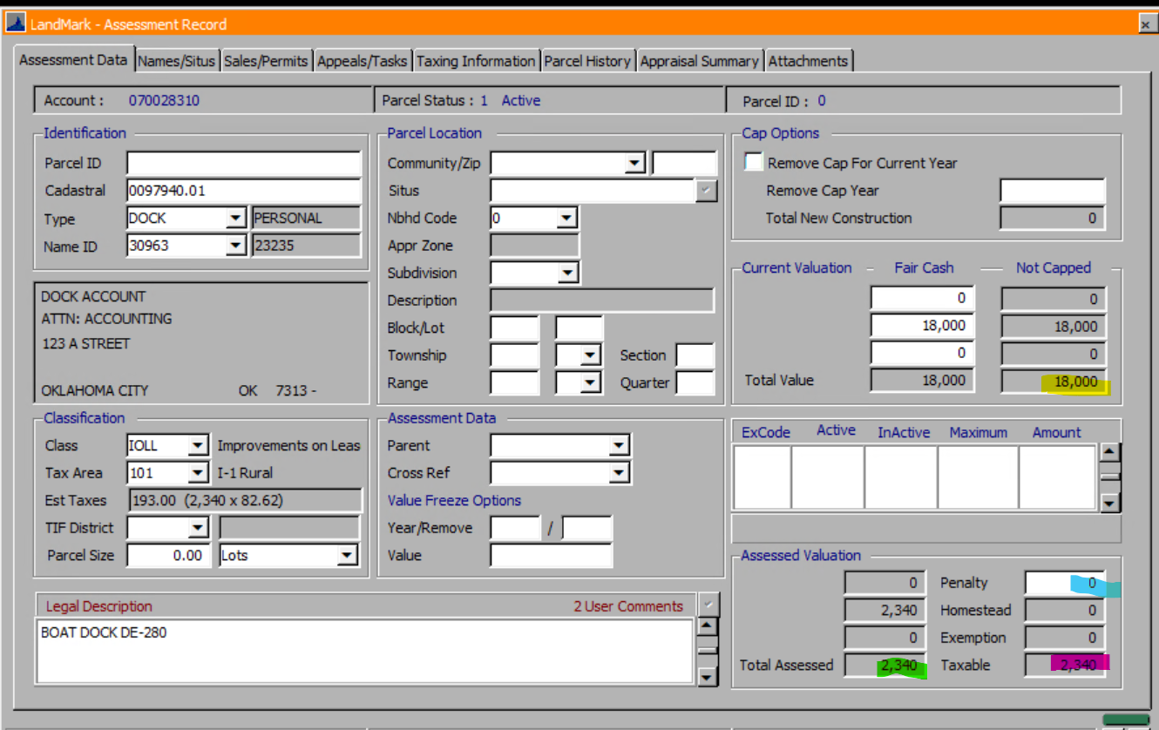
If Parameter USEASSESSMENT is false
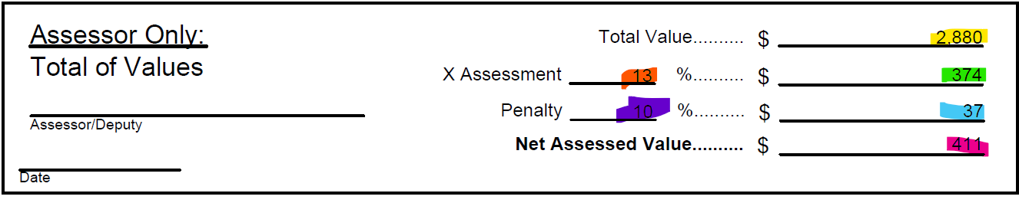
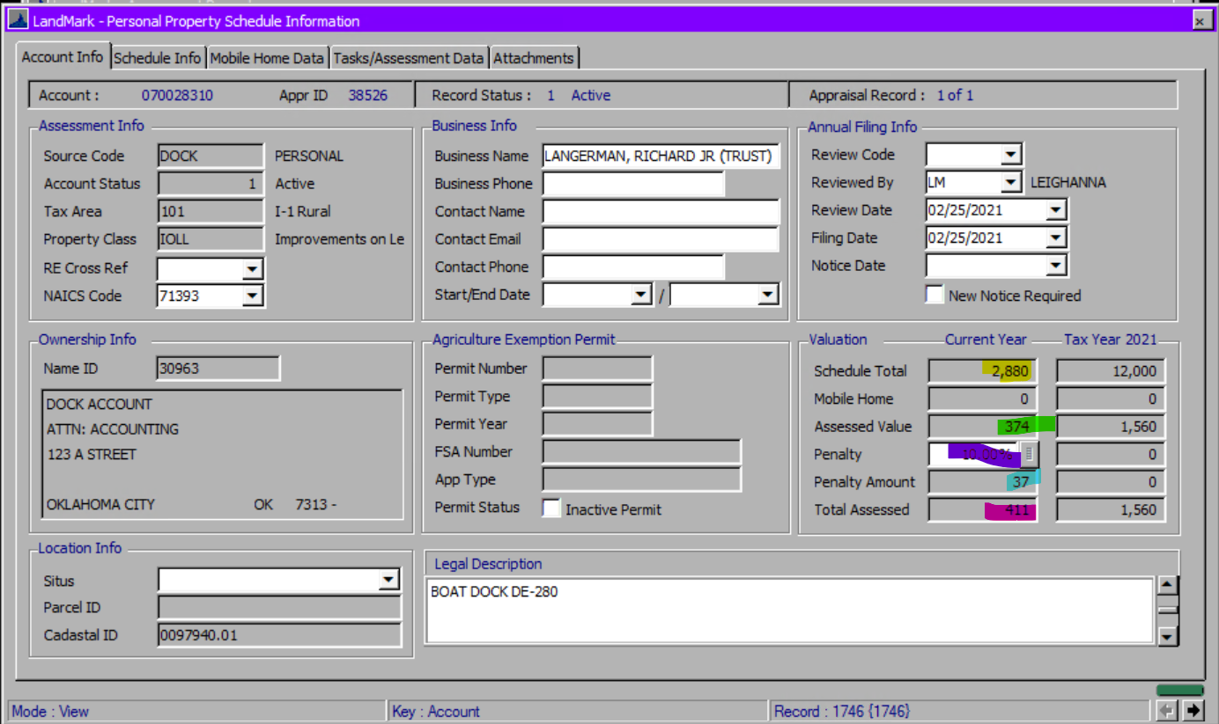
For Source
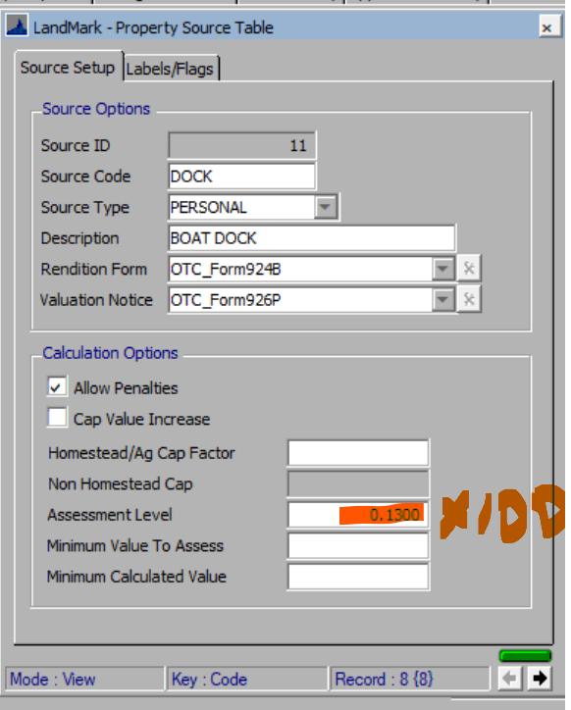

Example

