
LandMark GSI
OTC Form 924
Delivered: 12/01/2021
Version History
Version # | Date | Revised By | Reason for change
1.00 | 12/1/2021 | Mark Piller | - Initial Version
1.01 | 10/12/2023 | Mark Piller | - Review

Contents
Purpose 2
Brief Report Description 3
Parameters 3
PRINTTOTALS 4
INCSCHEDULE 5
INCINVENTORY 5
Information 5
Part 1 fields (Tractors) 5
Part 2 fields (Farm Equipment) 8
Part 4 fields (IOLL) 10
Schedule 10
Residential 10
Commercial 11
Miscellaneous 12
Outbuilding 12
Schedule Information 13
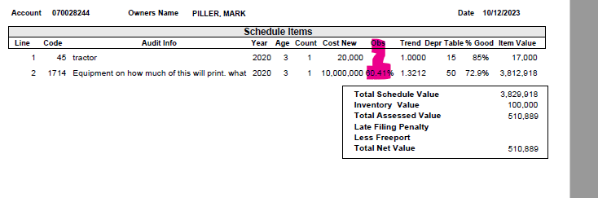 14
Examples 14

Purpose
The purpose of this document is to document what sections will print/not print based on parameters that can be set up. This will grow to include fields printing and other information on the report as versions of the document are expanded.

Brief Report Description
This report is printed for individual and IOLL accounts
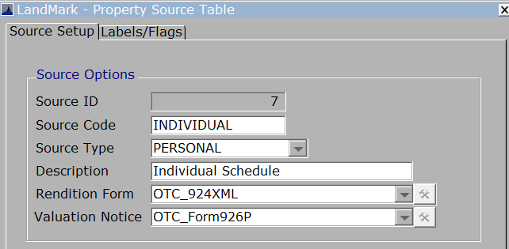
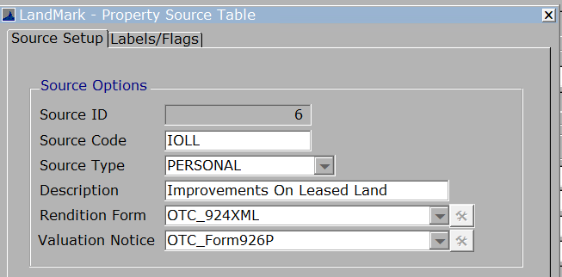

Parameters
These are the parameters that effect the printing of sections on the report. When the parameter is not in the parameters table there is a default. In the case of this report there are no parameters that cause sections to print or not.
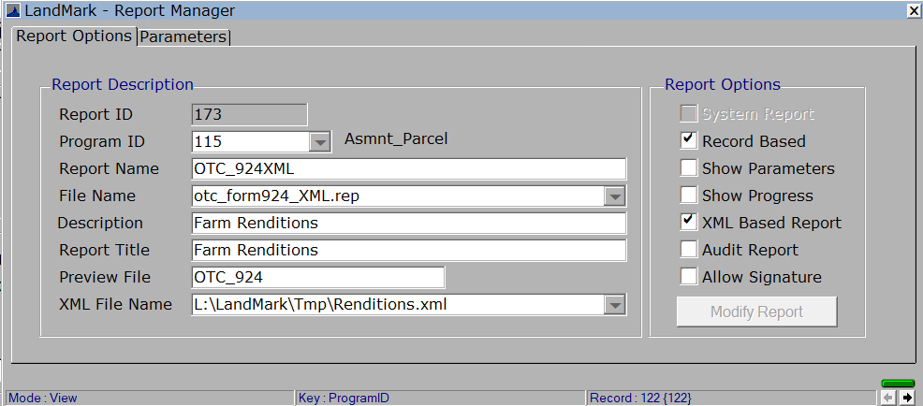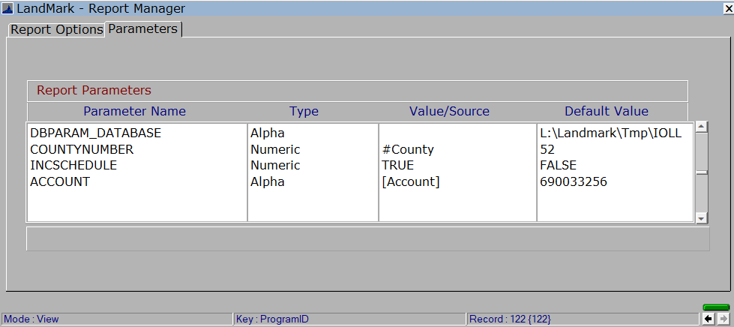

PRINTTOTALS
Default - True
What will not print if set to false
- The total values will print if set to false.
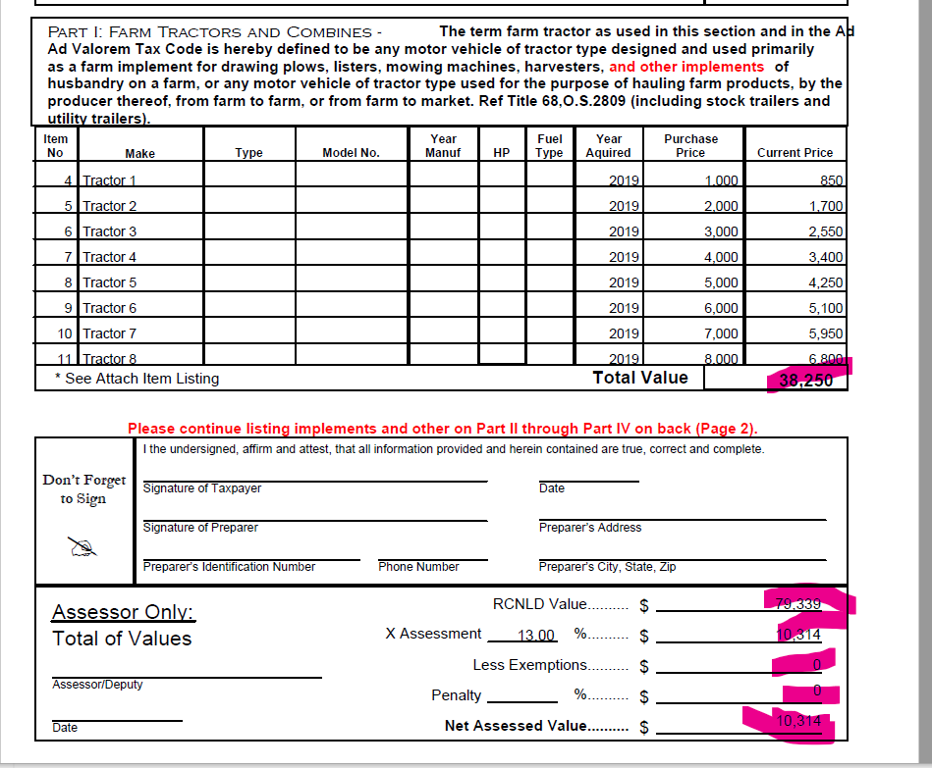
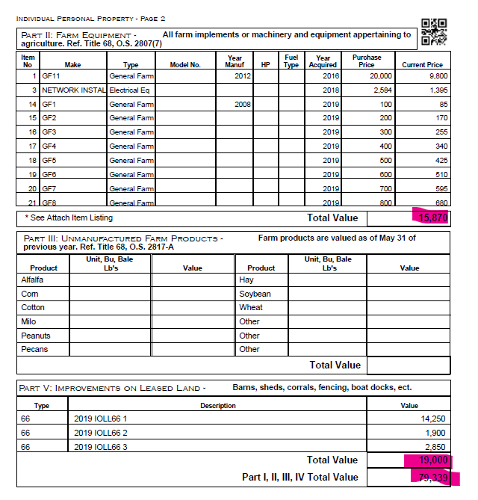

INCSCHEDULE
Default – False
What will print if set to True
- The schedule items of the personal property account. For this section to print the parameters PRINTALLPAGES and INCSCHEDULE will need to be set to TRUE, there will need to be schedule items on the account, and not using the OTC SQFT method.
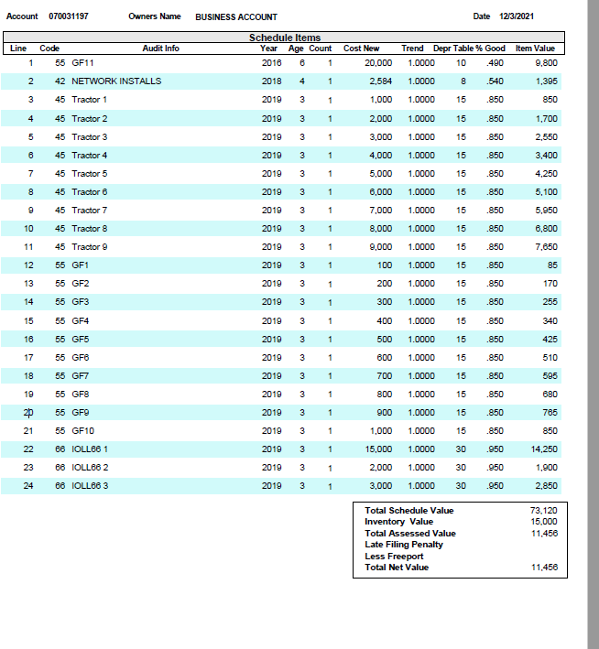

INCINVENTORY
Default - True
This parameter determines what prints for the freeport amount on the schedule listing. The parameter INCSCHEDULE must be set to true for this to have any effect.
If set to false the freeport amount will be 0. If true and the freeport year on the appraisal match the county information assessment year then the freeport amount * assessment level will print.

Information

Part 1 fields (Tractors)
The records are selected based on the schedule info where the OTC Form 924 part is set to 01.
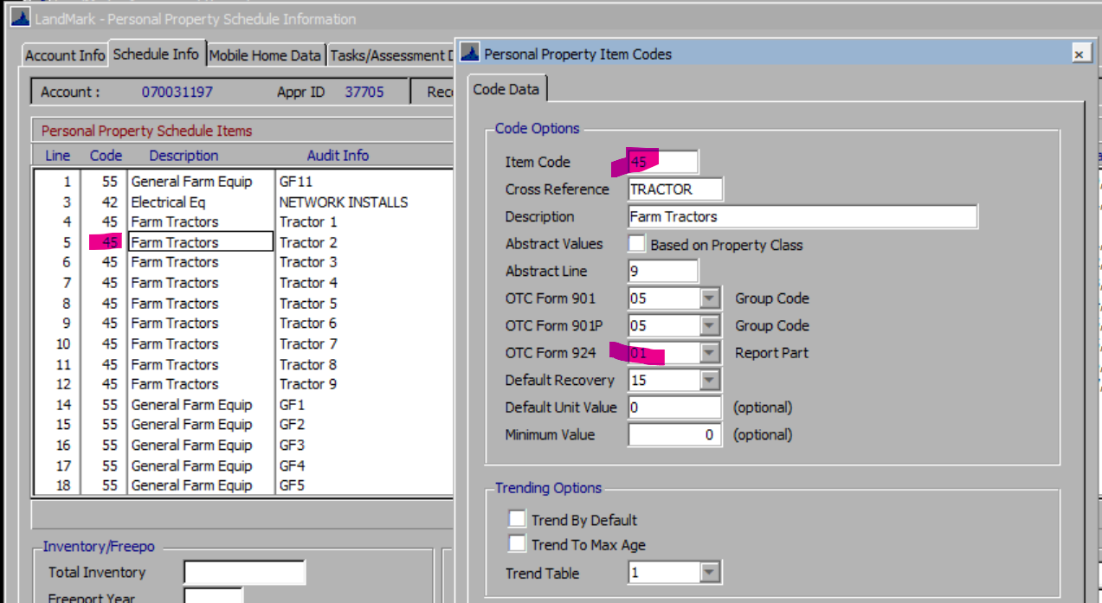

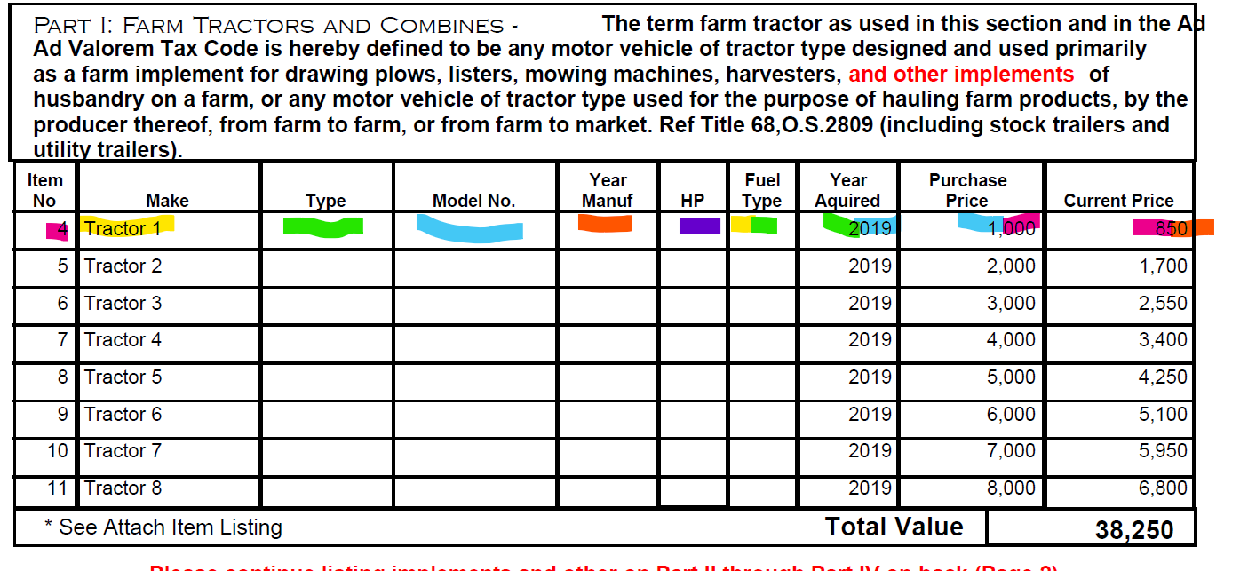
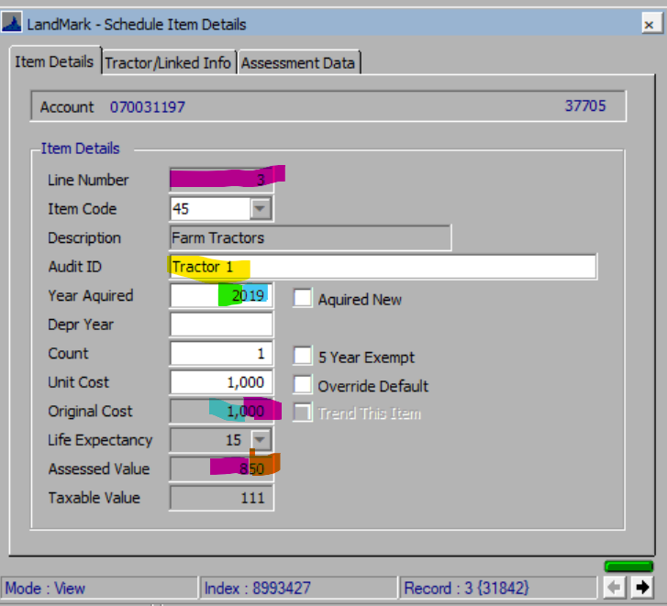
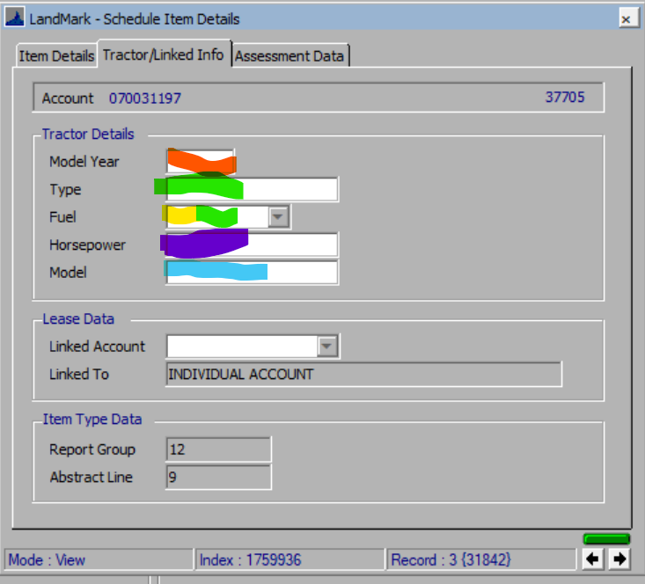

If there are more than 8 tractors, then the additional tractors will print at the end of the report.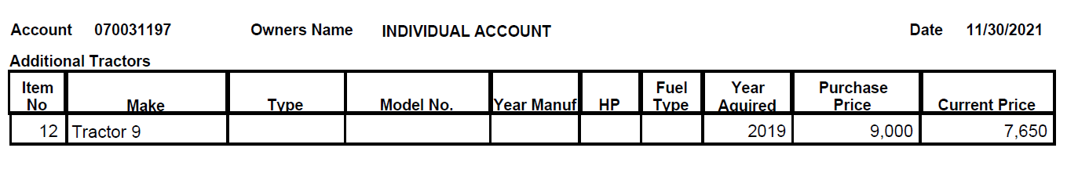

Part 2 fields (Farm Equipment)
The records are selected based on the schedule info where the OTC Form 924 part is set to 02 or 03 or 04.
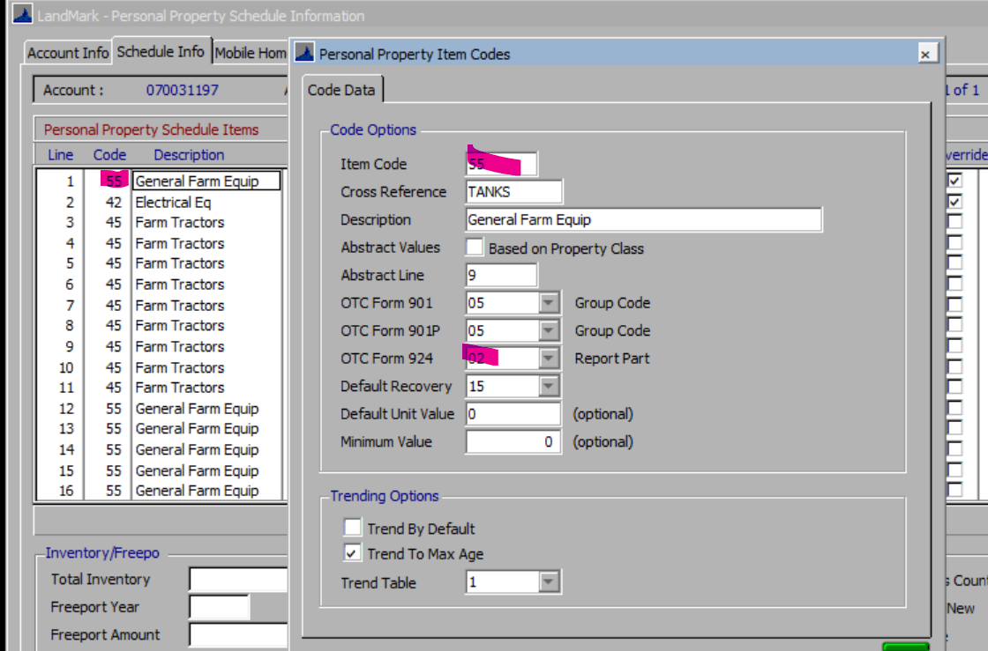

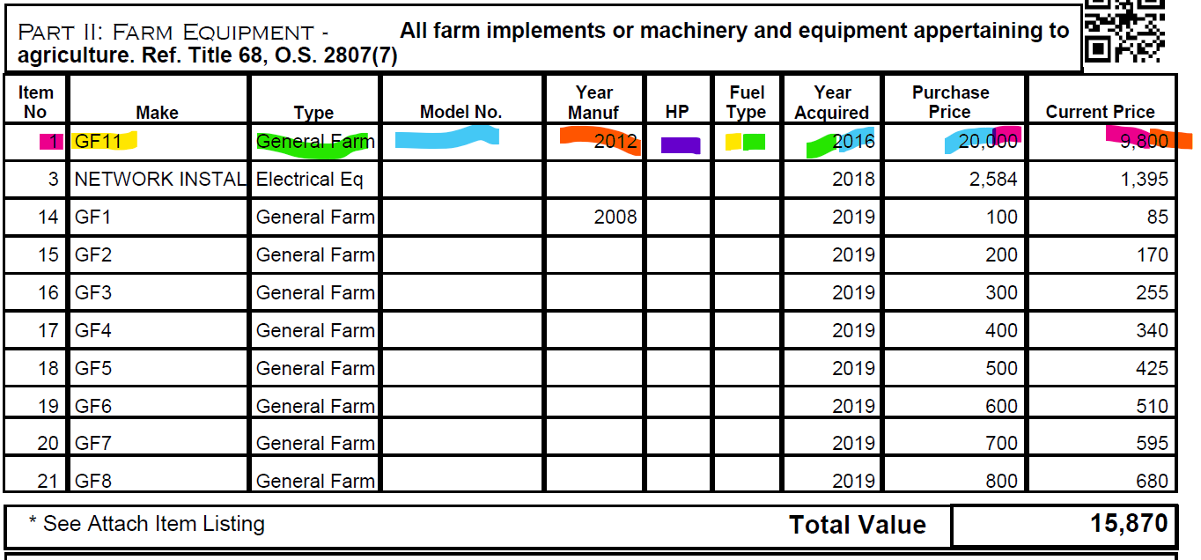
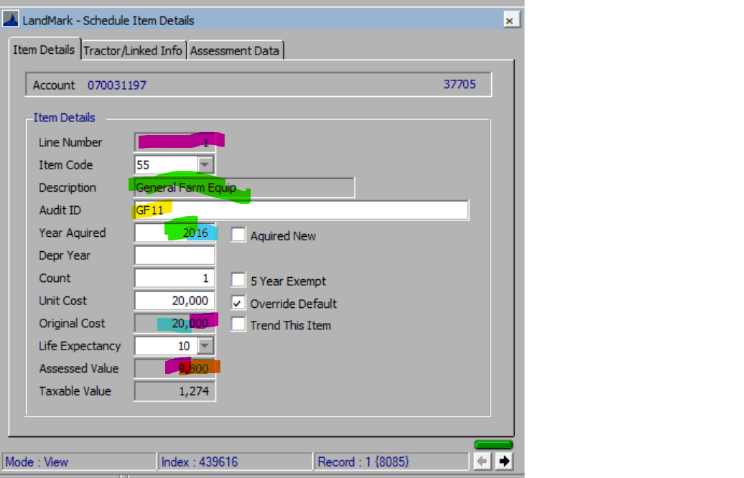
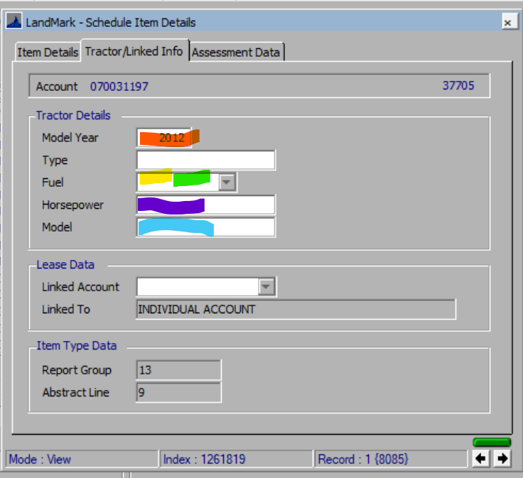
If there are more than 10 items, then the additional schedule items will print at the end of the report.
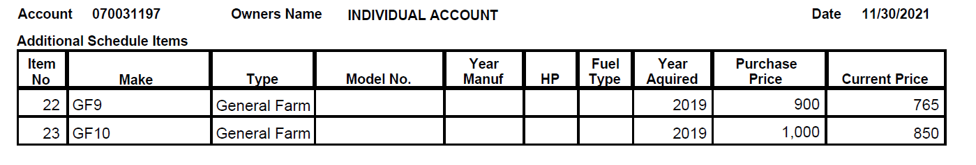

Part 4 fields (IOLL)
The records are selected based on the schedule info where the OTC Form 924 part is set to 05.
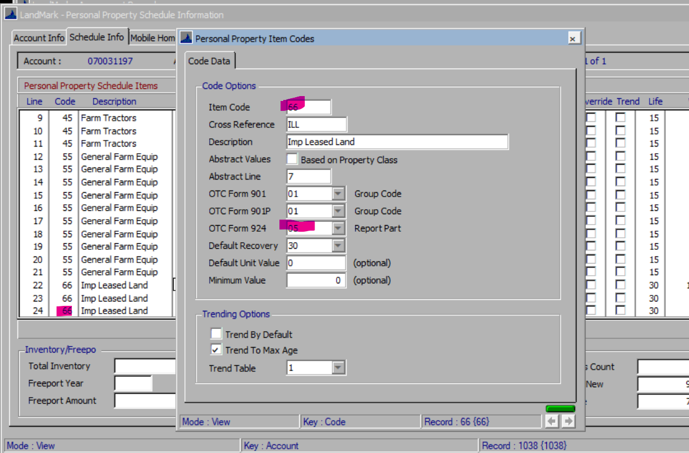
In addition to the schedule items these will print in this section if applicable to the account.
- Residential property if the type is not a mobile home
- Commercial buildings
- Miscellaneous Improvements
- Outbuildings (Site Improvements)

Schedule
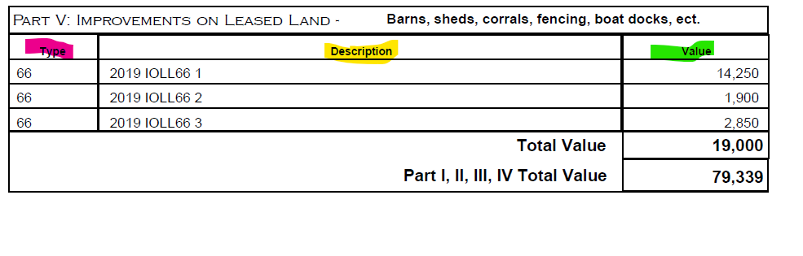

Residential
The records will be selected based on residential appraisal records for the account where the type <>6.
Type will always be “Res”
Description will be the year building along with “Resident”
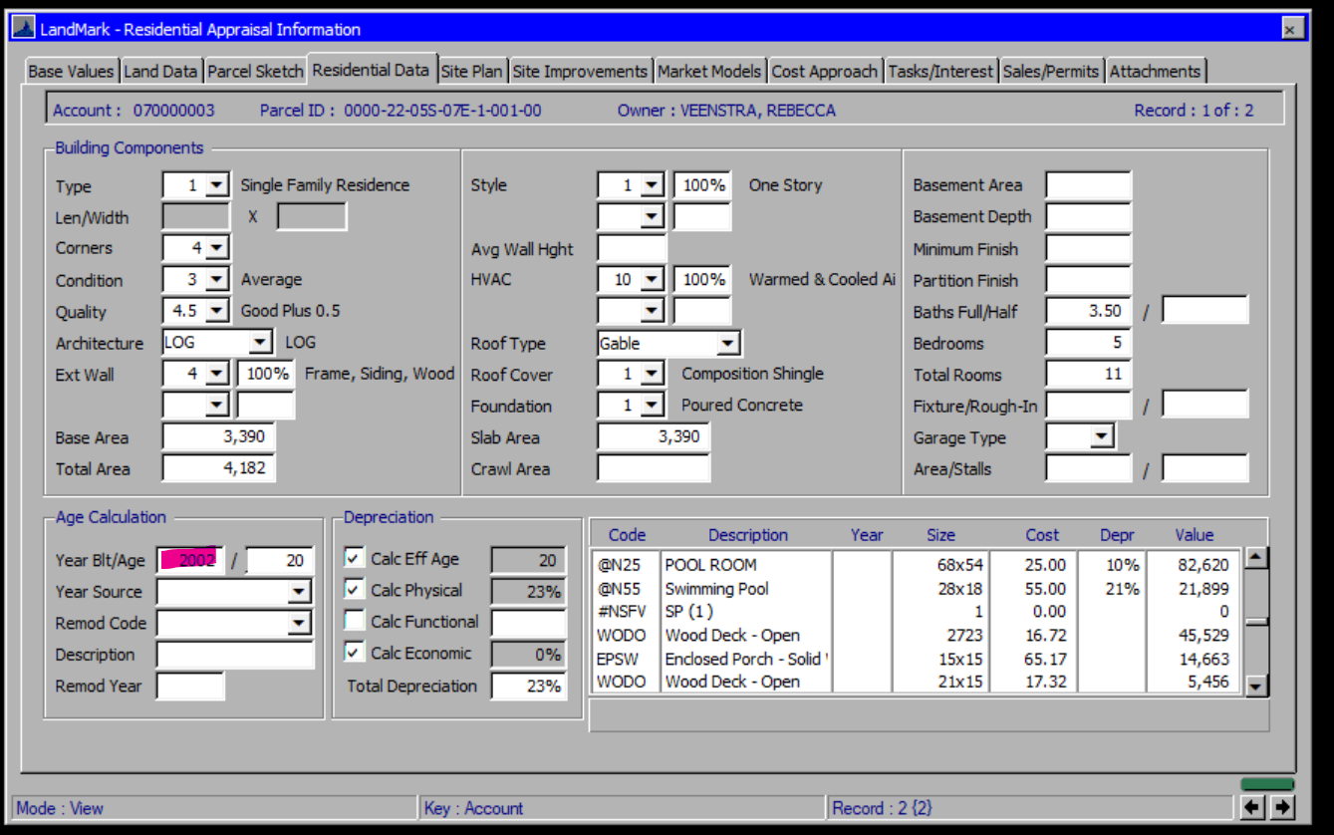
Value – Will be the RCNLD for the building
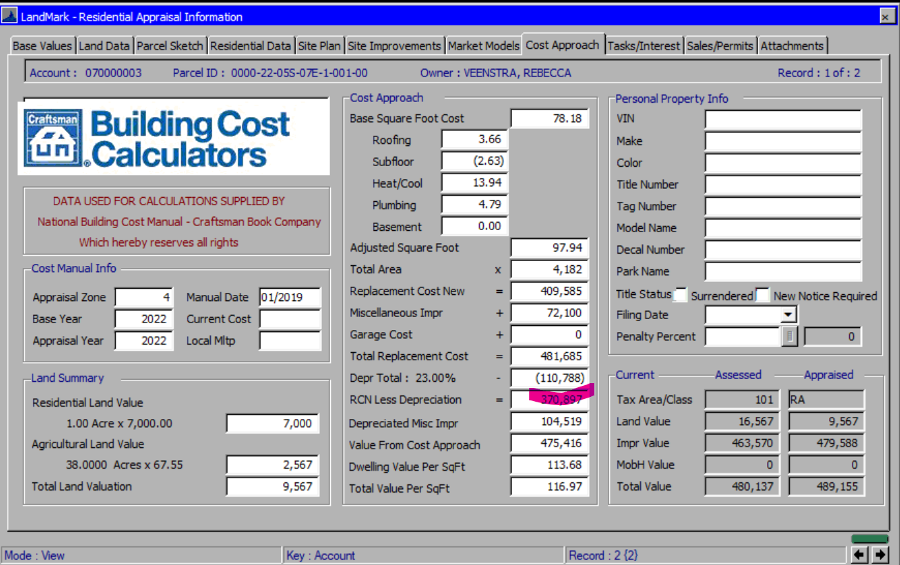

Commercial
The records will be selected based on commercial appraisal records for the account that have commercial buildings.
Type will always be “COMM”
Description will be the year built and the occupancy description.
Value-Will be RCNLD
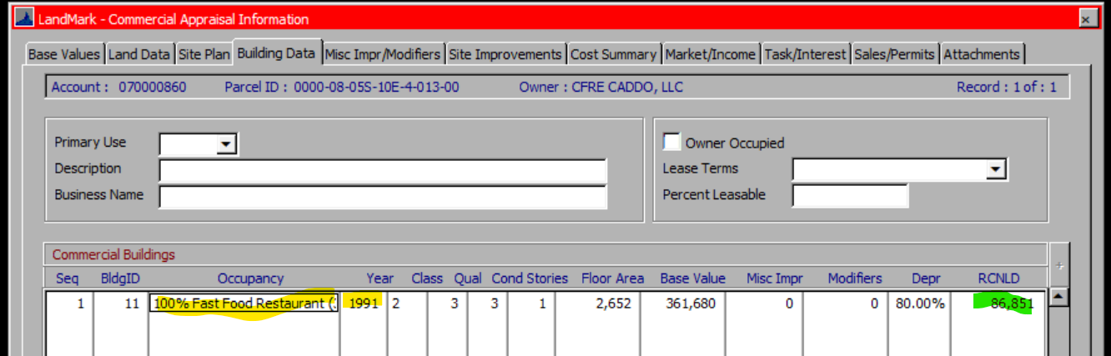

Miscellaneous
The records will be selected based on miscellaneous improvements for the account where the type <>6.
Type – Will be the miscellaneous code
Description – Will be the year followed by the description
Value – Will be the value for the improvements.
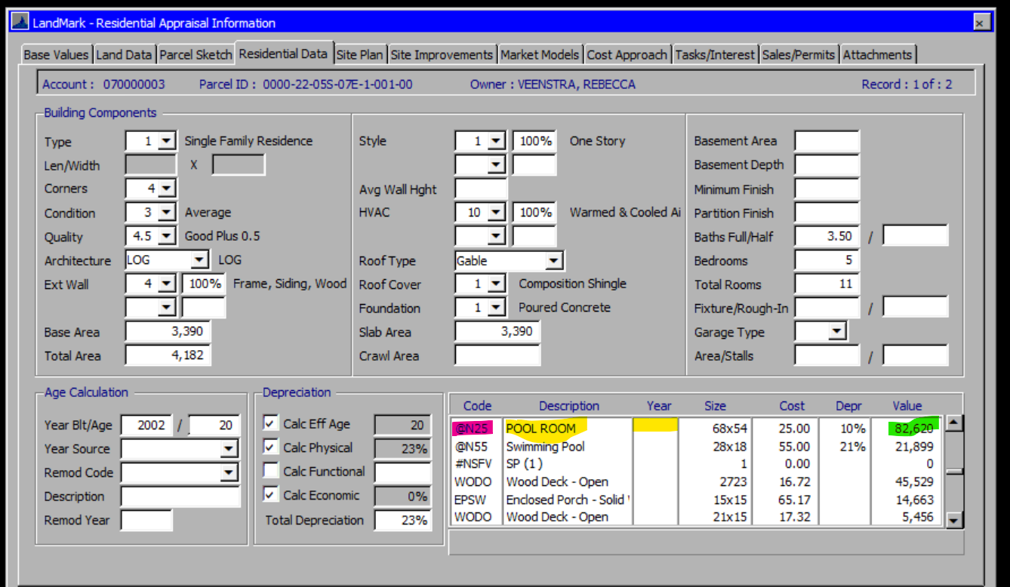

Outbuilding
This will be the outbuildings for the accounts
Type – Will be the miscellaneous code
Description – Will be the year followed by the description
Value – Will be RCNLD
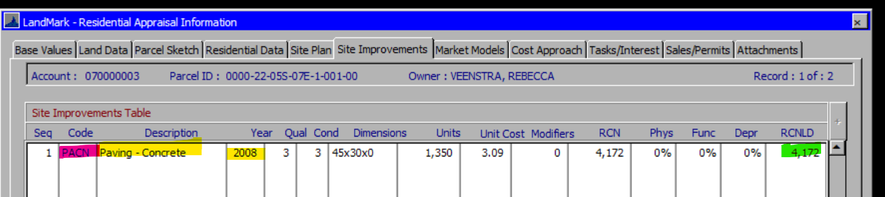
If there are more than 3 items, then the additional IOLL records will print at the end of the report.

Schedule Information
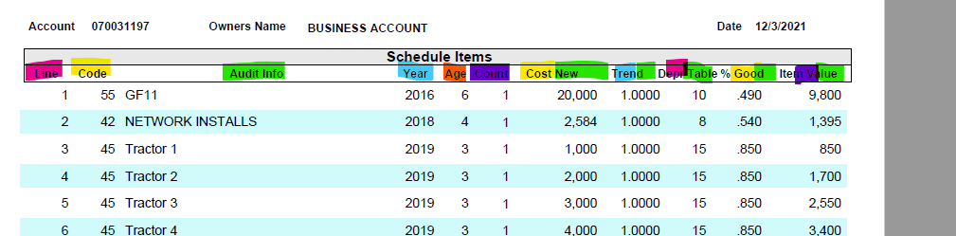

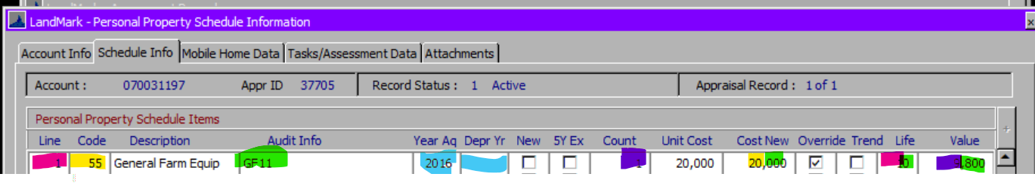
Year will be the depreciation year if there is otherwise year acquired
Age will be Assessment year in county information table – {Year}
If item is trended, then this is based on the age of the item and value in the table. If not trended this will be 1.
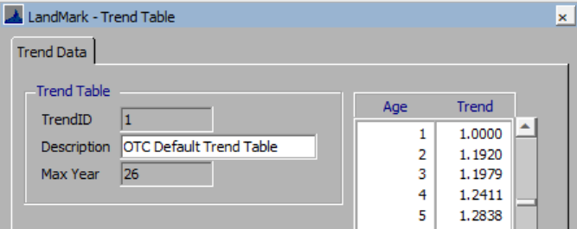
The % good will be based on the value for the recovery table being used and the age of item.
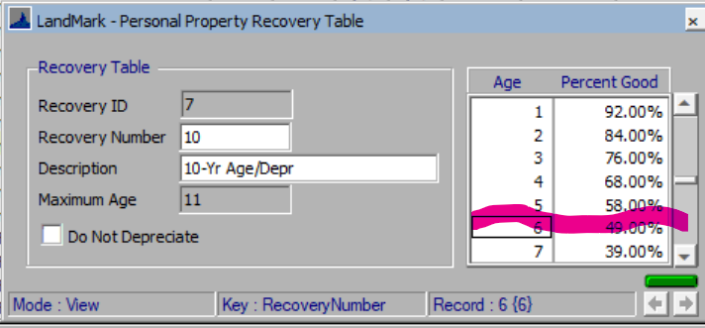
Obsolesce is on the report now as of Oct 2023.

Examples

