
LandMark GSI
OTC Form 901P
Delivered: 11/23/2021
Version History
Version # | Date | Revised By | Reason for change
1.00 | 11/23/2021 | Mark Piller | - Initial Version
1.01 | 12/27/2021 |  | - INCLUDESCHEDULE
1.02 | 10/12/2023 | Mark Piller | - Review

Contents
Purpose 2
Brief Report Description 2
Parameters 3
PRINTALLPAGES 3
INC904 4
INCLUDESCHEDULE 4
BEGPRINTTOTALS 5
PRINTTOTALS 6
PRINTTOTALS and PRINTALLPAGES 6
INCSIGPG 7
Examples 7

Purpose
The purpose of this document is to document what sections will print/not print based on parameters that can be set up. This will grow to include fields printing and other information on the report as versions of the document are expanded.

Brief Report Description
This report is printed for petroleum accounts.
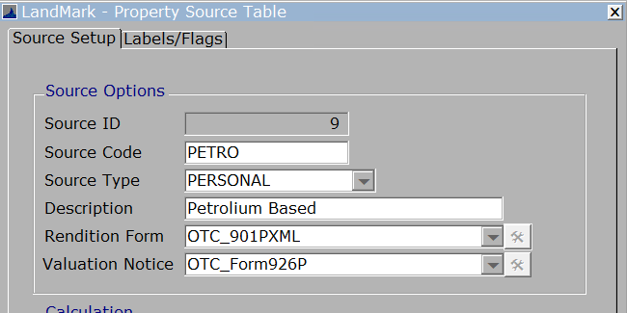
If there are schedule items on the account, then the schedule list will print and INCLUDESCHEDLE is set to true.
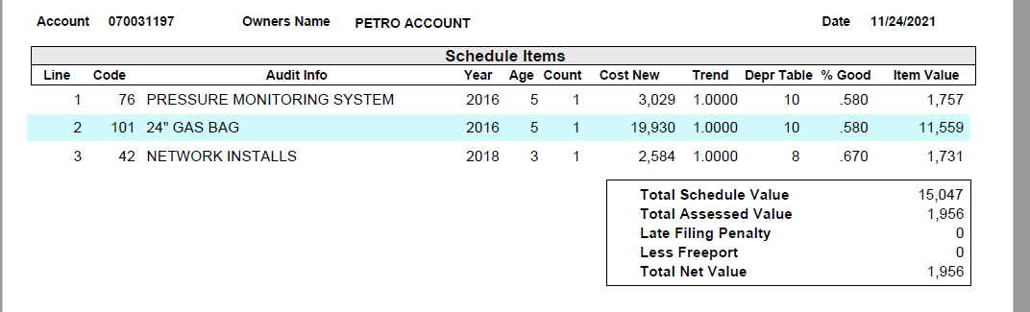
If there are no scheduled items, then then OTC 904-3-P will print after the 901P.
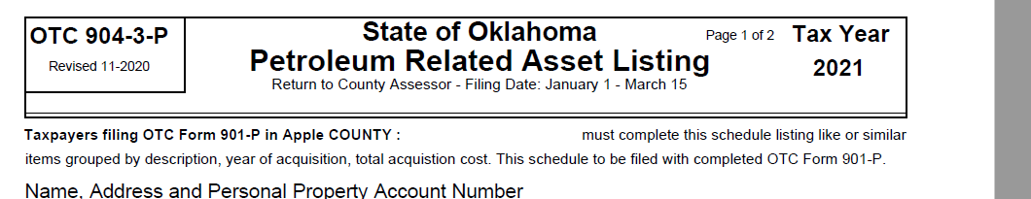

Parameters
These are the parameters that affect the printing of sections on the report. When the parameter is not in the parameters table there is generally a default.
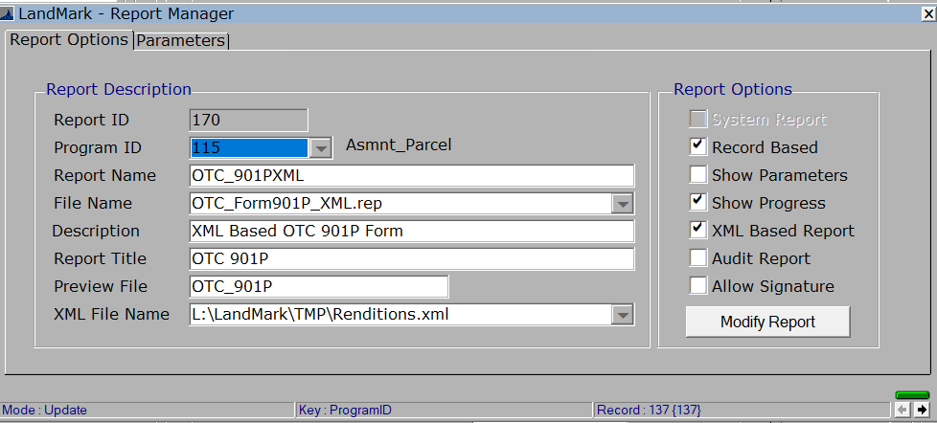
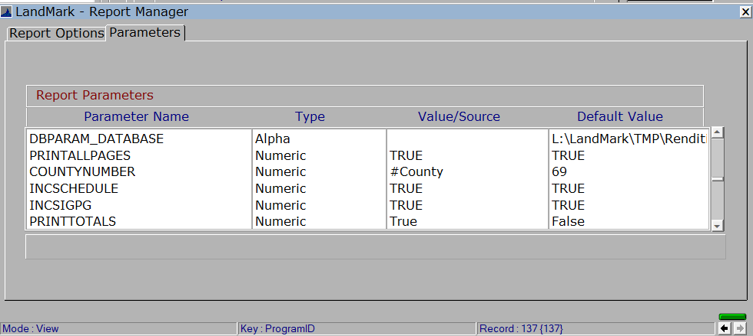

PRINTALLPAGES
Default - True
What won’t print if set to false
- Page 2 of the 901P
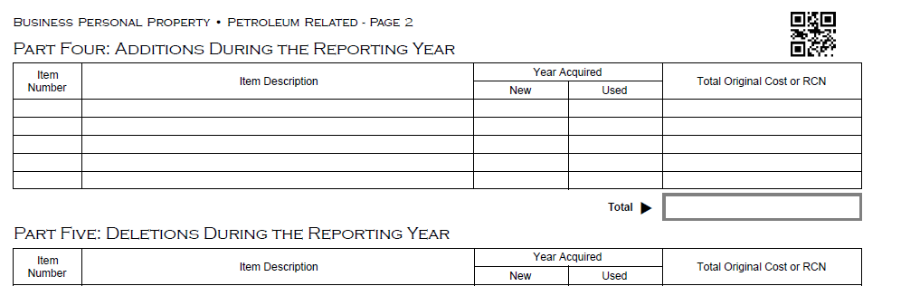
- The schedule items if there are any.
- The 904-3-P if there are no schedule items. The INC904 parameter must be set to TRUE as well.
- The last part of the report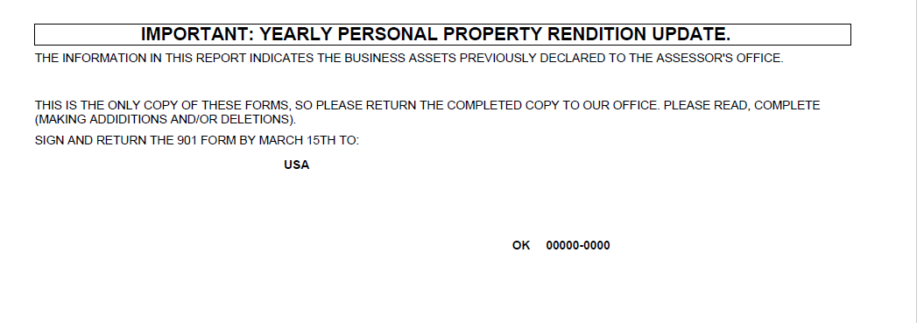

INC904
- The 904-3-P if there are no schedule items. The PRINTALLPAGES parameter must be set to TRUE as well.

INCLUDESCHEDULE
Default - True
What won’t print if set to false
The schedule items.
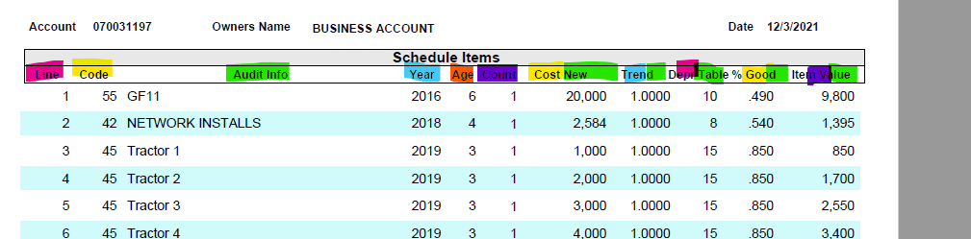

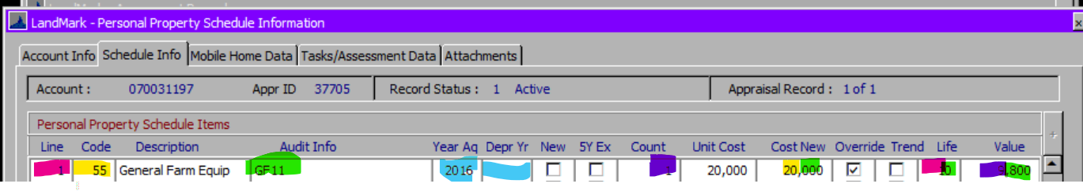
Year will be the depreciation year if there is otherwise year acquired.
Age will be Assessment year in county information table – {Year}
If item is trended, then this is based on the age of the item and value in the table. If not trended this will be 1.
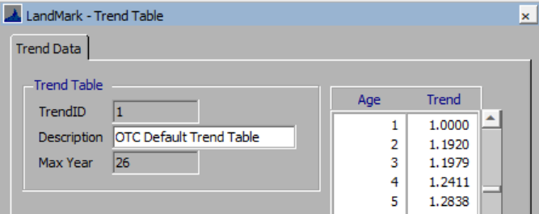
The % good will be based on the value for the recovery table being used and the age of item.
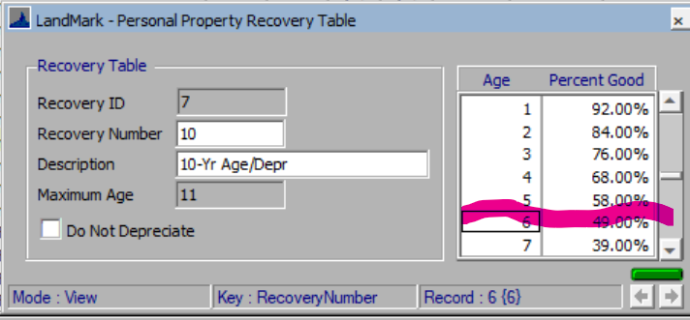
Obsolescence is on the report now as of Oct 2023.
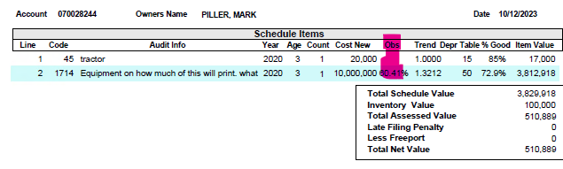

BEGPRINTTOTALS
Default – True
What will not print if set to false
- The beginning total original cost or RCN column.
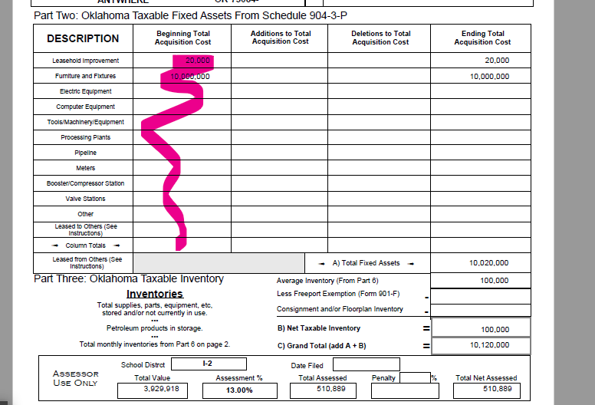

PRINTTOTALS
Default - False
What will not print if set to false
The ending totals will not print.
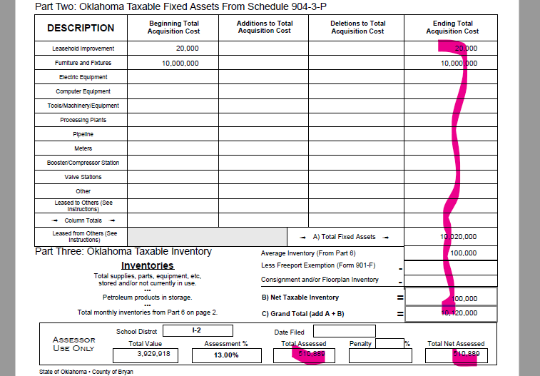

PRINTTOTALS and PRINTALLPAGES
- Both the PRINTTOTALS and PRINTALLPAGES must be set to true for these to print.
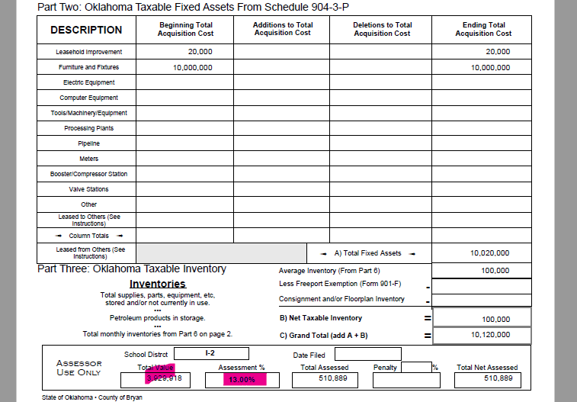

INCSIGPG
Default - True
What won’t print if set to false
- The parameter PRINTALLPAGES must be set to true as well.
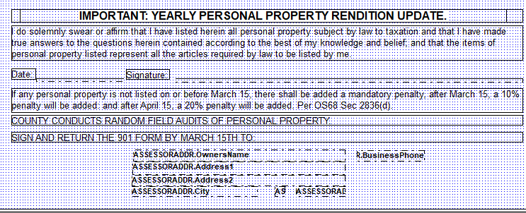

Examples
These have all sections printing.

