
LandMark GSI
OTC Form 901
Delivered: 12/3/2021
Version History
Version # | Date | Revised By | Reason for change
1.00 | 12/3/2021 | Mark Piller | - Initial Version
1.01 | 3/2/2022 | Mark Piller | - Review
1.02 | 10/12/2023 | Mark Piller | - Review

Contents
Purpose 2
Brief Report Description 2
Parameters 3
Use OTC SQFT method 4
PRINTTOTALS 4
INCSCHEDULE 5
INCLINKEDITEMS 6
INCINVENTORY 6
Average Inventory 7
Freeport Exemption 8
INCADDDELETE 8
INC904 9
INCSIGPG 9
PRINTALLPAGES 10
BEGPRINTTOTALS 14
INC904A 14
Information 15
Part 2 fields 15
NOT Using OTC SQFT Method 15
Using OTC SQFT Method 17
Schedule Information 17
Linked Items 19
Examples 19

Purpose
The purpose of this document is to document what sections will print/not print based on parameters that can be set up. This will grow to include fields printing and other information on the report as versions of the document are expanded.

Brief Report Description
This report is printed for business accounts..

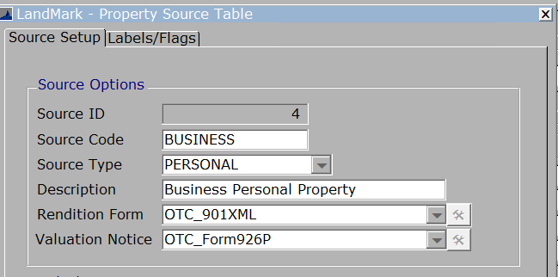

Parameters
These are the parameters that affect the printing of sections on the report. When the parameter is not in the parameters table there is a default. In the case of this report there are no parameters that cause sections to print or not.
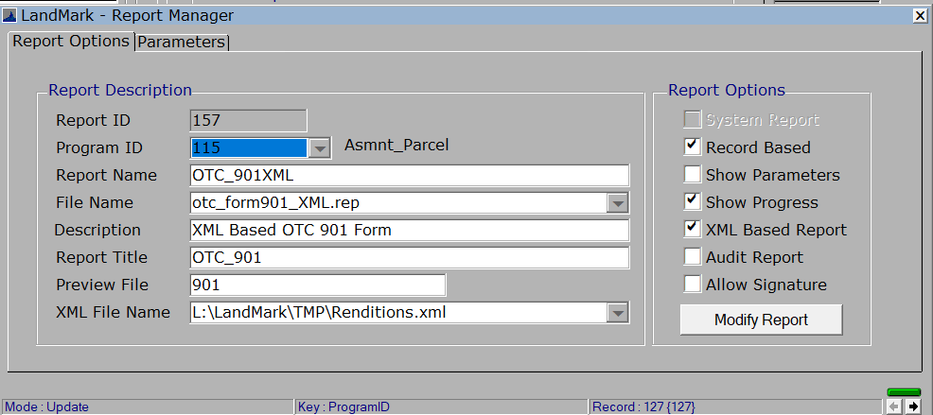

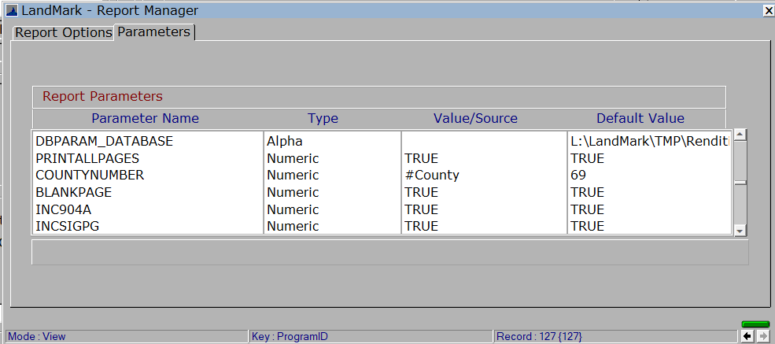

Use OTC SQFT method
- Although not a parameter this is used to determine if several of the sections will print. Generally, 95-100% of the account are not using this. (In many counties there are no records using this method)
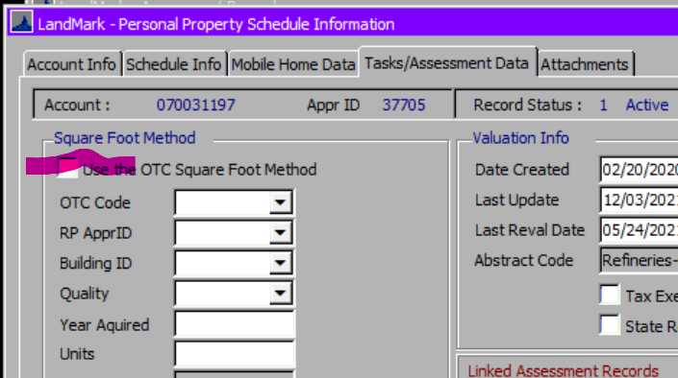

PRINTTOTALS
Default - True
What will not print if set to false
- Part 2 highlight items will not print if set to false. For this item to print the parameters PRINTALLPAGES and PRINTTOTALS will need to be set to TRUE.
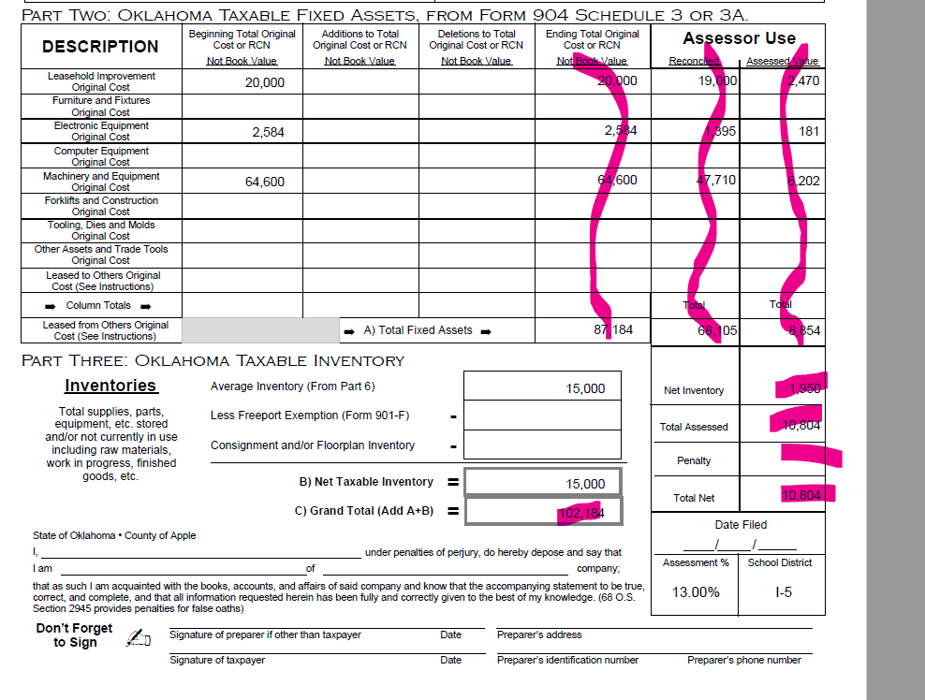
- The highlighted fields will not print if set to false.

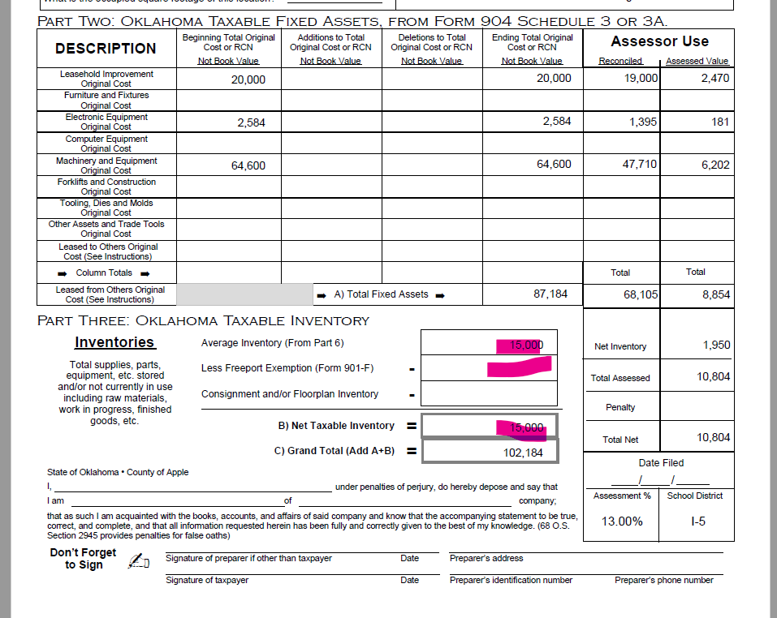

INCSCHEDULE
Default – True
What will not print if set to false
- The schedule items of the personal property account. For this section to print the parameters PRINTALLPAGES and INCSCHEDULE will need to be set to TRUE, there will need to be schedule items on the account, and not using the OTC SQFT method.
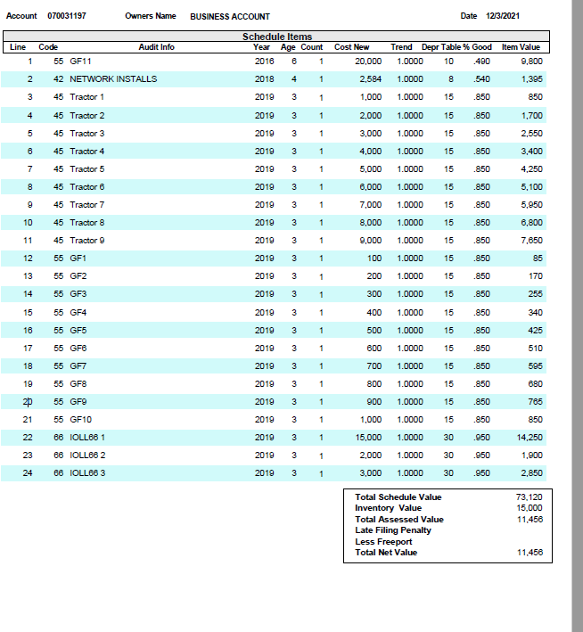

INCLINKEDITEMS
Default – False
What WILL print if set to true
- Be default the linked account information will not print unless the parameter is set up on the report and set to True.
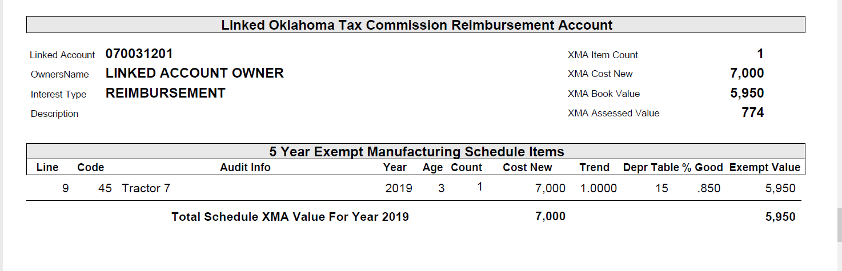

INCINVENTORY
Default - True
This parameter determines what prints on a couple fields for inventory.
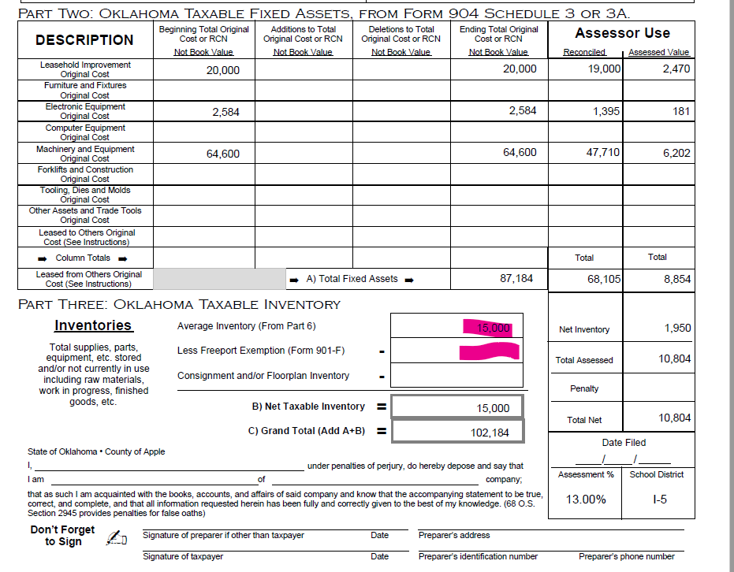
If false, the values will be 0 for each of these.

Average Inventory
If true and not using the OTC SQFT method, then the inventory amount will be used + schedule items where the 901 section type is 11. See the section on the Part 2 Values for this.
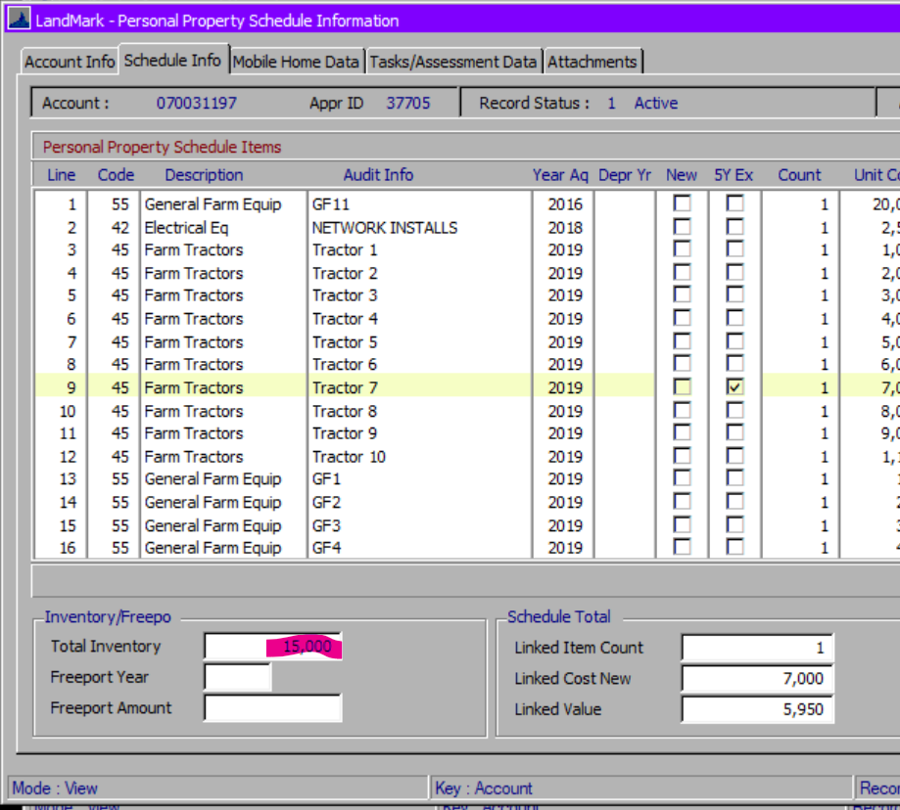
If true and using the OTC SQFT method, then the inventory on the calculation will be used.
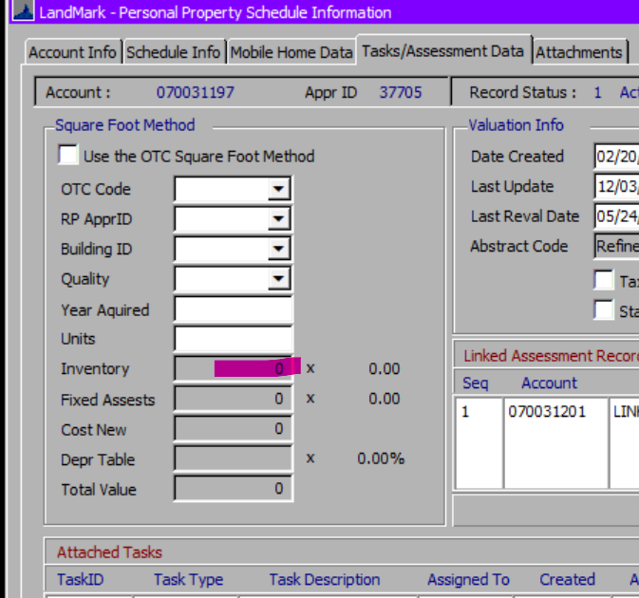

Freeport Exemption
It true and the freeport year is the same as the assessment year in the county information table this will be the freeport amount on the schedule information.
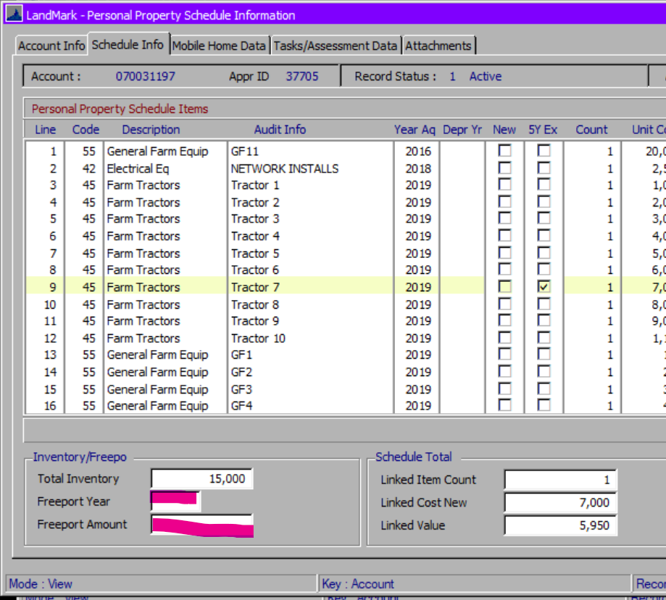

INCADDDELETE
Default – True
What will not print if set to false
- The second page of the personal property account. For this section to print the parameters PRINTALLPAGES and INCADDDELETE will need to be set to TRUE.
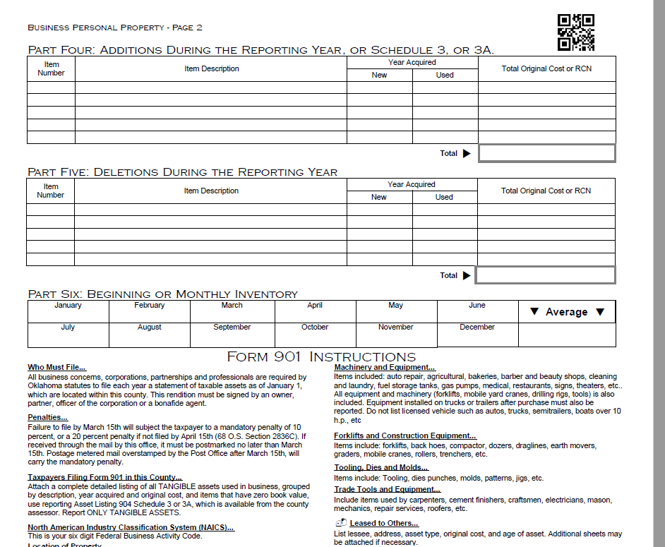

INC904
Default - False
- The 904-A Schedule 3-A form. In order for this section to print the parameters PRINTALLPAGES and INC904A will need to be set to TRUE and the OTC SQFT method is being used OR no schedule items on the account OR parameter INC904 is set to True.
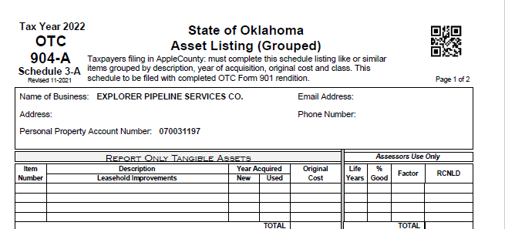

INCSIGPG
Default – True
What will not print if set to false
- The signature page. In order for this section to print the parameters PRINTALLPAGES and INCSIGPG will need to be set to TRUE and not using the OTC SQFT method.
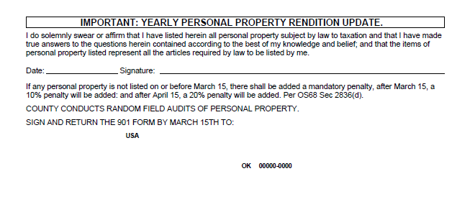

PRINTALLPAGES
Default - True
What will not print if set to false
- Part 2 highlight items will not print if set to false. For these items to print the parameters PRINTALLPAGES and PRINTTOTALS will need to be set to TRUE.
- The highlighted fields will not print if set to false.
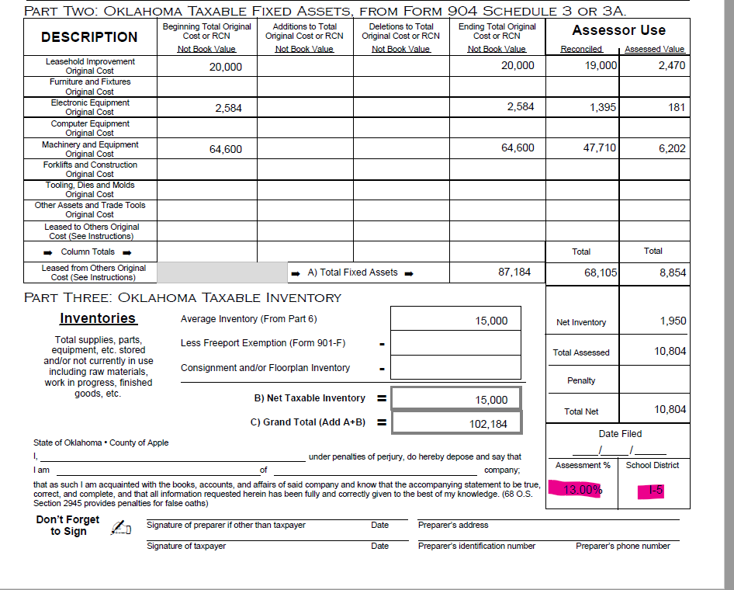

- The second page of the personal property account. For this section to print the parameters PRINTALLPAGES and INCADDDELETE will need to be set to TRUE.
- The schedule items of the personal property account. For this section to print the parameters PRINTALLPAGES and INCSCHEDULE will need to be set to TRUE, there will need to be schedule items on the account, and not using the OTC SQFT method.
- The schedule items of the personal property account. For this section to print the parameters PRINTALLPAGES and INCSCHEDULE will need to be set to TRUE, there will need to be schedule items on the account, and not using the OTC SQFT method.
- The schedule items of the personal property account. For this section to print the parameters PRINTALLPAGES and INCSCHEDULE will need to be set to TRUE, there will need to be schedule items on the account, and not using the OTC SQFT method.
- The 904-A Schedule 3-A form. In order for this section to print the parameters PRINTALLPAGES and INC904A will need to be set to TRUE and the OTC SQFT method is being used OR no schedule items on the account OR parameter INC904 is set to True.
- The signature page. In order for this section to print the parameters PRINTALLPAGES and INCSIGPG will need to be set to TRUE and not using the OTC SQFT method.

BEGPRINTTOTALS
Default – True
What will not print if set to false
- The beginning total original cost or RCN column.
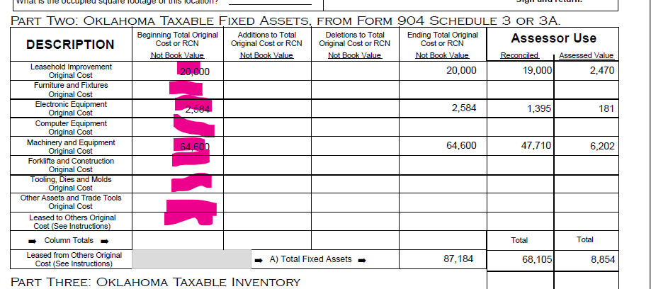

INC904A
Default – True
What will not print if set to false

- The 904-A Schedule 3-A form. In order for this section to print the parameters PRINTALLPAGES and INC904A will need to be set to TRUE and the OTC SQFT method is being used OR no schedule items on the account OR parameter INC904 is set to True.

Information

Part 2 fields

NOT Using OTC SQFT Method
The records are schedule items that are not linked to another account. (5 year exempt)
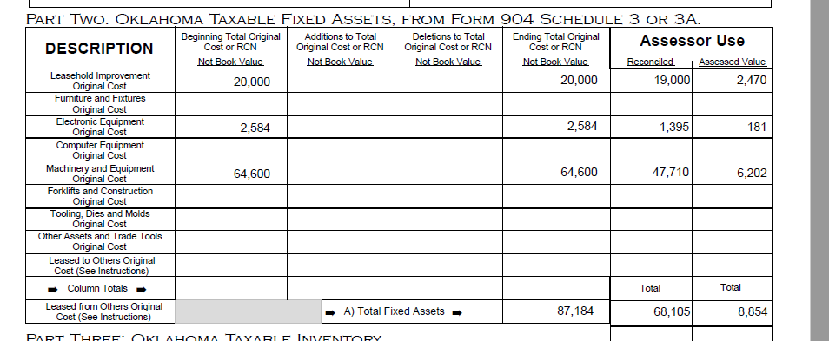
The schedule items will print in the rows based on the setup of the code. This will be the sum of the rows that fall within the row.
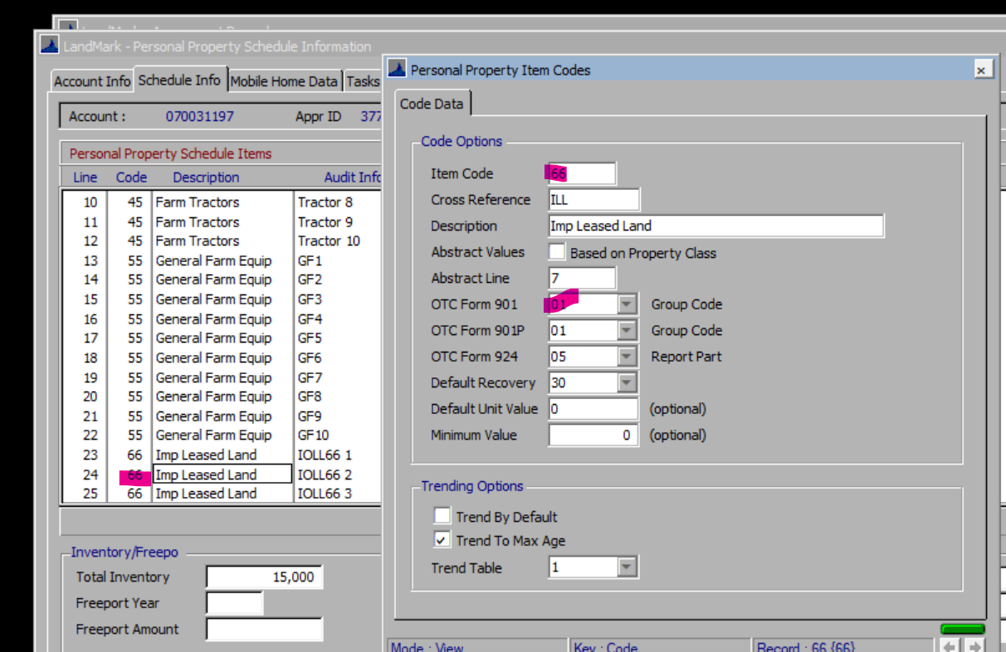
1 will be in the Leasehold Improvement…, 2 Furniture and Fixtures., 3 Electronics..., etc.
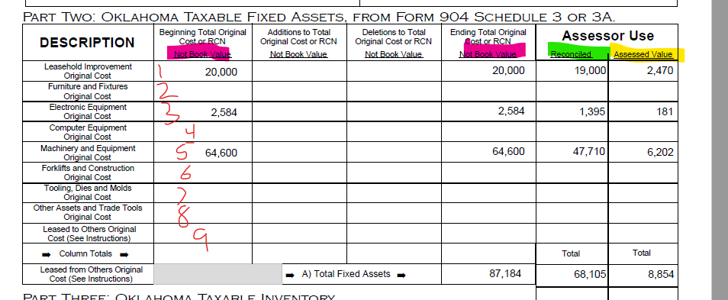
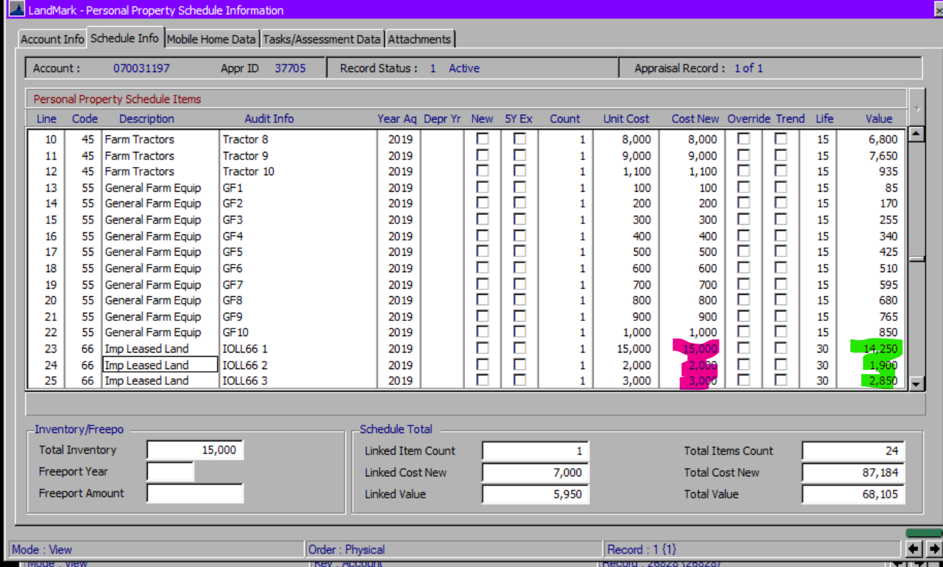
The assessed value will be the reconciled amount * assessment rate

Using OTC SQFT Method
All rows will be 0 except Furniture and Fixtures… which will come from the field below.
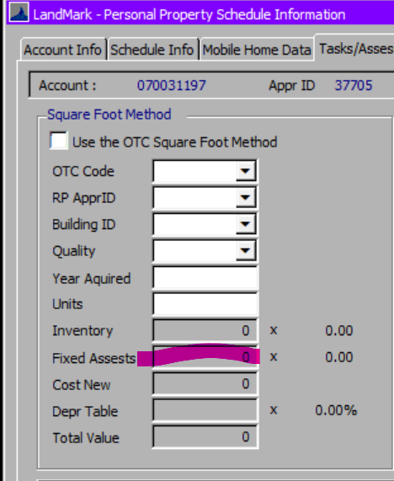

Schedule Information
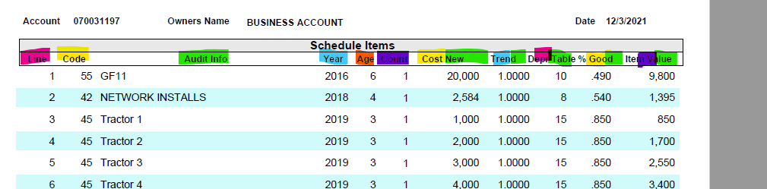

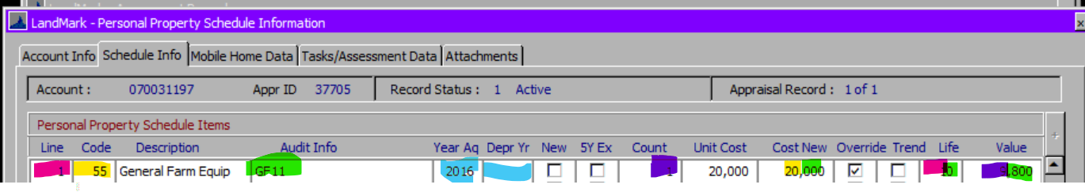
Year will be the depreciation year if there is otherwise year acquired
Age will be Assessment year in county information table – {Year}
If item is trended, then this is based on the age of the item and value in the table. If not trended this will be 1.
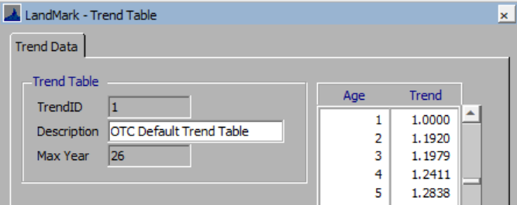
The % good will be based on the value for the recovery table being used and the age of item.
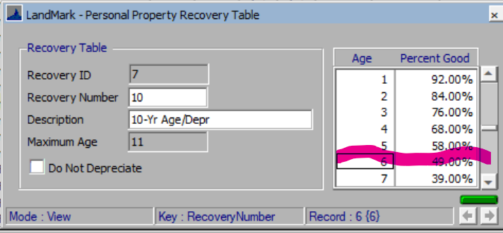
Obsolesce is on the report now as of Oct 2023.
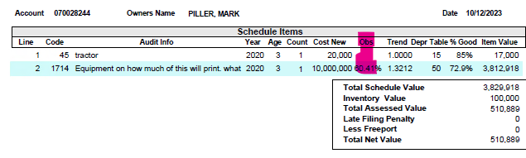

Linked Items
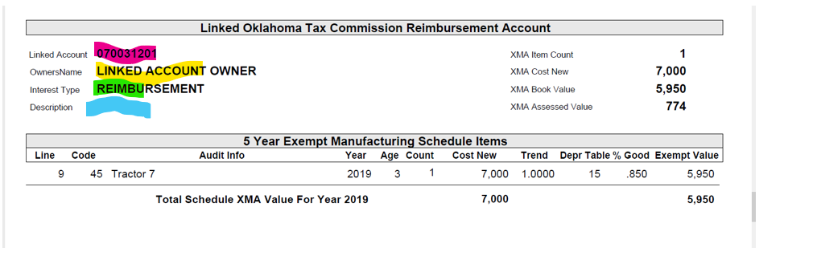
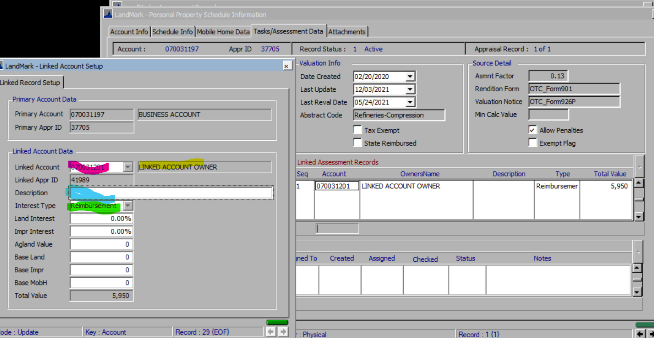
- The detail of the schedule items is the same as the schedule information.

Examples

