
LandMark GSI
OTC Form 926
Delivered: 01/30/2023
Version History
Version # | Date | Revised By | Reason for change
1.00 | 01/30/2023 | Mark Piller | - Initial Version
1.01 | 03/05/2023 | Mark Piller | - ESTTAX and TAXDOLLARS parameters

Contents
Purpose 2
Brief Report Description 2
Parameters 3
PRINTNOTICENOTES 4
NOTICENOTESRED 4
PREVVALUE 5
ESTTAX/TAXDOLLARS 5
Information 5
Name 5
Account Information 6
Value Information 7
Legal 9
Notes 9
Assessor Information 10
Attached Report Description 10

Purpose
The purpose of this document is to document what sections will print/not print based on parameters that can be set up. This will grow to include fields printing and other information on the report as versions of the document are expanded.

Brief Report Description
This is used when printing real property change of value notices. The help manual gives good information on what records are selected.
Change of Value Notices - Assessment File - 1 (manula.com)
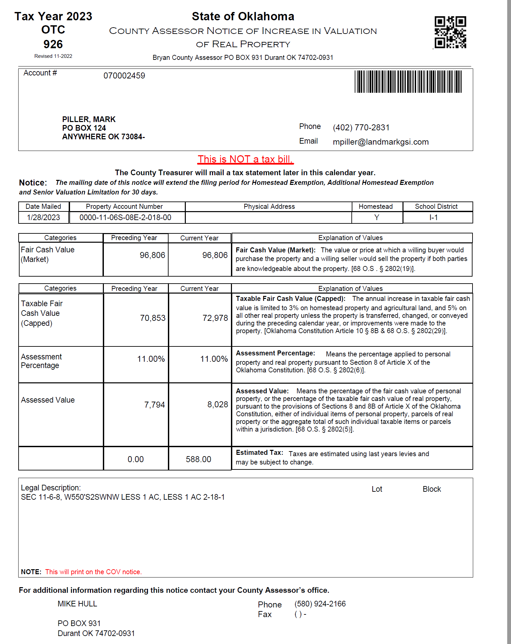

Parameters
These are the parameters that effect the printing of sections on the report. When the parameter is not in the parameters table there is a default. In the case of this report there are no parameters that cause sections to print or not.
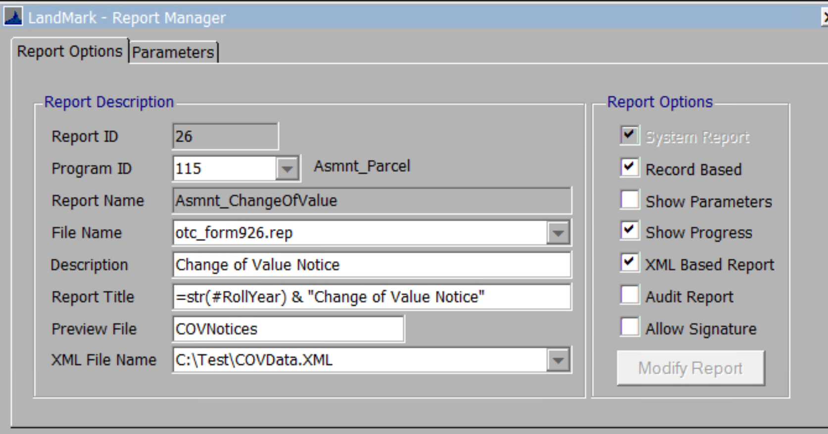
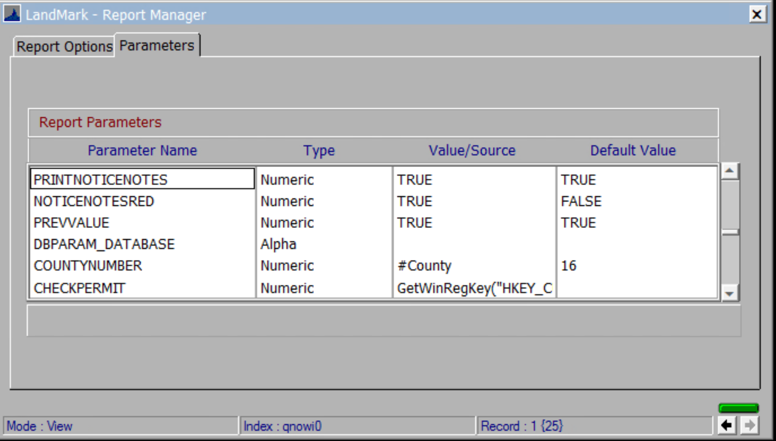

PRINTNOTICENOTES
Default - True
What will not print if set to false
- The notice notes.
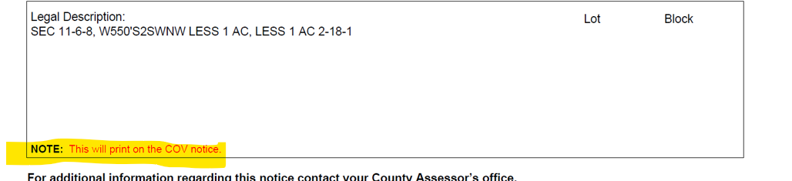

NOTICENOTESRED
Default - False
- The PRINTNOTICENOTES must be true for the notes to print. If this parameter is set to false the notes will print black. If set to True, the note will print red.

PREVVALUE
Default - True
What will not print if set to false
- The label for the preceding year and the fair cash value.
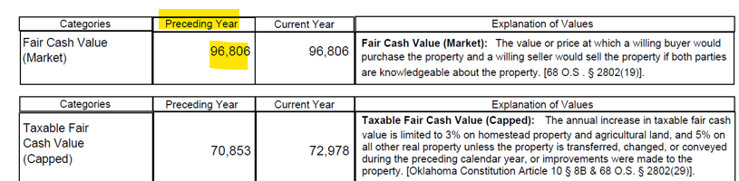

ESTTAX/TAXDOLLARS
Default – ESTTAX = True TAXDOLLARS = False
These two parameters work in conjunction with one another.
If ESTTAX is true, then the estimated tax section will print. If set to false and TAXDOLLARS is true, then the estimated change in tax dollars will print. If any other way, then neither will print.

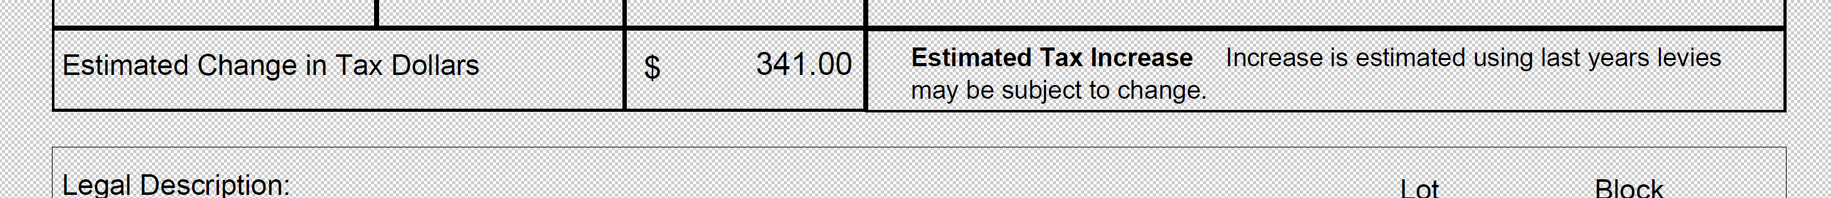

Information

Name
This is based on the name record on the assessment form. If there is not a business phone the home phone would be used.
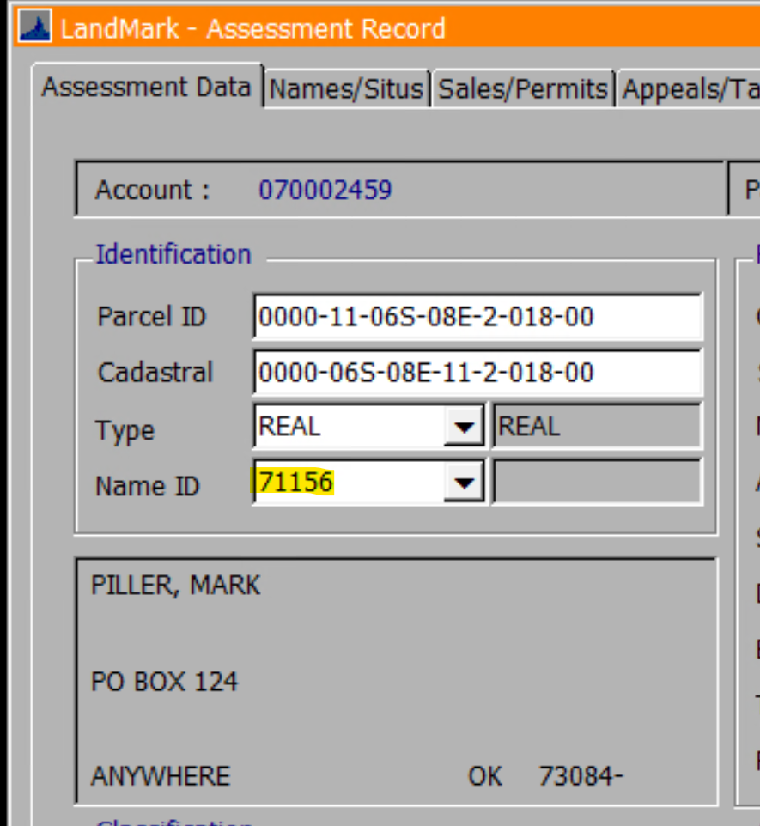
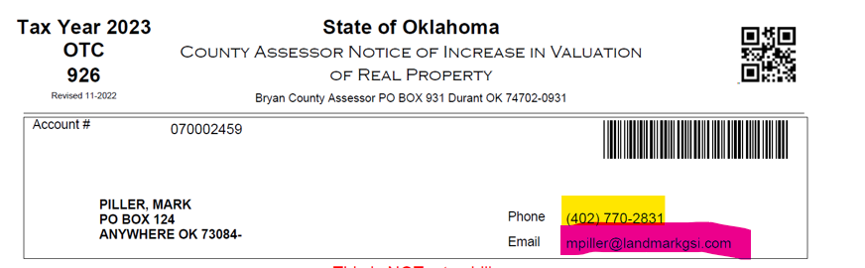

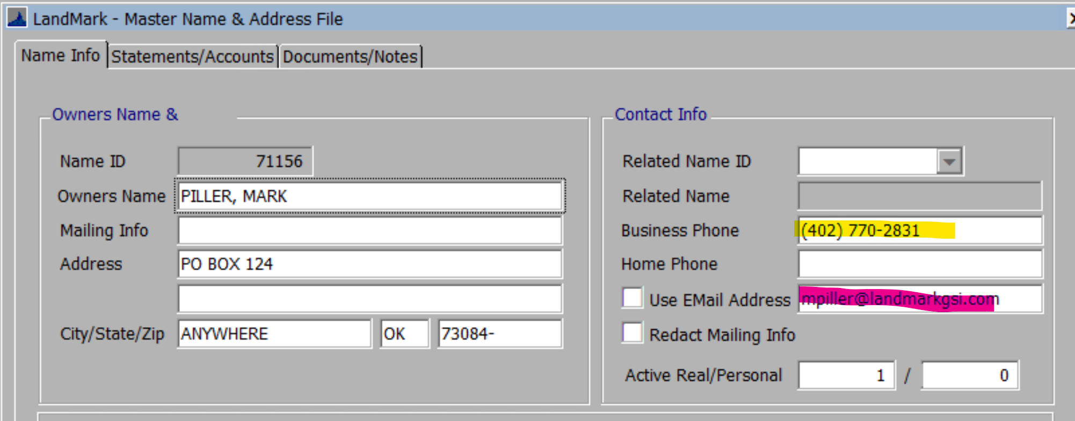

Account Information
- The date mailed will be the date in the COV parameters. If there is not a date in the parameters, then this will be the date of the printing.
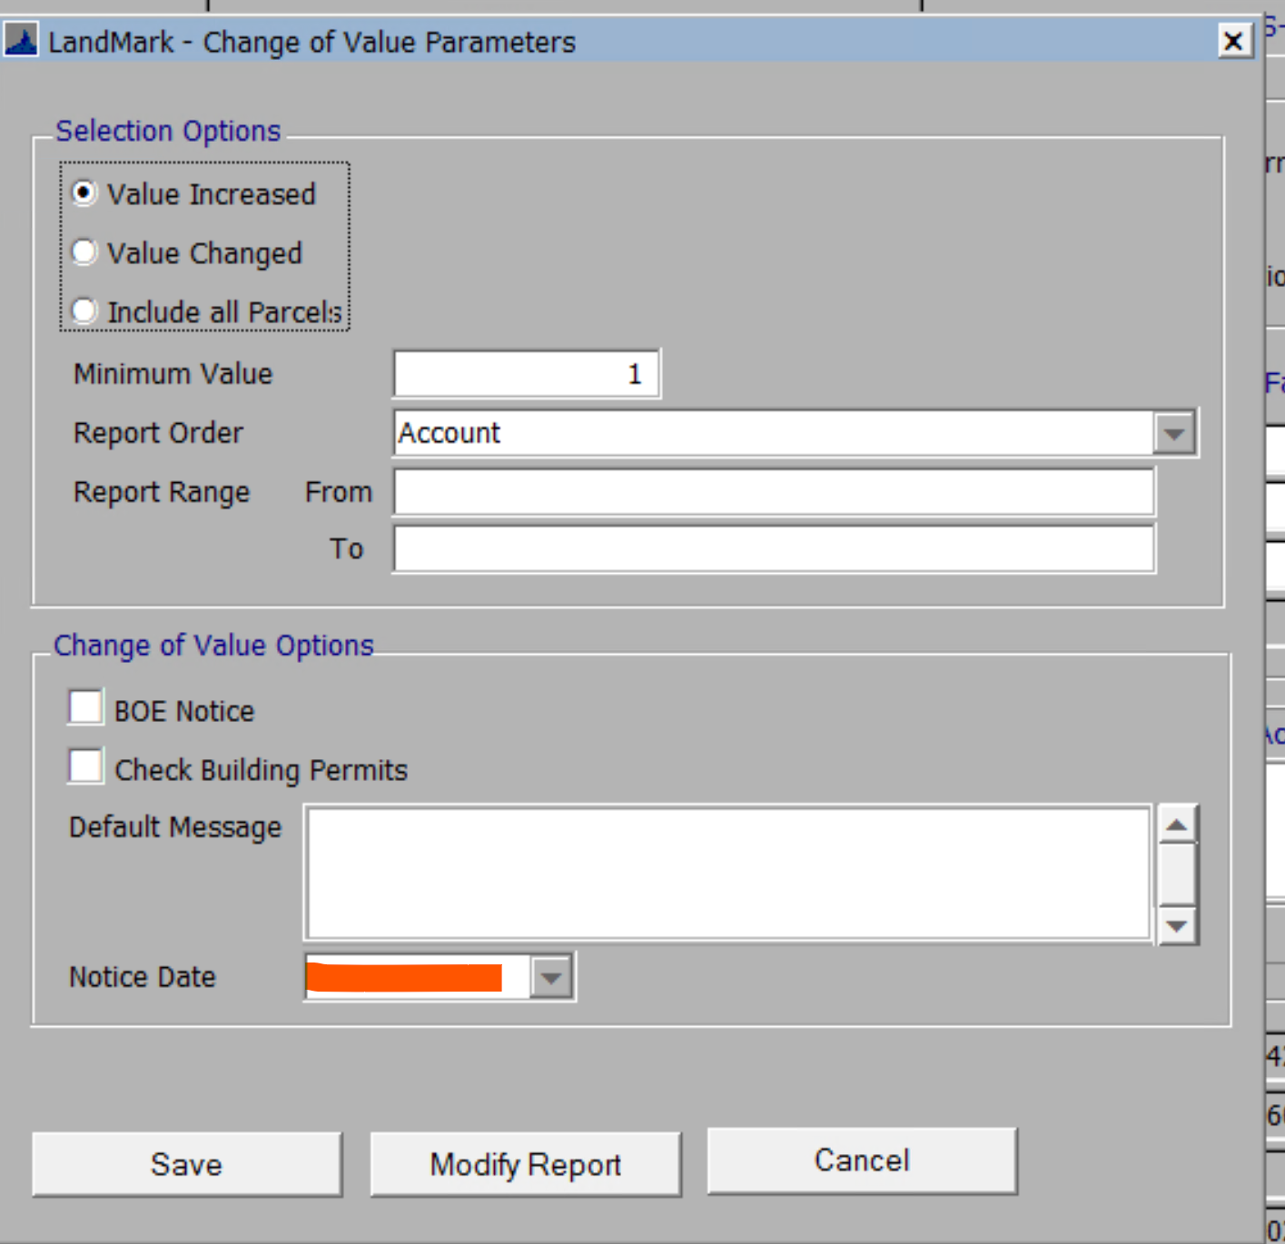
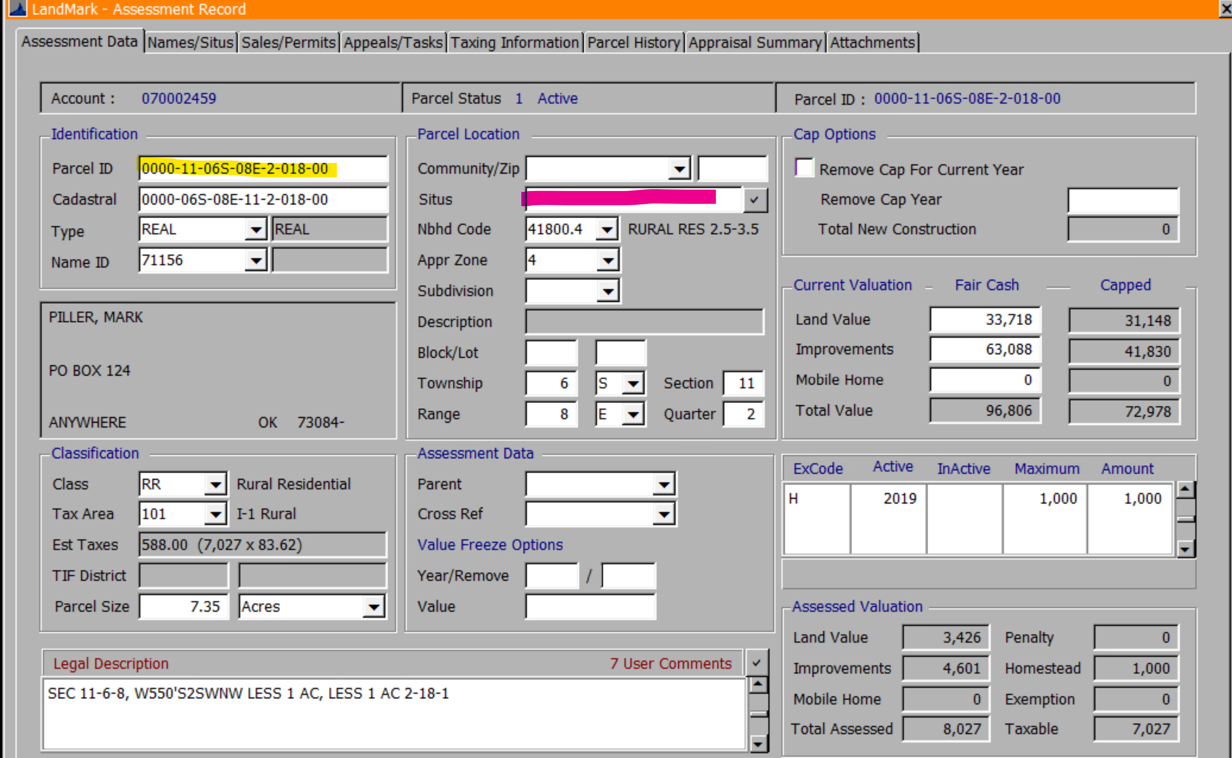
- Homestead will be Y is there is an exemption amount otherwise it will be N.
- The school district is the cross reference from the tax area table.
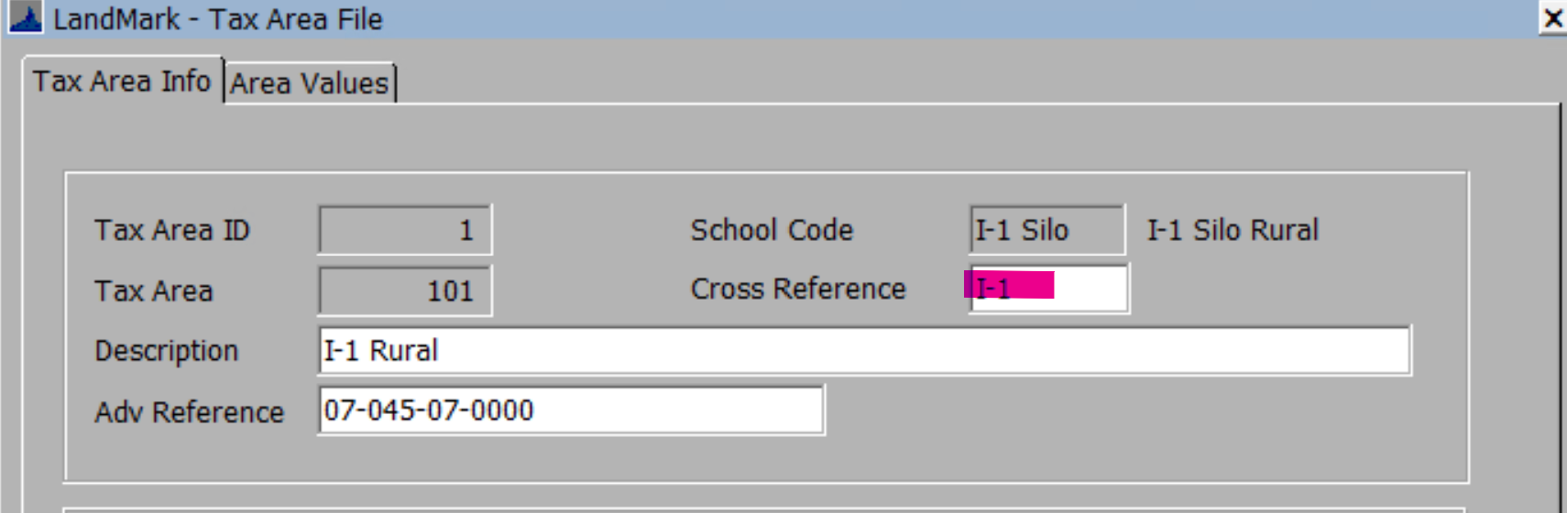

Value Information
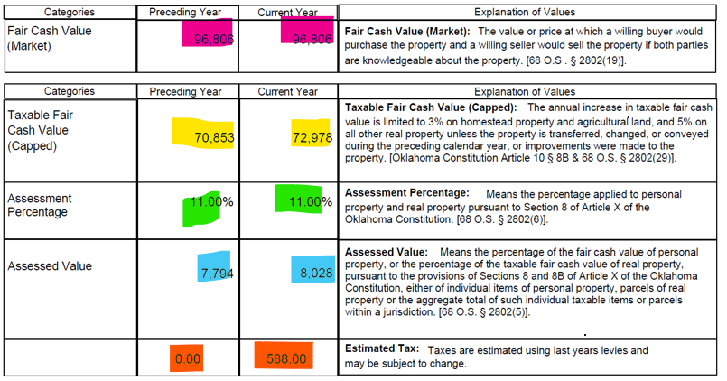
Preceding Year
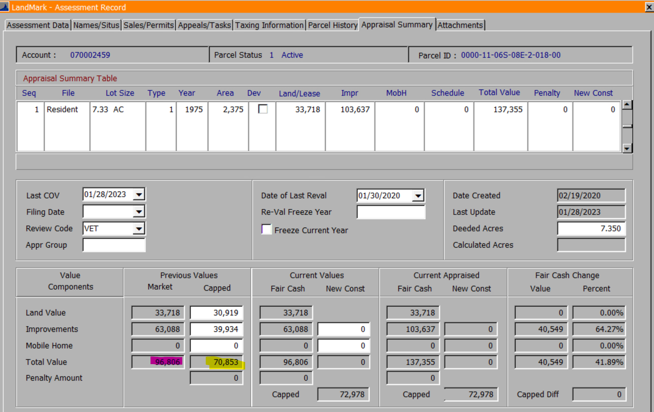
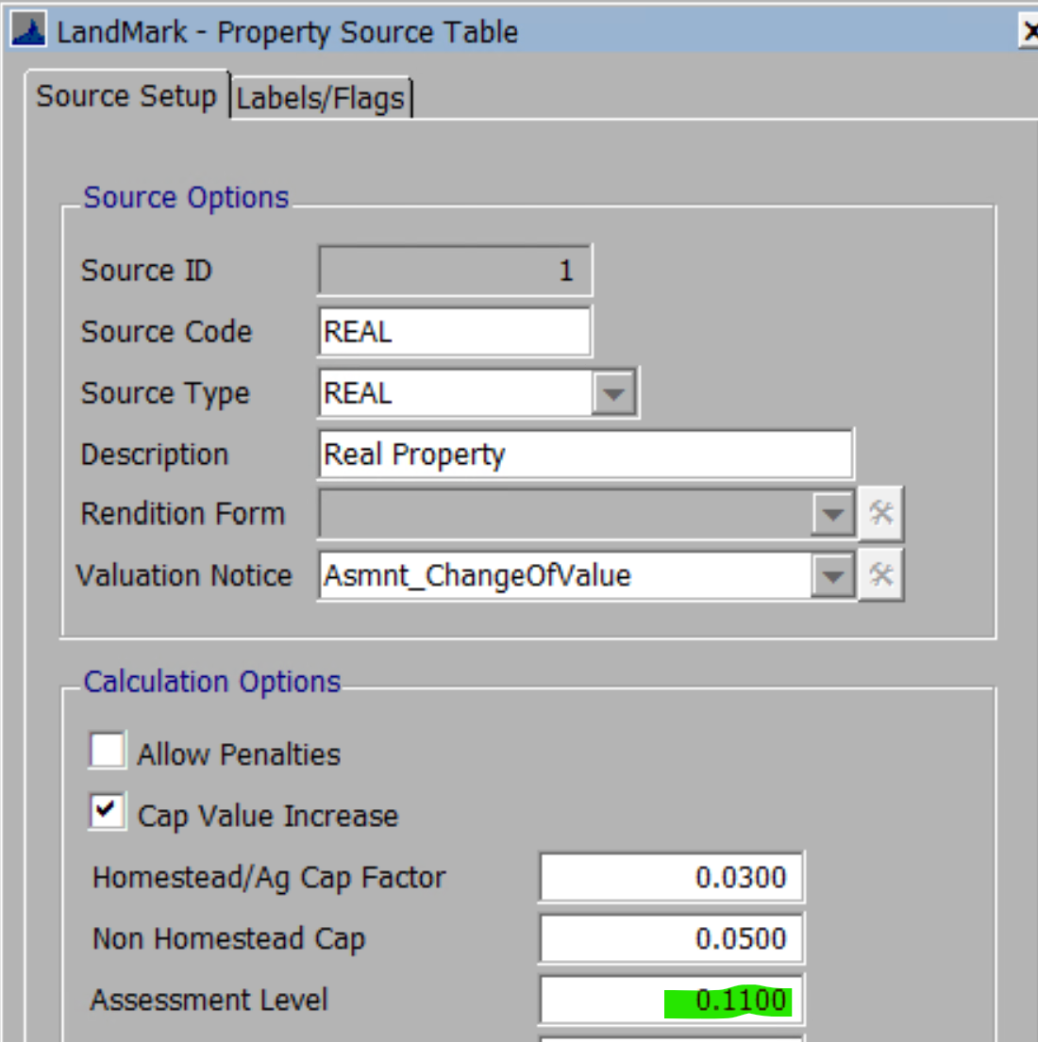
- Assessed value will be the previous capped * assessment level.
- The estimated will be the prior year that the COV is for.
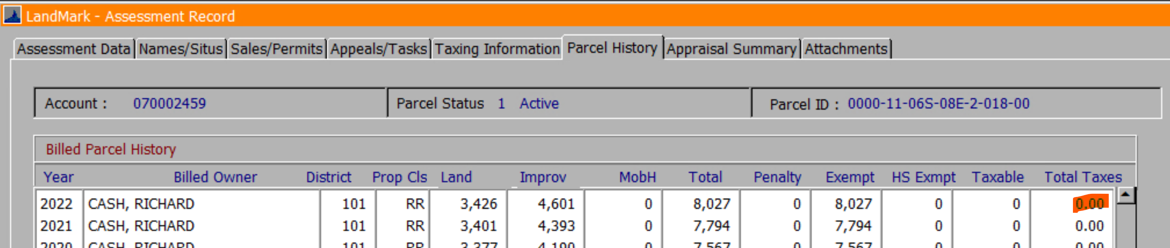
Current Year
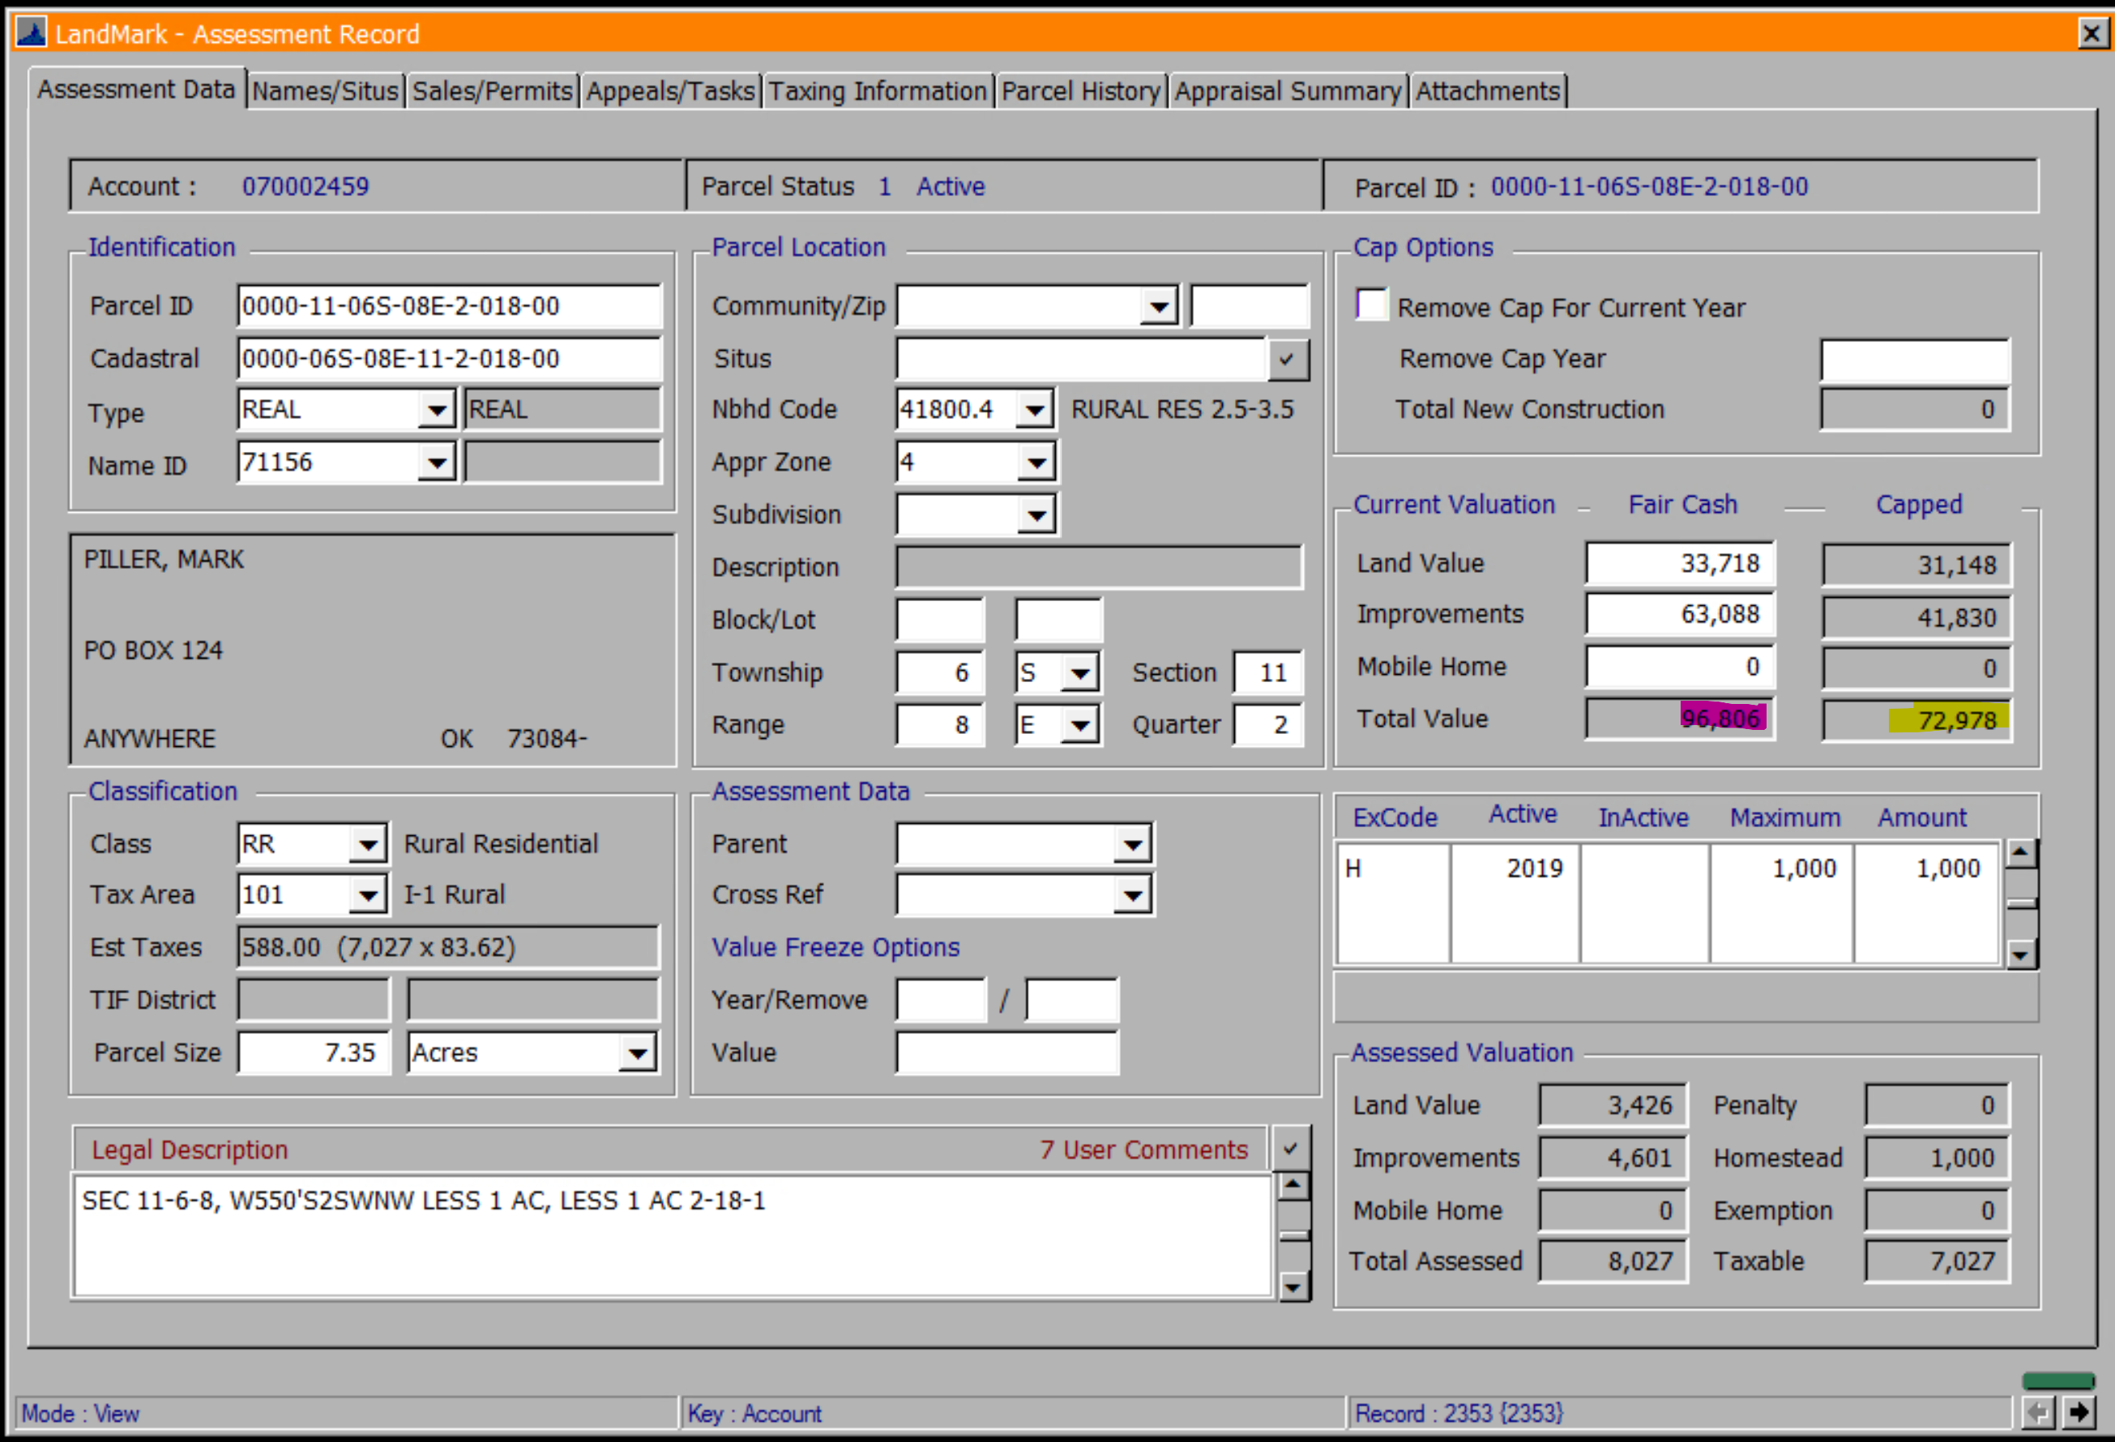
- Assessed value will be the total capped value * assessment level.
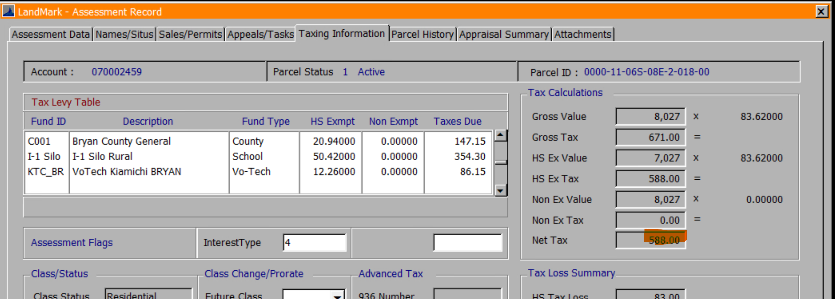

Legal
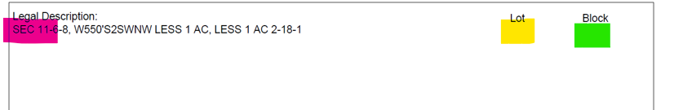
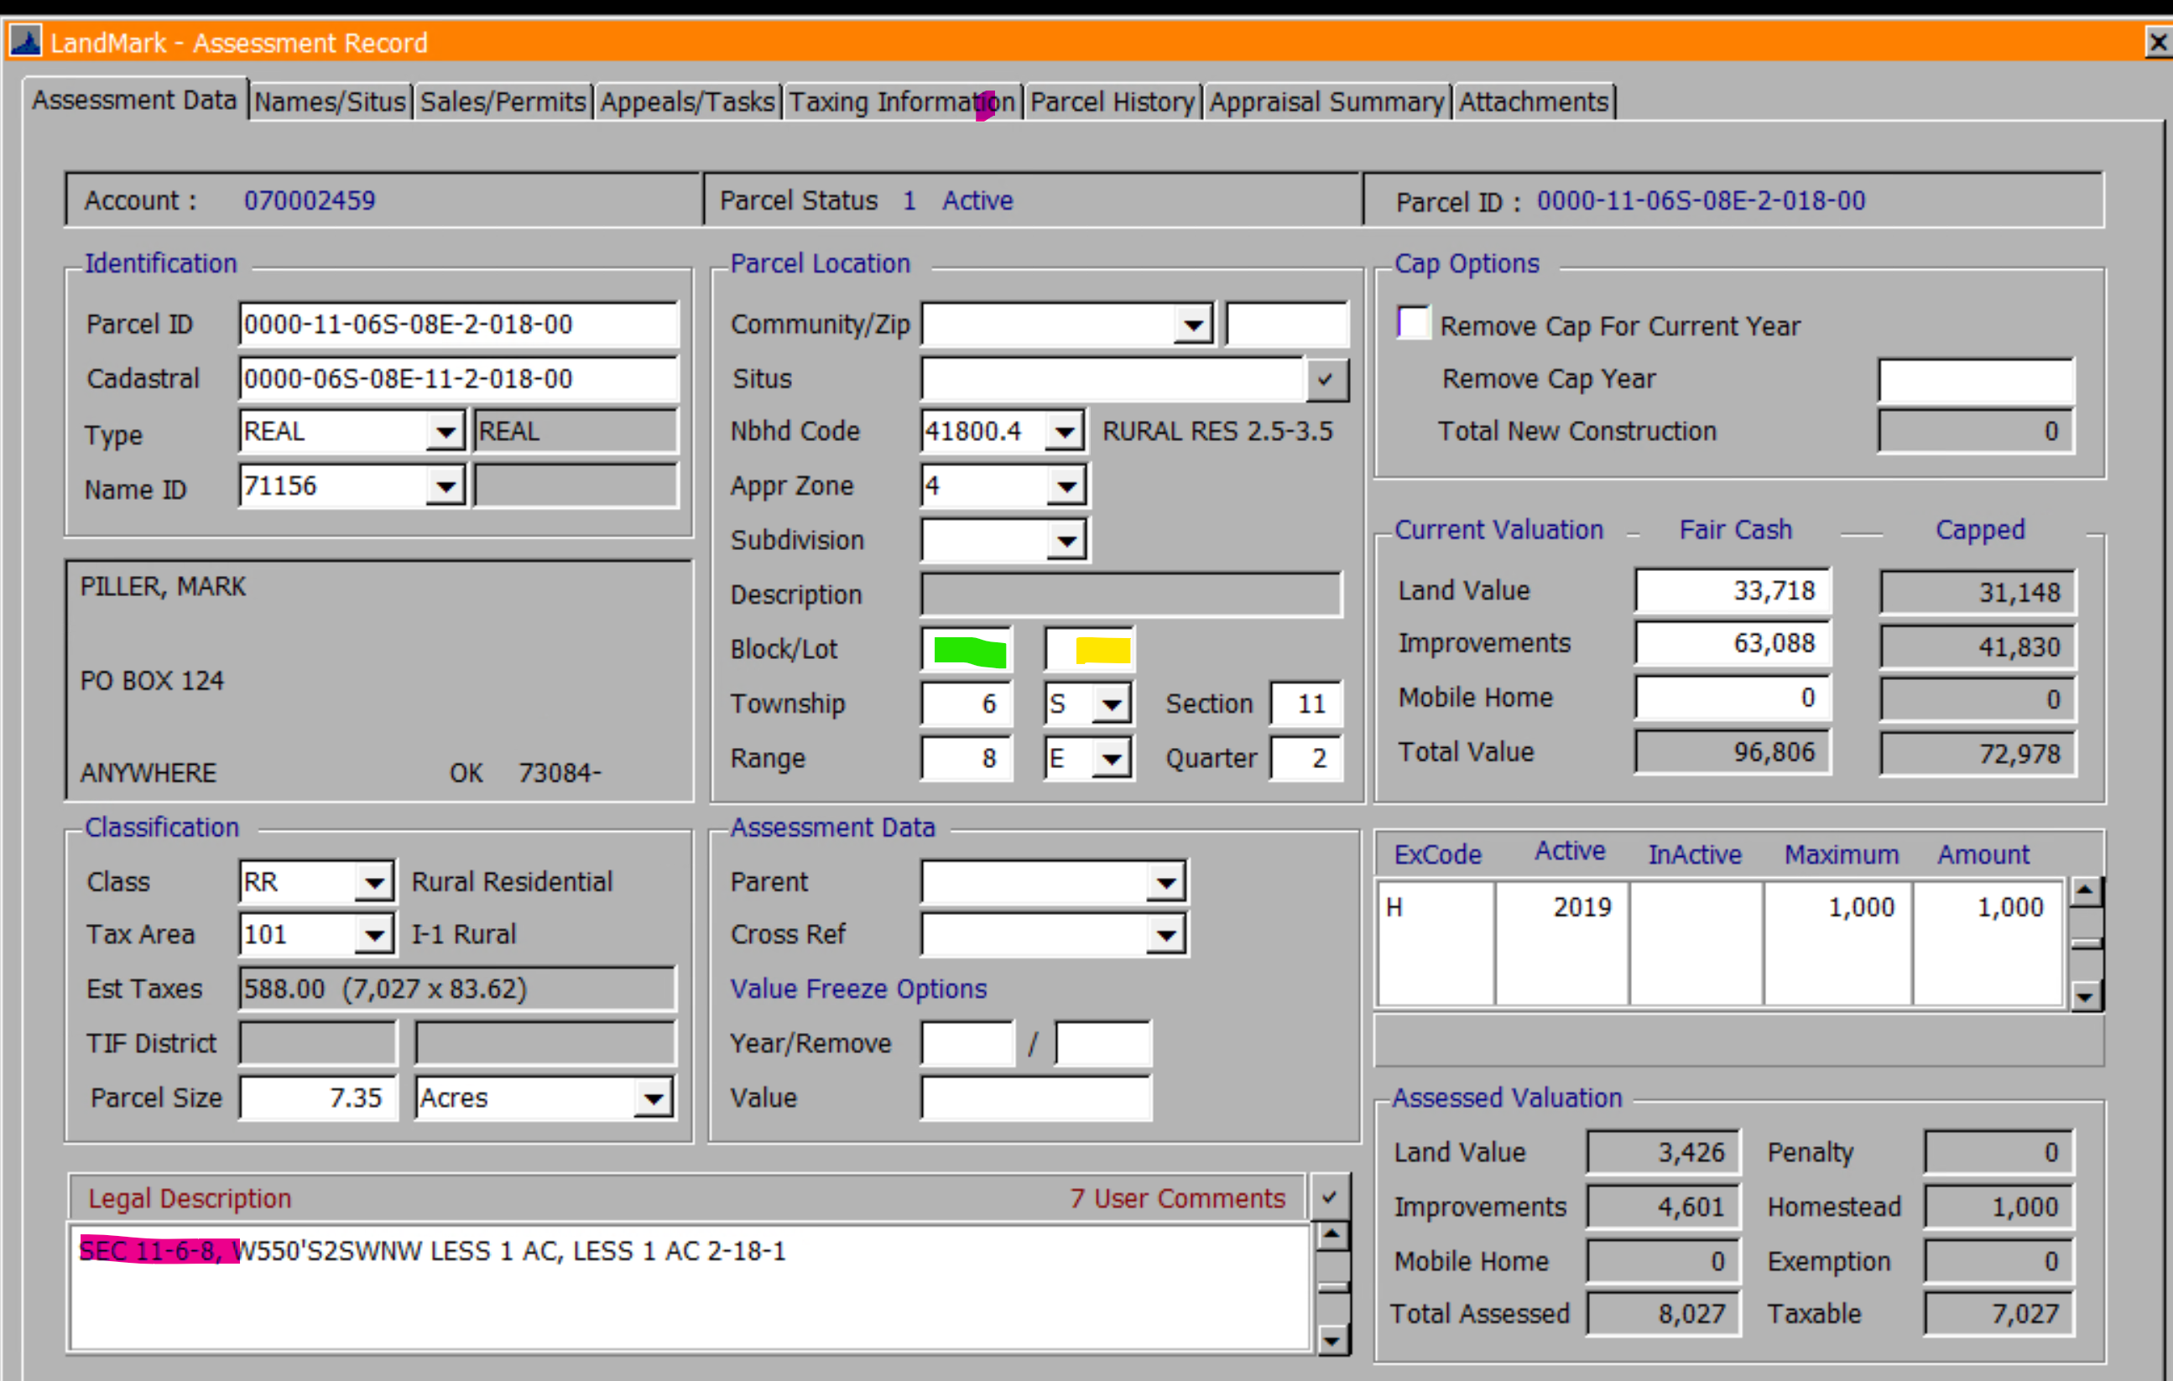

Notes
- Will be the first Notice-Text document type on the parcel with the same notice year as what is in the assessment year on the county information table.
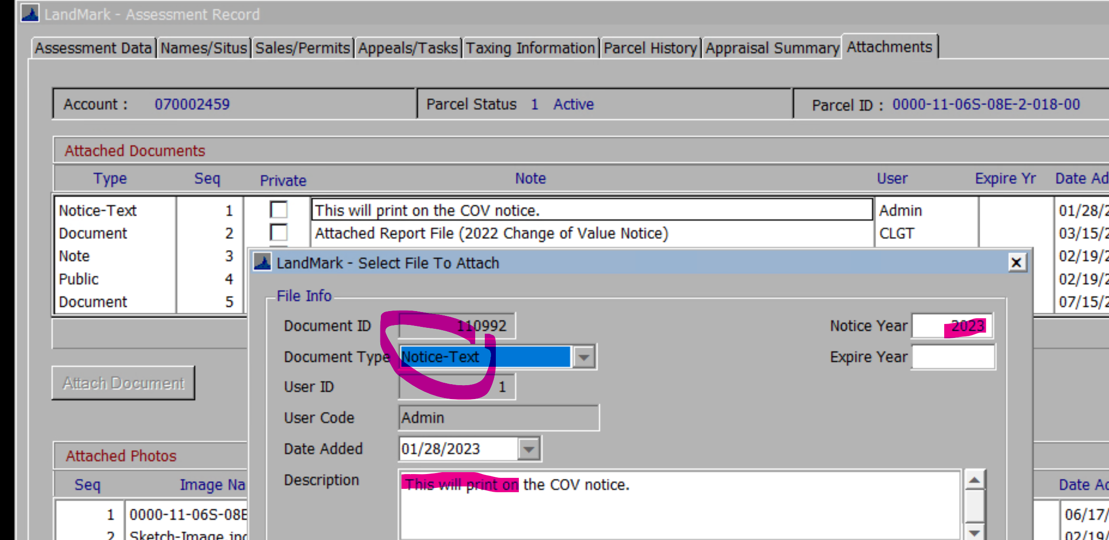

Assessor Information

- The home phone will the fax number and mailing information does not print on the form.
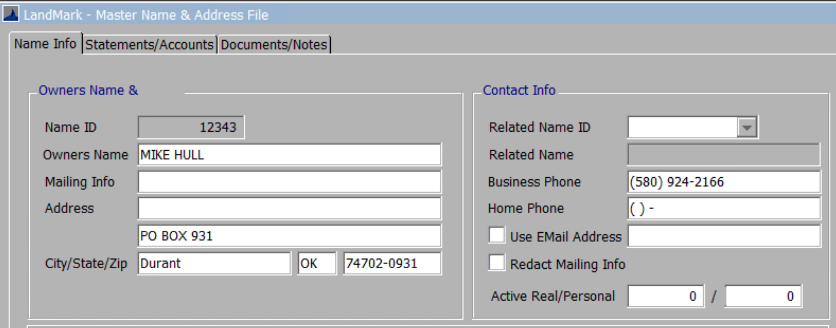

Attached Report Description
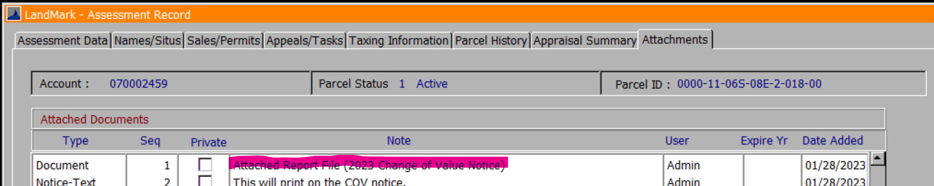
- The report title will be in parentheses.
