Contents
Weekly Changes Oct 16, 2023 1
Appraisal Files 1
Residential Appraisal 3
Sales 3
Nbhd Table 3
County Information 4
Personal Property 4
Map Analyser 5
Reports 5
Residential Report 5

Weekly Changes Oct 16, 2023

Appraisal Files
- Oct 16th The notes will be in the site plan list. This will correct this issue when selecting a section and the incorrect section would highlight.
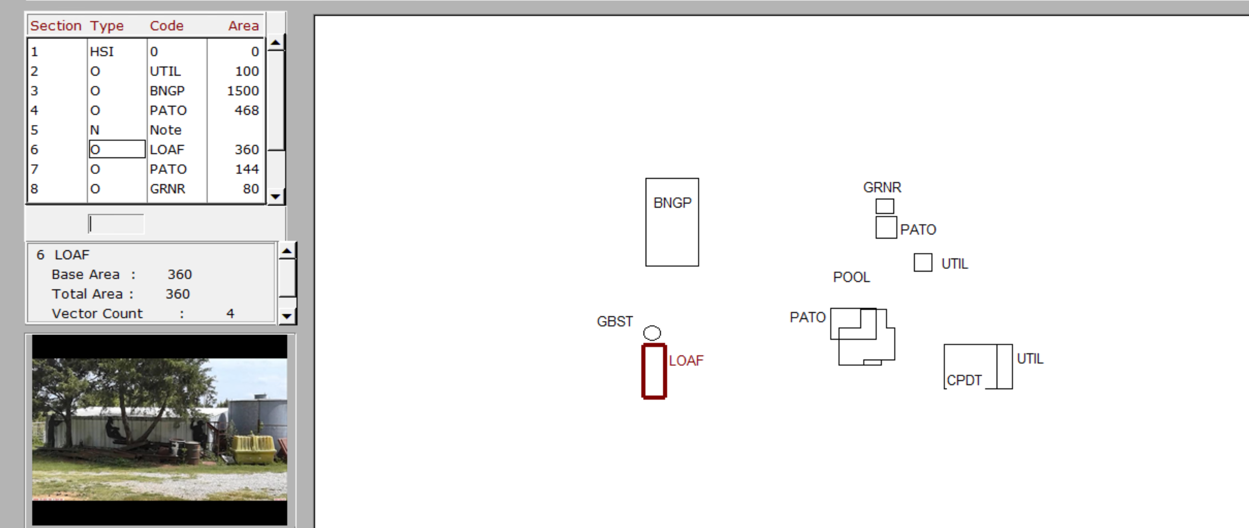
- Oct 16th – The Entrance/Inspection Info will remember the last selections entered per user except for the date. Before when logging off all information would have to be reentered. After logging off the date will default back to the current date.
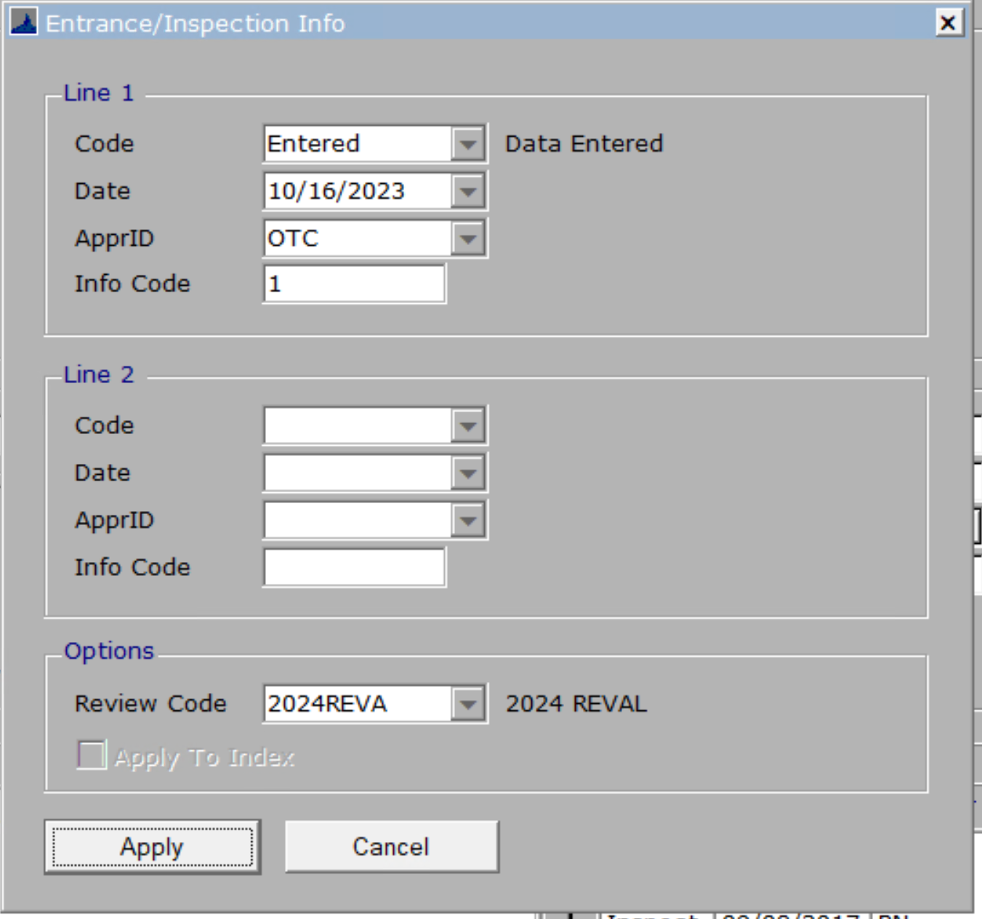
  - An FYI: While in edit mode you can select the + button to add the entered/inspected information.
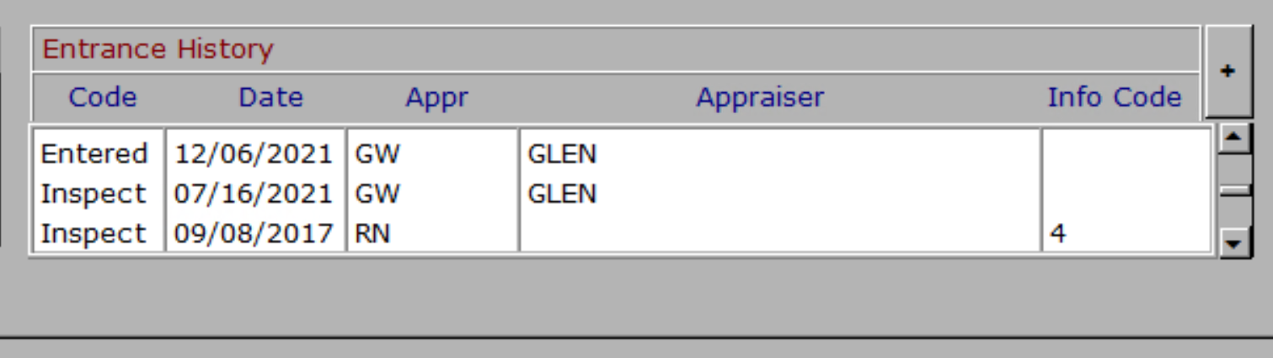
  - Another FYI: A hot key could be set up to open the add entrance information. This could be done in the residential, commercial, or both functions.
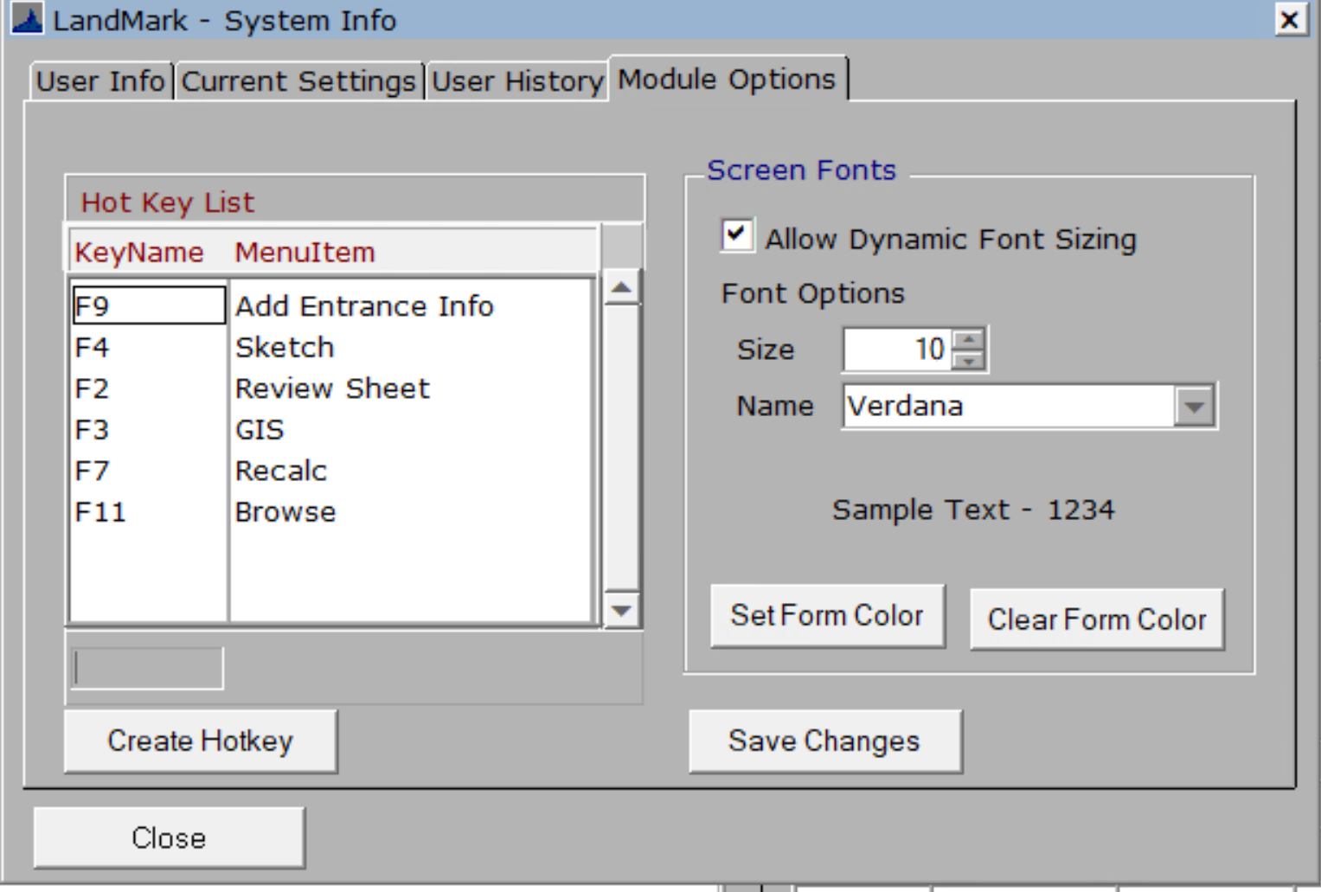
- Oct 16th – In the appraisal files (including personal) there is an option for pending inactive appraisal records. This is for an appraisal record that should be inactive when process pending is done. These will be included in the reading appraisal record and will change to an inactive record when process pending is run.
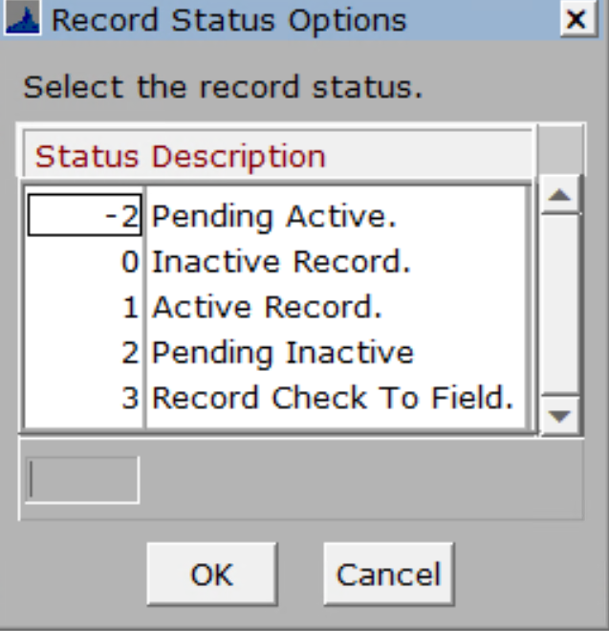

Residential Appraisal
- Oct 2nd – When using physical distance in the selection criteria the process of selecting records will be quicker.

Sales
- Oct 2nd – The remove year is editable. This will allow you to modify if while entering the sale you don’t remove the exemptions and then work on this later.
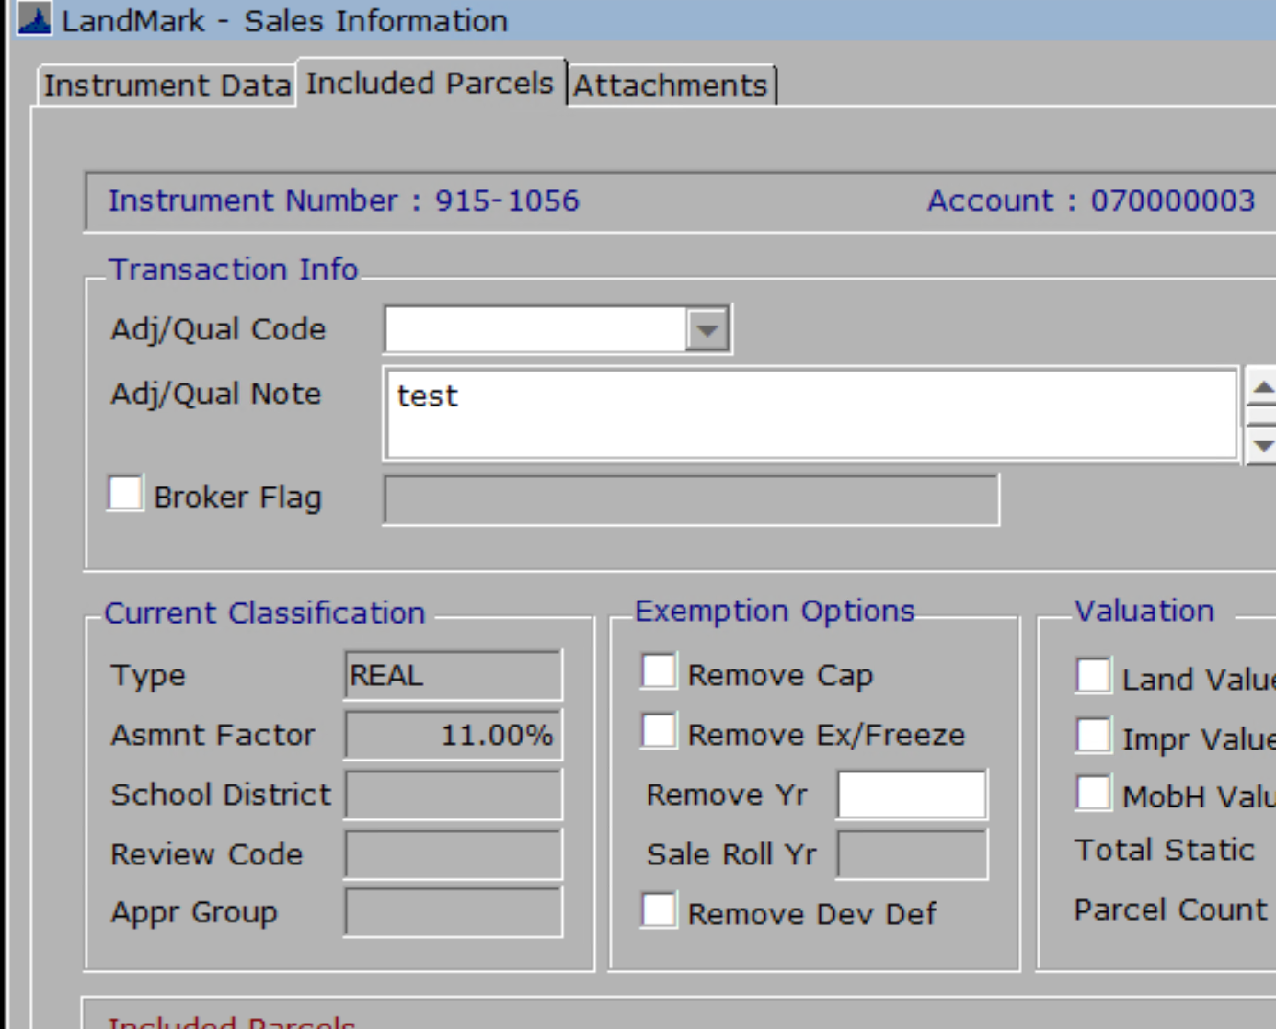

Nbhd Table
- Oct 9th – If you edit the appraisal zone in the neighborhood table the appr zone on the assessment/appraisal forms will be automatic. Before you would need to recalculate the assessment file for the change to occur. This only applies if you allow the appraisal zone to be determined by the nbhd table.
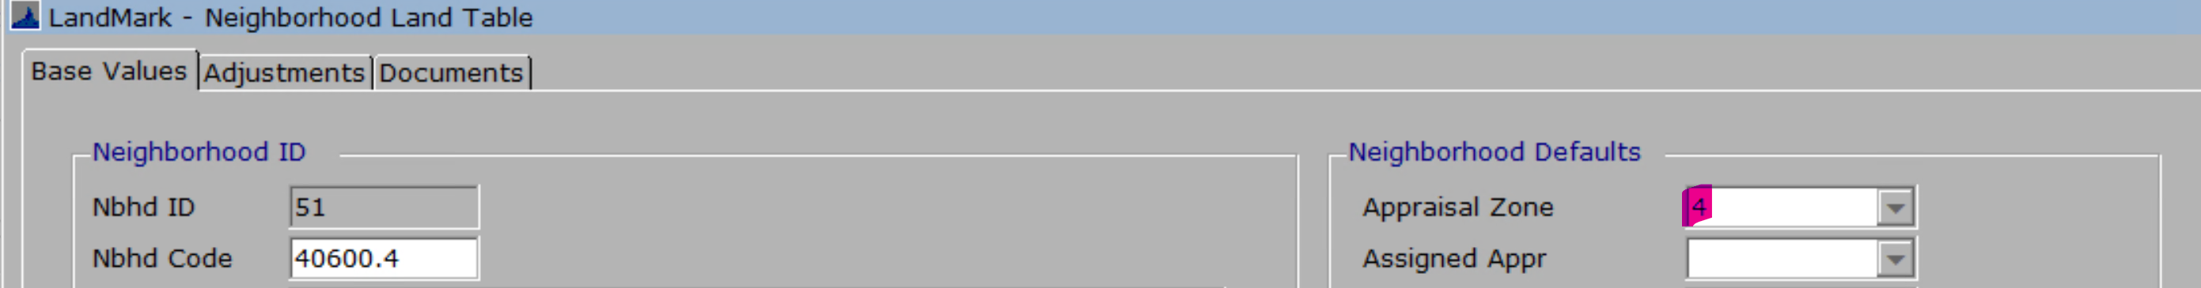

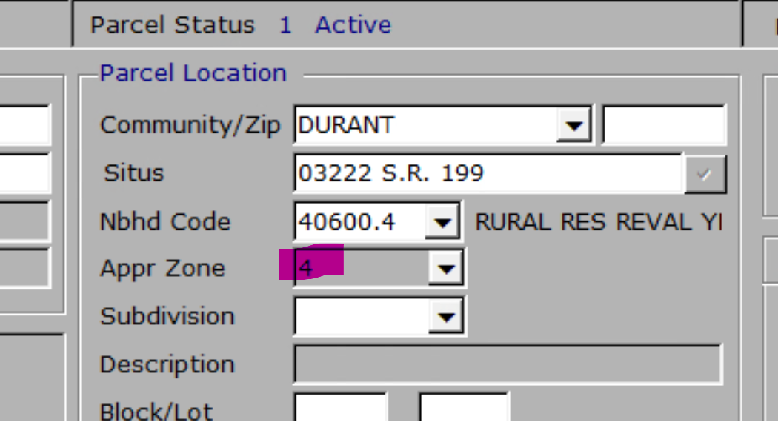
  - The Input Appr Zone field determines if the appr zone is table based or if the user can enter the appraisal zone. Checked is where the user can enter the appraisal zone and unchecked is where it is table based.
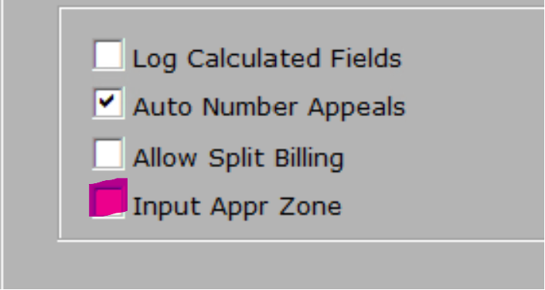

County Information
- Oct 9th – The field to indicate if the process pending has been run and completed has been added. This will be checked until the taxroll process is done where it will then be unchecked. Once the process pending has been run and completed this will be checked. Once checked the process pending will not be able to be run.
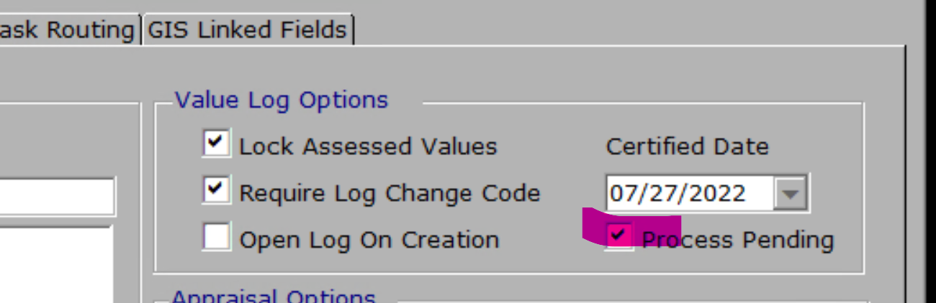

Personal Property
- Oct 16th – When linking schedule items if the 5 year exempt is not checked you will be informed of this. The reason: If the 5 year is not checked the value is not removed from the current schedule and added to the linked account.
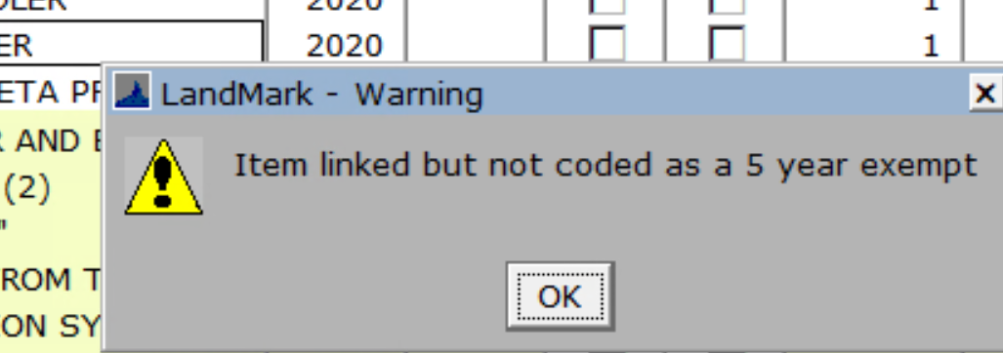
- Oct 16th The TASC import will use the obsolescence value for the set factor. This will allow for the cost new to match with the RCN in most cases. At times there are rounding issue where it will be a few dollars off in certain cases. The value column will be the FMV.
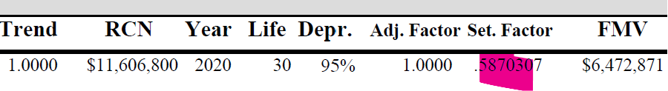
- Oct 16th – The renditions, 926P, asset listing, and schedule listings.
  - The obs percentage will be on each of these reports. In the case of Obs and % Good they will be represented as a percentage where before there would be some inconsistency in the % good being in percentage and other time 0.729. In the case of obsolescence this is displayed as entered when 60.41% is entered the remainder 39.59% is the value left of the cost new. To get item value: Cost New * (1-Obs) * Trend * % Good.
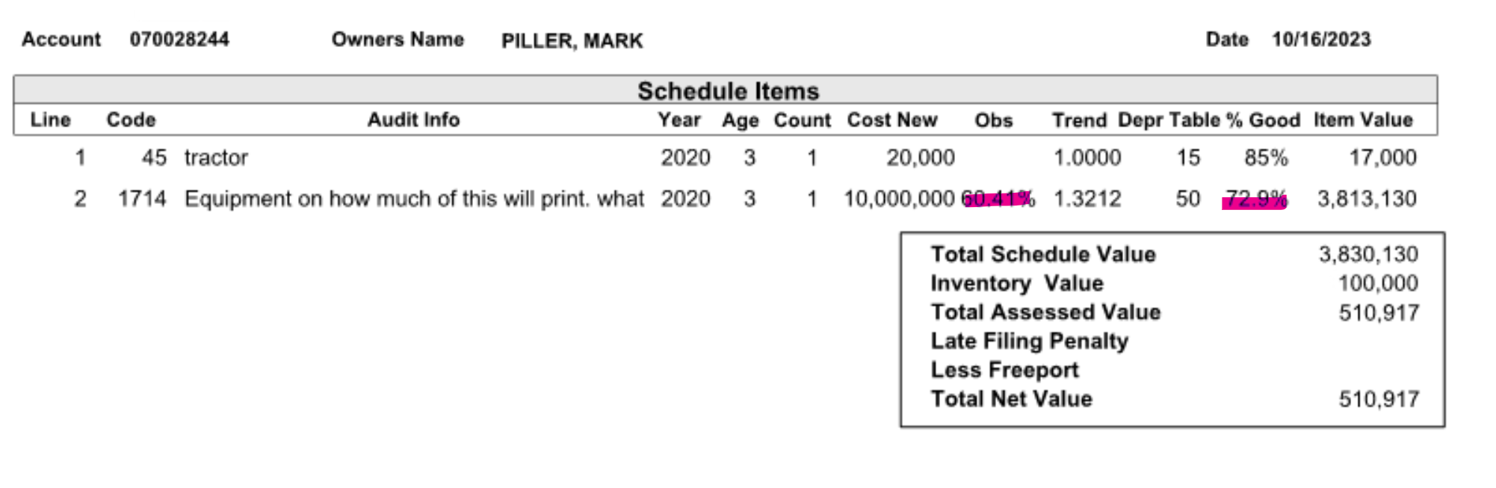

Map Analyser
- Oct 9th – The street view will now work. There can be multiple Eagle view layers set up. Can create new layers.
- Oct 16th – The account list will now have the lot size printed.

Reports

Residential Report
- Oct 9th – The remodel code will have the code and year on the report instead of true/false. This is run from the residential appraisal by select File – Print – Residential Report.

