Contents

Weekly Changes November 8, 2021 1

Assessment File 1

Sketches 1

Reports 1

# Weekly Changes November 8, 2021

## Assessment File

* Nov 8th When modifying the filing date the filing date on the appraisal file will be updated.

## Sketches

* In the update on the 15th on the residential file there will be an option to

## Reports

* Nov 8th The File - Print Forms have been updated and will go out with the weekly update on Sunday. Please note your tax year will not change until you process pending accounts.
* Nov 8th Sales Verification Letters are also complete. To change the report you want to use, go to System - Report Manger. Browse to find the Sale_VerificationLetter. By default, everyone is using the Sale_VerificationLetterNew report (the first Ref 961). To change this report, edit the report options and drop down the File Name. In the browse box, you can either select OTC_Form961 or Sale_Verification3 (the new Ref 961 which prints based on Property Class). You may need to edit your parameters to only show InstrumentID and CountyNumber. Your CLGT person can also do this for you if you want.

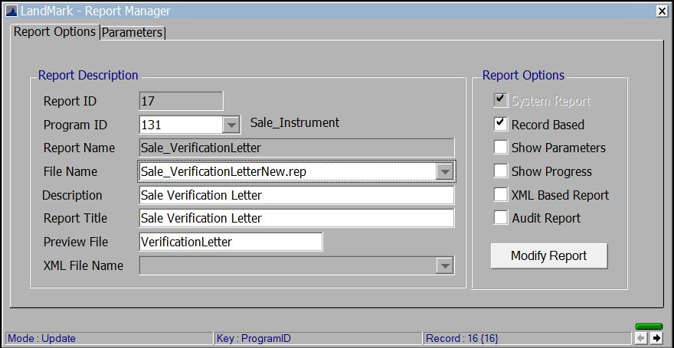

* Nov 8th The OTC Editable forms have been updated. To update these go to System - System Updates - Update OTC Forms. Gerald sent these to me yesterday afternoon so I will work on having the other forms ready to go out in the weekly update.

Test