Contents

Weekly Changes Nov 25, 2020 1

Application 1

Assessment Form 1

Appraisal 2

Personal Property 5

Name 5

Street 6

Tax Districts 6

Reports 6

# Weekly Changes Nov 25, 2020

## Application

### Assessment Form

1. There were times when the error message would be indicted when there were none. This has been corrected.
2. If there are two active homestead exemptions “H” there will be an error message.
3. If there is advance year for the current year and no advance tax amount this will show as an error/warning.

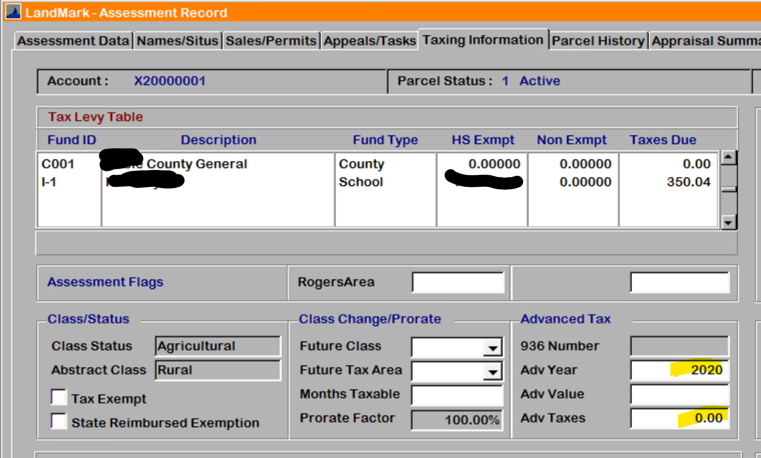

1. If an account has advanced tax (936) for the current year you will not be able to inactivate an account. You will be able to change to pending inactive. (Added to manual 3/18/2021 AR) This was an issue in balancing at times.

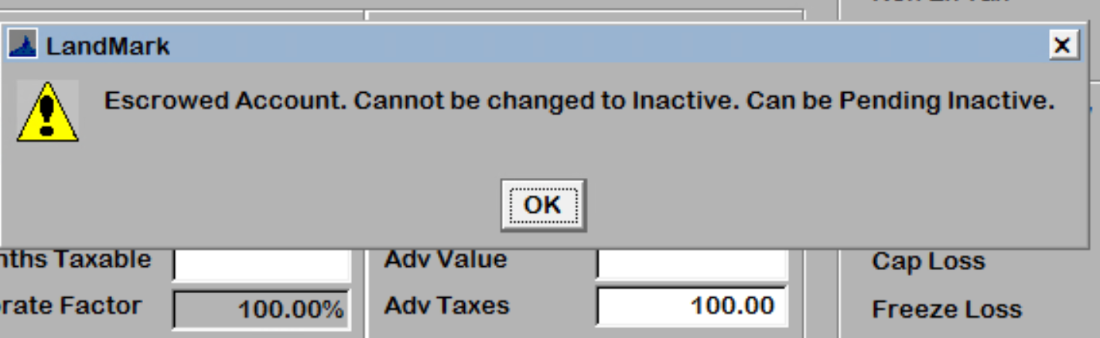

1. If you are in an index and go to the appraisal record and come back to the assessment screen the status bar will still indicate what index you are in. Before the screen was not refreshing.
2. If reading the appraisal values Appraisal Value – Read appraisal file you will receive a message that there are no appraisal records. Prior you would get a message about security.

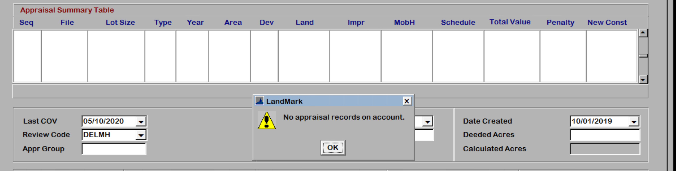

### Appraisal

1. On residential sketches if the style was changed and the structure type wasn’t SFR the area multiplier would not adjust. This is part of the 11/30 update.

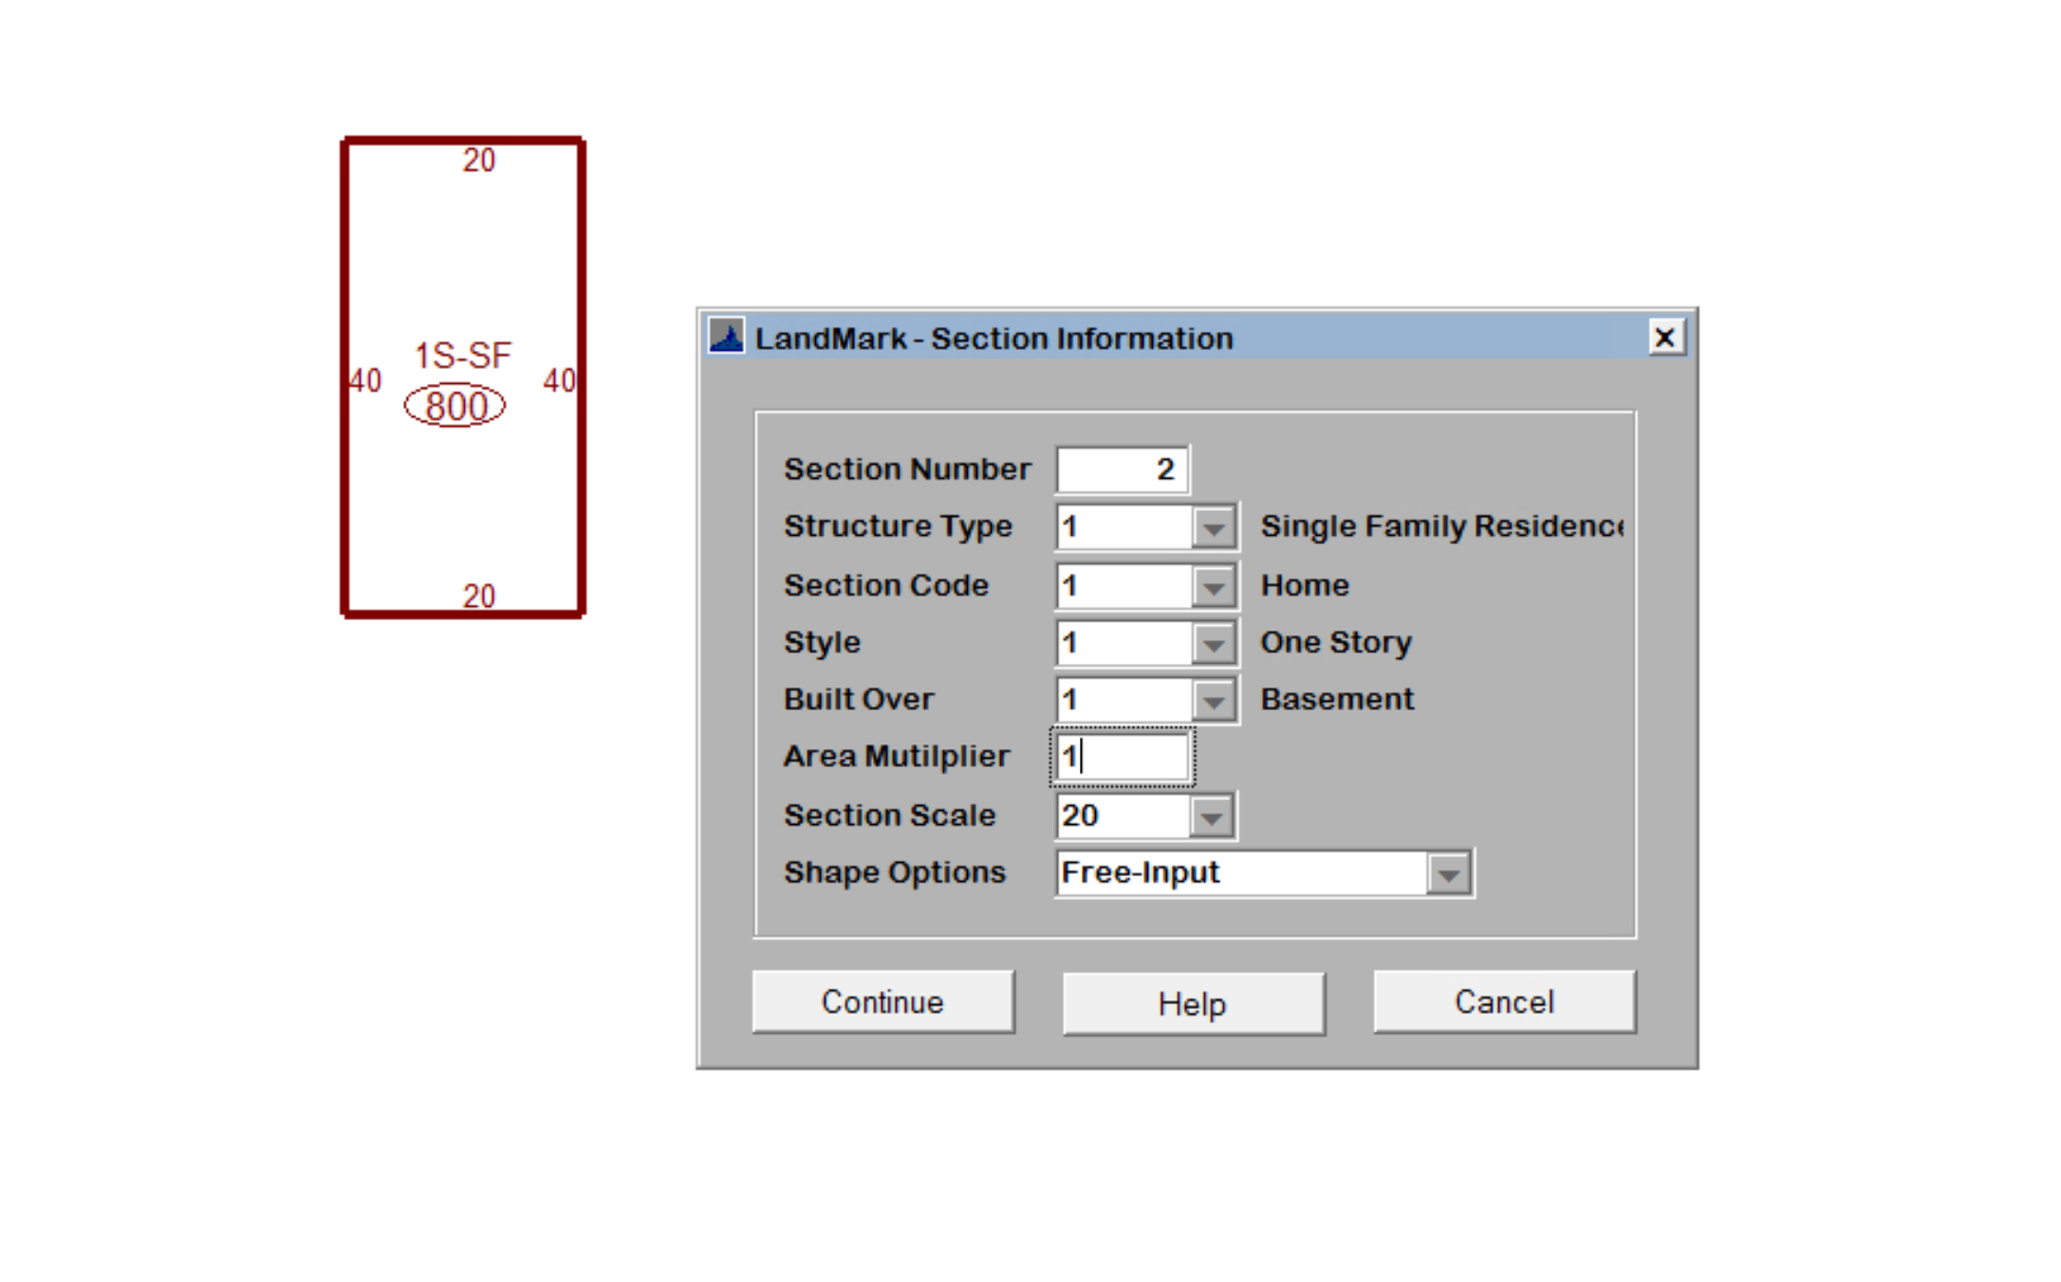

1. The tab order on the residential building data has changed. Prior the corners field was the last field in the tab sequence.

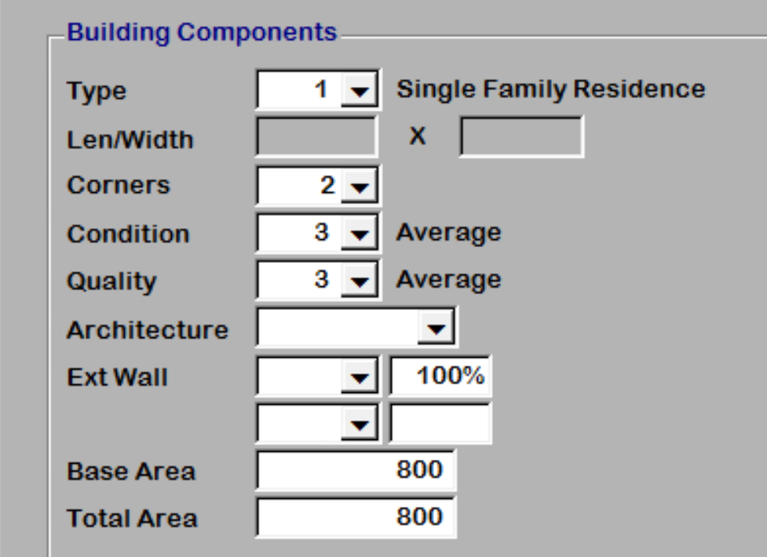

1. On the residential properties screen the form will not lose focus as it has been doing.
2. On the conversion the corners were not calculated. The can now be calculated. This will modify the cost as the number of corners is part of the cost in NBC. To calculate the corners create an index in the appraisal file of all appraisal records with type 1. Then select Tools – Sketch – Resave Sketch. Select to Apply to Index and Update Corners Only. This process can be done on an individual process if needed.

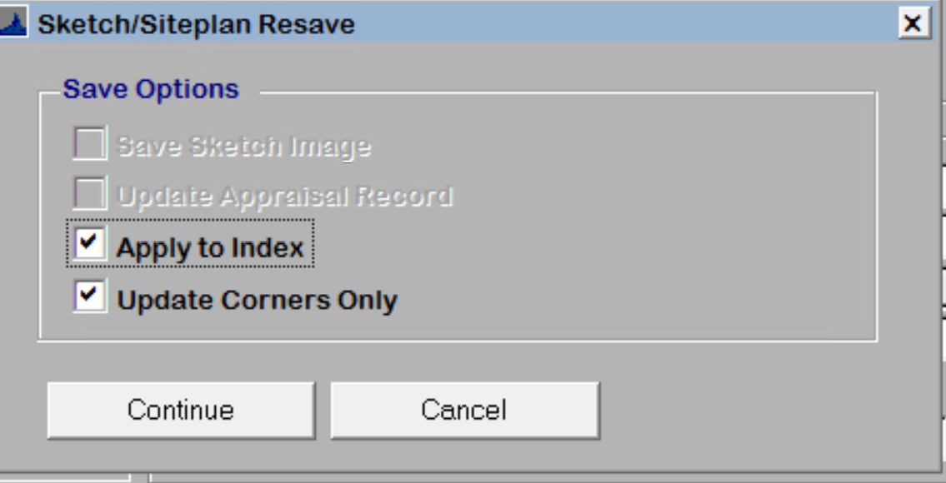

1. There are additional miscellaneous codes that are available on different menus and/or cost. These include subterranean garage, outdoor kitchen, firepits, and tennis courts.

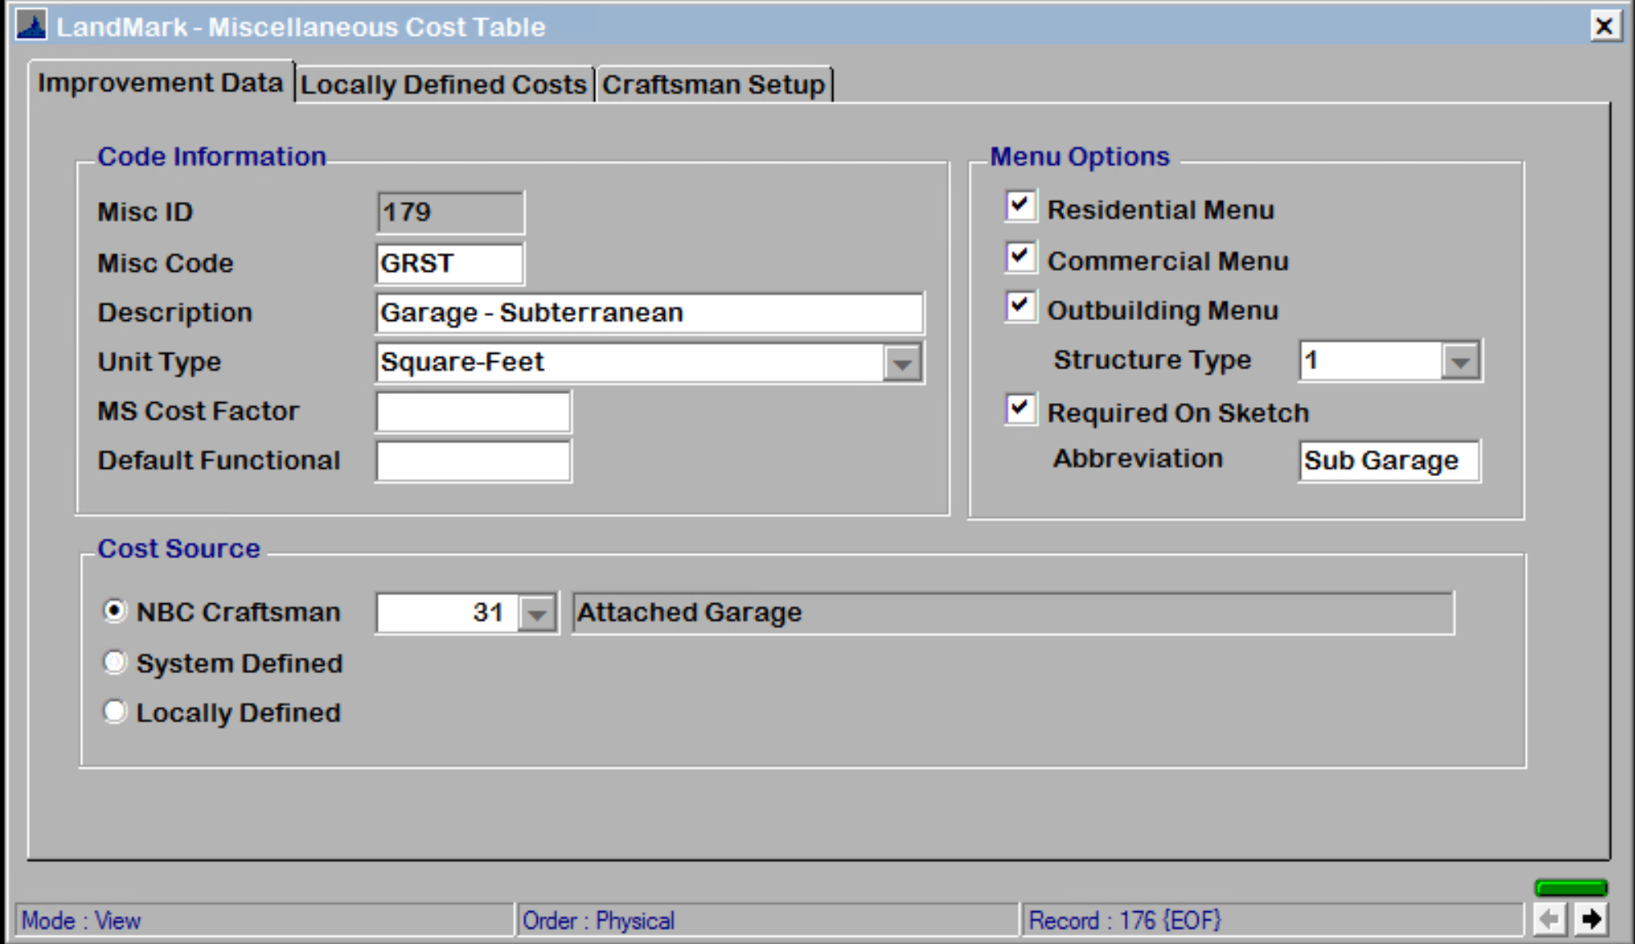

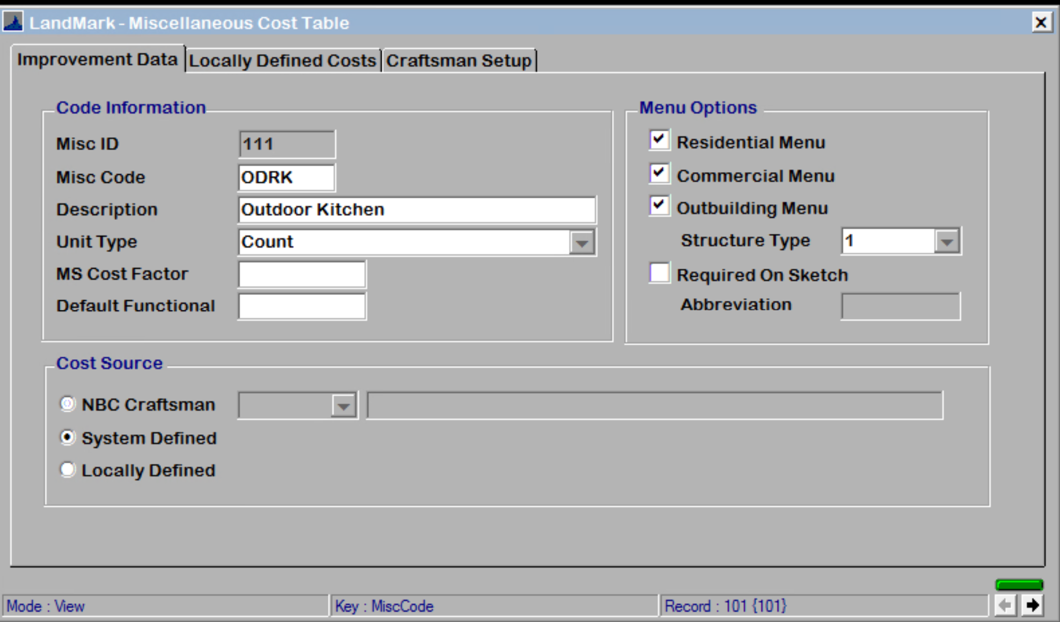

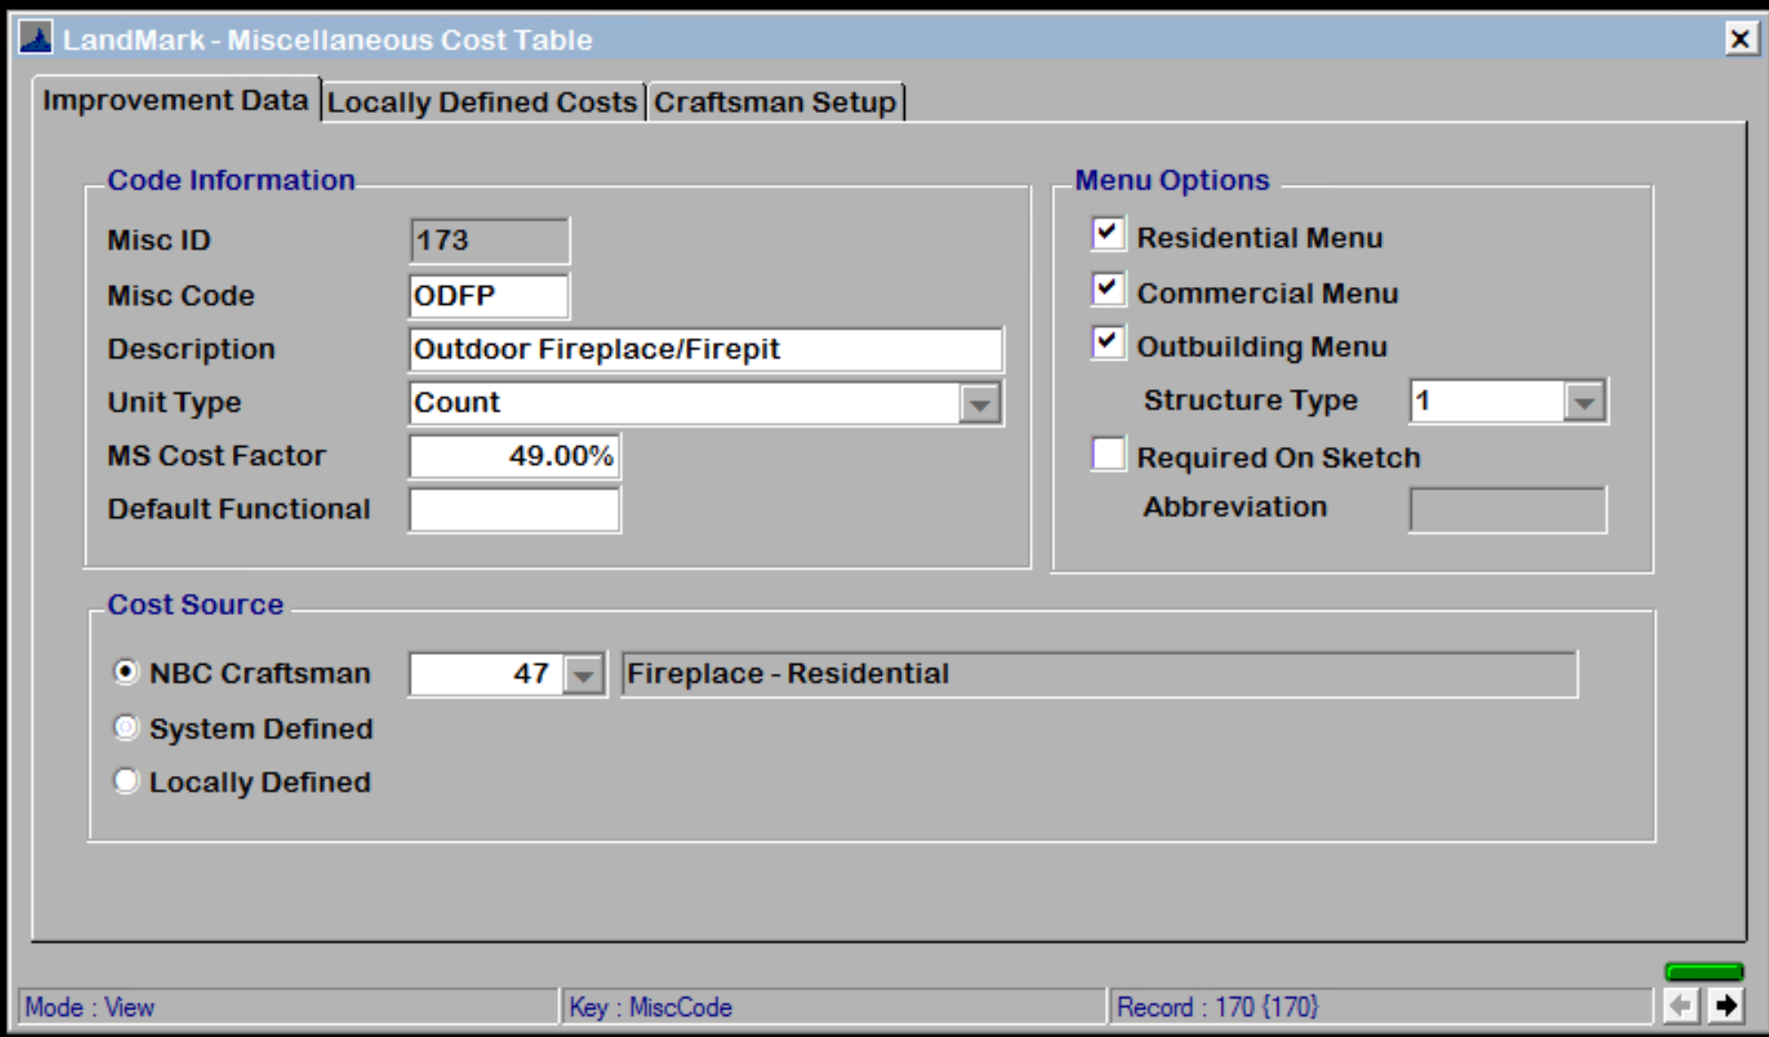

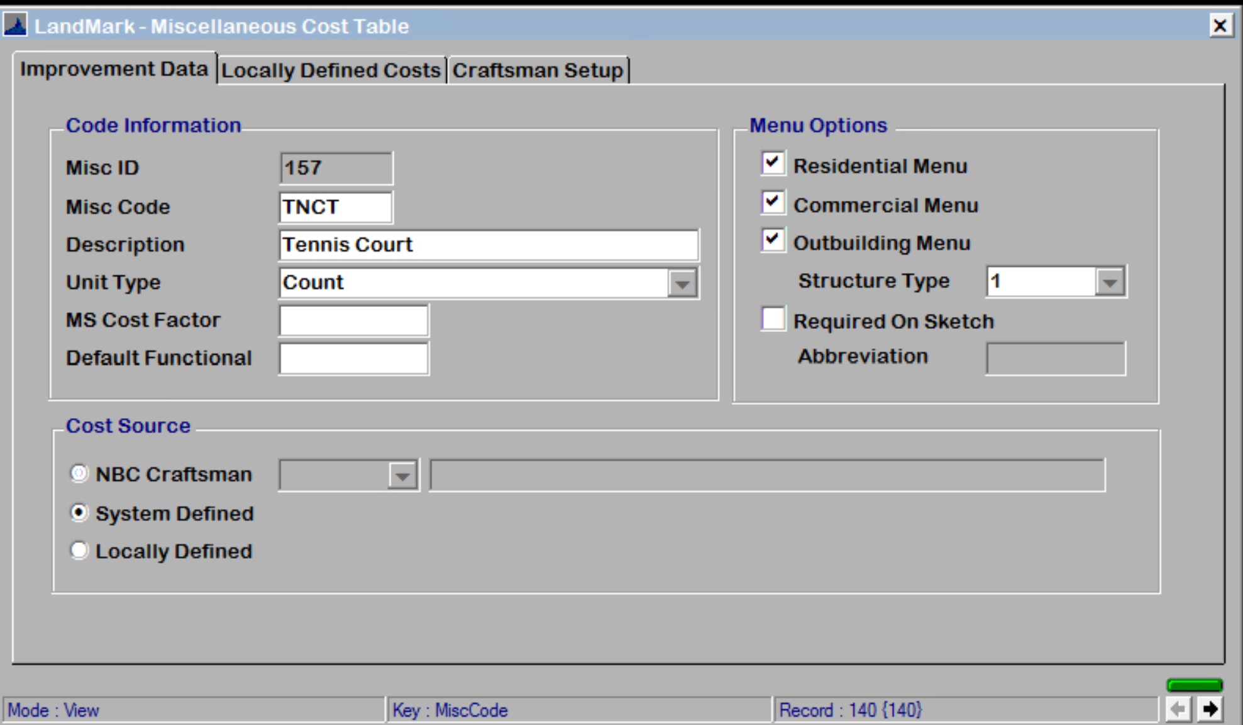

1. There are modifiers for area over the garage. The area will be the area that is not included in the garage area. The fixture count can be entered for costing as well.

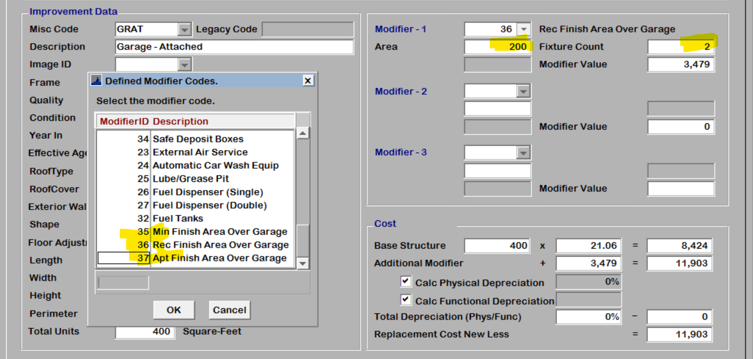

### Personal Property

1. The new trending tables are available. Appraisal – Personal Property Tables – Trending Table

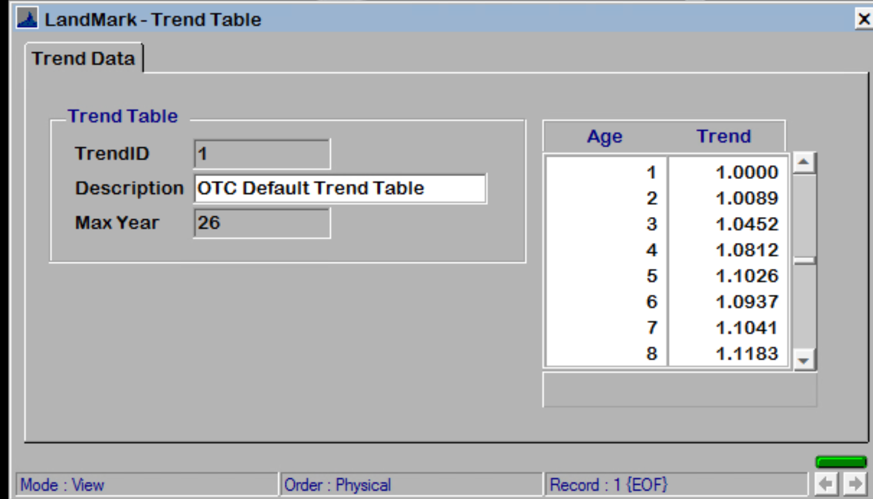

1. A complete list of NACIS codes is available. (In personal property appraisal select View – Personal Property Tables – NACIS Codes)

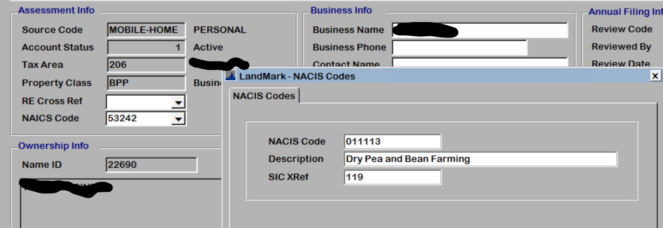

### Name

1. Notes and documents can be added to name records.

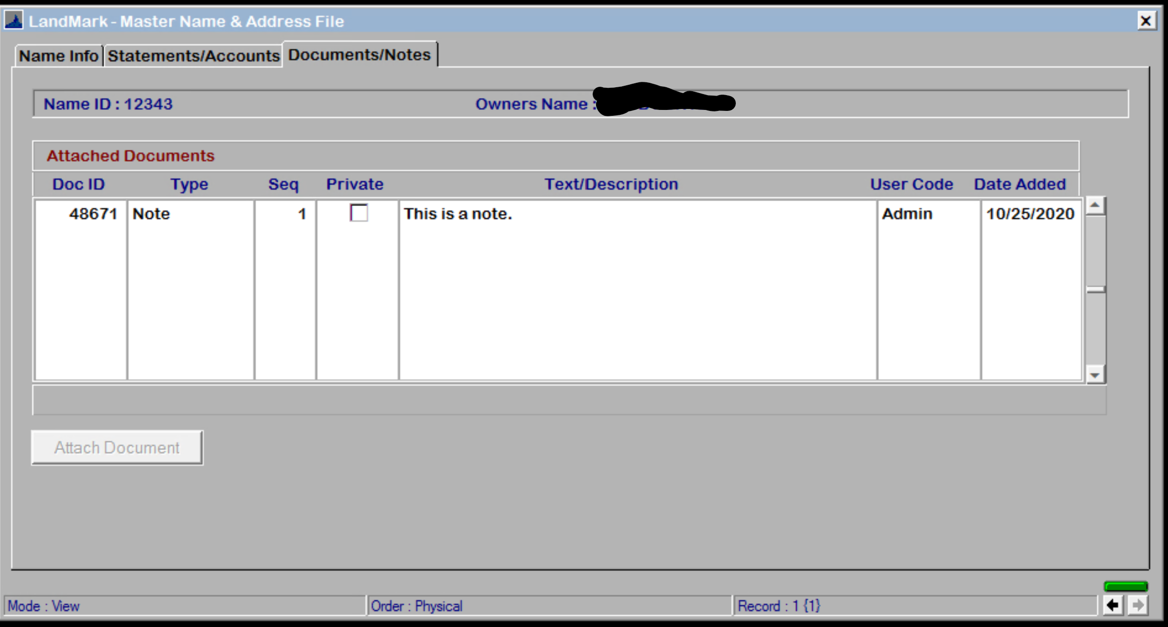

### Street

1. If the street name is changed the situs records will be changed in all locations. This was not being done and the situs would not print on the property record card.
2. If the street is being used it cannot be deleted. (Added to the manual 03/18/2021 AR)

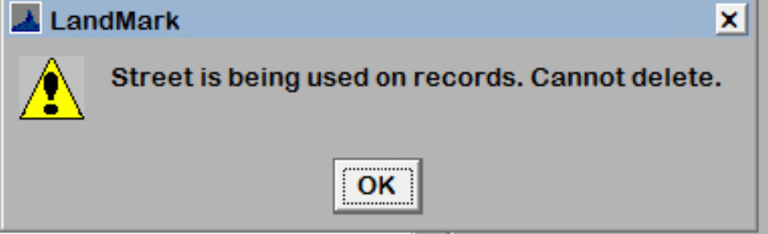

### Tax Districts

1. If a district is being used on a tax area you will not be able to delete the district. (Added to manual 3/18/2021 AR)

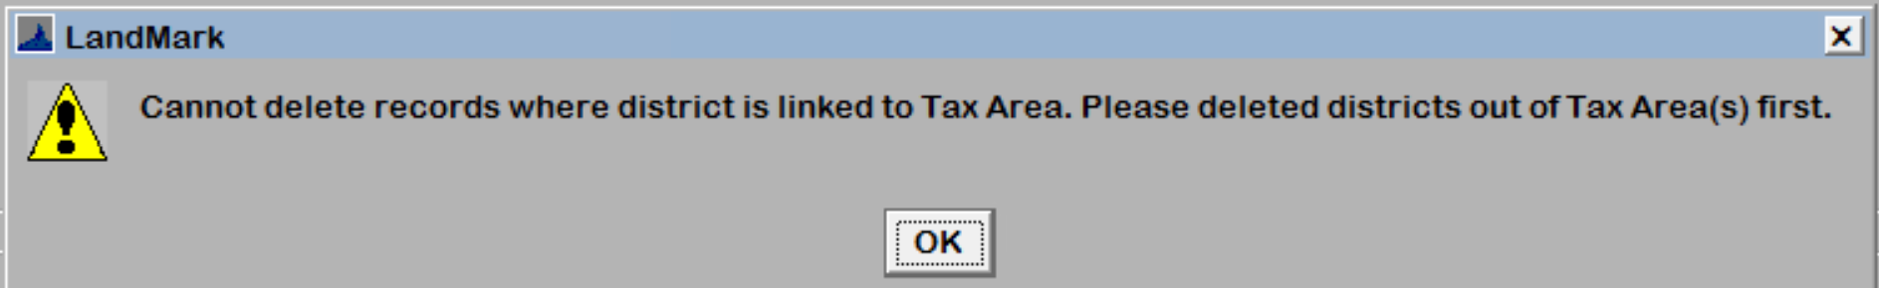

## Reports

1. The OTC report with changes have been provided.
2. On the reports that use the tax the advance tax amount will be used prior to depending on the report so the net tax amounts should match on the reports.
3. The taxroll abstract report on the TIF increment gross tax was using the base value which then would represent the net incorrectly. This has been adjusted.
4. Review sheet will now print the fireplace description on the report. In addition the land value was printing the value from the assessment side vs appraisal which then caused the totals to be off if there was a different if land value from the assessment and appraisal files. This will print the appraisal land value now.
5. From October 25 through the update on Nov 30th the appr_id would print on line 25 for residential properties. This has been removed.