Contents

Weekly Changes November 17, 2021 1

Personal Property 1

Assessment File 1

Sketches 1

Reports 1

# Weekly Changes November 17, 2021

## Personal Property

* Nov 15th The new trending rates are available. These are updated in the process pending accounts process. After the pending process is done the personal property file should be recalculated. The reasons: This will update the items with the additional year of depreciation and new trending rates will apply to the applicable accounts. If you have already processed pending accounts, please let us know.

## Assessment File

* Nov 8th When modifying the filing date, the filing date on the appraisal file will be updated.
* Nov 15th When doing a combine the option of combining images will be checked by default.

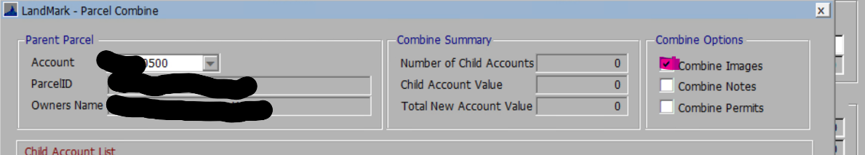

* Nov 15th When updating the filing date on the appraisal file the filing date on the assessment form will update.

## Sketches

* In the update on the 15th on the residential file there will be an option to select outbuilding on the site plan that are currently on the sketch. After selecting this you will go to the sketch and remove the outbuildings that were just placed on the site plan. This will be a good option to use if creating site plans from converted records.
* Nov 15th When creating outbuildings and commercial buildings from the sketch/site plan the calculated effective age, physical depreciation, and functional depreciation will automatically be checked by default. In the case of editing the residential properties in the residential sketch if there is not a type of these fields will automatically be checked.

## Reports

* Nov 8th The File - Print Forms have been updated and will go out with the weekly update on Sunday. Please note your tax year will not change until you process pending accounts.
* Nov 8th Sales Verification Letters are also complete. To change the report you want to use, go to System - Report Manger. Browse to find the Sale_VerificationLetter. By default, everyone is using the Sale_VerificationLetterNew report (the first Ref 961). To change this report, edit the report options and drop down the File Name. In the browse box, you can either select OTC_Form961 or Sale_Verification3 (the new Ref 961 which prints based on Property Class). You may need to edit your parameters to only show InstrumentID and CountyNumber. Your CLGT person can also do this for you if you want.

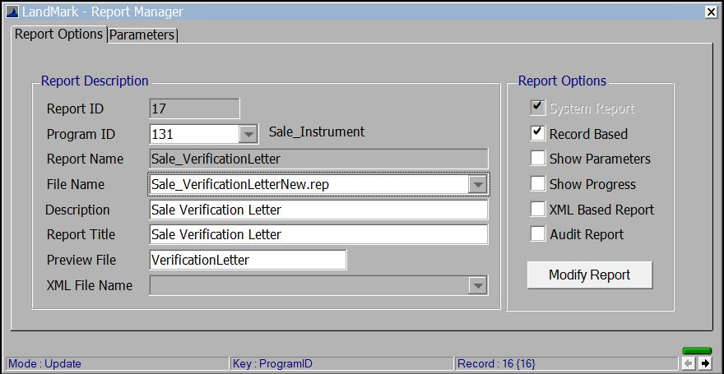

* Nov 8th The OTC Editable forms have been updated. To update these, go to System - System Updates - Update OTC Forms. Gerald sent these to me yesterday afternoon so I will work on having the other forms ready to go out in the weekly update.