Contents

Weekly Changes November 1, 2021 1

Residential and Commercial Appraisal 1

Commercial Appraisal 2

Remodel Code 2

Appeal 3

Assessment 4

Code Reference 5

Reports 6

TIF 7

Other 8

MapAnalyzer 8

# Weekly Changes November 1, 2021

## Residential and Commercial Appraisal

* There were times where adding a site improvement the total of the site improvements would not be updated. This has been reviewed and updated.
* In the miscellaneous improvements table on both residential and commercial if a code is entered that is required on the sketch you will receive a message like the one below.

* When printing the report from the sketch (File-Print) if you entered by selected Edit Sketch (or Edit Site) the menu would not return on the sketch. This has been corrected.

## Commercial Appraisal

* When selecting the option to copy a commercial building (Edit – Copy in the sketch form) the structure class, calculate effective age, remodel code, and remodel year did not copy to the new building. This has been adjusted.

## Remodel Code

* The remodel type has been added to the remodel table. In additional based on the appraisal records the respective remodel types will be available in the drop down in the commercial file and sketch/site improvement screens. In the sketch and site improvements the description of the remodel code will change.

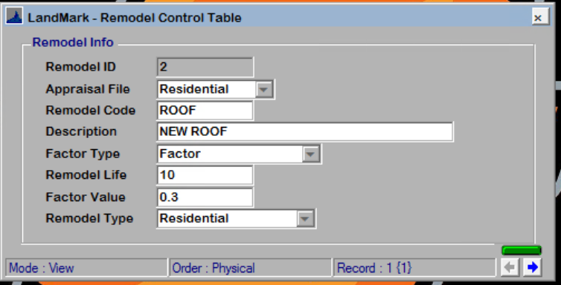

## Appeal

In the appeal module when you select Tools- Update Assessment Record after select to update the assessment value you will be asked to freeze the value for the current year. This will check Freeze Current Year and put the assessment year in the Re-Val Freeze Year. This will keep the fair cash value the same regardless of what is in the appraisal file.

## Assessment

* There is a new option on the mapped parcel report. (File-Print-OTC Audits – Mapped Parcel Report. This option will exclude parcels that only have a fractional interest and may only be tied to a main parcel and for that reason rightfully not mapped.

* When moving a mobile home from real to personal if this is selected then the source will be MH936 which will have the assessment ratio of the real property.

* + If the 936 option isn’t selected, then the type will be MOBILE-HOME with the personal property ratio.

## Code Reference

* The unit type was not displaying on the form. This has been corrected.

## Reports

* On the verification letter Residential was misspelled.
* On the 936 form the phone number of the buyer will be included.

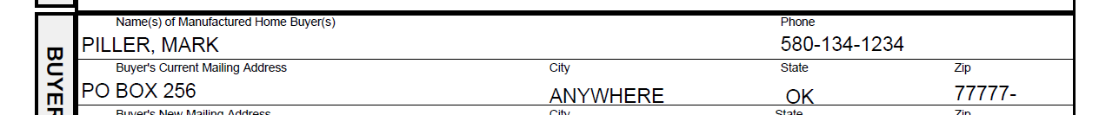

* On the TIF Yearly Summary report the project and captured values will be using total assessed vs total taxable.

* On review sheet the story/style is placed in the box and the date of the note

## TIF

* There is a new field for a retained factor in the TIF file. This is if a portion of the excess value needs to continue to be reported in the base district.

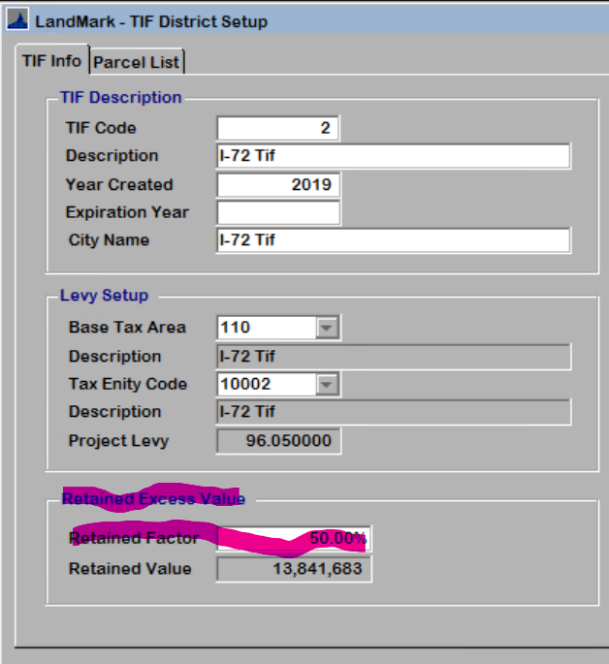

## Other

* The OTC forms will import from the LandMark ftp site with the new forms once we receive these.

## MapAnalyzer

OCT 13th

They system no longer removed invalid shapes such as self intersecting, counter clockwise, etc. . Therefore if you are trying to edit a layer and it is kicking you out. Right click on the shape file under map legend , shapefile tools, fix shapefile, check the fix in place box. Remove any invalid shapes. You can view the log and see any shapes that were fixed and what was wrong.

Attributes can be sorted and properties screen no longer hangs

Oct 16th

Discovered that parcels disappearing was actually being “cloaked” meaning they were in your attributes and on the shape but users might now see it till a few days later. All cloaked parcels are set to appear.

Multiple users pasting and adding polygons has been addressed.

Don’t forget to Reload (arrow pointing up out of the oval under map legend) to fix labels.