Contents

Weekly Changes May 9, 2021 1

Application 1

Assessment 1

Appraisal 2

Residential and Commercial Sketches 2

Personal Property 2

Land Summary 2

Deed Viewer 2

Image Export 3

Reports 3

Property Record Card 3

Sales Forms 3

Personal Property Asset Listing 3

926P 4

924XML 4

901 and 901XML 4

Omitted Tax Form 6

# Weekly Changes May 9, 2021

## Application

There have been reports of error such as Process #### not found. This issue has been resolved.

### Assessment

* The unmapped parcel count report would generate all parcels as not mapped in certain circumstances. This has been reviewed and corrected.
* On commercial splits the user would get these errors on occasion. These have been reviewed and corrected.



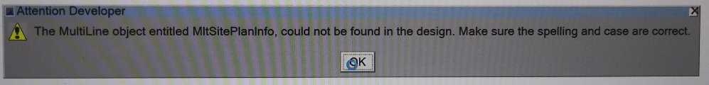

### Appraisal

### Residential and Commercial Sketches

* When entering an outbuilding if an invalid condition is entered the user may have been getting the error below.

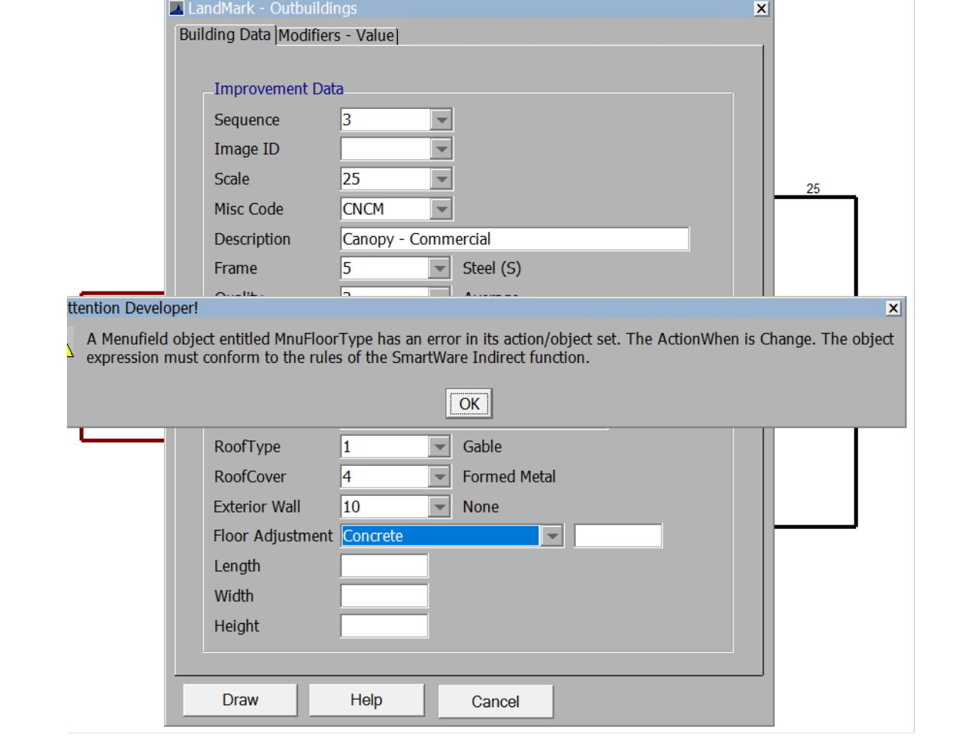

* + A change is made that if an invalid condition is entered the user will get the following message.

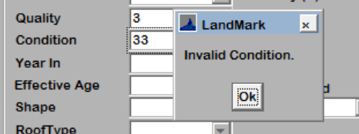

### Personal Property

* On the report manager the xml renditions can be printed.

### Land Summary

* When updating from the land summary the first appraisal record found is the one that the agland is updated with. If in the residential appraisal file and if the first appraisal record found for the account is commercial this is where the agland will be placed. Before if the first record were inactive the agland would be placed on that record. This has been changed where the appraisal record must be active or pending active.

### Deed Viewer

* When displaying the deeds from KellPro this was not displaying in the order scanned. This meant the pages were scattered on the image. This has been changed.

### Image Export

* Each week all images and documents are exported to t:\transfrer\lmexports\images. This at times is sent to vendors. Archived images were exporting out with this. This has been changed where archived images will not export by default. This can be set up to export the archived images. If you would like this done, please let us know.
* There images are exported with the account number as part of the names. There is now the option to replace this with the parcel id. If there is not a parcel id then the account number will be used for individual images. If you would like this done, please let us know.

## Reports

### Property Record Card

* If there was a building permit and no exemptions or sales the sketch would print underneath the permits and not fully display.
* If there was a penalty amount this was being reflected in the exemption amount. This has been changed to be included in the penalty row.
* If using nonexempt tax rates, the exemption was not excluding these rates causing the tax amount report to be too high. This has been corrected.

### Sales Forms

* On multiple parcel sales the information on the parcel and photo/sketch was the same for each account. This has been changed. In addition to this the legal description for each parcel.

### Personal Property Asset Listing

* On the personal schedule information report there is an option to have signature line at the bottom of the report.

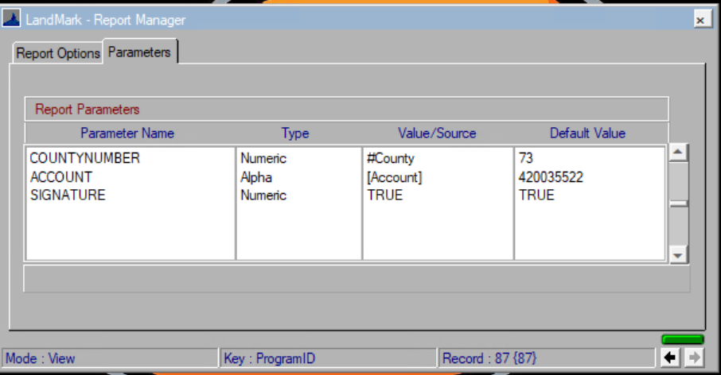

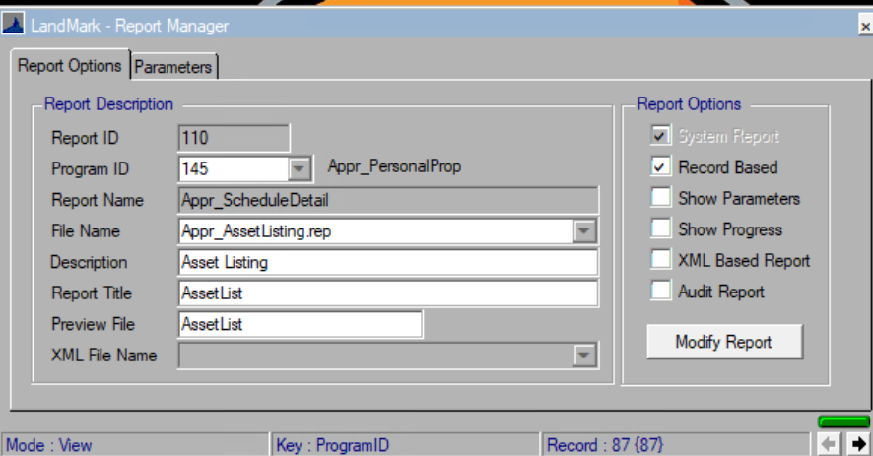

### 926P

* The penalty will be the percentages vs amount. The tax will continue to include the tax and penalty.

### 924XML

* The penalty percentage will print on the form. The amount already did.

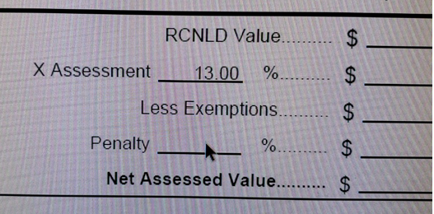

### 901 and 901XML

When using the OTC method to value the 901 and 901XML was taking the value on the furniture and fixture line by the assessment level twice and the total fixed assets was taking the RCN vs the RCNLD by the assessment level. The transfer to assessment was not affected.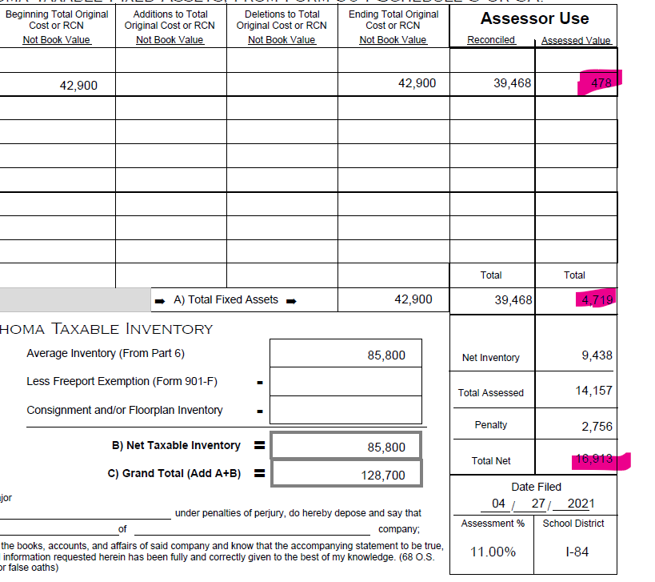d.



### Omitted Tax Form

* The omitted tax form has the MH VIN number in the year cell. This has been corrected.
* At the bottom of the form there is more room for the signature.