Contents

Weekly Changes May 17, 2021 1

Appraisal 1

Commercial Sketches 1

Residential Sketches 1

Reports 2

Omitted Tax Form 2

# Weekly Changes May 17, 2021

### Appraisal

* On the residential and commercial file cost tab the following error would appear. This has been reviewed and should not show up.

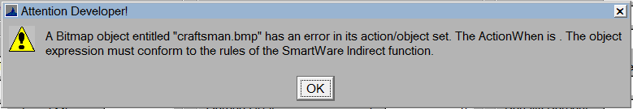

### Commercial Sketches

* When changing the occupancies from the commercial building form they will change on the sketch. Prior they were not updated. The occupancies changed from the sketch have always updated the commercial building.

### Residential Sketches

* In the case of outbuildings when they were being selected to be drawn on the sketch or site plan, they would create a second entry in the outbuilding table. In addition, an outbuilding could be added to the sketch and outbuilding. This has been changed.
* When a site plan is on the record the outbuildings will need to be added to the site plan vs the sketch. If there is only a sketch the outbuildings can be added to the sketch. If trying to add outbuildings on a sketch that already has a site plan you will receive the following message.

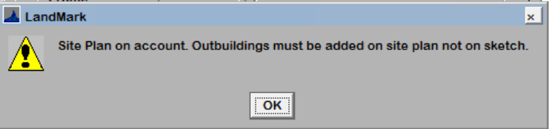

## Reports

### Omitted Tax Form

* The first two lines of the legal was printing on the report. There is a new parameter to print all the legal. With the parameter of PrintAllLegal set to true a second page will print if there is more than 2 lines of legal. This should duplex print if the printer is set up that way.  By default, only the first two lines of the legal will print.

