Contents
Weekly Changes March 7, 2022 1
Assessment 1
Residential Appraisal 1
Commercial Appraisal 2
Reports 2
Review Sheet 2
Property Record Card 2
Residential Report 2

Weekly Changes March 7, 2022

Assessment
- Mar 7th When doing a split, the site plan would not be removed if an account had all items moved to the child parcel. This has been addressed. There will be additional split changes in next week’s release.

Residential Appraisal
- Mar 7th When moving a site improvement from residential to commercial the sketch would not move the sketch. This has been addressed.
- Mar 7th Cannot move a misc. improvement from a residential card to commercial card. This is because the miscellaneous improvements in commercial are tied to the buildings.
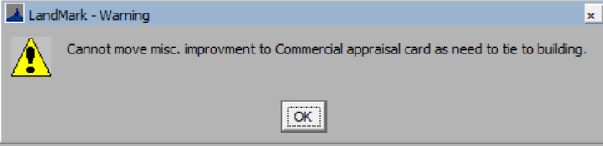
- Mar 7th When adding a residential building and there is already a site plan there is a need to display the site plan and the place the homesite in the site plan. If this is not done the homesite will not be on the site plan. There is a report to find these. In the residential file select Tools – Listings-Sketch Not On Site Plan.
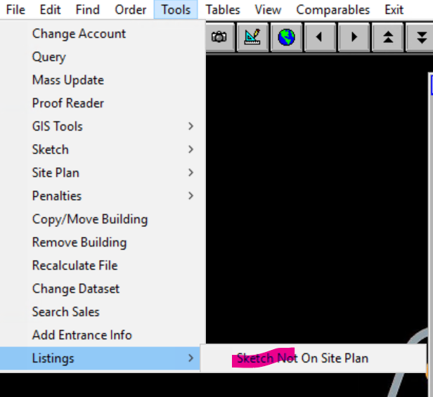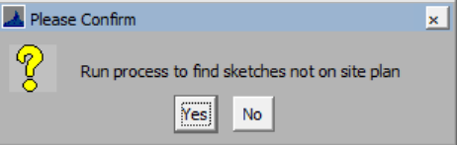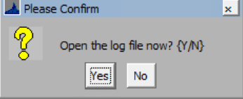

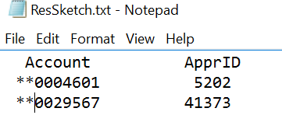
- Mar 7th If a value >1 is entered in the percent of style the user will be informed of this and the percent will change to 100%. If multiple styles are in place the second style will be removed. If the percentage of the style is changed the second style percent will automatically change instead of having to tab through the second style.
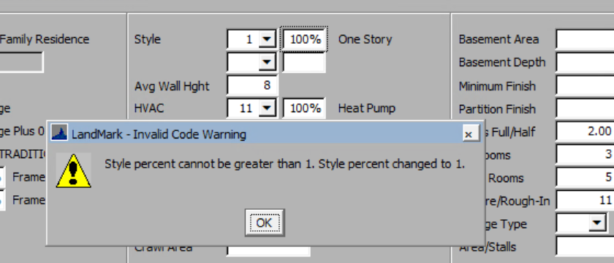
- Mar 7th If a value >1 is entered in the percent of the hvac the user will be informed of this, and the percent will change to 100%. If multiple styles are in place the second style will be removed. If the percentage of the hvac is changed the second hvac percent will automatically change instead of having to tab through the second hvac. This also occurs when editing the residential properties on the sketch.
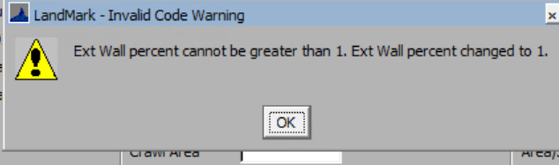

Commercial Appraisal
- Mar 7th On the right click options on the miscellaneous improvements took the option of Move Misc. Improvement off list. This was not doing anything.

Reports

Review Sheet
- Mar 7th On residential accounts the lot model description at times would not reflect what was on the account.

Property Record Card
- Mar 7th On residential accounts the lot model description at times would not reflect what was on the account.

Residential Report
- Mar 7th On residential accounts the lot model description at times would not reflect what was on the account.

