Contents

Weekly Changes March 8, 2021 1

Application 1

Appraisal 1

Sales 2

Reports 2

# Weekly Changes March 8, 2021

## Application

### Appraisal

* When tabbing on the cost tab of residential and commercial appraisal the system won’t lock up.
* When entering the code for chain link fence a height was needed for the cost to be calculated. If no height is entered the default fence height will be 6’.
* On the residential and commercial file there is a checkbox for New Notice Required. This will be for IOLL and mobile homes that have the 926-P COV notice print. This changes the wording of the report. This is the same for the personal property file that has always been in place.

Residential

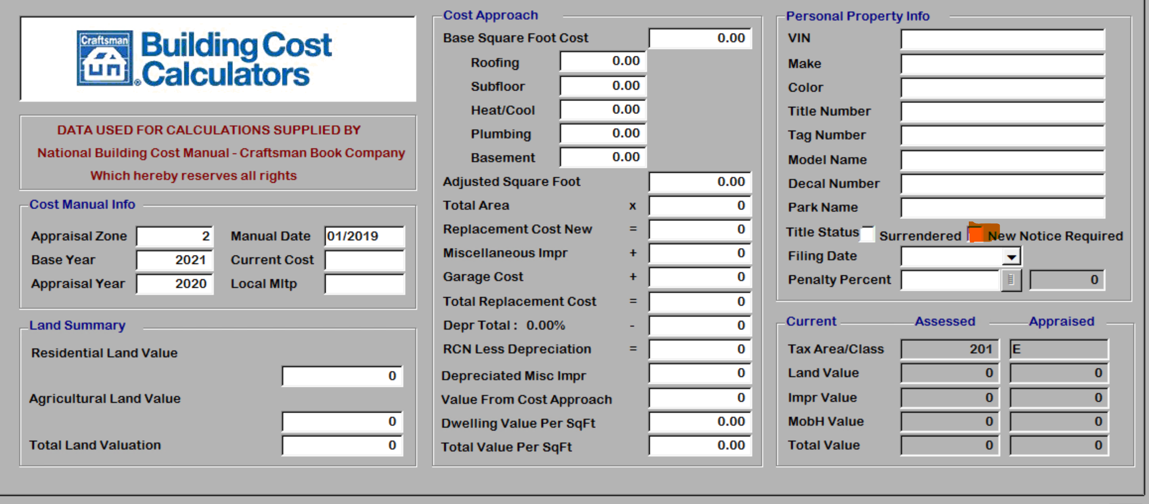

Commercial

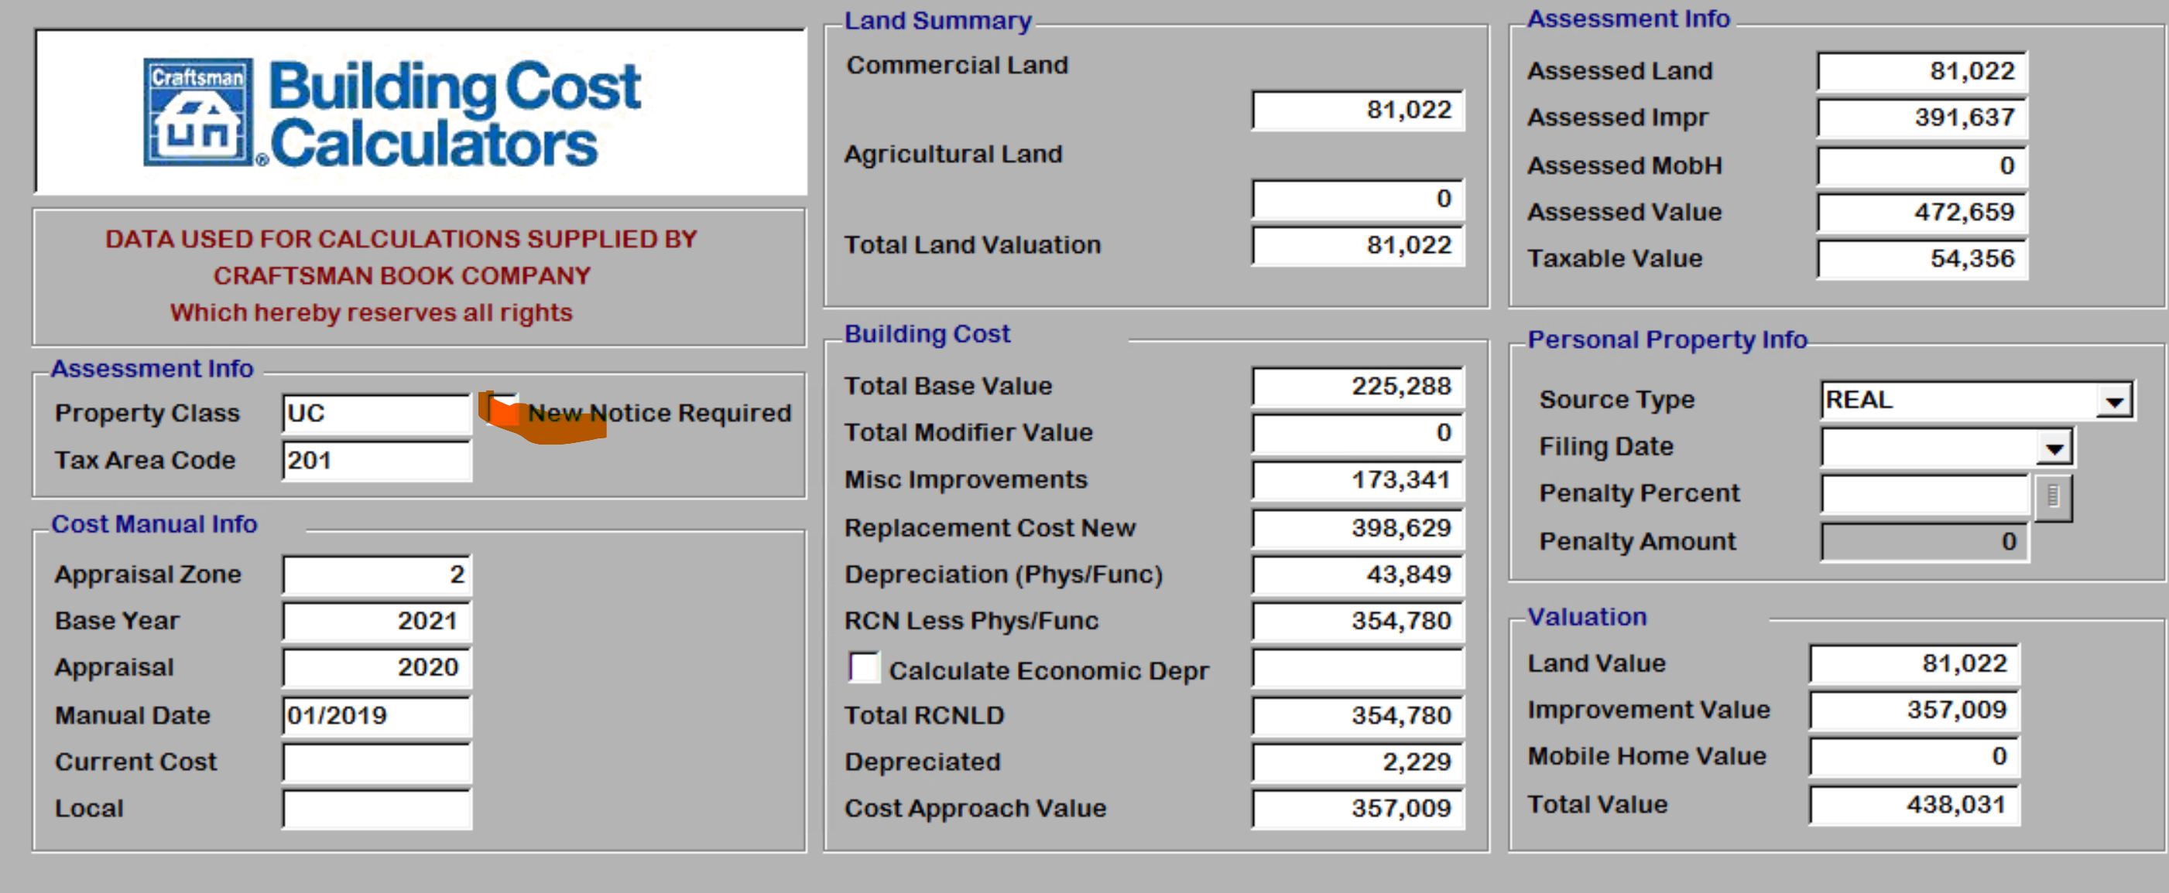

Wording unchecked



Wording checked



## Sales

* When exporting statistical analysis the instrument number was exporting to the book/page field. This has been changed to be the book and page.

## Reports

* On the 926 the Notice-Text was moved from under the bar code to the notes section under the legal description.
  + These notes will print in black by default. A parameter can be added to the report (NOTICENOTESRED) to TRUE to have these print in red.

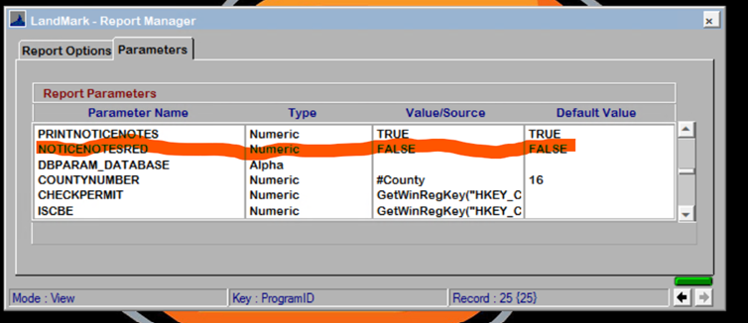

* On sale verification letter there is parameter that can be added that will only print the first line of the legal description for each account.
* There is a menu option that can be used if you get the error message some receive when printing a review or property record card. This is a temporary solution until we work with the report writing company to come up with a solution.

