Contents

Weekly Changes March 28, 2021 1

Application 1

Appraisal 2

Residential and Commercial Sketches 2

Personal Property 2

BOE 2

Personal Property Recovery Table 3

Sales 3

County Information Form 4

Reports 4

Review Sheet 4

Renditions 5

926-P 5

COV Report 6

Correction Form Change 6

# Weekly Changes March 28, 2021

*= Change will be in place Monday March 29th.

## Application

* *The help files will use the same session instead of creating a new session on each request. Before the change you could have and unlimited number of tabs/sessions open for help.
* *A help button has been added to the Split, Combine, Subdivide and Taxroll Correction forms that opens the help document for each task.

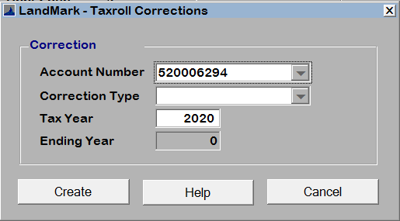

* The images and GIS will be exported to the T:\ drive under LMExports. Images will be in the images folder. (run once a week) GIS will be exported to GIS\NAD83 and GIS\WGS84 for the projects.

### Appraisal

### Residential and Commercial Sketches

* There were times when you would have a vector area with no area on this. This generally occurred when a building was removed. This should not occur any longer.

### Personal Property

* When using the Import Excel Rendition function or the bar code on the rendition to fill in the filing information you will have the option to have the Notice Required check box selected. This is located on the personal property appraisal form and the residential and commercial property cost table if mobile home or IOLL.

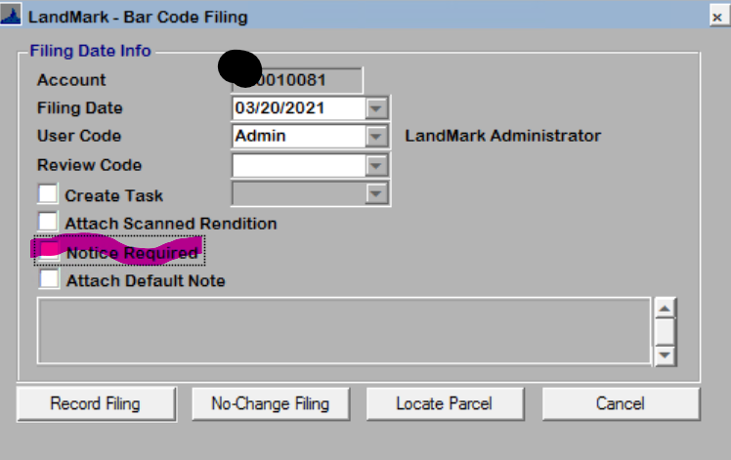

* When exporting excel items or schedule the file will save under your T:\ drive at your windows login\documents\excel renditions. This will allow you to find these files to modify them at a later time before import the file back in.

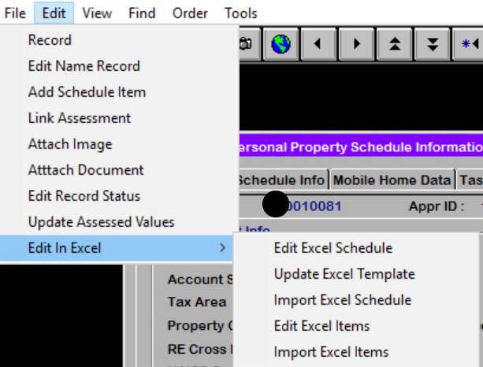

### BOE

* The update assessment menu option has been changed to update the assessment file with the final values. The BOE record must be set to complete and be a current year record to be able to run the process.
* Indexing has changed, updating of values when changes are made, and several other changes has been done.

### Personal Property Recovery Table

* When creating a new record a ID will be assigned.

### Sales

* *The Set Account Value on the sale instrument table rounded the improvement value to the nearest ones digit if the sale price was greater than the fair cash and there was both improvement and mobile home value. (i.e. 111 would round to 110, 116 would round to 120)

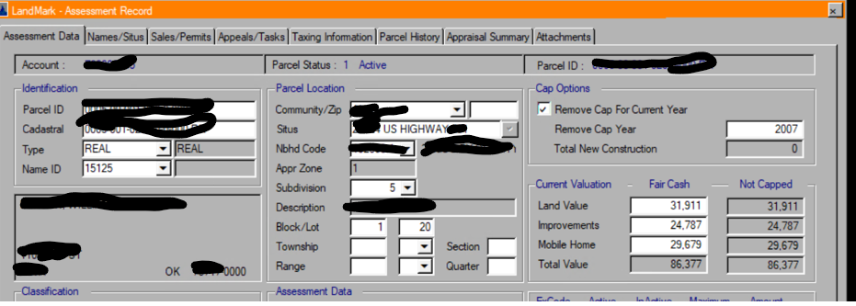

54,466 total impr and mh value

150,000 - 86,377 (current fair cash) = 63,623 value to increase

Impr value 24, 787 + Round( (24,787 /54,466) * 63,623,-1) = 28,950 rounded from 28,954

MobH value 29,679 + Round( (29,679 /54,466) * 63,623,-1) = 34,670 rounded from 34,669

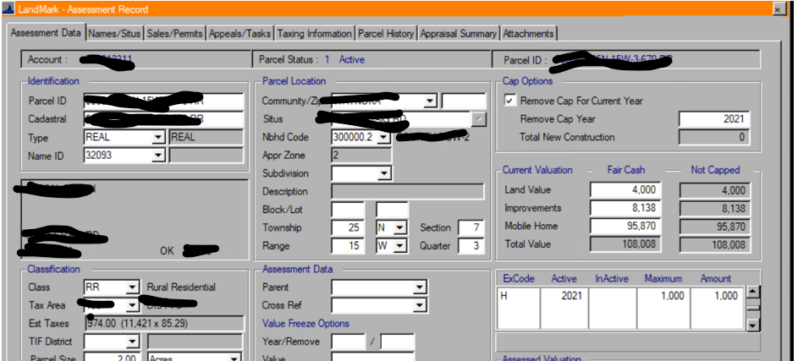

Before update Improvement 8,088 and mh 95,320

103,408 total impr and mh value

108,000 – 107,408 (current fair cash) = 592 value to increase

Impr value 8,008 + Round( (8,008 /103,408) * 592,-1) = 50 rounded from 45.845

MobH value 95,320 + Round( (95,320 /103,408) *592,-1) = 550 rounded from 545.697

There are new fields available in the sale instrument table:

The Assessed Fields are the Fair Cash fields from the assessment screen. The Capped Fields are those that are under the capped, no capped column in the assessment screen. The fields to export will not be available to users until Monday.

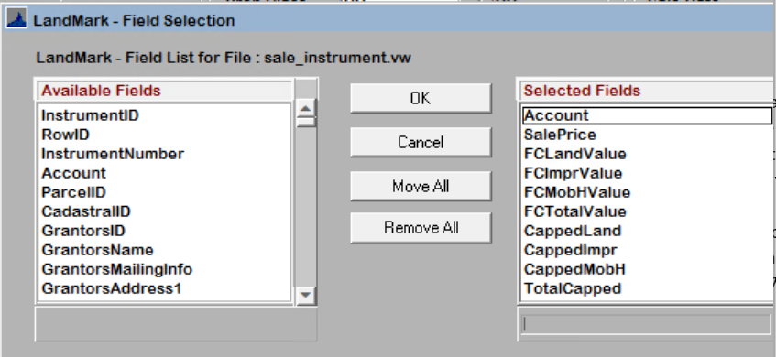

An additional query could be added to the normal qualified sale query to find sales where the FC and Total Capped columns do not match the sale price.

The user could add this to the query of qualified sales to find those that the fair cash and/or capped value does not match the sale.

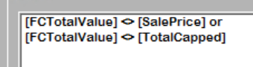

### County Information Form

* The assessor’s phone number will display on the form.

## Reports

### Review Sheet

* Previously the primary situs printed for each of the cards. There can be a separate situs associated to each card. The address associated with the card will now print.
* Previously notes where the table sequence was <6 would print. This has been changed where by default the first 5 notes will print regardless table sequence. If 0 is select the notes section will not print.

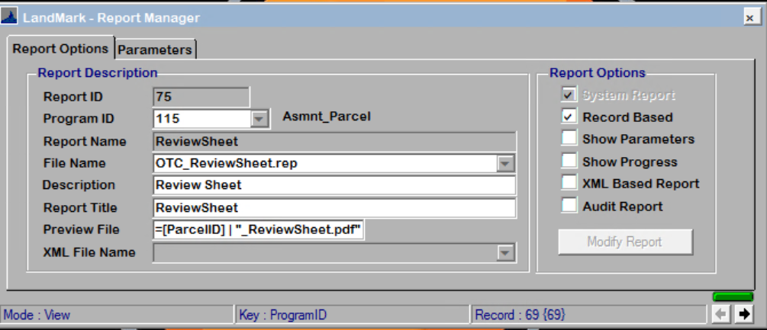

In this example the first 3 notes will print.

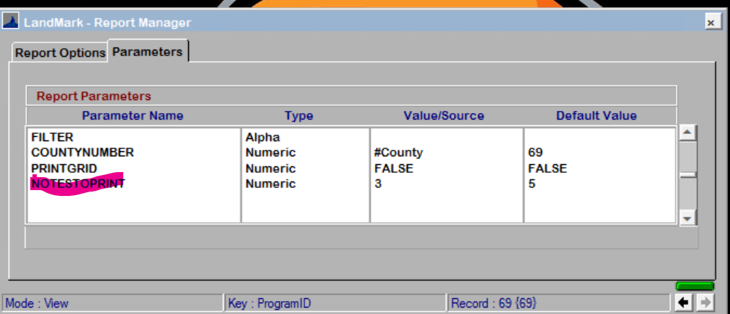

### Renditions

* The renditions will pull the freeport exemption from the appraisal record. In the case of the 926-P the exemptions will pull from the assessment file.

### 926-P

* The Notice-Text notes will print on the report.

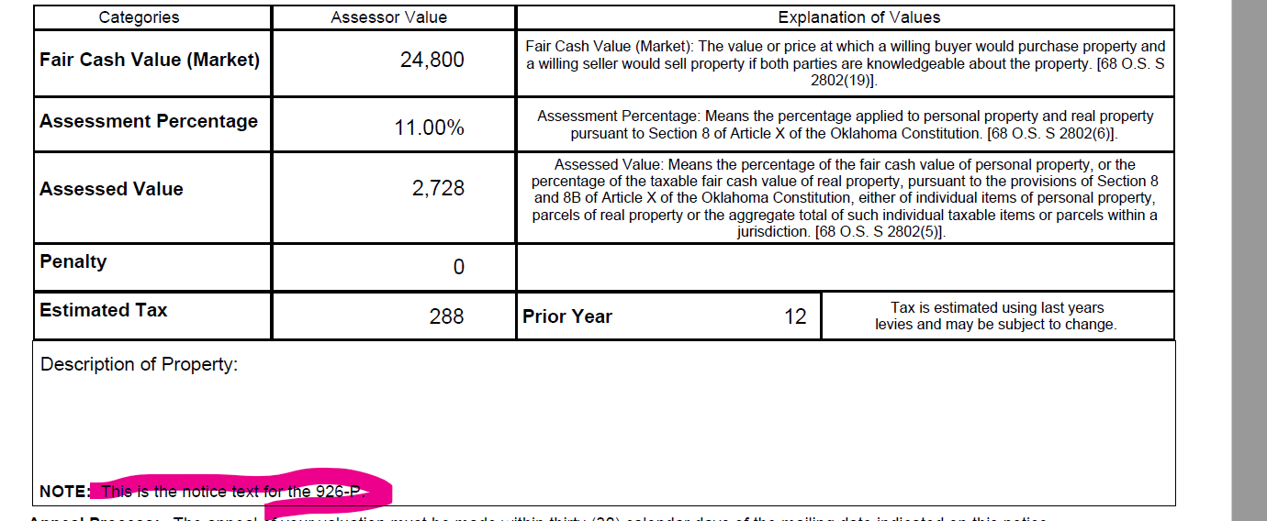

* + There are parameters than can be added to not have the not print and/or print in red. By default if there is not the parameter on the report the note will print in black.

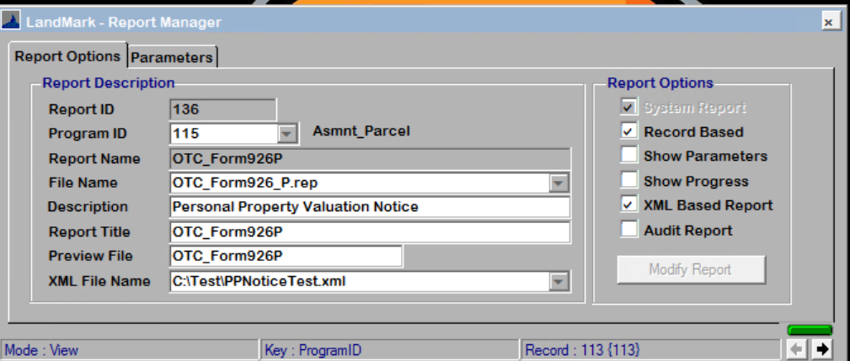

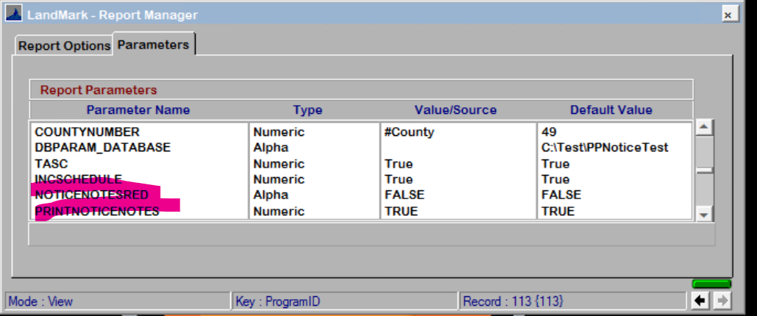

### COV Report

* When printing the COV error report on occasion you would receive and error about the error. This should not occur any longer.

### Correction Form Change

* *Item 6 on the form has been changed

From

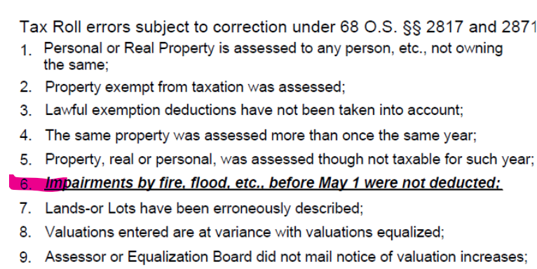

To

