Contents

Weekly Changes Mar 21,2023 1

Assessment 1

Reports 1

901 1

926P – Personal Property COV 1

926 Real Property COV 2

Commercial 3

Personal Property 3

Sketch 4

Sales 4

# Weekly Changes Mar 21,2023

## Assessment

* Feb 28th – When using editable forms and the PFD viewer is disabled the entire form should display. Prior it may be to the right side of the page when opening.
* Mar 13th – When running the excise board report if it is before June and values have not been locked you will be asked if you really want to set certified values if you select to certify them.

* Mar 21st – When editing new construction on the form the capped value will update when changing the values vs when the record is saved.

## Reports

### 901

* Mar 6th – A count of the schedule items will be on the report.

### 926P – Personal Property COV

* Mar 6th – There is a new parameter where the estimated tax can be removed from the report. If nothing is done there will be no change to the report.

**What will not print if set to false**

* The estimated tax section.



### 926 Real Property COV

* Mar 6th – There are two new parameters ESTTAX and TAXDOLLARS. Currently the estimated tax prints. With the ESTTAX this can be turned off if the parameter is set to false. The TAXDOLLARS will print the estimated change in tax dollars. This will print only if the ESTTAX is set to false and TAXDOLLARS is set to true. If nothing is done there will be no change to the report.



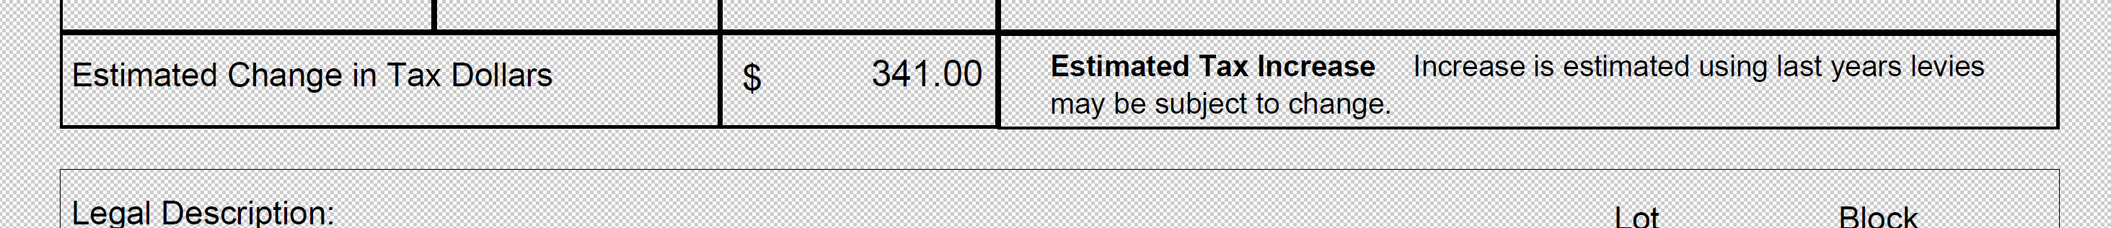

## Commercial

* Mar 13th – Agland market has been removed from the form. Agland use value is still on the form.

## Personal Property

* Mar 20th When using the bar code if the filing date has been filed for the current year you will be asked if you want to change the filing date.

## Sketch

* Mar 6th – On adjusting residential accounts that had upper levels the area was not calculating property. (Note on new records there was no issue)

## Sales

* Mar 6th The drop down will be alpha numeric order where before it was the order the codes were entered.