Contents

Weekly Changes June 27, 2021 1

Sketches 1

Assessment File and Public Service 1

Tax Area 2

Assessment Form 2

Table Maintenance 2

Data Extract 3

Reports 3

Abstract 3

## Weekly Changes June 27, 2021 (Angie added to manual 6-29-21)

## Sketches

These messages will appear under certain circumstances when in the residential sketch file when selecting Edit – Insert - Outbuilding

* When trying to add an outbuilding to a residential card if there is not a residential building you will get this message. The outbuildings will need to be added to the site plan.

* If on a residential card and there is a residential building and there is a site plan, and you try to add and outbuilding on the sketch you will receive the follow message.

## Assessment File and Public Service

* On the tax area drop down you will have a new column with the status of the district. This will be deleted if the area has been deleted.

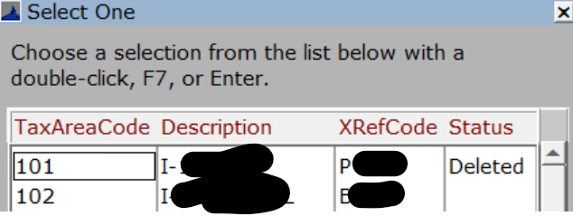

* + If you select a deleted area for the account, you will receive this message. This will have to be corrected before going to the next field.

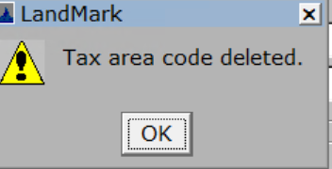

## Tax Area

* If you try to delete a tax area that is being used on accounts or public service accounts, you will receive a message.

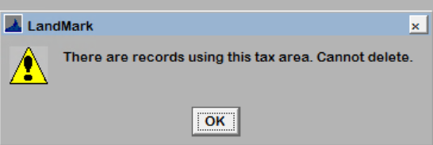

## Assessment Form

* The filing date will be next to the COV date on the assessment screen on the Appraisal Summary tab.

* There were times when doing a subdivide that the parcel size and type would not fill in. This will fill in during each subdivide.

## Table Maintenance

* When selecting System – Table Maintenance only “Admin” user would be able to access this. All others the menu option would not do anything or notify the user they cannot select the option. This has changed that if the user through user or group security has edit or admin rights to the County Information Table they will be able to access this option. This is where users go to purge files.

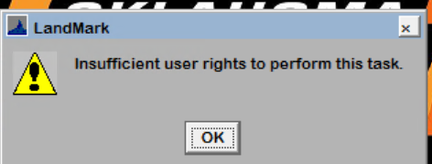

## Data Extract

* The Ptx Tech option has been replaced with the Ryan option.

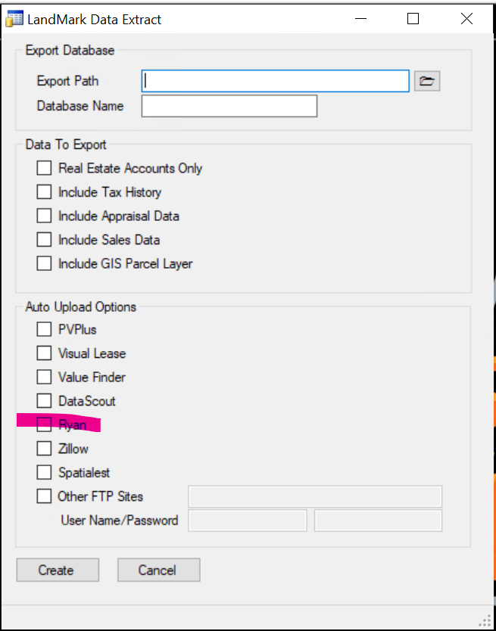

## Reports

### Abstract

* The word fractional was misspelled on the personal property section of the report.