Contents
Weekly Changes July 27, 2022 1
Reports 1
Excise Report 1
Productivity Report 2
VI Parcel Count and Subd Count 3
Assessment 3
Name 4
Tax District 4
Tax Area 5
Public Service 6

Weekly Changes July 27, 2022

Reports

Excise Report
- July 4th If a protest is complete, it will not be included on the report.
- July 25th The Protest label was changed to Net Assessed Under Protest and is the net assessed change based on the requested and recommended. The protest amount in the public service section has been removed from the report. There is a note that public protests are not included on the report.
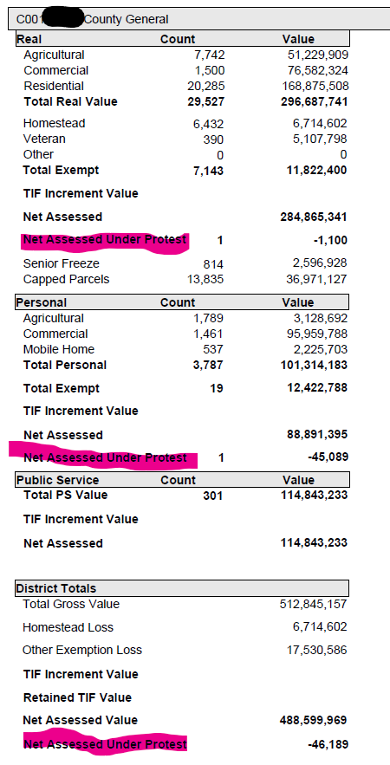
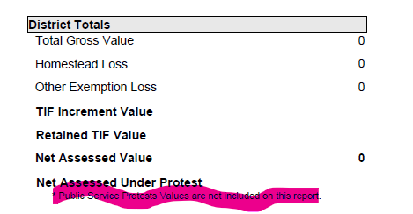
- July 27th Protest amounts will be reported as a positive number vs negative.
- July 27th The pie chart will contain the same colors for each category in each tax district.

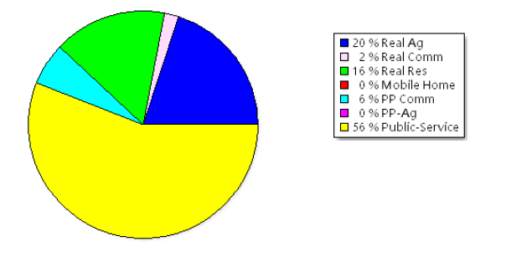

Productivity Report
- July 4th This is a report that will report on the number of inspection and entered records a user generated for a date range. This is printed from the Appraiser table. (Appraisal Tables – Appraiser Codes)
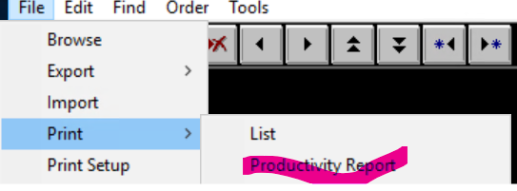
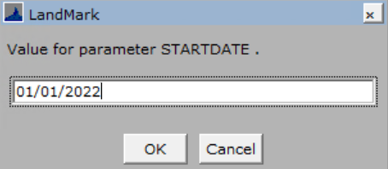
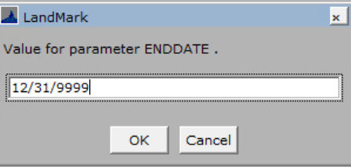
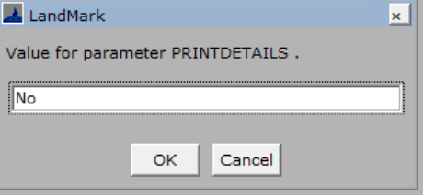
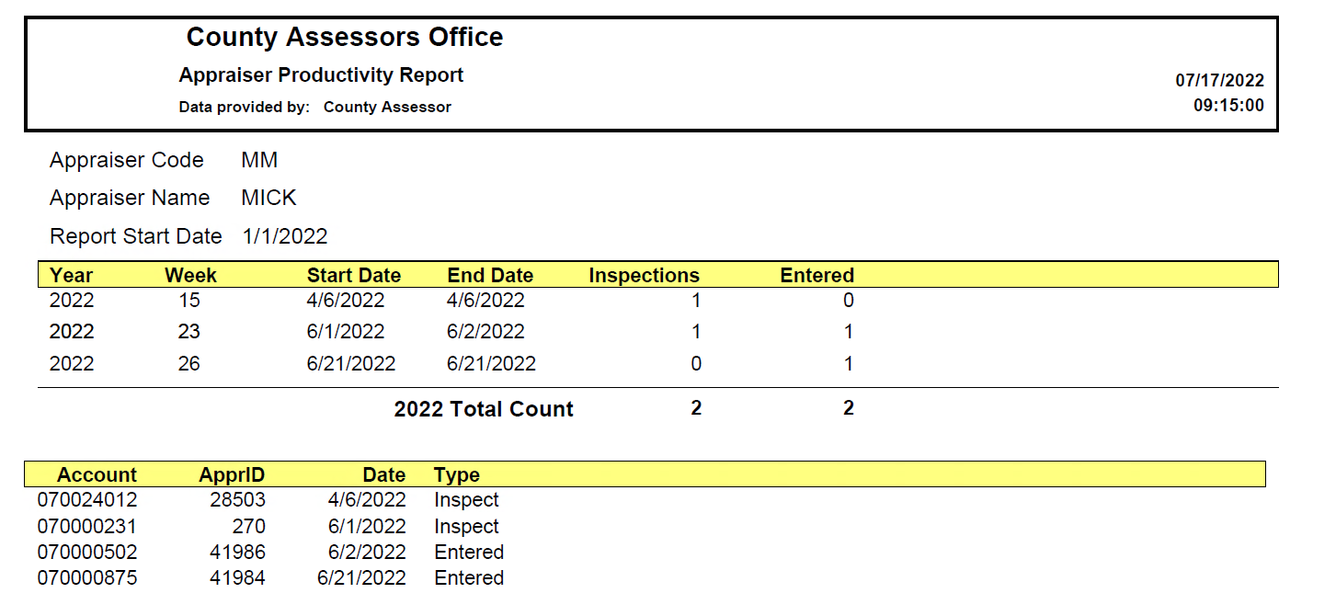

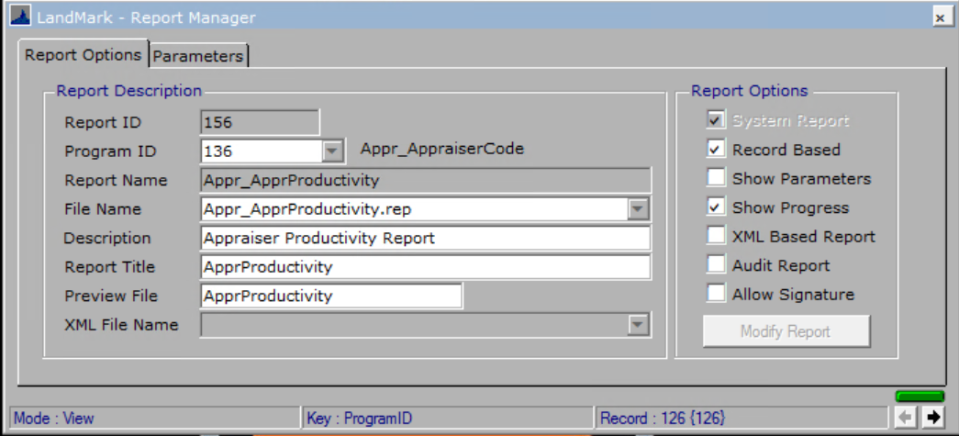

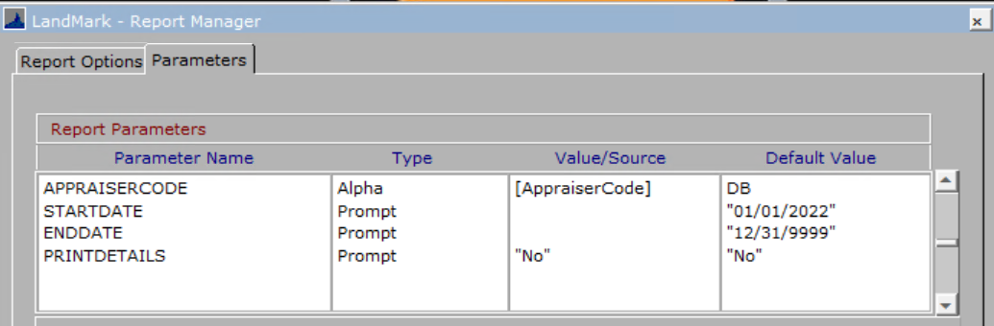

VI Parcel Count and Subd Count

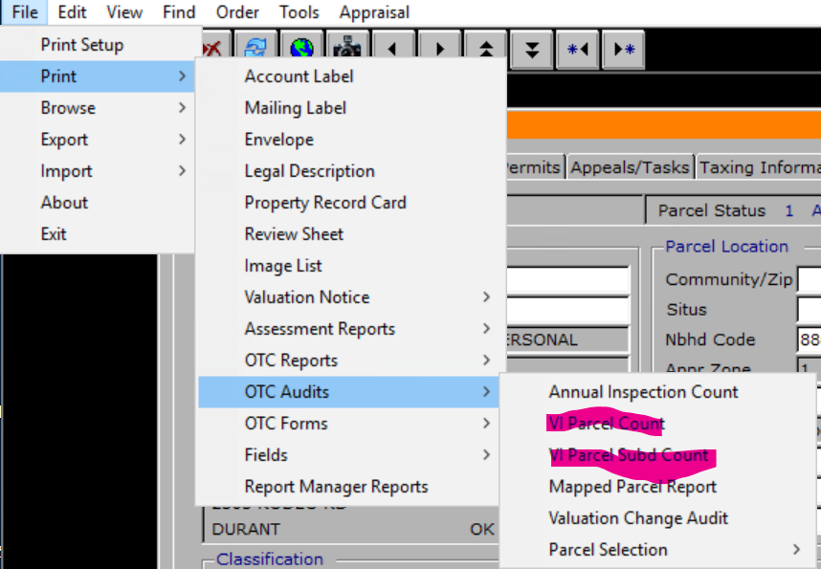
- July 4th VI Parcel count and sub would print a year 0 with no counts.

Assessment
- July 4th On the assessment form there is a field XCrossRefName that will be the owners name based on the Cross Ref number on the assessment form. This will allow for exporting cross reference name and the owners name of the cross reference from the assessment form.
  - This caused issues with the next record from working which has been corrected.
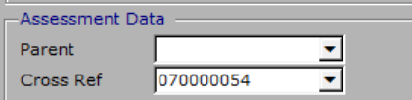
- July 18th When using the combine functionality, the sketch and site plans were not being transferred to the new account. The photos were not transferred to the appraisal records. This has been corrected.
- July 18th When doing a split if using acres and changing the parent log size amount and then the new lot size the significant decimals were limited based on the original lot size value.
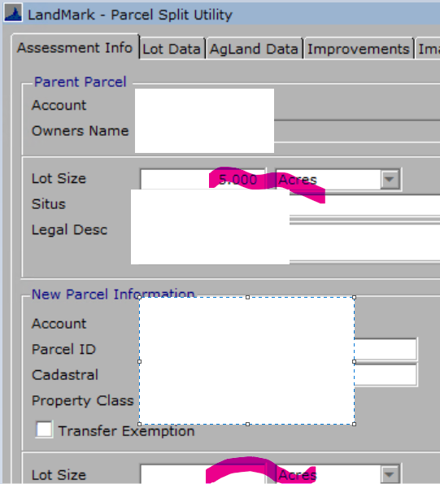

Name
- July 11th In the name file if you edit a name, you were not able to go to the next record if there was a related name on the account.

Tax District
- July 18th If the district code was changed there would be orphaned records in the tax area table. If changed now the code in the tax area table along with the TIF district will update.
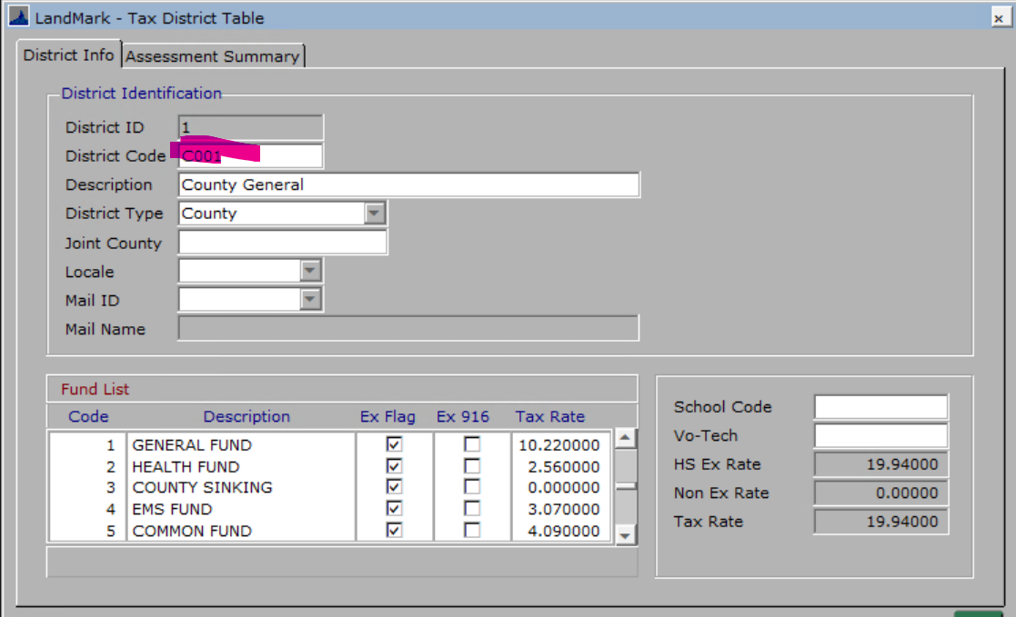
- July 25th When creating or editing a record if you enter a code that already exists then you will receive a message that the code is already in use.
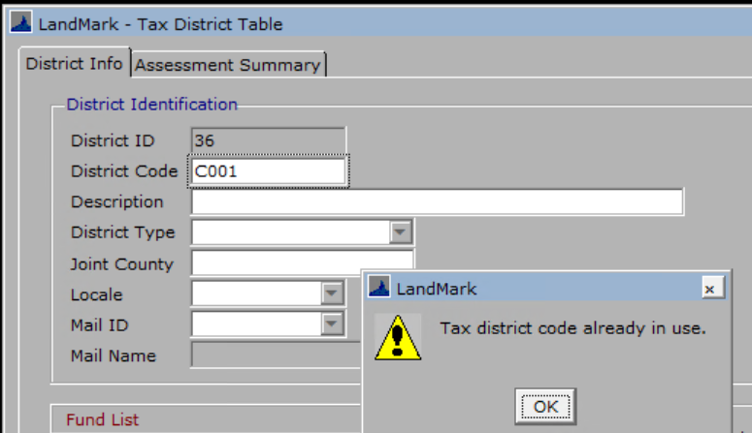
- August 1st If you edit a deleted record, you will be asked if you want to edit the record.
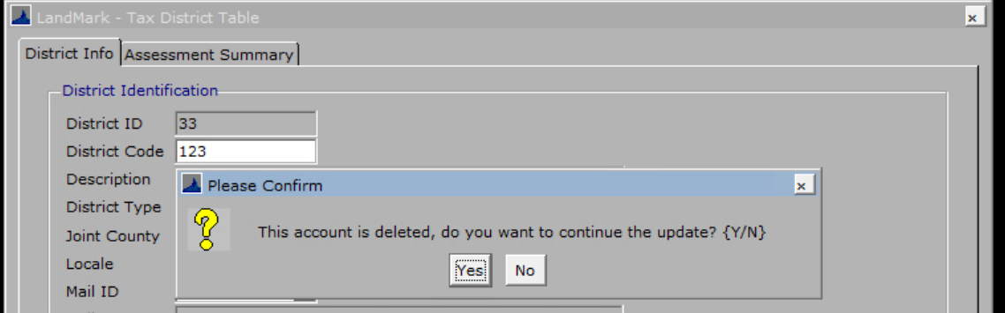

Tax Area
- July 18th The tax area field is read only unless creating a new record.
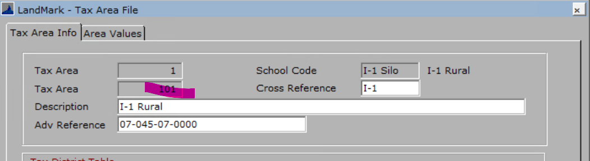
- July 18th When creating a new record if an existing tax area code is entered you will get a message that the record already exists.
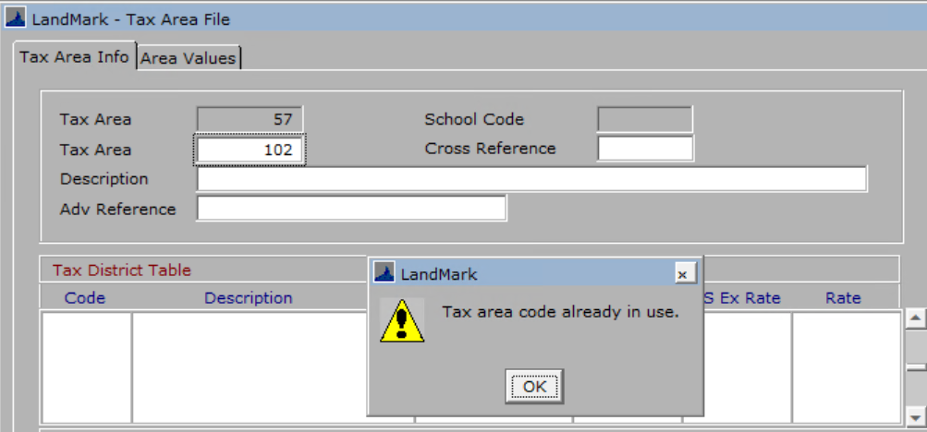
- July 18th There is a new menu option to copy a tax area. This will copy the area and district information. This could be used for a TIF district. Once created you will be taken to the new area where it can be edited.
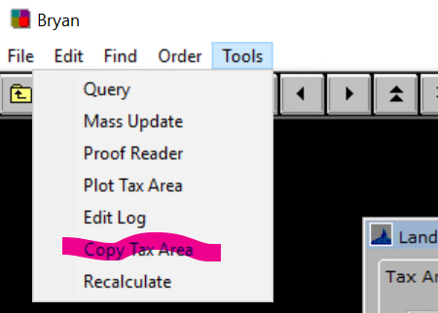
  - To copy the tax area, find the tax area to be copied and select menu option. You ill then be asked what the new area should be.
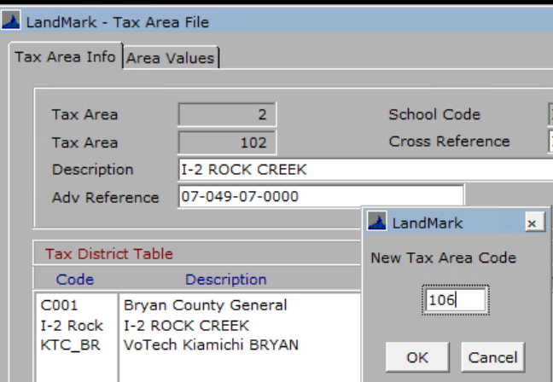
    - If the tax area already exists, you will be informed of this.
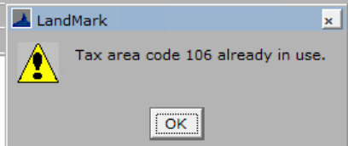
- August 1st If you edit a deleted record, you will be asked if you want to edit the record.
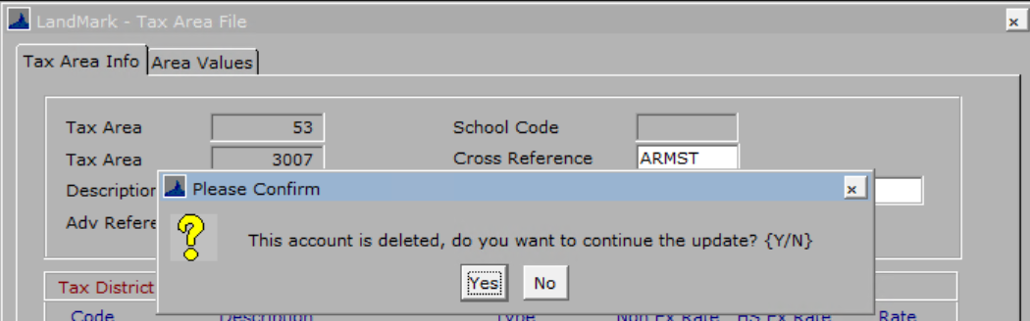

Public Service
- July 25th The Company List, Company Detail, and Tax roll reports were including inactive accounts in the report. On active accounts will be included on these reports.
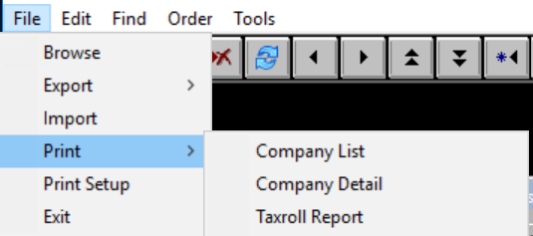
- July 25th The menu option Edit – Edit Account Status will not work like the assessment file.
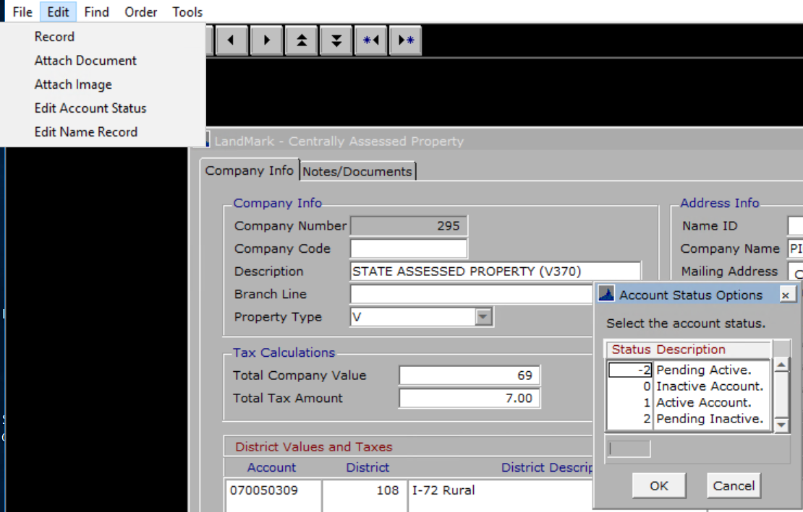
- July 25th When deleting a record, the account status will change to inactive and if the record is activated that status will change to 1 (active).
- July 25th The menu option Edit – Edit has been changed to Edit-Record
