Contents
Weekly Changes January 12, 2022 1
Assessment 1
Indexing 1
User Profile 1
Sales 1
Tractors 2

Weekly Changes January 12, 2022

Assessment
- The exemptions will be order by active exemptions followed by the exemption codes descending. Before they were in the order entered where active records may be at the end of the file.
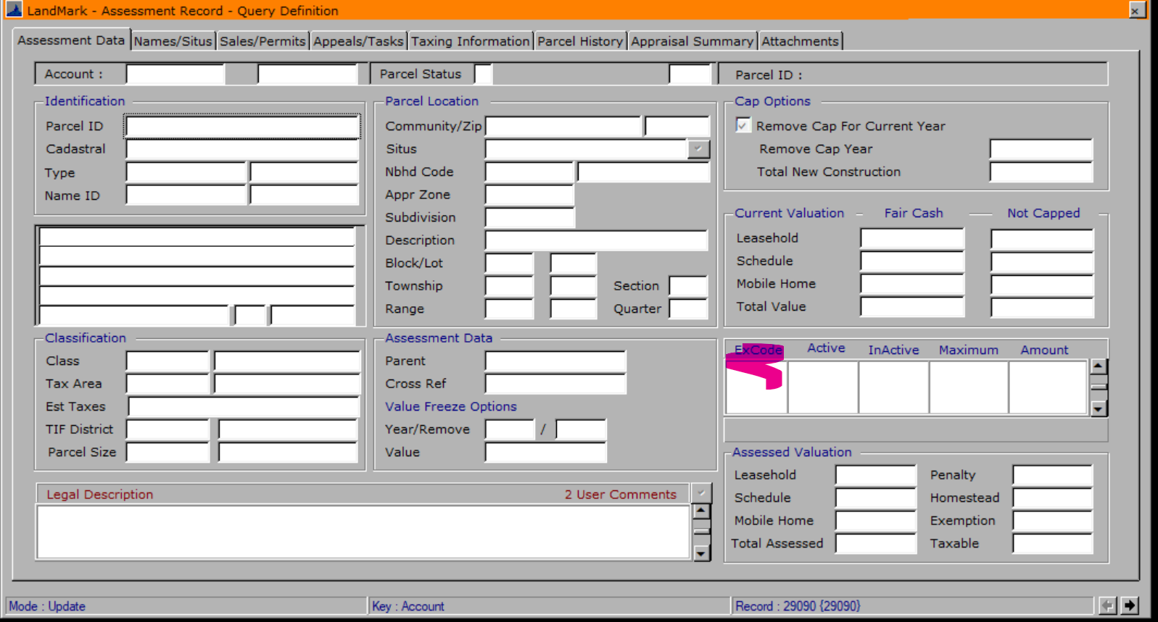

Indexing
- The creating of indexes was requiring the user to create an index and then save vs creating this at the same time.
- If the user would run a query and then sort the user would go to physical order.
- If the user would sort the file after a temporary index an index would save, however it could not be reopened.
- If the user would give a sort of file a long name an error message would appear. This has been corrected.

User Profile
- The update web profiles were not working for certain users. This has been corrected.

Sales
- The sales options that are selected when entering a sale will be stored in the sales files. This started being done for sale entered after January 1st.
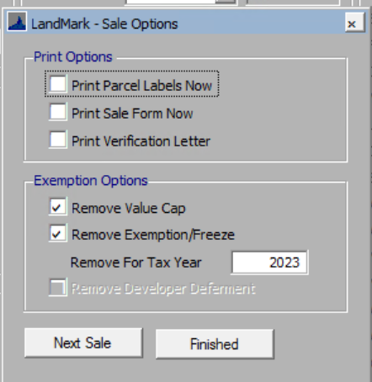
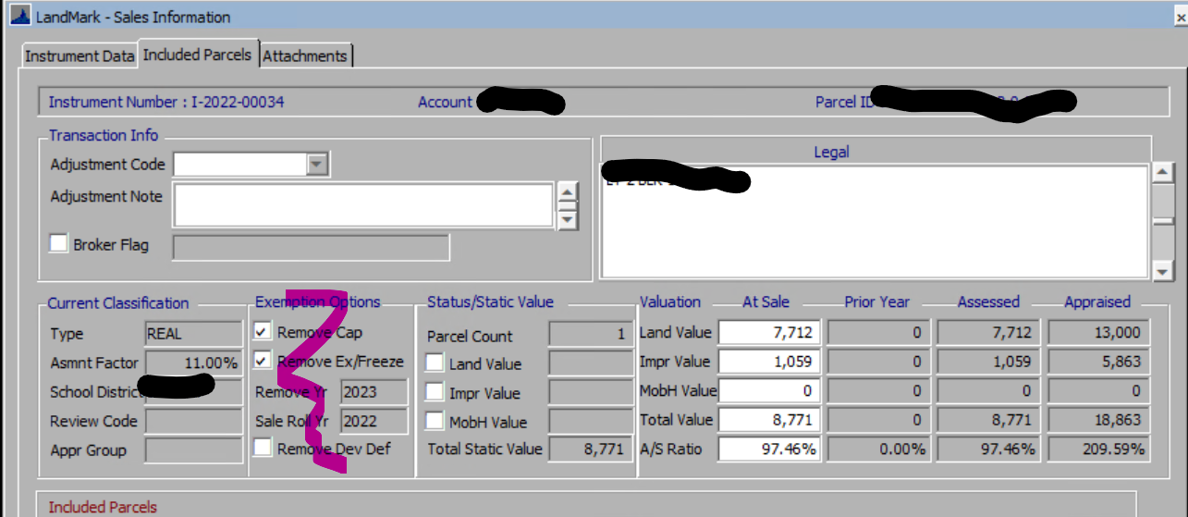

Tractors
- If you are wondering whether you are trending and what depreciation table is being used for tractors you can see this in the item type table and recovery. The item type will tell you whether the item is being trended and what recovery table is being used. The recovery table gives you the details of the depreciation schedule. For tractor item codes 45 and 1525 are used. In either case there is the option of overriding the default on any given schedule item and using a specific life and to trend/not trend the item.
