Contents

Weekly Changes February 9, 2021 1

Application 1

Appraisal 1

Miscellaneous Cost 1

Agland Table 1

Personal Property 1

Reports 2

COV Notice 2

# Weekly Changes February 9, 2021

## Application

### Appraisal

* Miscellaneous code GENR – Generator – Residential Standby will be on site improvements and commercial property drop downs and will depreciate when used in site improvements.
* Miscellaneous code CMDC – Composite Deck – Covered will depreciate when used in the site improvements.

#### Miscellaneous Cost

* File – Browse is spelled correctly and will function.

#### Agland Table

* The lot model and total acres for the appraisal card and the property class for the account were added. This was primarily done for indexing purposes.

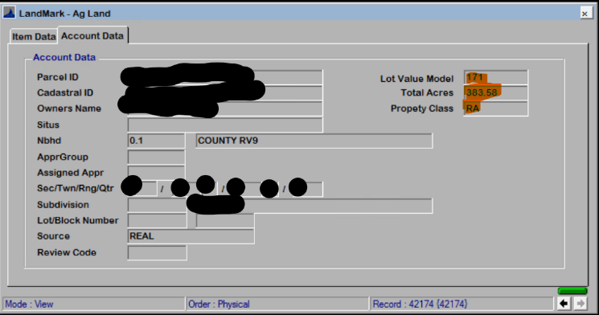

### Personal Property

* The template was changed where if the override of the template is used the calculation will update. (Menu option Edit – Edit In Excel – Edit Excel Schedule if the template has not been update) The template
* Import of excel document will check the override flag. The tractor information will be imported.
* There are two new menu options Edit Excel Item and Import Excel Items

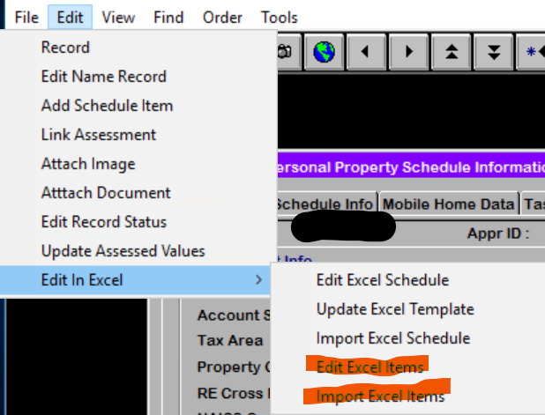

* + The Edit Excel Items will export out only the items on the account. This file can then be sorted and then reviewed. The first column in the sheet is labeled “Reviewed”. This can be used however you would like. This will not be imported back into LandMark. The account number will be in the file name at the top of the spreadsheet.

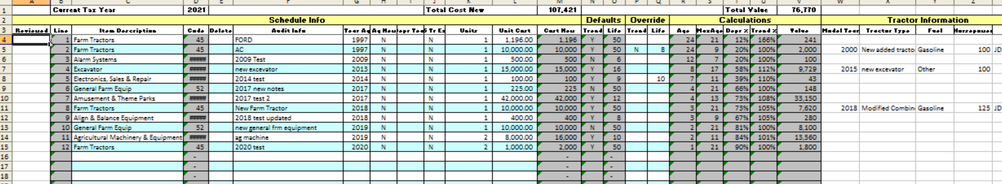

* + The Import Excel Items is used to import the spreadsheet for the menu option Edit Excel Items.

## Reports

### COV Notice

* The last note for the notice will print on the COV for real property. There is a parameter that can be set to not have this print. PRINTNOTICENOTES to FALSE. (Default is the notes will print.

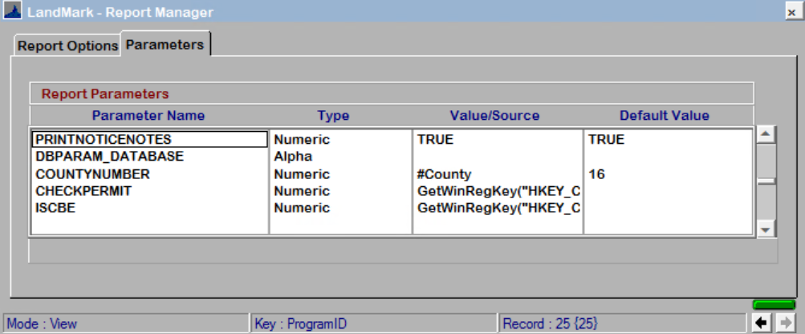

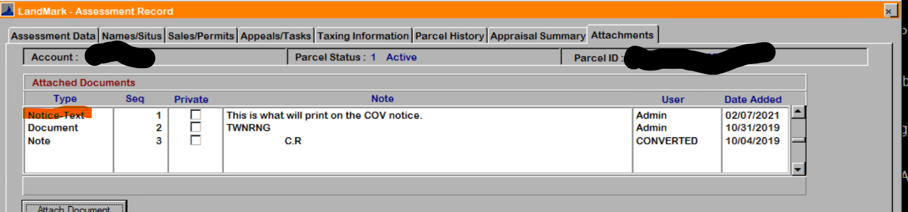

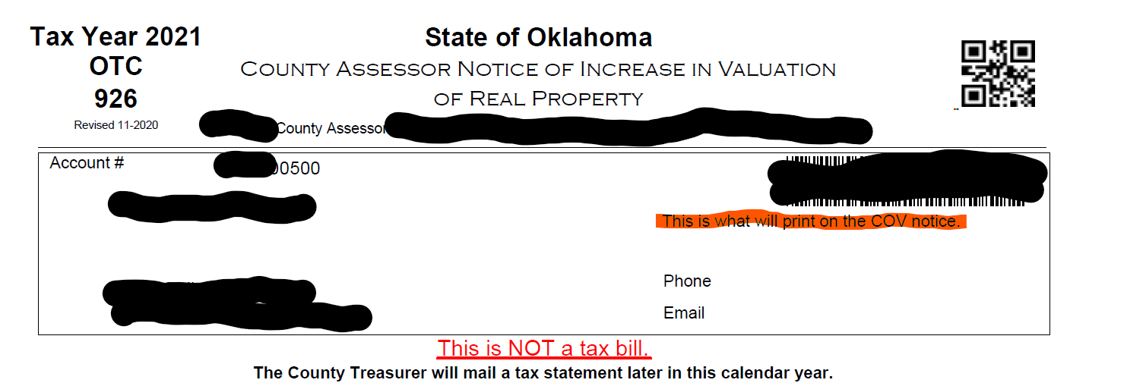

### OTC Personal Property Audit report

* The date format on the audit rendition was changed from dd/mm/yyyy to mm/dd/yyyy. This is the menu option File - Print - OTC Audites – Parcel Selections – PP Renditions.