Contents

Weekly Changes February 24, 2021 1

Application 1

Appraisal 1

Miscellaneous Cost 1

Agland Table 1

Personal Property 2

Reports 3

COV Notice 3

Personal Property COV Notice 3

OTC Personal Property Audit report 4

Sales Form 4

Help Files 4

MapView Update 4

# Weekly Changes February 24, 2021

## Application

### Appraisal

* Prior to the 15th update the exterior wall on mobile homes did not have any effect on costs. After the 15th this will. All type 6 mobile homes should be recalculated. If you DO NOT want this change due to renditions having been printed, please let us know and we will make sure this is reverted back until June 1st.
* Miscellaneous code GENR – Generator – Residential Standby will be on site improvements and commercial property drop downs and will depreciate when used in site improvements.
* Miscellaneous code CMDC – Composite Deck – Covered will depreciate when used in the site improvements.

#### Miscellaneous Cost

* File – Browse is spelled correctly and will function.

#### Agland Table

* The lot model and total acres for the appraisal card and the property class for the account were added. This was primarily done for indexing purposes.

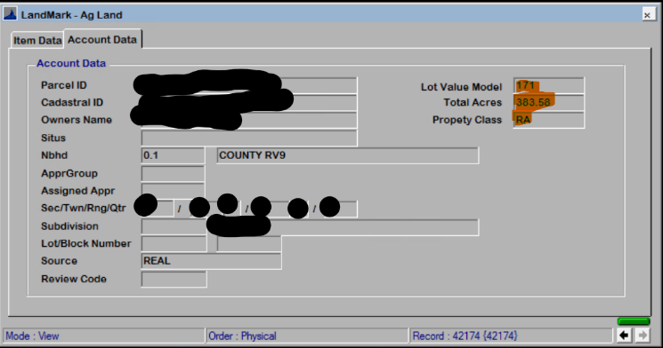

### Personal Property

* The template was changed where if the override of the template is used the calculation will update. (Menu option Edit – Edit In Excel – Edit Excel Schedule if the template has not been update) The template
* Import of excel document will check the override flag. The tractor information will be imported.
* There are two new menu options Edit Excel Item and Import Excel Items

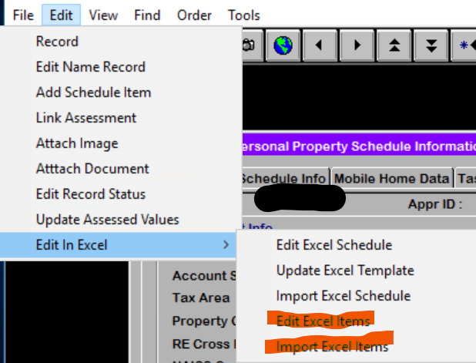

* + The Edit Excel Items will export out only the items on the account. This file can then be sorted and then reviewed. The first column in the sheet is labeled “Reviewed”. This can be used however you would like. This will not be imported back into LandMark. The account number will be in the file name at the top of the spreadsheet.

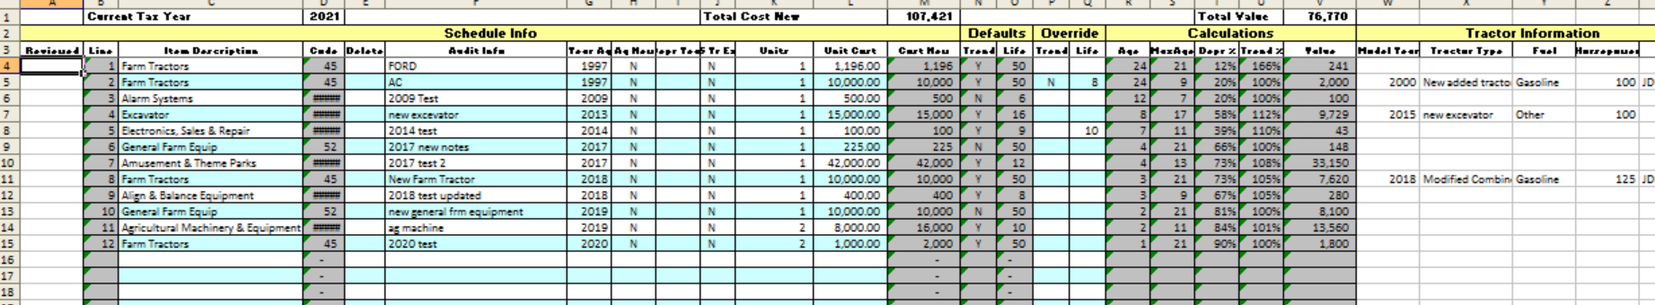

* + The Import Excel Items is used to import the spreadsheet for the menu option Edit Excel Items.

## Reports

### COV Notice

* The last note for the notice will print on the COV for real property. There is a parameter that can be set to not have this print. PRINTNOTICENOTES to FALSE. (Default is the notes will print.

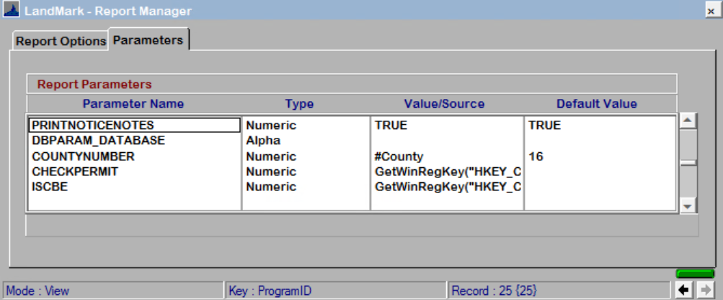

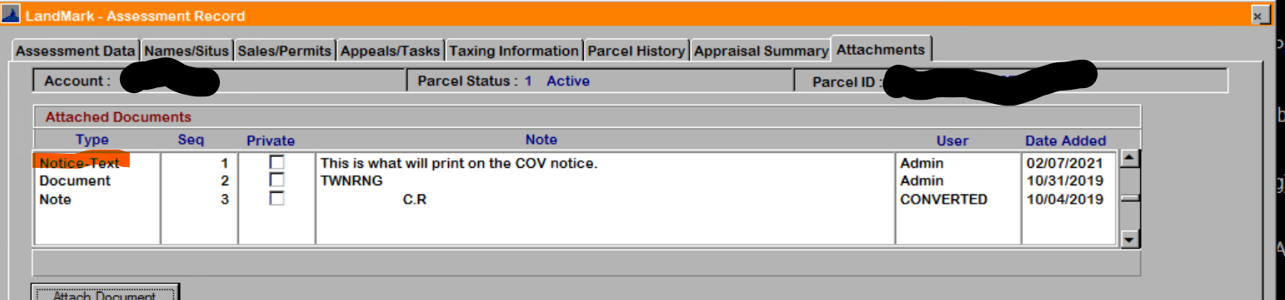

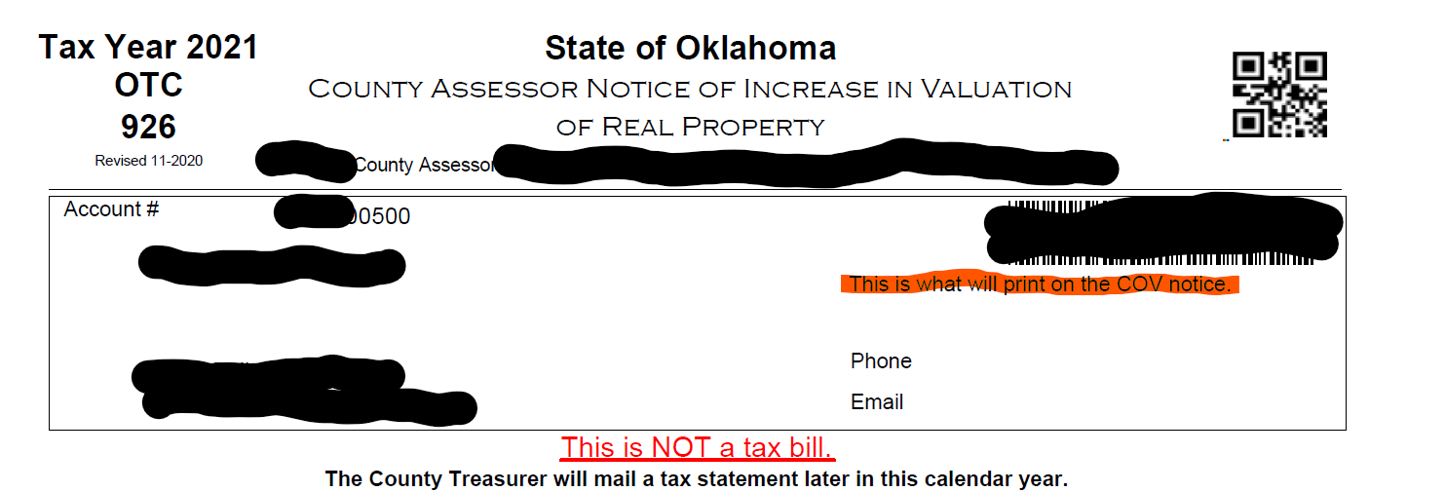

### Personal Property COV Notice

* There is a parameter than can be set where the personal property schedule WON’T (set to false) print on the COV report. By default this is set to true.

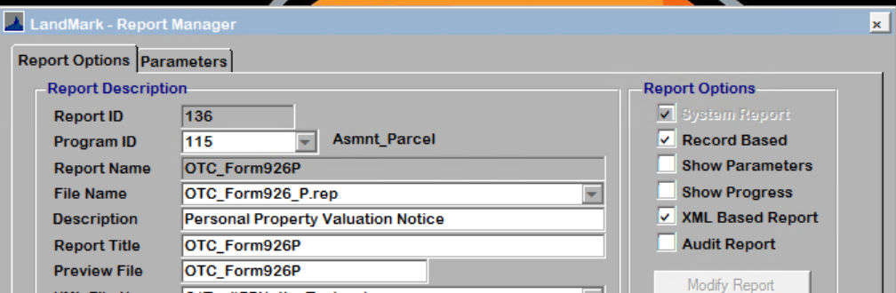

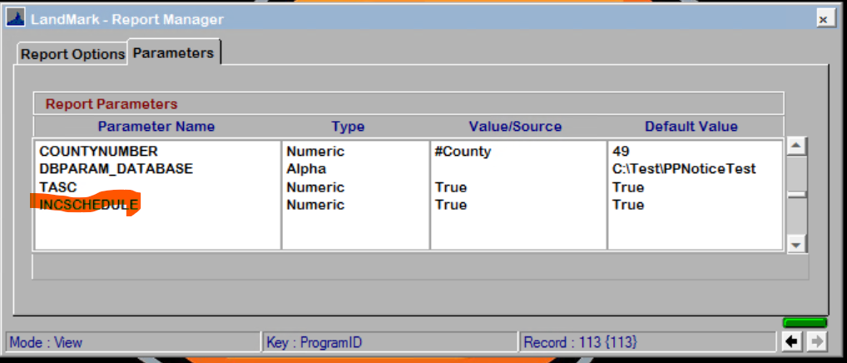

### OTC Personal Property Audit report

* The date format on the audit rendition was changed from dd/mm/yyyy to mm/dd/yyyy. This is the menu option File - Print - OTC Audits – Parcel Selections – PP Renditions.

### Sales Form

* The parcel id and assessor’s email has been added to the form.

## Help Files

* Many of the forms when you press F1 or the help tool will open up the help. The manual update is an iterative process where links will be made as the information in the manual is updated.
* In the case of the residential appraisal file and county information the help is tab based. Based on the tab you are on when selecting to open help you will be directed to a page about that tab. This is iterative and as additional help is complete this will be added.

## MapView Update

* A couple weeks ago in this update I mentioned how to update the website through task scheduler. There is an option of on the menu to do this.

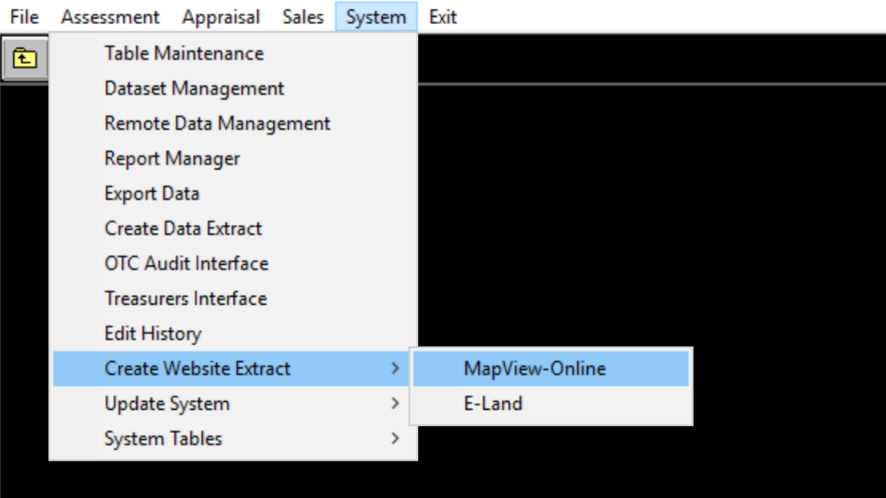

The first time you run this. (by user the options will be blank)

Fields:

Webserver address: <ftp://lmweb.dyndns.org>

User Name: {Countyname} (NOT case sensitive)

Password: Contact us for this.