Contents

Weekly Changes Jan 29, 2021 1

Application 1

Assessment Form 1

Appraisal 2

Personal Property 3

Sales 3

Reports 3

Update web site 6

# Weekly Changes February 1, 2021

## Application

### Assessment Form

* On omitted correction there is an option to enter interest and this will print on the form.

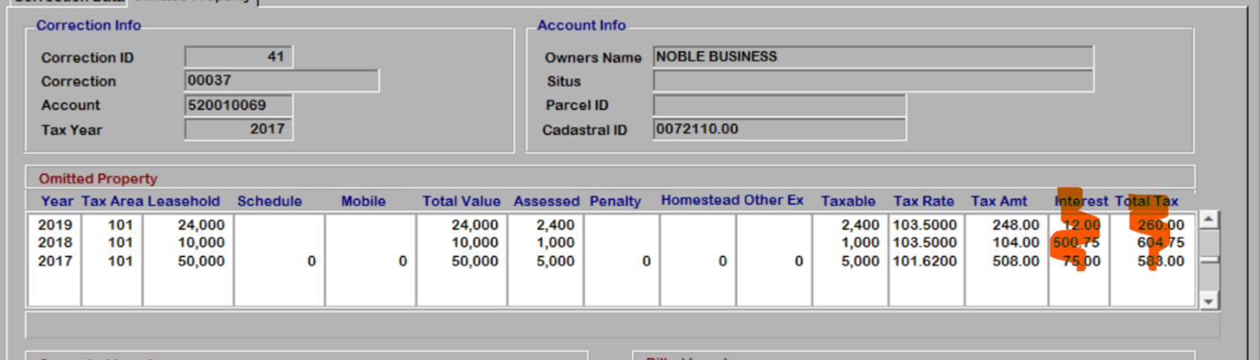

* When exporting out sect/twns/range/qtr from the parcel the township and range direction were in the incorrect spot.
* Property class added to parcel history and history form.

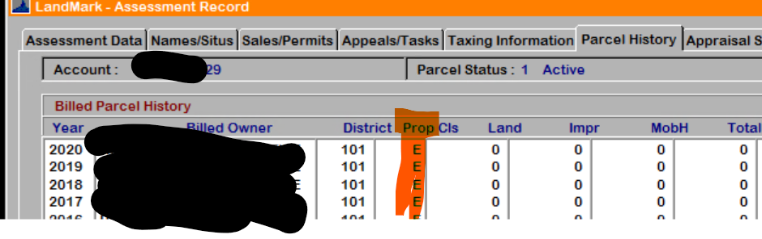

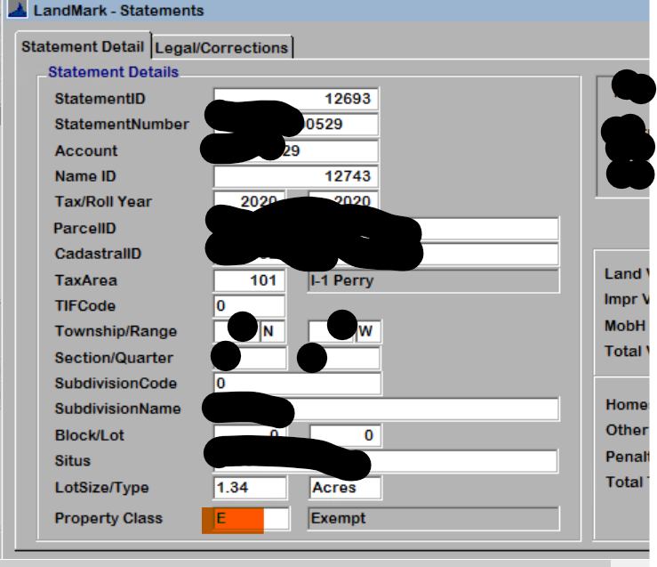

* On several forms there was mention of just land when on a personal property value. This was updated to ready land/leasehold when appropriate. This would be for the reading of appraisal file, taxroll corrections, collections form, parcel history tab.

### Appraisal

* On occupancy 455 (Car Dealership) the cost was around ¼ of what it needed to be.
* On Arena – Covered and Arena – Enclosed. Codes ARNC and ARNE there was an adjustment of 89.6% of the cost. This was changed to 100%.
* HVAC and exterior wall modifiers were taking quality and local multiplier out twice.
  + I was able to review this in more detail. The exterior wall and HVAC modifiers are to modify the element and cannot be greater than 100% of the area.  An example would be a where only ½ the building has warm and cooled air. The modifier would be used to enter 50% with code 15 (No HVAC) to decrease the HVAC cost.  Instead of 50% the area could be entered. The system takes anything <=1 as a percentage and >1 as an area.
  + If the individual units need to be cost these would need to be entered in as a site improvement.
  + In evaluating this I did come across that the exterior wall and HVAC modifier were accounting for the quality factor and local multiplier twice. What this meant was that you would get a lower cost if you entered a HVAC code vs no HVAC and 100% as a modifier.
* In the case of the semi-luxury and luxury the effective age would not calculate.
* When moving a building there was not an edit done on these. There will be now.
  + On appraisal where the building was moved FROM

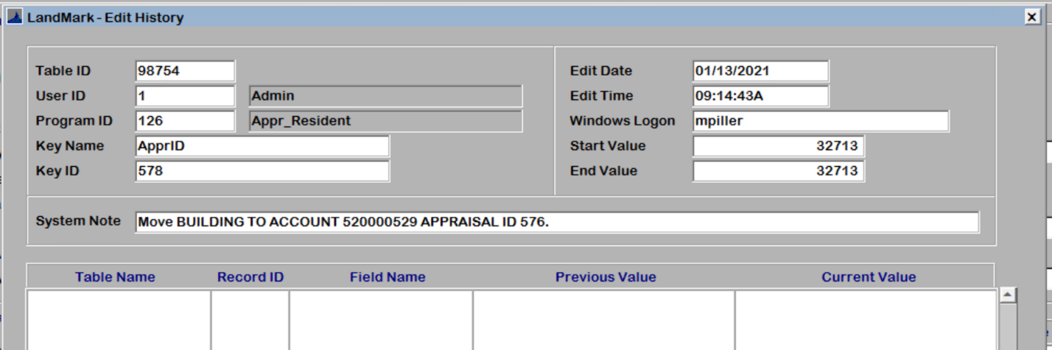

* + On appraisal where the building was moved TO

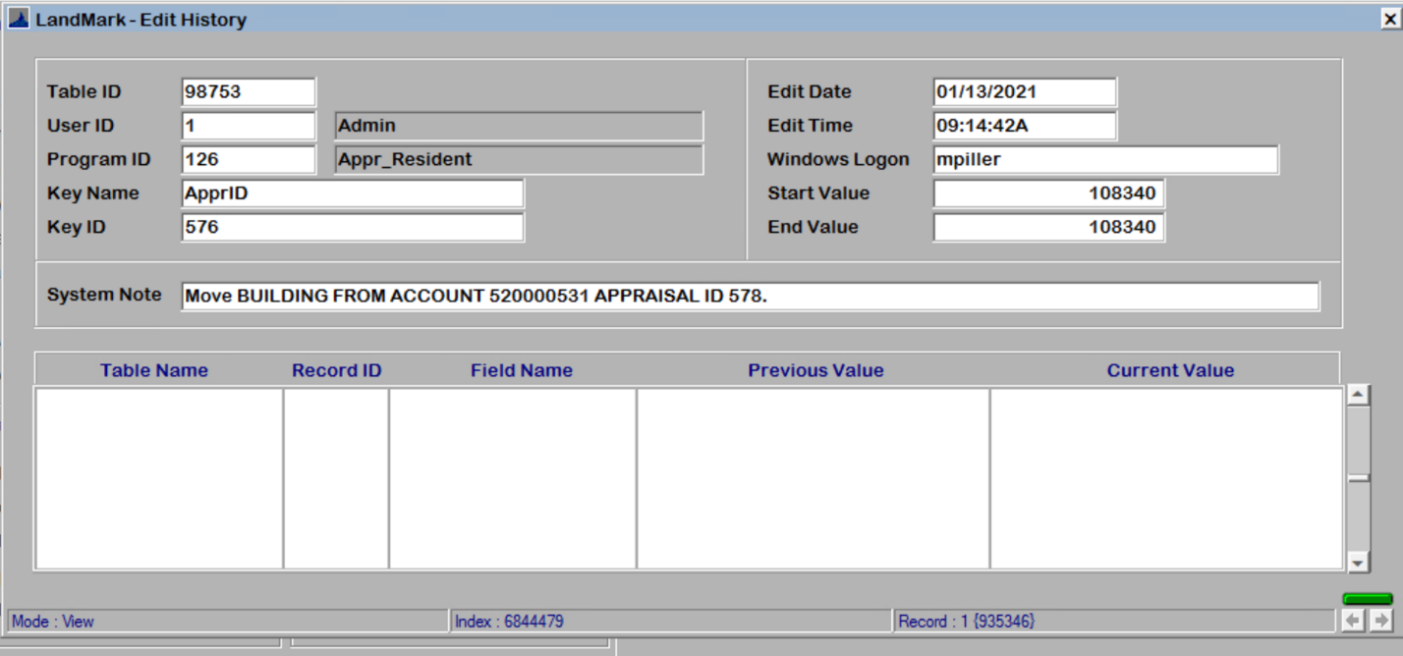

* In the sketch when sketching an A-Frame and changing the style the modifier would not change. This has been updated.

### Personal Property

* On moving a personal property item there is now the option to search an account by name.

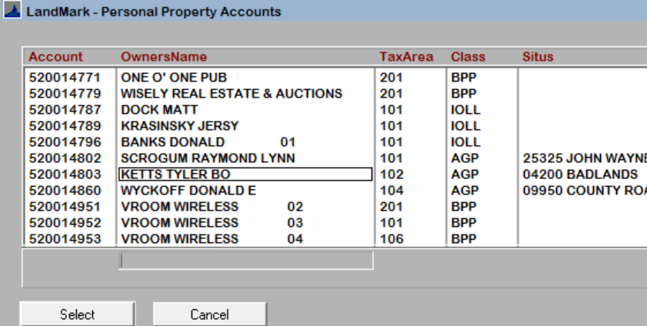

## Sales

* The export of the KellPro deeds will not generate the log of what was exported. One page deeds were not exporting but are now exporting.

## Reports

* The omitted correction form has interest print and the total of multiple years will be on the form.

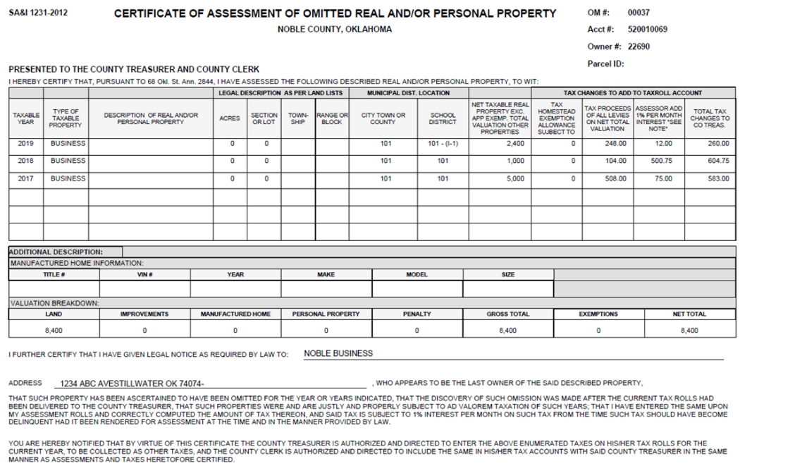

* Report 994 directly to printer was causing a section error.
* There is a parameter on the VI Parcel Count report that allows you to print details or totals. I have the set up on your system to print totals only now.

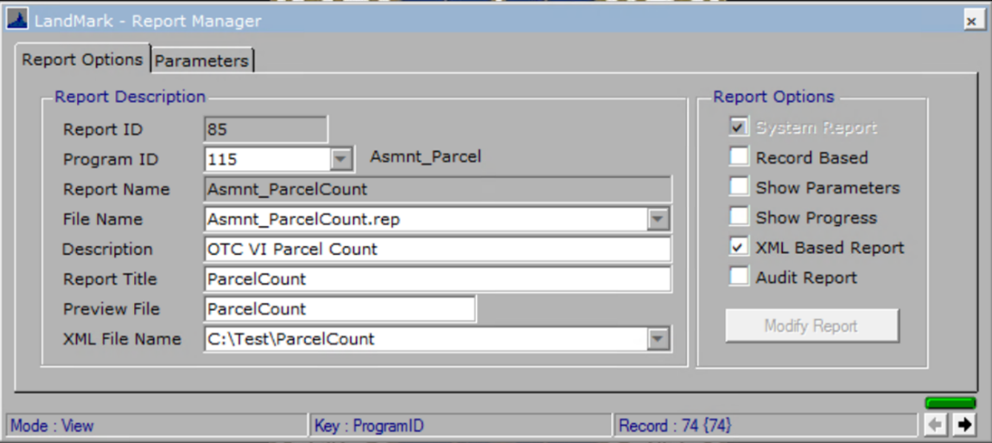

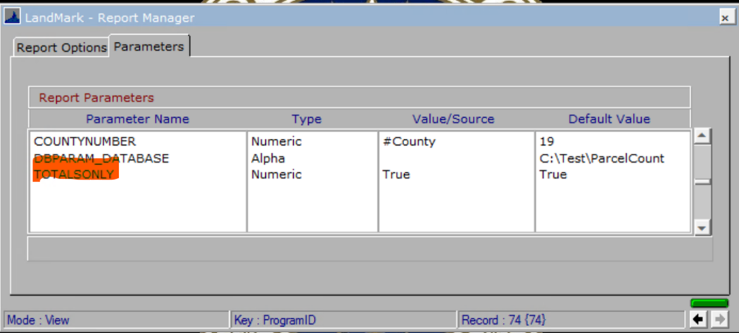

* On the Top Taxpayer report the option for the net taxes was replaced with taxable value. There was a selection section that was not needed that was removed as well.

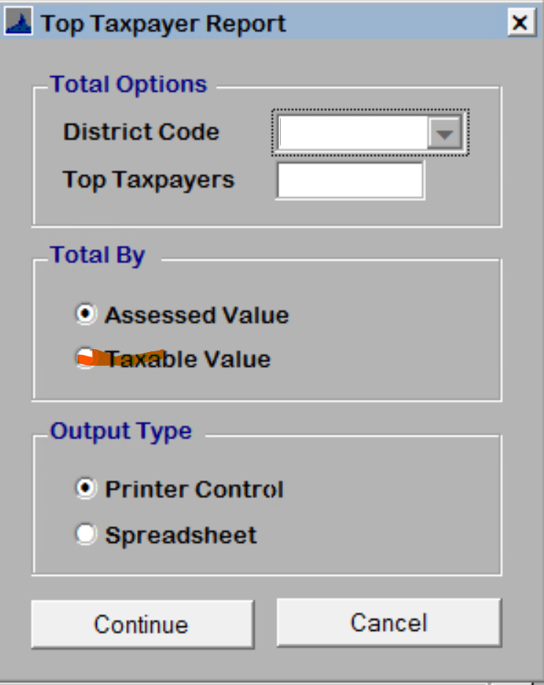

* + The report will have the taxable value along with the assessed value. Based on the option selected the records will be sorted as selected as such.

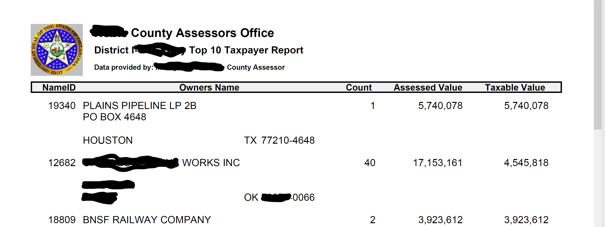

* On the 935mh and 935mhxl there is the option to print the appraisal values and the on the improvements. When doing this the appraisal values will need to be read to the assessment side when doing this. This is because the abstracts, excise, and billing will be based on the assessment side.

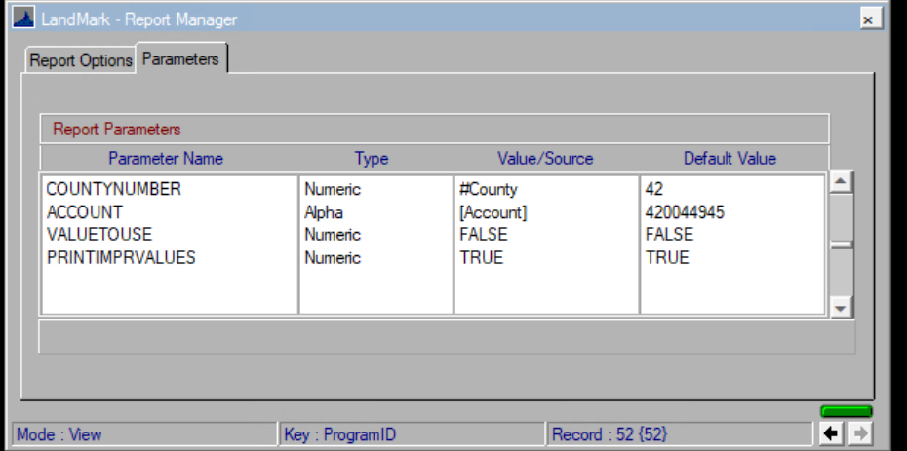

* + Under the scenario of the value of the items printed from the appraisal file you will need to be sure the values for the mobile homes are rolled to the assessment side to be in sync. LandMark does not store the assessed value of each improvement on the assessment side. The abstract and taxroll process are coming from the assessment side.
  + The parameter VALUETOUSE: TRUE – Assessment value, FALSE – Appraisal value
  + The parameter PRINTIMPRVALUES – TRUE – will printing individual miscellaneous and assessment values and will be taken away from the MH value. FALSE – All value will in the MH value. For this to be TRUE the VALUETOUSE parameter must be set to FALSE.
* The filing date will print on the 901 and 901P if the filing date year matches the assessment year.

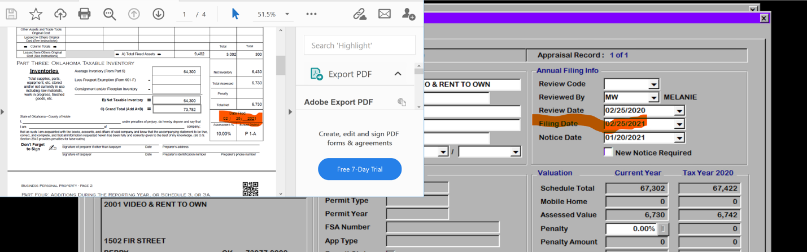

Filing date year must equal assessment year to print otherwise numbers in date will be blank.

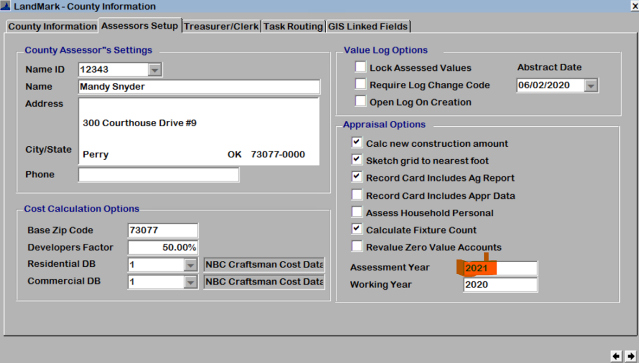

## Update web site

1. Go to the task scheduler.
2. Open up Task Schedule Library.
3. Right click on LM_UpdateWebsite and select Run. The process will take 20-30 minutes to be updated on the websites based on what I saw today making sure your data was updated.

