Contents
Weekly Changes Dec 23, 2022 1
Reports 1
Renditions 1
District Taxroll Abstract 1
926P 2
Millage Report 2
Tablet Import 2
Sketches 2
Assessment File 2
MH Transfer 2
Sales 2

Weekly Changes Dec 23, 2022

Reports

Renditions
- Dec 26th When running renditions in larger batches (generally greater than 500 records) a memory error would show up. This has been reviewed and now the renditions with a large volume will print without the error.

District Taxroll Abstract
- Dec 12th The District Abstract report will sort by district type and then district code. Prior it was by district code. This causes issues with the breaks on the reports.
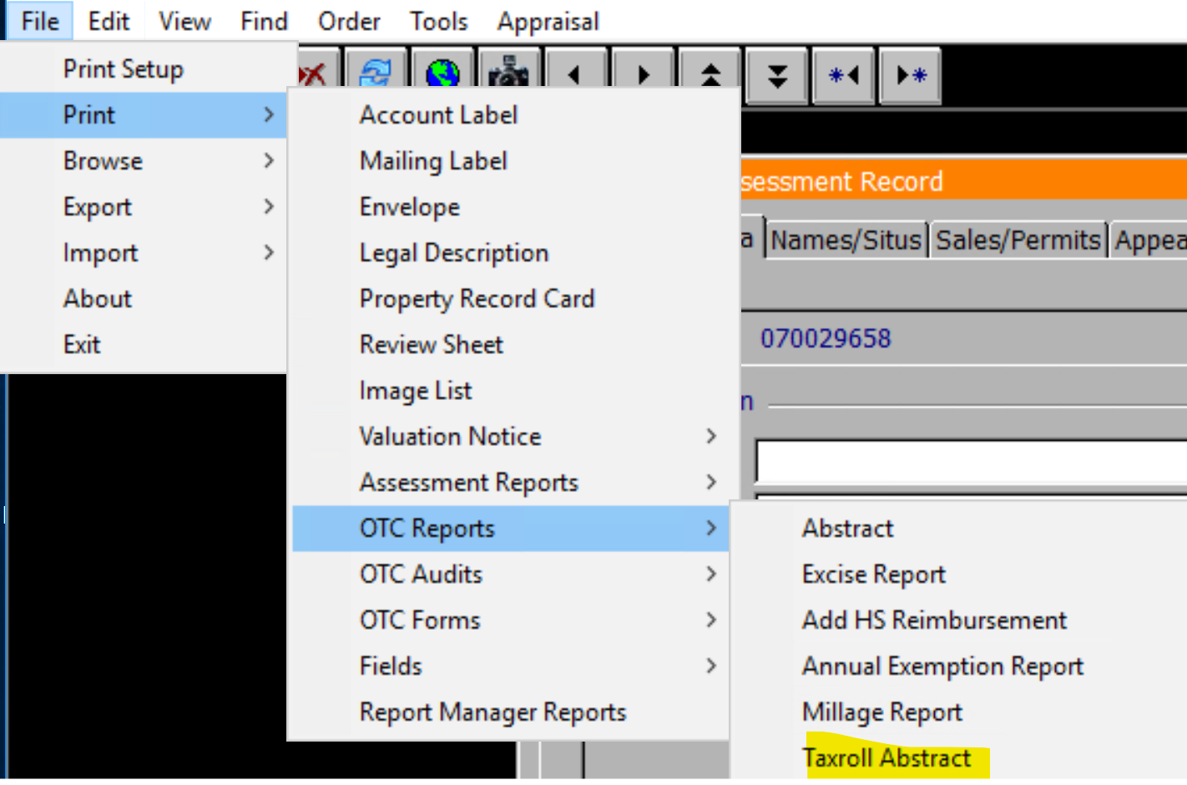

926P
- Dec 12th If the schedule items are included on the report they will begin on a new page. Before the first couple printed on the second page of the report and the continued on the next page.

Millage Report
- Dec 19th When running the millage report there were times when the totals would be doubled. This has been addressed.

Tablet Import
- Dec 19th If the card being imported has multiple appraisal records each of the appraisal records will have an inspected record entered in the entrance table. In addition to this the review sheet document and images will link to an active appraisal record. If there was an inactive record there was a chance it would link to that.

Sketches
- Dec 19th In order to get bushels on grain bins a circular object would have to be drawn. In addition to this a rectangular shape can be drawn.

Assessment File
- Dec 12th The process pending process will run quicker. It will on average be 15-20% quicker.
- Dec 12th The editable form 998B will now run.

MH Transfer
- Dec 19th Indexing in the MH transfer file will be more efficient.

Sales
- Dec 19th The validation table for the sale adjustment reason can now be accessed on the main menu.

