Contents

Weekly Changes Dec 23, 2020 1

Application 1

Assessment Form 1

Appraisal 1

Personal Property 2

Edit Log 2

Reports 2

# Weekly Changes Dec 23, 2020

## Application

### Assessment Form

* When using correction at the beginning of the year the number would start at 11. This will now start at 1.

### Appraisal

* On removing of buildings, deleting sketches, moving buildings, misc. improvements images of site plan and sketch will be updated on main parcel.
  + As there is not a good way on the site plan to where on the site plan the account the item was moved should be reviewed.
* When moving outbuildings there was a chance the incorrect outbuilding would be moved.
* On pole buildings done in commercial buildings the depreciation may not have calculated at times.
* In the case of entering an invalid modifier for commercial buildings the label will indicate it is an invalid code.

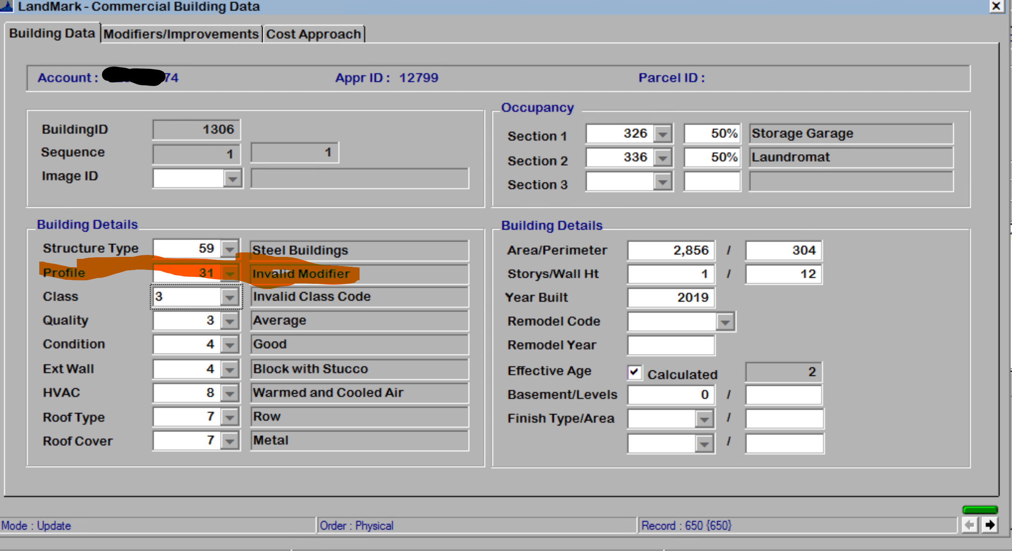

* Attached garages on the site plan were not depreciating. This has been corrected.
* Drive In Bank Canopies where not depreciating.
* On site plan if the code of the outbuilding is changed the label will change as well.

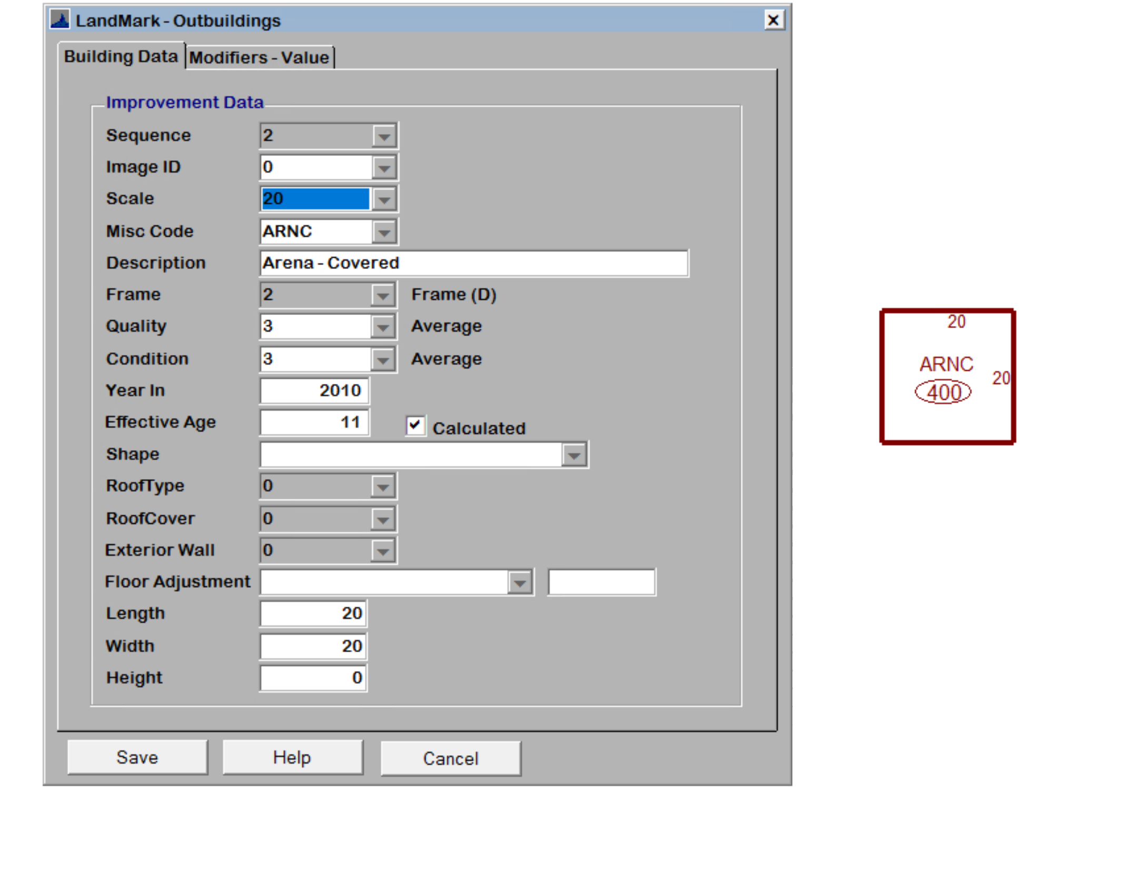

### Personal Property

* No changes

### Edit Log

* When rolling back the edit log the user would get an error message this has been corrected.

## Reports

* Review Sheet with site plan with arches were not printing properly. The site plan when multiple arches would not be closed on the report. This has
  + Sketch

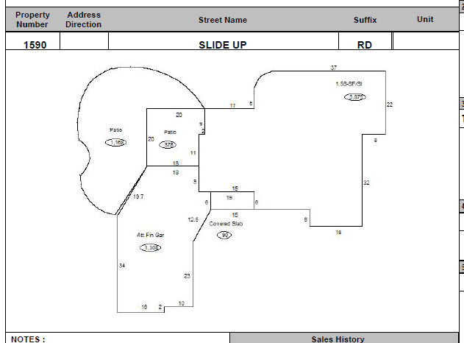

* + Site Plan

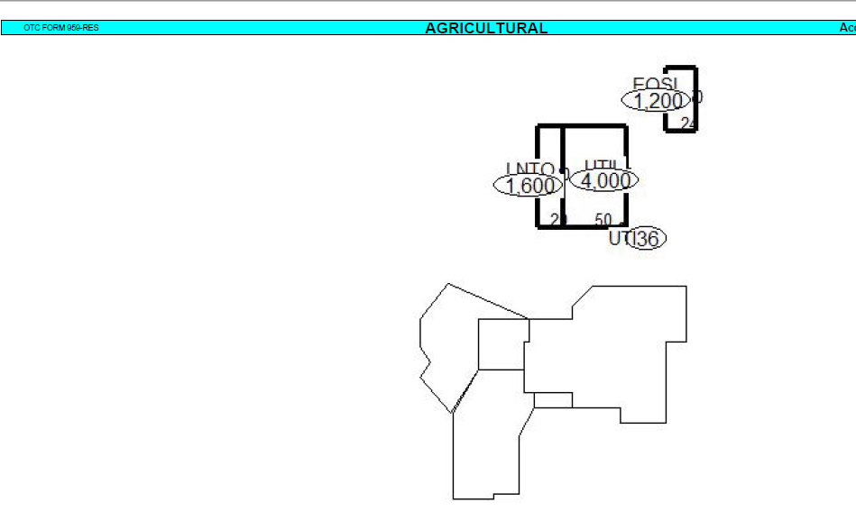

Sketch



* The schedule item report will have and IOLL totals and will be included in the assessment piece of things.

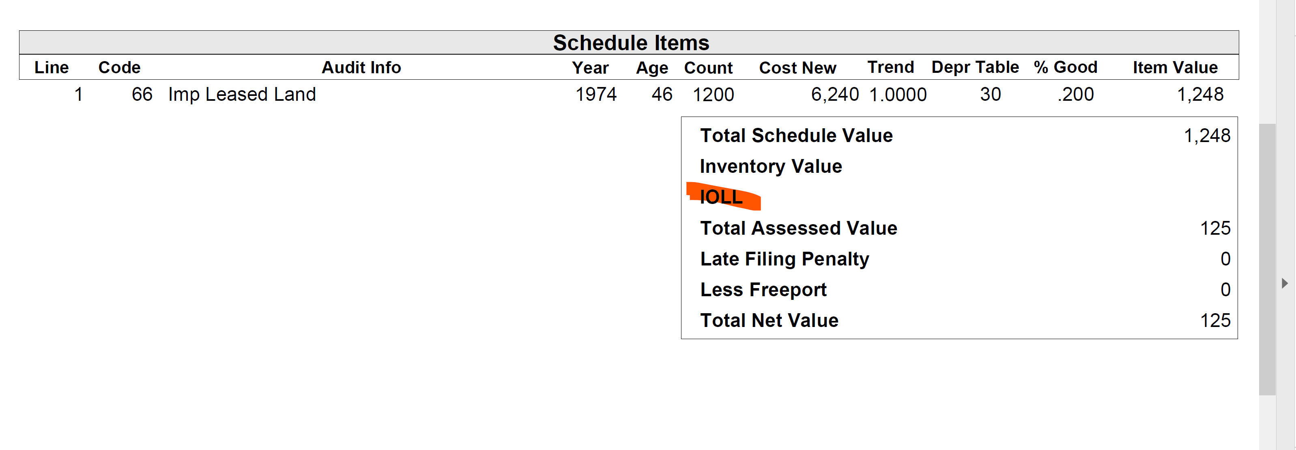

* Review sheet notes will print only if there are notes. (no documents)Added to the manual 03/18/2021 AR)