Contents
Weekly Changes August 15, 2022 1
Commercial Costing – HVAC and Sprinkler 1
Reports 2
Excise Report 2
Review Sheet 2
Revaluation Edit 3
TIF 3
Neighborhood 4
Personal Property Penalty 5
Tasks 5

Weekly Changes August 15, 2022

Commercial Costing – HVAC and Sprinkler
- Aug 15th There is a new cost table that can be implemented. (PropertyValuation2022M.mdb) In the future we will release new cost tables between late May and July 1st. This will include the NBC costs that we receive in mid to late September and Moore costs which we receive in late February.
- Aug 15th This new cost table and future tables will handle HVAC different. Dr. Moore provided HVAC where before there was an indication of HVAC. This is based on occupancy and then there is a factor associated with each heating cost that is also used in adjusting the value. If you don’t make a change to the cost table being used there will be no change to this.
- Aug 15th There is a new field on the commercial buildings for the fire sprinkler area. This will be used to calculate sprinkler cost to the base cost based on the Moore Costing. Currently sprinkled area is entered as a modifier and is using NBC costing. When doing this you will need to remove the modifier and enter the sprinkled area. This can be used with the manual you are currently using. If you would like to know which accounts that have sprinkler modifiers on them, please let us know and we can provide those to you.
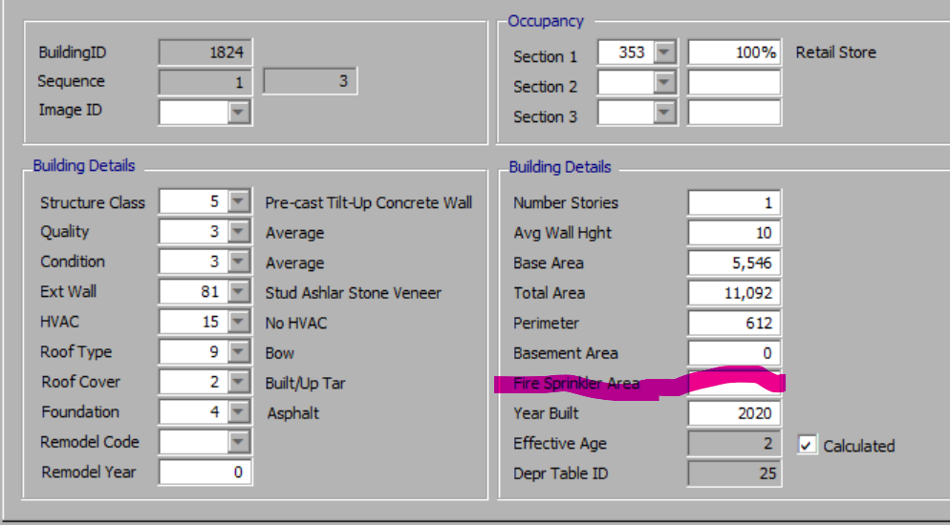

Reports

Excise Report
- Aug 15th When running the excise report if there is not an expiration year (which should be caught prior to this when entering the TIF) or there is not a TIF fund on the tax area tied to an active TIF you will not be able to print the excise report until corrected.
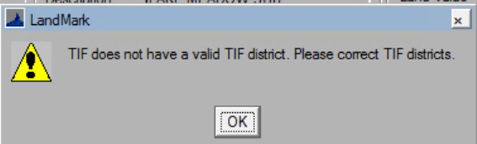
- Aug 15th The excise report has location for the assessor to date after signing the report. This was requested by OTC last week. There is not a need to run the existing report.
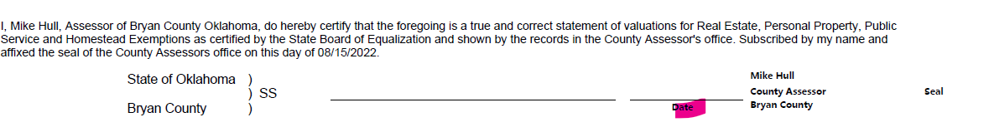

Review Sheet
- Aug 15th Added Veteran on the review sheet if there is an active exemption.
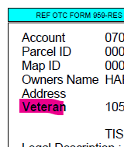
- Aug 15th The appr code will print based on the parameter PRINTAPPRDATE. Before only the Appr Date was affected. This information will print by default.
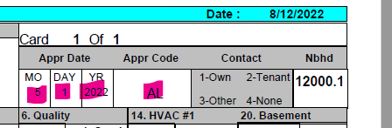

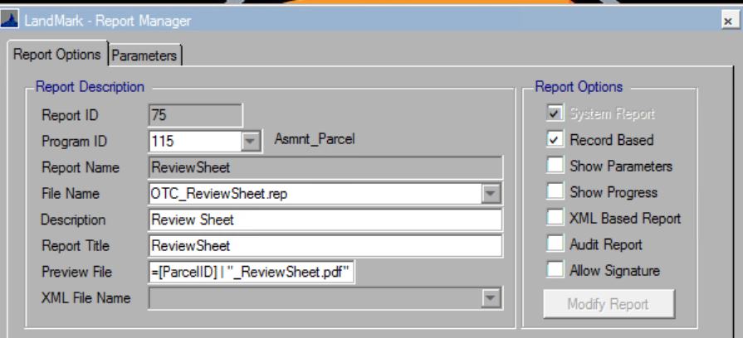

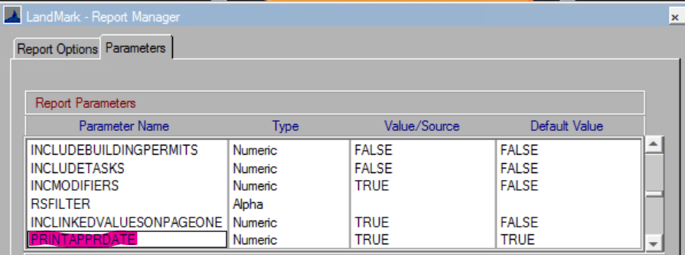

Revaluation Edit
- Aug 15th The last inspection date for the account will be included on the report.
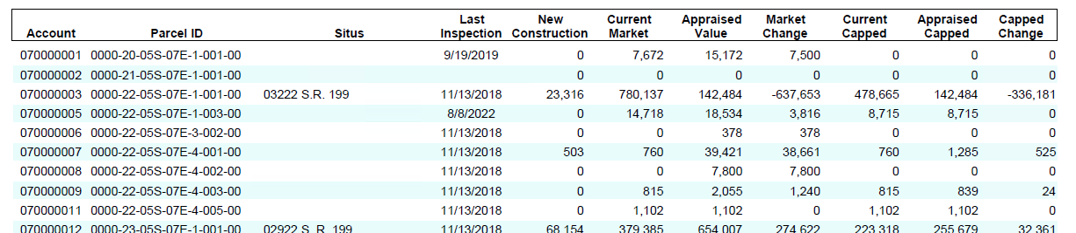

TIF
- Aug 1st The user will not be able to exit out of the field without entering an expiration year. This is needed for the excise report.
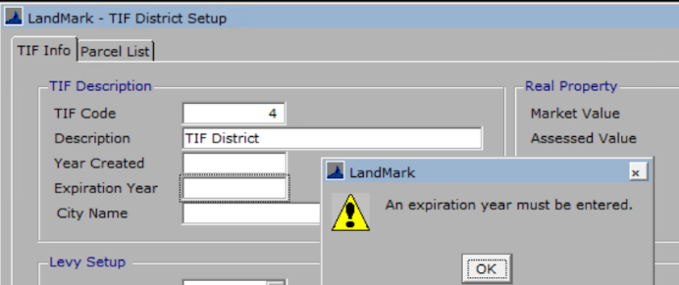
- Aug 15th If a tax area is entered that does not have a TIF fund associated you will be informed of this. You can proceed. You will need to place a TIF district on the tax area and then come back to the TIF area and recalculate the record.
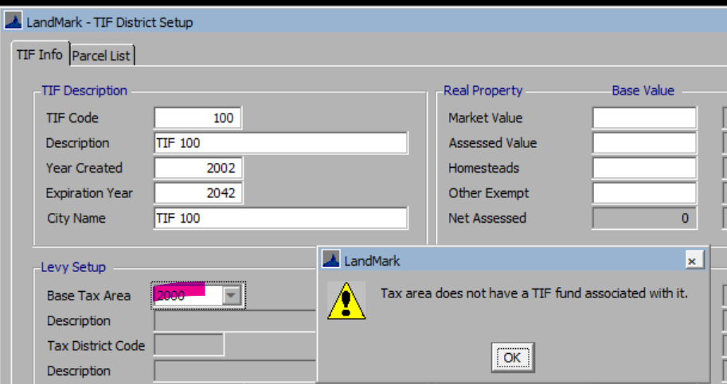
- Aug 15th The label tax entity was changed to Tax District Code. Once the Base Tax Area is entered or changed the Tax District Code and description will fill in. The tax district field is no longer editable.
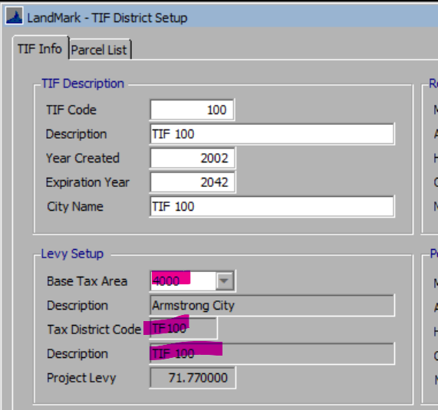
- Aug 15th If you try delete a TIF district being used you will receive the message that the record cannot be deleted.
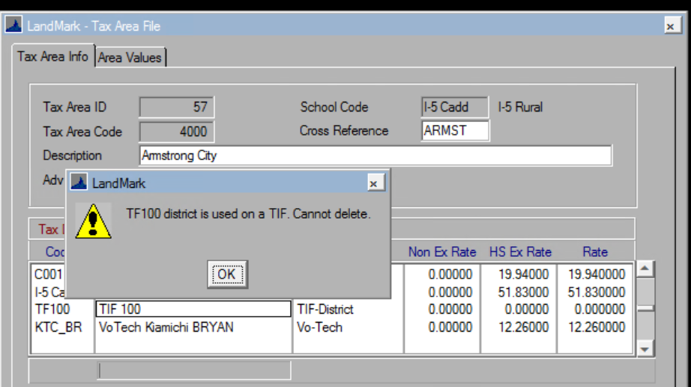

Neighborhood
- Aug 1st When creating or editing a record if you enter a code that already exists then you will receive a message that the code is already in use.
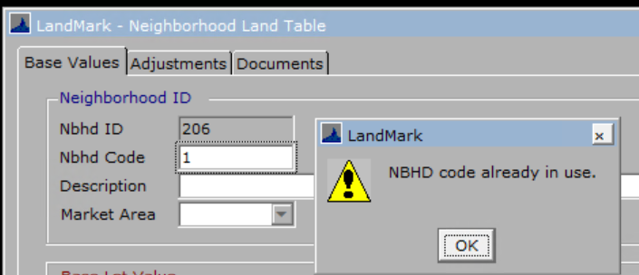
- Aug 1st If you edit a deleted record, you will be asked if you want to edit the record.
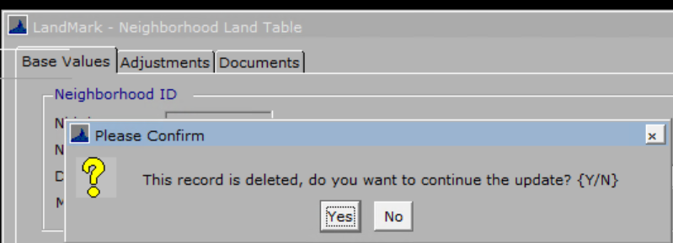
- Aug 15th If an appraisal zone is entered in the neighborhood table that does not exist in the appraisal zone table the user will receive an error message.
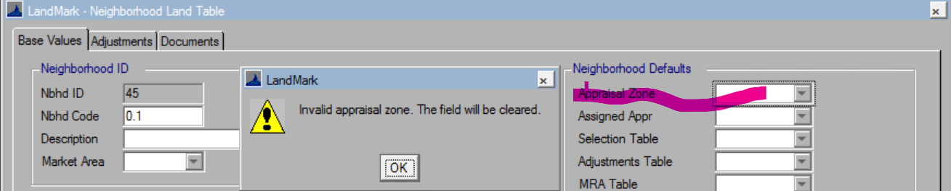

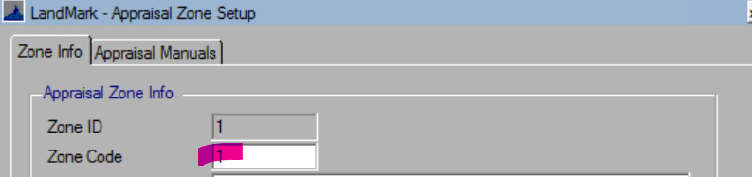

Personal Property Penalty
- Aug 8th If you enter more than 20% for the penalty you will get the message that it is more than 20% and change to this.

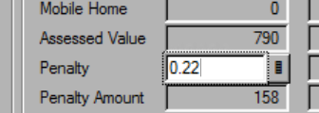

Will get this message and change to the maximum.
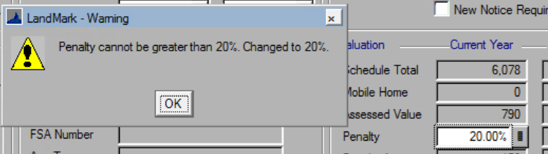

Tasks
- Aug 15th Task list will have the tax area on the form.
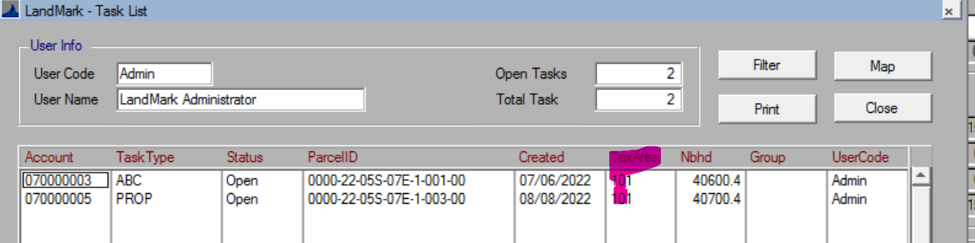
- Aug 15th Can filter task by tax area.
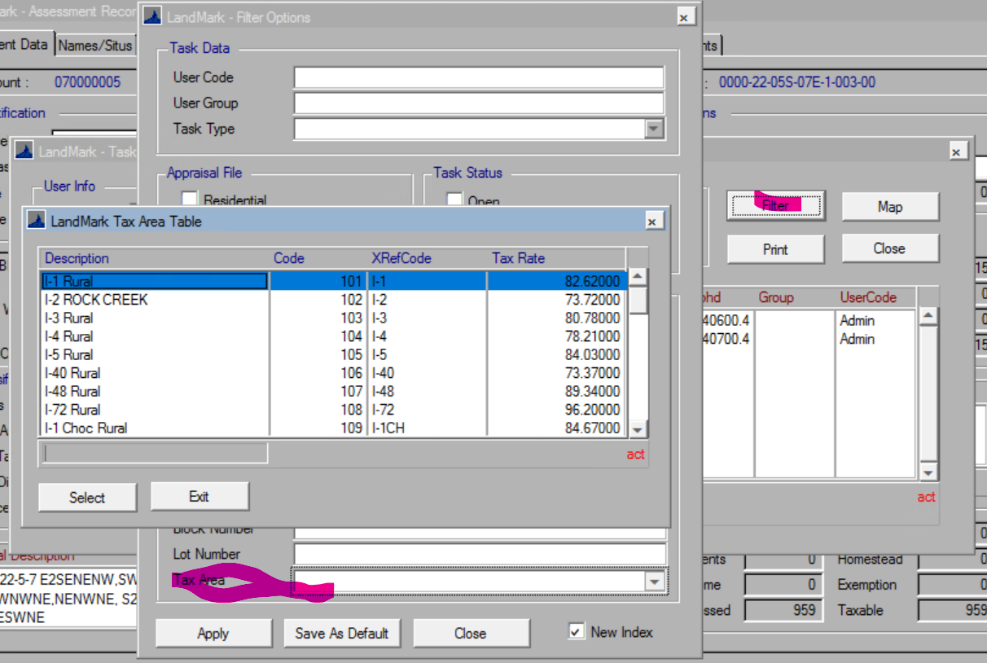
- Aug 15th Task list report will have tax area.
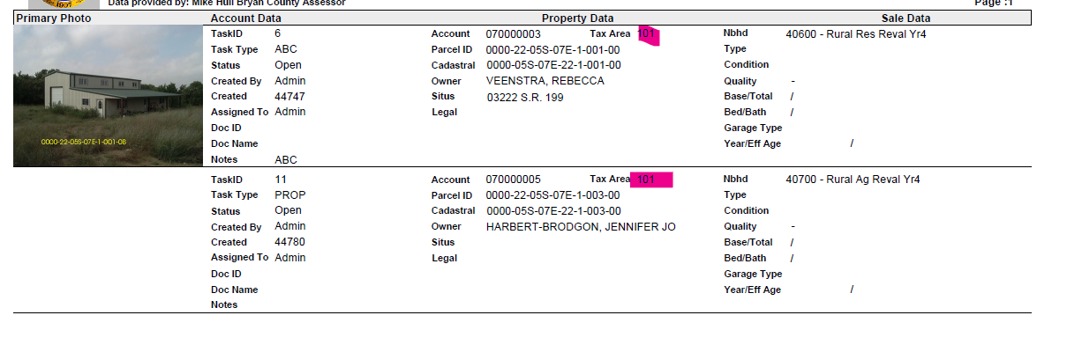
- Aug 15th Main task form will have the tax area.
