Contents

Weekly Changes April 25, 2022 1

Appraisal 1

Tax roll Correction 1

Personal Property 2

Exemptions Table 2

Reports 2

Review Sheet 2

901P 2

Change of Value Notices 2

Schedule Detail;Item Listing 3

935MH 3

# Weekly Changes April 25, 2022

## Appraisal

* Apr 10th When in the form the sketch and site plan will resize to be as large as possible for viewing on the from.
* Apr 18th When modifying sketch area font and size you would receive an error message.
* Apr 25th There is a menu option to copy outbuilding on commercial cards. In addition, the sketch of the outbuilding will move whether moving from a residential to commercial card or vice versa.

## Tax roll Correction

* Apr 10th If the correction has been applied or denied you will get a message that the record cannot be deleted because it is applied/denied. In order to delete would have to roll back the transaction.

* Apr 10th There will be an edit log on when a correction is applied or rolled back.

## Personal Property

* Apr 25th When moving personal property items if there was inactive account the item would be moved there if that was the first record created.

## Exemptions Table

* Apr 25th When viewing the edit log in the exemptions table an error message would pop up.

## Reports

### Review Sheet

* Apr 25th If there is an active homestead on the account this shows up on the review sheet.

* Apr 10th The review sheet will have the exterior wall options for commercial buildings (first 20 options) based on the class/frame. AS another note the class/frame section placed the options available. (There are options 1 – Residential Stud Frame and 9 – Steel Reinforced Concrete Frame are available but there is not space on the report for these.)

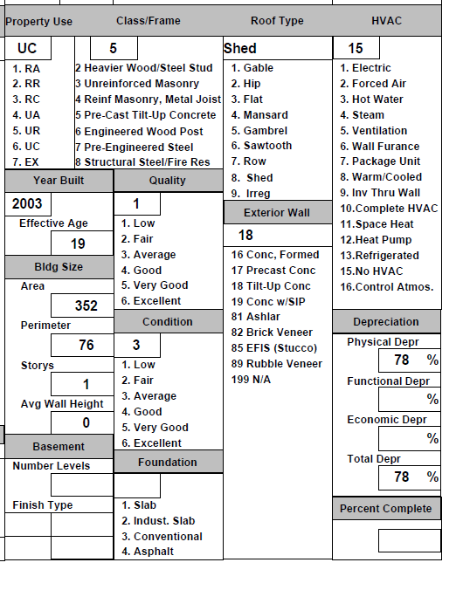

### 901P

* Apr 10th If the schedule listing is printed it will now include the inventory amount.
* Apr 10th If the print totals parameters are set to TRUE the assessed value will be used in the calculation of the assessed value instead of the acquisition cost.

### Change of Value Notices

* Apr 18th When printing the COV notices from an index you can use the records to print. Before all records would print.

### Schedule Detail;Item Listing

* Apr 18th When there were inactive appraisal records the schedule items would print for these records.

### 935MH

* Apr 25th In the heading the Assessor’s phone number will print in the heading of the report.